

**Usability Report**

05.06.2016

**Tushar Gupta**

ITP 341

**Participants**

Basic demographic information (participant sample size: 5)

|  |  |  |  |
| --- | --- | --- | --- |
| Name | Gender | Age | Occupation |
| Garvita Sharma | Female | 24 | Grad Student |
| Tushar Aggarwal | Male | 27 | Grad Student |
| Abinash Khandelwal | Male | 23 | Grad Student |
| Ritesh Chandna | Male | 24 | Grad Student |
| Sudhanshi Upadhyay | Female | 24 | Grad Student |

**Tasks**

1. Sign-up
2. Search and find matches
3. Check user details/pictures and send SMS.

**Overall Findings**

On the sign up page, the users were confused about what to enter and the format required for date and phone number. After clicking on Signup button, the app connects to server to create an account which takes a little time during which users did not know if app had stopped working. On the list view screen, it was taking a lot of time to load images since images are also loaded from backend server. The same problem was on the user details screen as all images of users are loaded there.

A couple of issues that I noticed while the users were using app are: users were not filling the first form completely which is crucial for the backend algorithm. Also, when search on list view returned 0 results, the users were confused if that was it. Also, it seemed that list view is too cluttered.

A big problem was that every time user was opening the app, register page was being displayed.

**Specific Findings**

**Overall App:**

* Issue: Color combination was not good
* Solution: Changed the color combination and logo

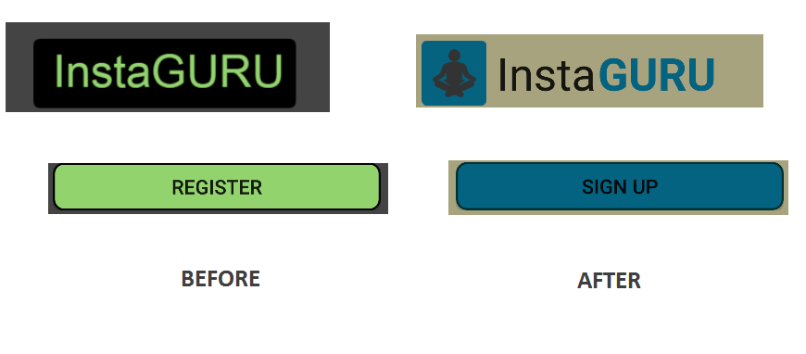

**Main Activity/ Signup Screen**

* Issue: Unclear about the format to enter
* Solution: Added hints to show a sample of required format
* Issue: Users were not filling all fields
* Solution: Added a simple validation which shows a Toast if any field is missing
* Issue: On clicking Signup button, no way to tell if app was doing anything
* Solution: Added a progress bar

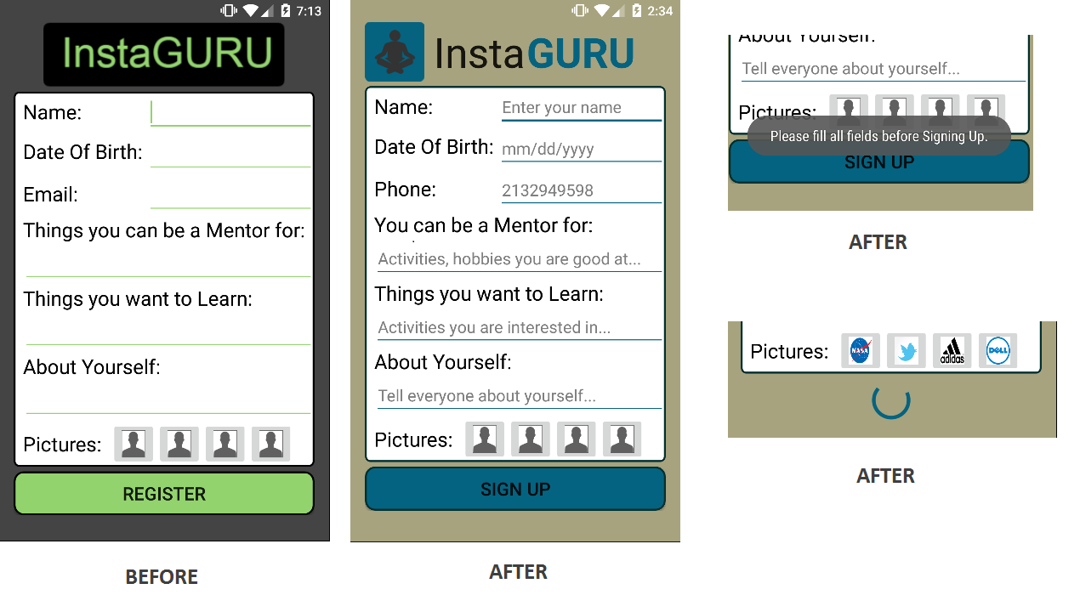

**Matches Activity/ List View Screen**

* Issue: List view cluttered
* Solution: Removed some info from List View as it is available in User Information Screen

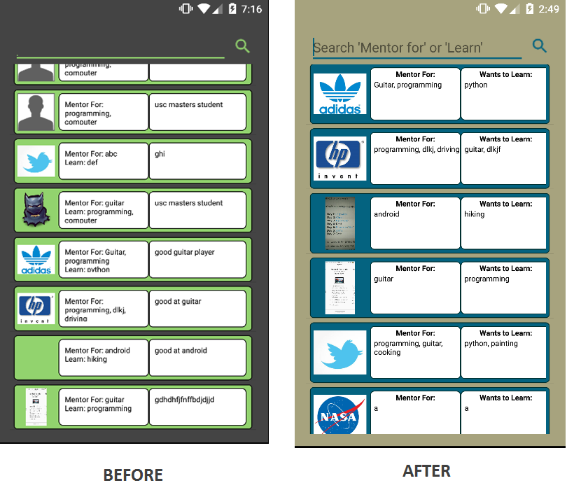

* Issue: Blank screen if search did not match anything
* Solution: Added a toast notification informing that there were no matches

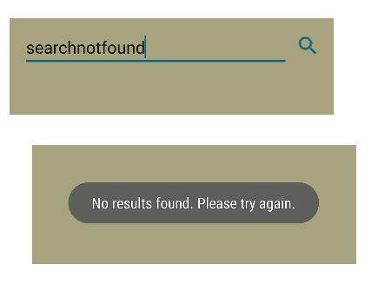

**Information Activity/ User Info Screen**

* Issue: Color combinations/ the way the information was displayed not good
* Solution: Changed color/design. Added grid view to display information

