Lesson 1: Tổng quan về bảng IPA. Vowels /i/ and /i:/, /u/ and /u:/

Talk about yourself

1. The IPA: The International Phonetic Alphabet

IPA stands for (=)

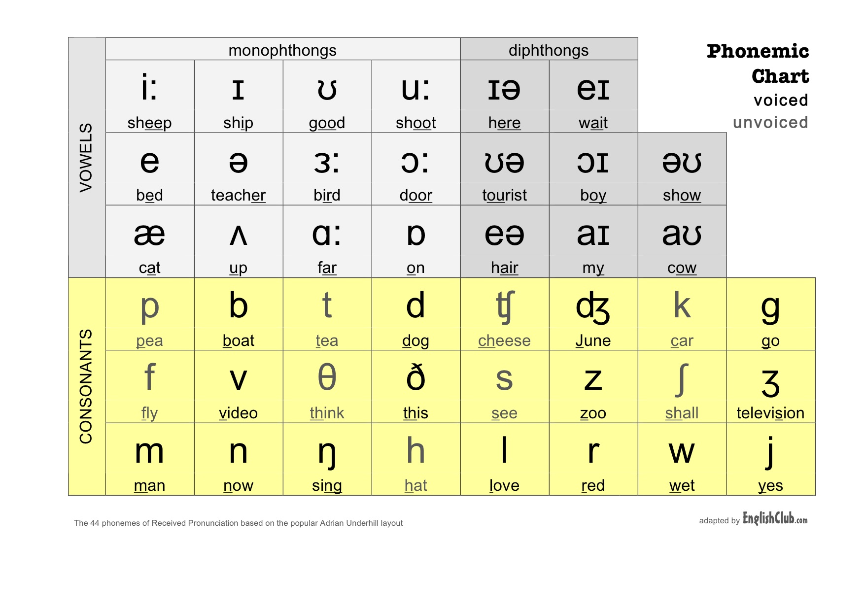

* Vowels: 20 sounds
* 12 monothongs
* 8 diphthongs
* Consonants: 24 sounds
* Nguyên tắc:
* Cố gắng phát âm to, rõ ràng.
* Phát âm bắt đầu từ chậm trước.
* Đôi khi cần sự thái quá.

1. Vowels /i/ and /i:/, /u/ and /u:/

# /i:/ and /i/

* Difference:
* Example:

**Seat Sit**

/siːt/ /sɪt/

Please have a seat. Sit down, please!

**Heat Hit**

/hiːt/ /hɪt/

You should **heat up** the soup for dinner. I hit my head on the wall.

**Bean Bin**

/biːn/ /bɪn/

I’m cooking green beans. Please, put your trash on the litter bin!

**Feel Fill**

/fiːl/ /fɪl/

I feel happy today. Do you want me to fill your coke, Sir?

Cheap Chip

/tʃiːp/ /tʃɪp/

He didn’t give me any tip. He is so cheap. I love potato chips.

# /u:/ and /u/

* Difference:
* Example:
* /u:/

**Soup Spoon**

/suːp/ /spuːn/

Would you like some soup? It’s a silver spoon.

**Shoes Group**

/ʃuːz/ /ɡruːp/

I love Adidas shoes. There is a group of students on campus.

**Two**

/tuː/

Two children are waiting for their mom.

* /u/

**Book Look**

/bʊk/ /lʊk/

I love reading books. Look at the sky.

**Good** Put

/gʊd/ /pʊt/

I’m good at English. Put your hand on my shoulder.

**Should**

/ʃʊd/

You should put everything in its place.

III. Talk about yourself.

1. What is your name?

I am Sinh. (It is spelled S-I-N-H).

1. How old are you?

I was born in 1995, which means that I am 26 years old.

1. Where are you from?

I am from Hai Duong province, which is about 80 kilometer from Hanoi.

1. What do you do?/ What is your job (=occupation)?

I am currently working as a software engineer. I work with a computer for the whole day so I usually feel really tired and exhausted at the end of the day.

1. What do you like to do most in your free time?

In my free time, I love hanging out (=go out) with my friends. I also prefer going backpacking from the morning to the late afternoon. I also love running around the park and playing football with my friends to keep fit.

I am Sinh. (It is spelled S-I-N-H). I was born in 1995, which means that I am 26 years old. I am from Hai Duong province, which is about 80 kilometer from Hanoi. I am currently working as a software engineer. I work with a computer for the whole day so I usually feel really tired and exhausted at the end of the day. In my free time, I love hanging out (=go out) with my friends. I also prefer going backpacking from the morning to the late afternoon. I also love running around the park and playing football with my friends to keep fit.