 **ASSIGNMENT2**



*Multi-user Chat Board*

Tushar|2018201

**DESCRIPTION OF CODE**

* int main() takes input for user no. and message, whenever a message is available, it sends a signal to the all the recipients of that message according to the input format.
* void handler(int signum) whenever called for handling the signal, prints the message and details of the message (i.e. sender, individual or group message etc.)
* char** tokenize(char str1[]) returns a array of tokens from a space separated string.



**IMPLEMENTATION OF CHAT-BOARD**

* Shared memory is used for inter-process communication

between two users.

* Whenever a message is present we send a kill signal to the recipient to read the message from the shared memory. Signal is sent to every user in case of group message or to an individual otherwise.

• An array of available users is stored in shared memory to keep record of all current users.

* Handled invalid input for smooth functioning of chat-board.

**INPUT FORMAT**

***For Individual message:***

**<user no. of the recipient><space><message>**

***For Group message:***

**0<space><message>**

**EXPECTED OUTPUT**

***For Individual message:***

**“Received from <user no>:<message>”**

***For Group message:***

**“Received in group chat from <user no>:<message>”**

**ERROR HANDLED AND ERROR**

***Invalid User No.***

* User no. should be between 1 and 100.
* User no. should be a integer value.

***Duplicate users***

* There should not exist a user with same user no. already.

***Invalid recipient***

* Recipient no. should be between 0 and 100.
* User no. should be a integer value.
* There should exist a user with that user no. already.

**DESCRIPTION OF THE SYSTEM**

This multi-chat board works on unix/linux based systems.

**TESTING THE SYSTEM CALL**

• Compile user.c using make

* Open user application in multiple terminal windows using ./user
* Pass a valid user no.
* Send a text as per given input format
* Sent message will appear on other users window

**#NOTE: Exit the user only using** “>exit”, **or otherwise** **key has to be changed everytime you restart the whole chat board.**

**WORKING OF MULTI-USER CHAT BOARD**

* Task info printed into the file.

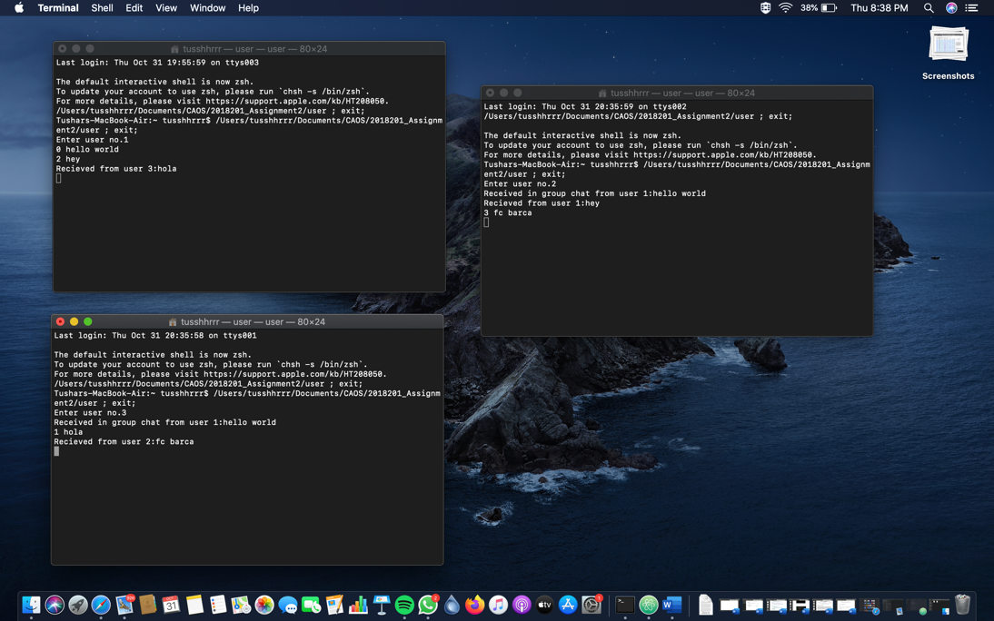

Error thrown for wrong input values.

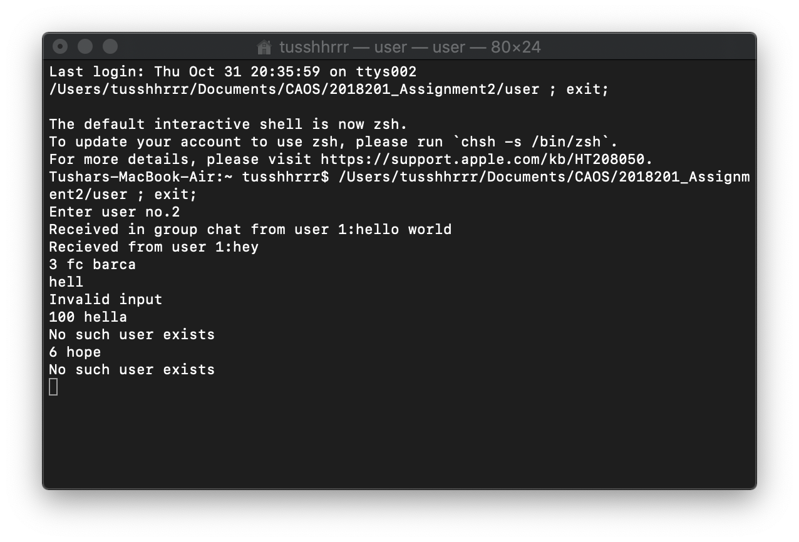

**REFERENCES**

<https://www.geeksforgeeks.org/chat-application-between-two-processes-using-signals-and-shared-memory/>

<https://stackoverflow.com/questions/6168636/how-to-trigger-sigusr1-and-sigusr2>

<https://www.tutorialspoint.com/c_standard_library/c_function_signal.htm>

<http://man7.org/linux/man-pages/man2/shmget.2.html>   
<https://www.geeksforgeeks.org/ipc-shared-memory/>

<https://www.w3resource.com/c-programming-exercises/string/c-string-exercise-31.php>

**5**