**Tableau**

1. Open tableau free trail 15 days
2. There are main two options: to connect server, file.
3. After connecting to anything just drag and drop the required table in center.
4. We can apply filter to a table by adding it from top-right side.
5. There is connection option beside add filter, two types: live and extract.
6. In live it is directly reflected to actual data whatever changes we make. It is slower since we are working with live data.
7. In extract, the whole data is taken in tableau memory. It is faster. It is advisable to use extract. We can schedule data daily to extract for example we can schedule at 4pm to extract daily data.
8. Now this is a book, so while saving there are two options: .twb, .twbx
9. .twb file stores the tableau changes and don’t store the data so if you want to share .twb file then you also have to share source file.
10. .twbx file contains data.
11. Double on dragged table and drag another table to have join. After dragging you will get all the join options.
12. Now to do analysis, charts, etc click on sheet1.
13. Tableau will automatically differentiates Dimension and Measures with a thin line.
14. Dimensions are the columns which can be city, country, etc
15. Measures are numeric data columns in which we can aggregate numeric data.
16. Now to do analysis, drag and drop sales to canvas or to row. Tableau will give sum of sales.
17. Click on Show me button on top-right corner to get charts and select one of it.
18. Now drag and drop category to column or canvas to show category wise sales.
19. By default, measures when we drag and drop, tableau will automatically aggregate it.
20. We can change aggregate by clicking on dropdown.
21. At bottomleft corner you will get count of marks which means that it is the data points in chart.
22. Drag and drop profit also in row. It will create two charts.
23. We can swap rows and columns by clicking on option above.
24. To apply filter, drag and drop the column in filter section and in that select which value you want.
25. Add other column to filter, it will act like AND filter just like in where clause of SQL.
26. Drag and drop sales to label to see details on bar graph
27. Tooltip is the text which comes when we hover on bar graph
28. 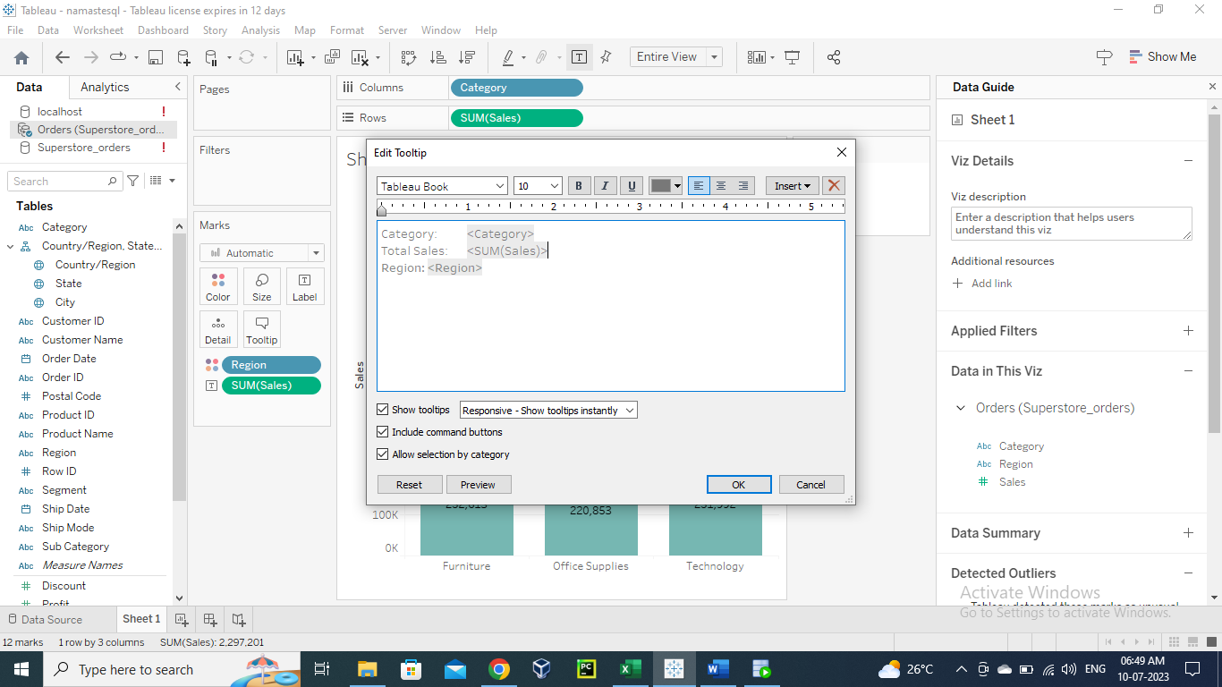
29. 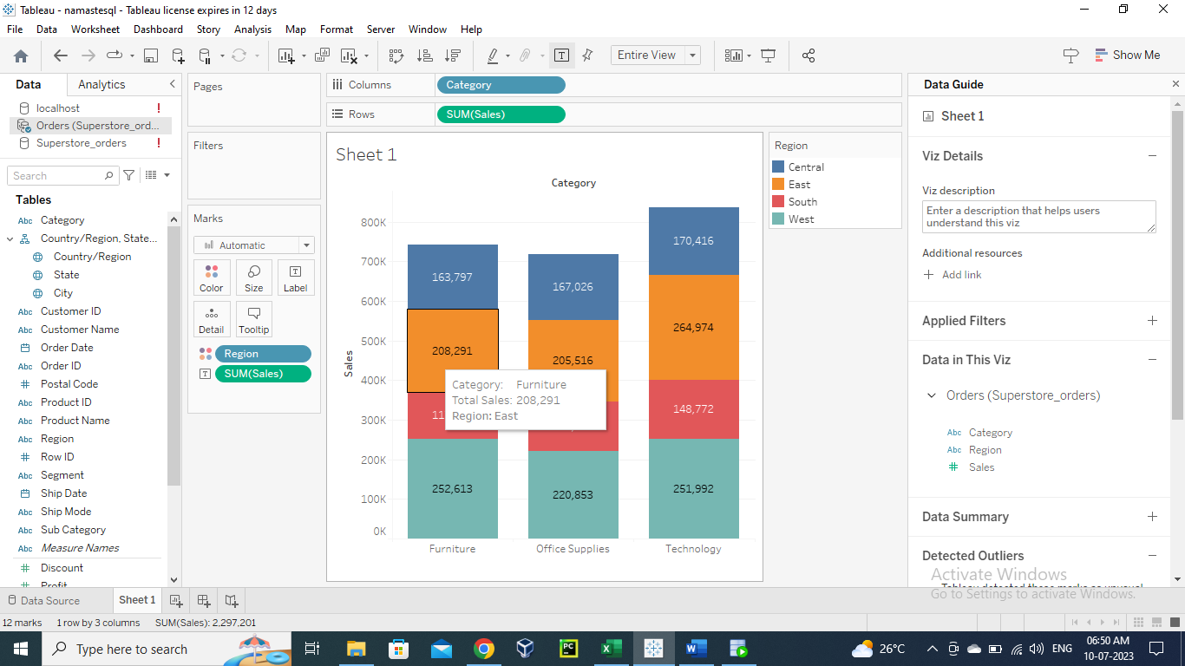
30. In tableau graph we have row and column which represent in SQL row as aggregate function column and column as group by columns in sql.
31. 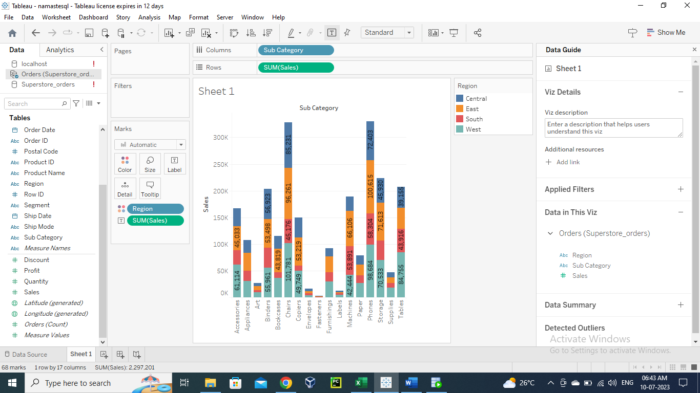
32. select sub_category, region, sum(sales) from orders group by sub_category, region;
33. whenever you add a field to a color or size, you are automatically adding to group by as well. Just like region in below eg.
34. 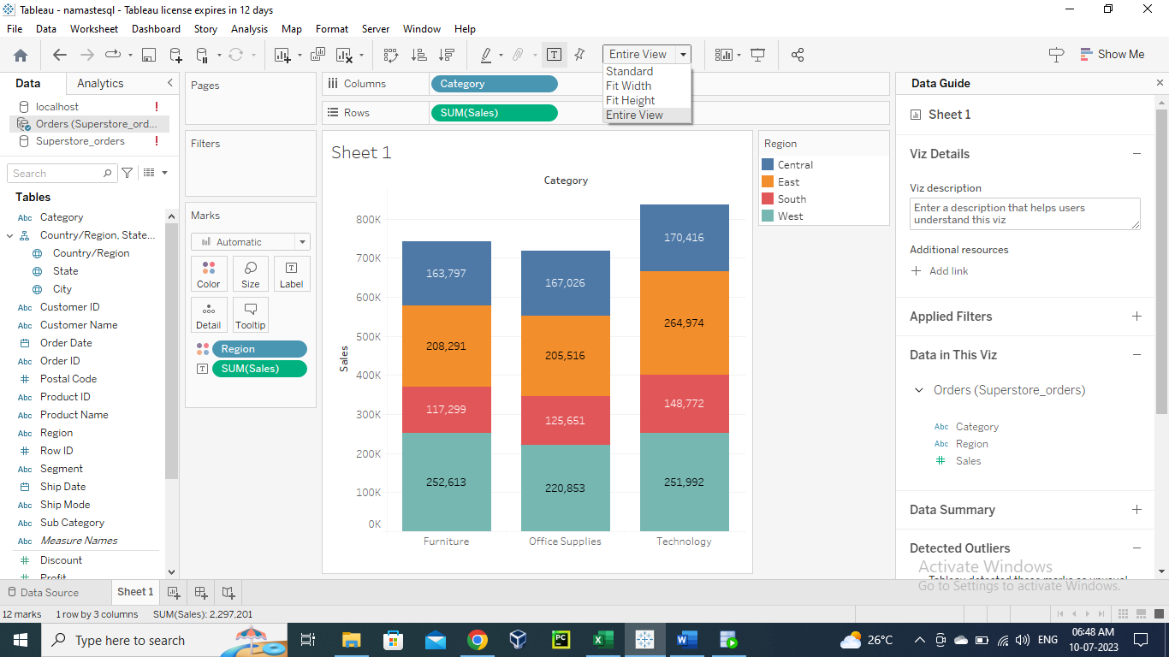
35. You can change the view of graph from above option.
36. Can change it from color to size
37. 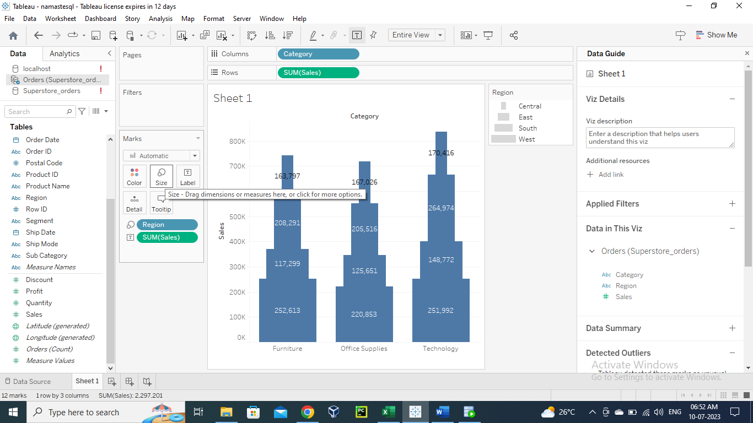
38. 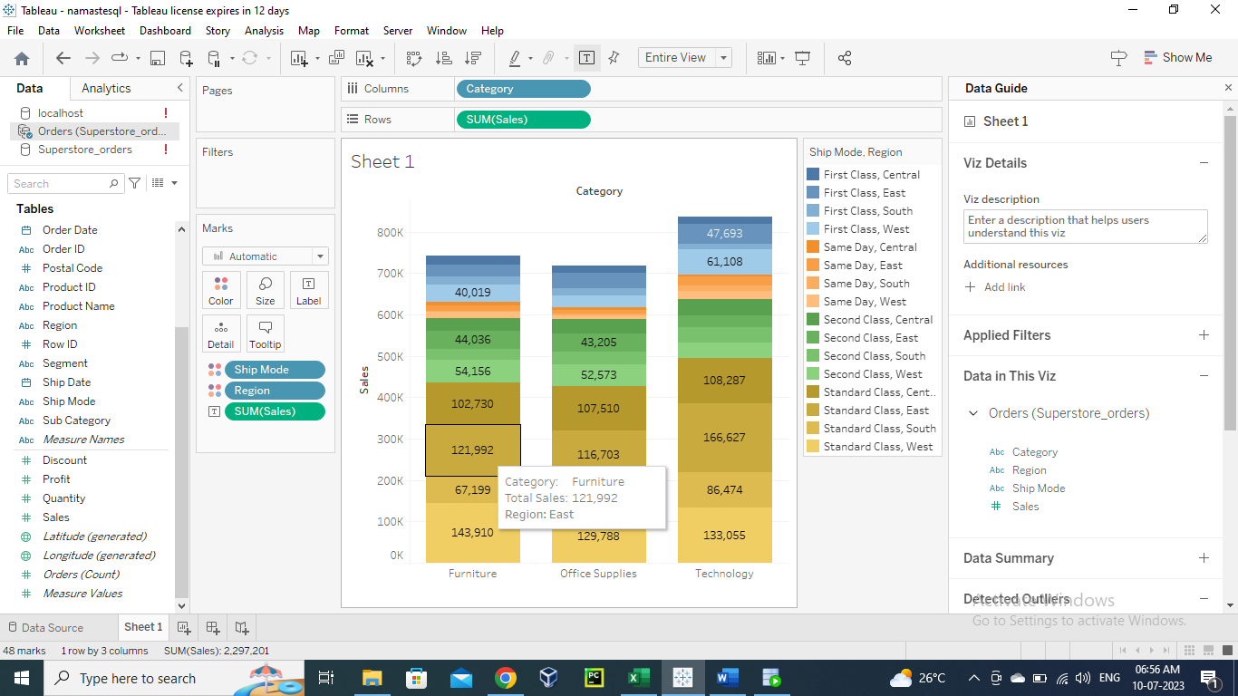
39. We can change currency of label by going to format of sales
40. 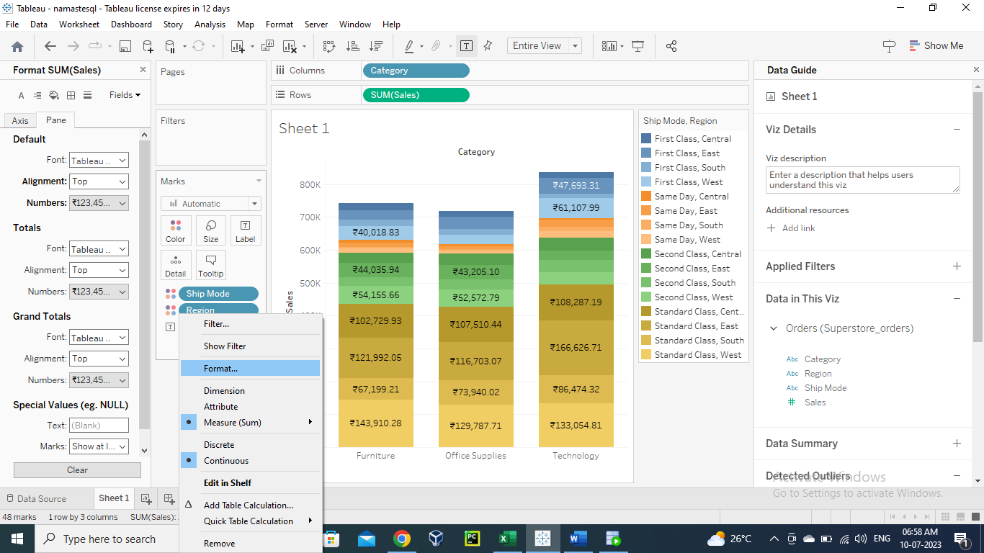
41. Playing with date:
42. 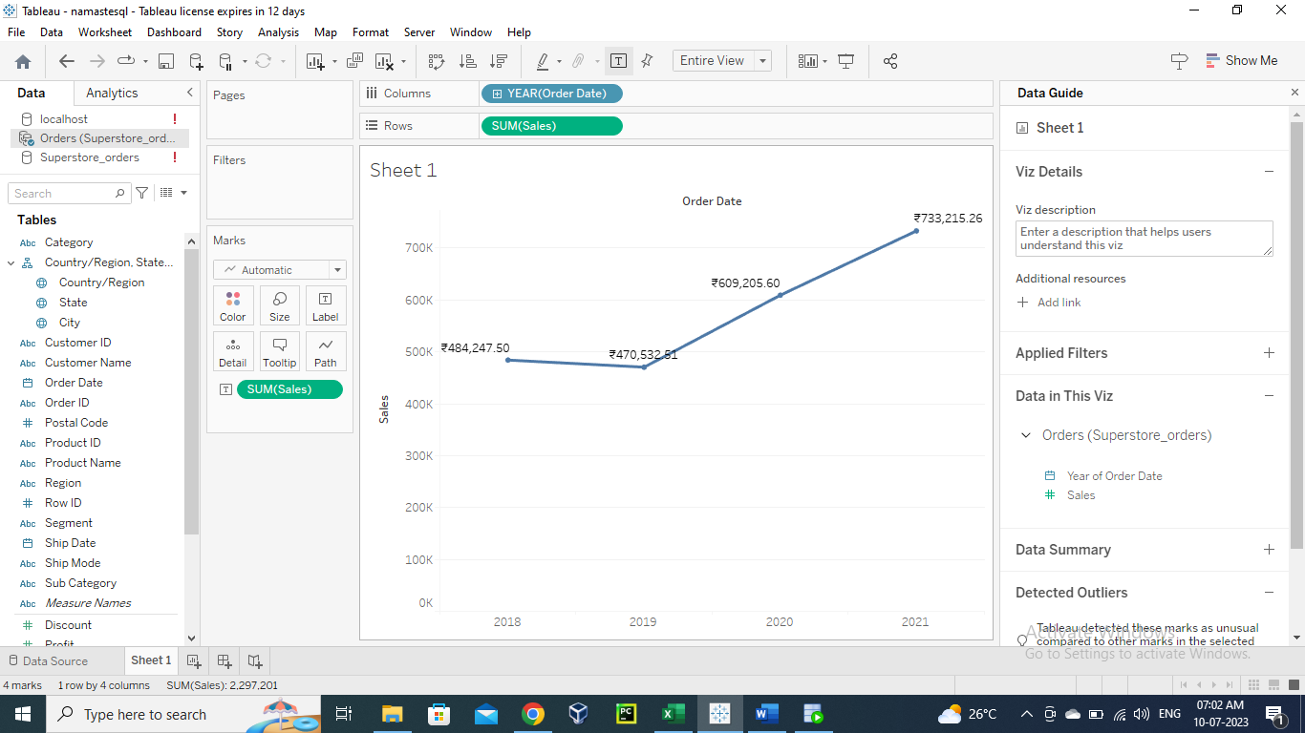
43. select extract(year from order_date), extract(month from order_date), sum(sales) from orders group by extract(year from order_date), extract(month from order_date);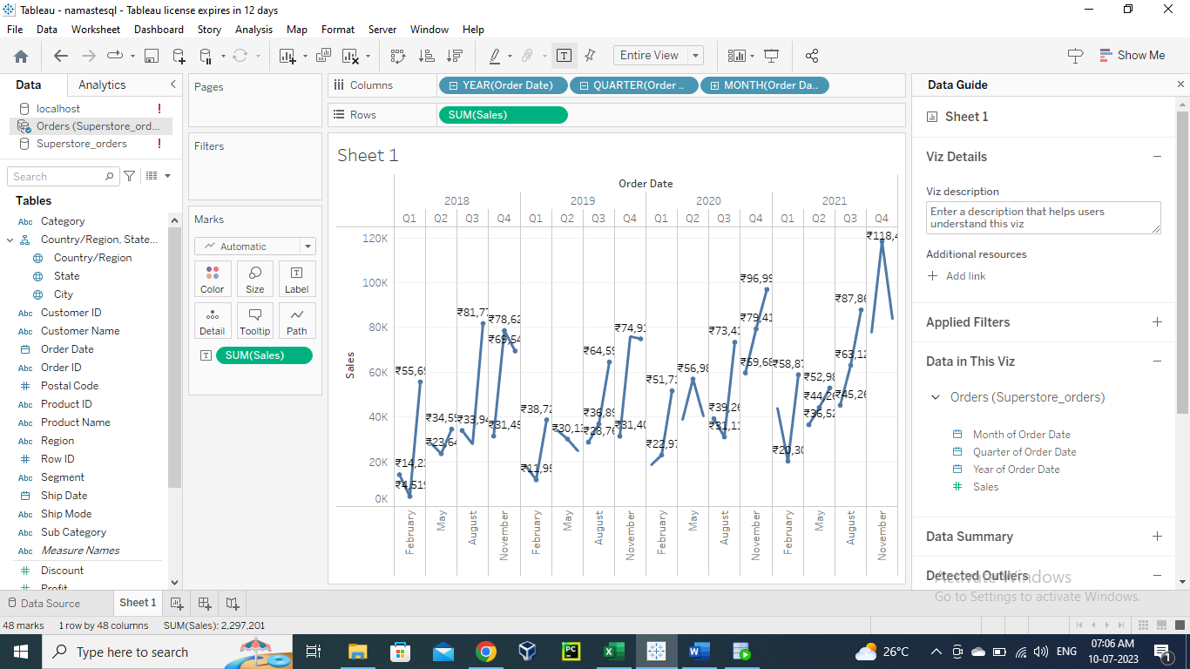
44. 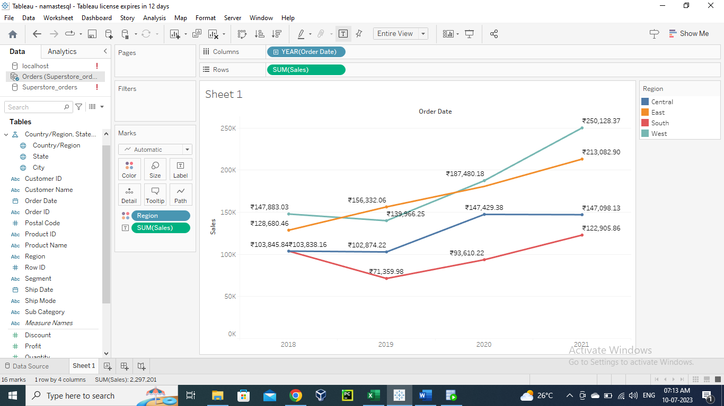
45. select extract(year from order_date), region, sum(sales) from orders group by extract(year from order_date), region order by extract(year from order_date), region;
46. 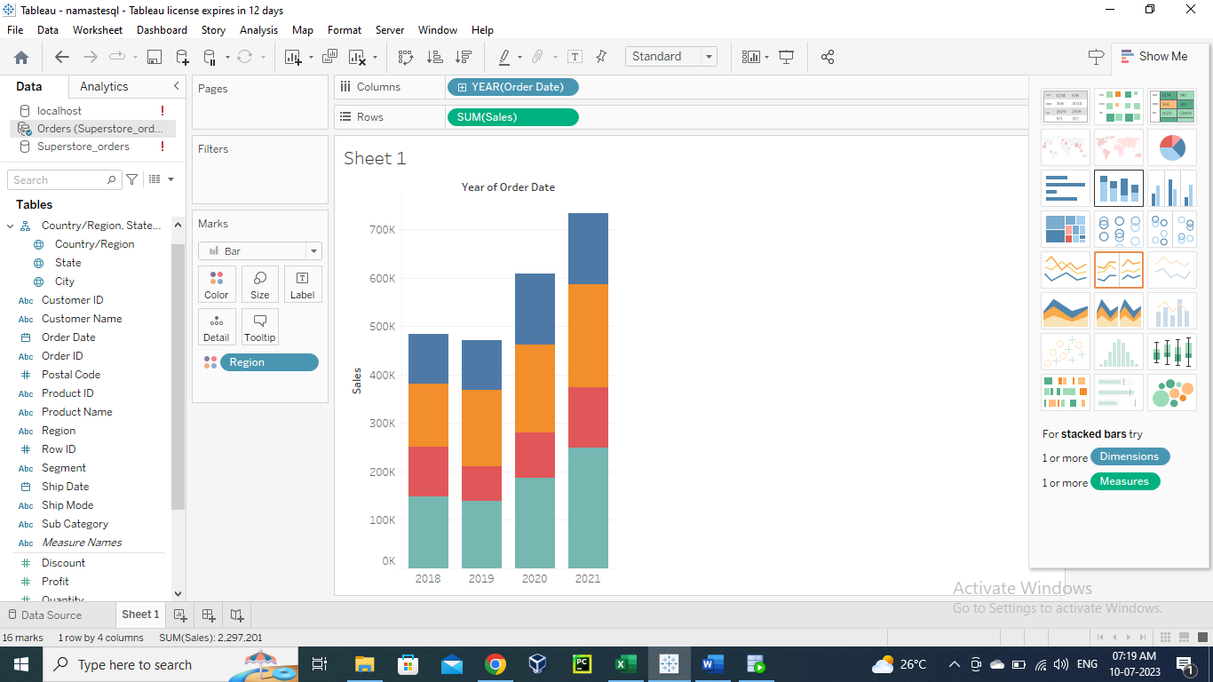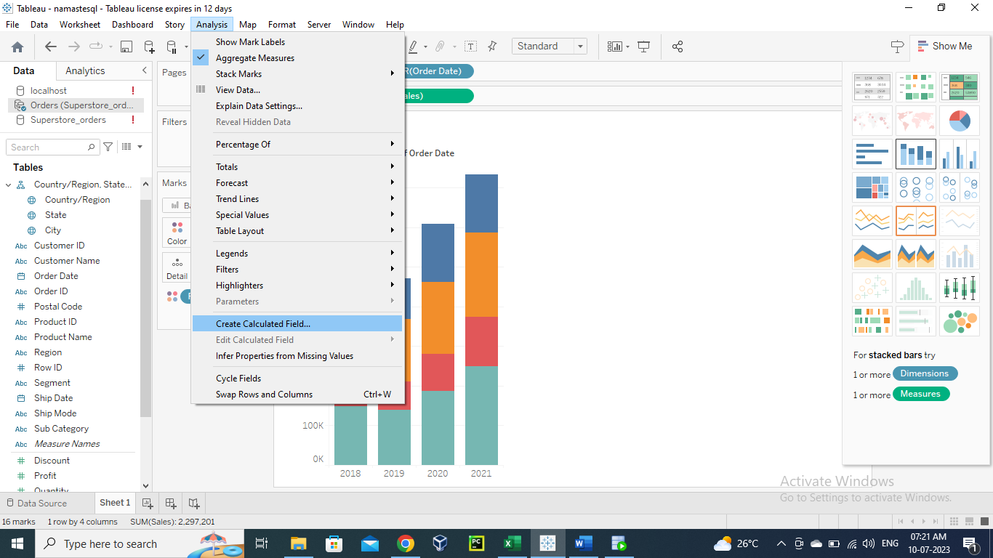
47. 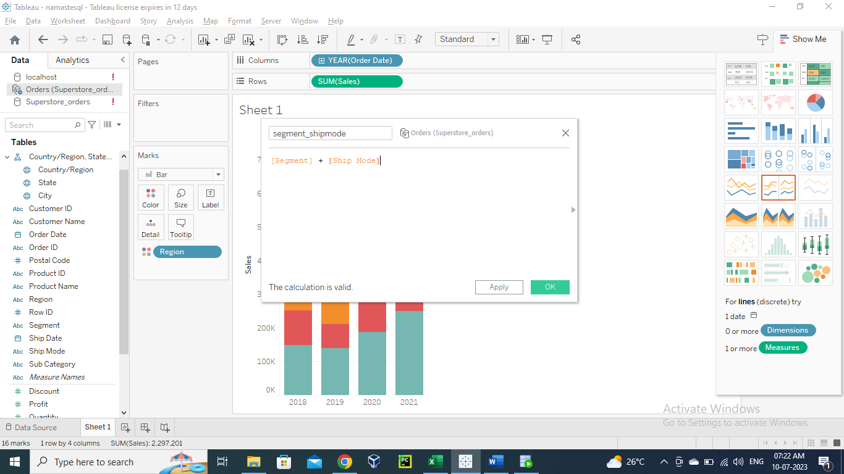
48. 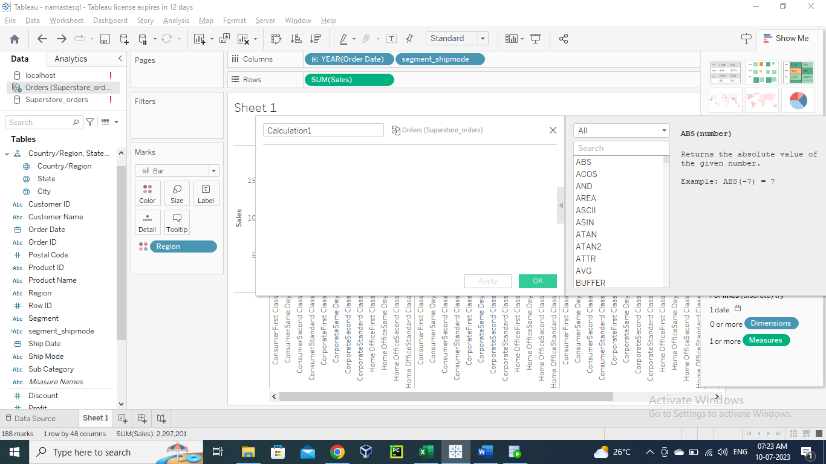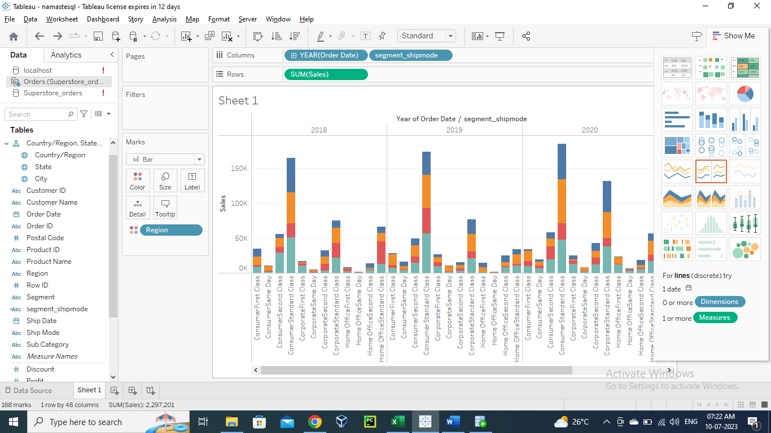
49. Can also convert any required column from dimension to measure or vice-versa.
50. Running sum:
51. 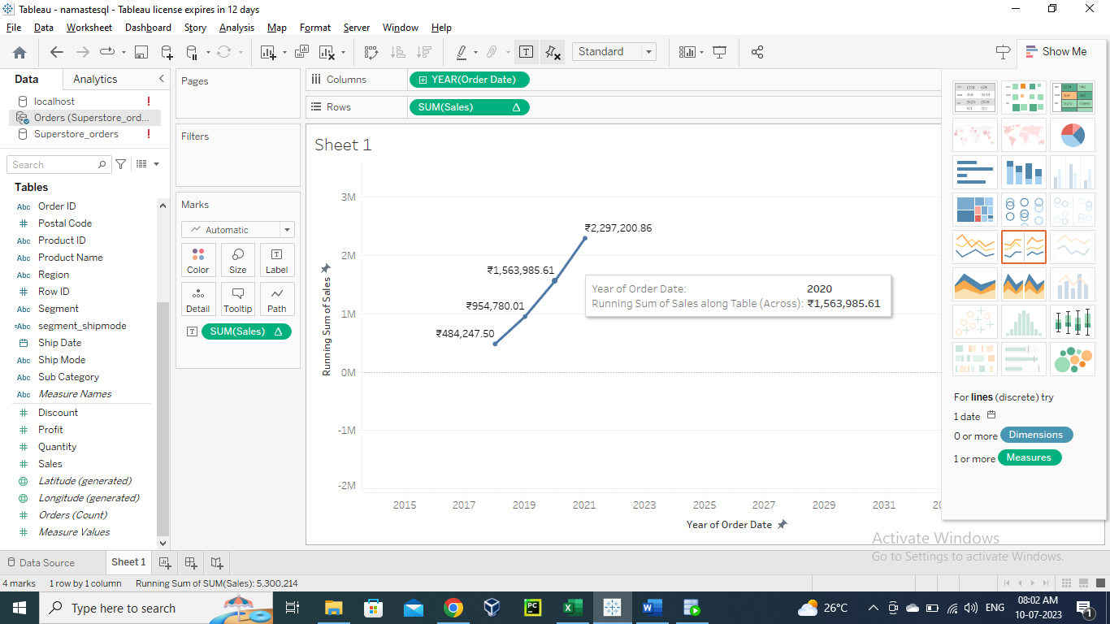
52. select a.*, sum(a.sum_sales) over(order by a.sum_sales) from (select extract(year from order_date), sum(sales) as sum_sales from orders group by extract(year from order_date)) a;
53. can create hierarchy of multiple columns:
54. 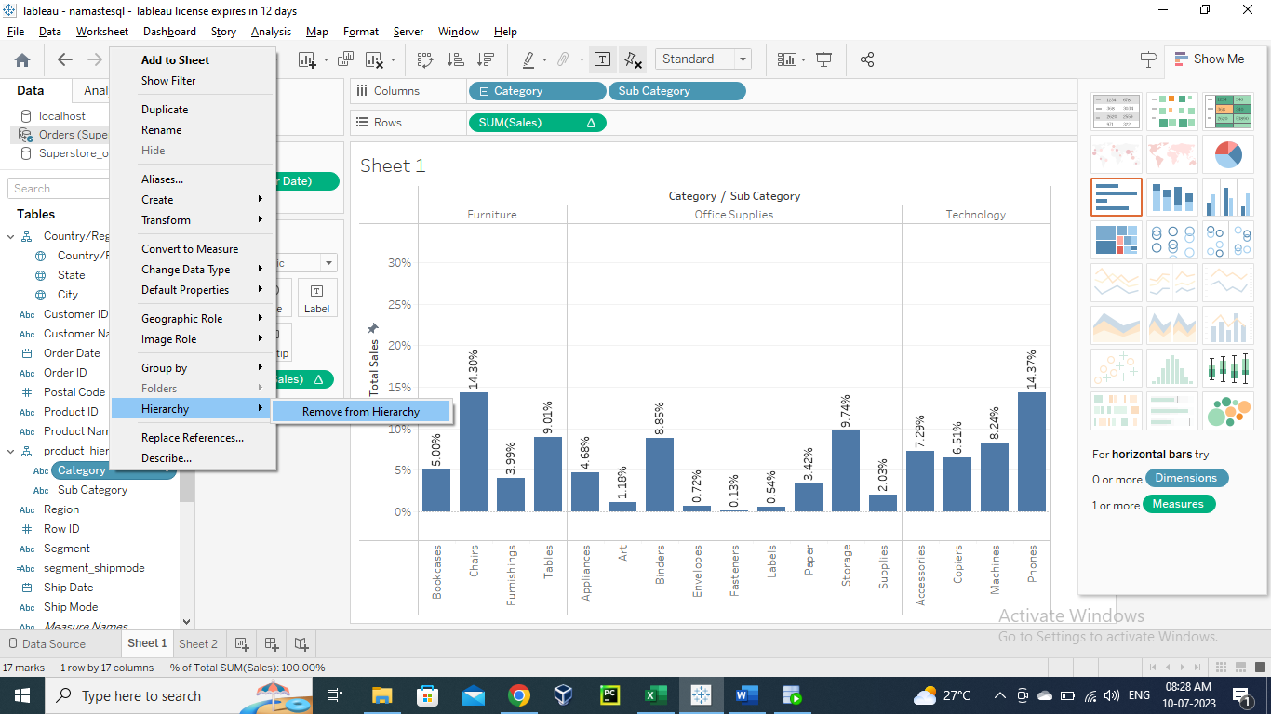
55. Now we can create multiple sheets for each chart.
56. We can create dashboard to inherit all the sheets there.
57. 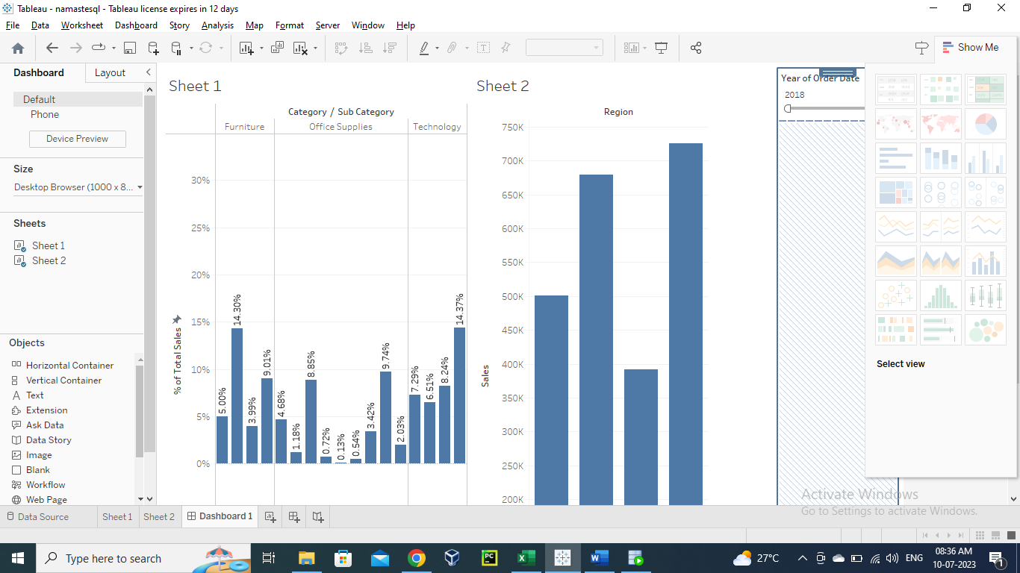
58. Now we can save our dashboard to tableau public:
59. 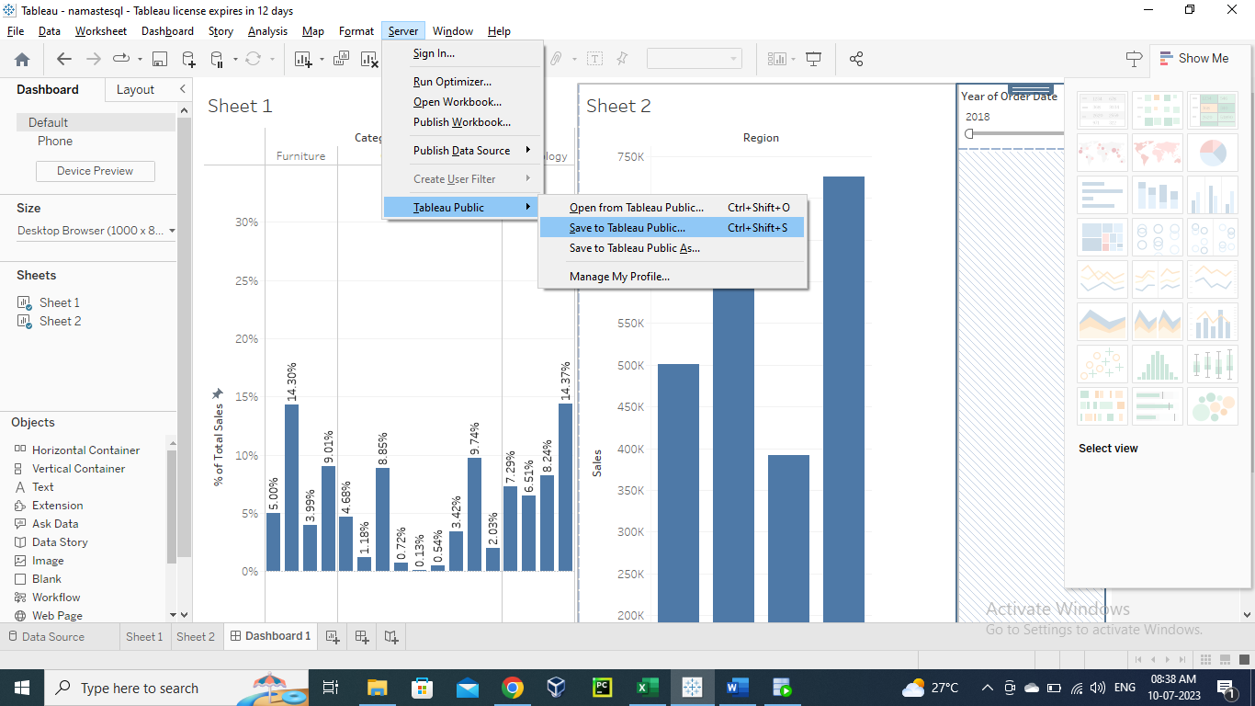
60. To go to different servers:
61. 