**TUTEDUDE-LINUX ASSIGNMENT**

**Task 1: Creating and Renaming Files/Directories**

* I created a directory named test_dir using the mkdir command.
* Inside that directory, I created an empty file called example.txt using the touch command.
* Then, I renamed example.txt to renamed_example.txt using the mv command.

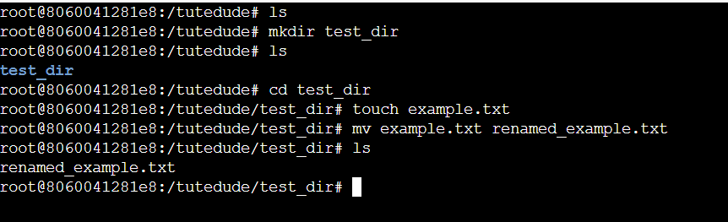

**Task 2: Viewing File Contents**

* I used the cat command to display the full contents of the /etc/passwd file.
* I used the head command with -n 5 to show only the first 5 lines of the file.
* I used the tail command with -n 5 to show only the last 5 lines of the file.

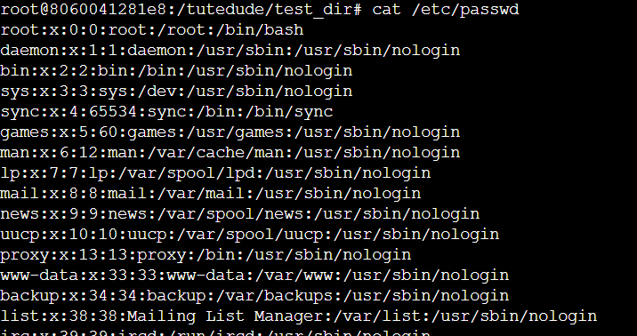

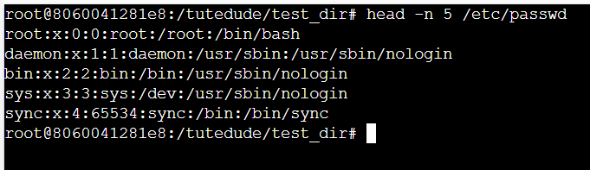

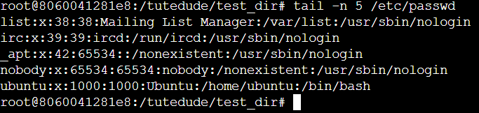

**Task 3: Searching for Patterns**

* I used the grep command to search for all lines that contain the word **"root"** inside /etc/passwd.

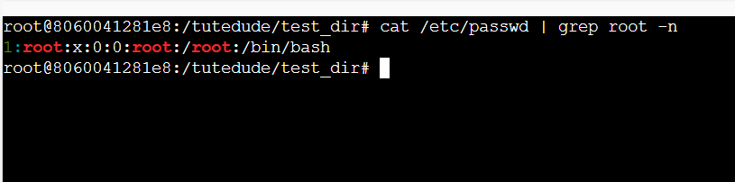

**Task 4: Zipping and Unzipping**

* I compressed the test_dir directory into a .zip file using the tar and zip command.
* Then, I created a new directory named unzipped_dir and extracted the zip contents into it using unzip.

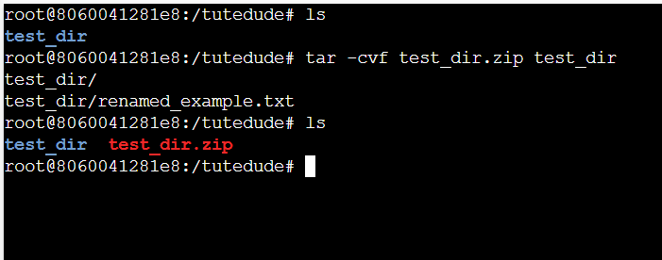

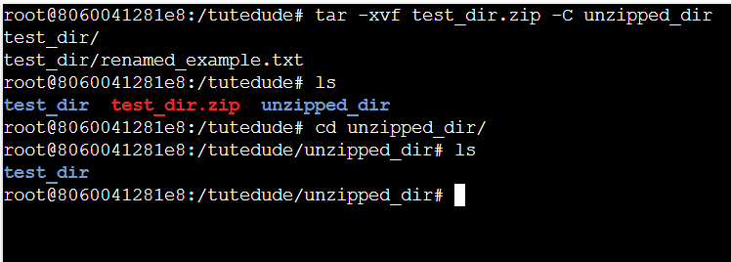

**Task 5: Downloading Files**

* I used the wget command to download a sample file from a URL. This saves the file to the current directory.

(Note: You can test with any downloadable link, e.g., https://example.com/sample.txt)

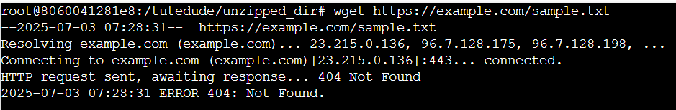

**Task 6: Changing Permissions**

* I created a file named secure.txt using touch.
* Then I used chmod 444 to make it **read-only for everyone** (user, group, and others).

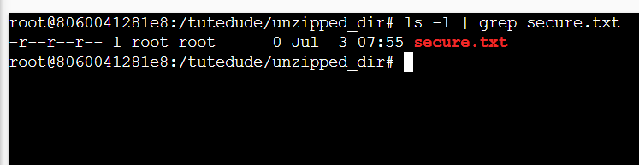

**Task 7: Working with Environment Variables**

* I used the export command to set a new environment variable called MY_VAR with the value "Hello, Linux!".
* Then, I used echo to verify the value.

