Database Design Document
Fuel Station Network
Tamar Tutisani

Table of Contents
1 Business Description 3
1.1 Project Vision and Benefits of a Database 3
1.2 Definitions & Acronyms 3
2 Model description 4
2.1 Conceptual Model 4
2.2 Logical Model 4
2.3 Physical Model 5
2.4 Key Design Decisions 6
2.5 Step-by-Step Modeling Approach 6

Business Description

Project Vision and Benefits of a Database
A fuel station network operates dozens of physical sites across multiple regions, each selling different fuel types at different prices, staffed by different people, and replenished by different suppliers. Before a database, that kind of information ends up split across spreadsheets, paper logs, and someone's memory. That works fine for two stations, but it breaks down quickly when you have eight sites, sixteen fuel types across them, sixteen employees, six suppliers, and thousands of pump transactions per week.
Without a database, a network manager is likely reconciling data manually across separate files, one file per station, no consistent format, no way to tell which price was active at the time of a sale, no reliable audit trail for deliveries. Two cashiers updating different copies of the same spreadsheet, a supplier name spelled three ways across the records, no history of when fuel prices changed. The database solves this by giving every piece of information one place to live.
Data integrity and consistency are handled at the database level rather than relying on the application to get it right. Constraints enforce business rules: a fuel type cannot appear twice for the same station, a sale quantity cannot be negative, a payment method must be one of the four accepted values. If a supplier updates their contact details, one row changes and it reflects everywhere.
Traceability comes from the append-only design of the fuel_prices table. Price changes are never overwritten, a new row is inserted each time a price changes, with an effective_from timestamp. This means the exact price active at the time of any historical sale can always be reconstructed. The same logic applies to delivery records: every replenishment event is recorded with its waybill number, supplier, and line items.
The schema is also easy to extend. Adding a new fuel type, a new region, or a new supplier is one INSERT into the lookup table. No structural changes needed.

Definitions & Acronyms
Term | Definition
Station | A physical fuel retail site in the network, identified by name and address.
Fuel Type | A product category sold at the pump, e.g. Regular 92, Premium 95, Diesel, LPG.
Station Fuel | The bridge record that links a specific fuel type to a specific station and records its tank capacity and current stock.
Fuel Price | A pricing record for a specific station and fuel type, valid from a given timestamp. Stored in an append-only history table, current price = latest record.
Fuel Sale | A single pump transaction: one customer (or anonymous), one fuel type, one employee, one station. total_amount is computed automatically.
Delivery | A replenishment event: a supplier truck arriving at a station. Line items (delivery_items) record which fuels and how many litres.
Loyalty Customer | A registered customer with a loyalty card. Walk-in / cash sales record no customer (NULL FK).

Model description

Conceptual Model
The conceptual model identifies the core real-world entities and their relationships without committing to any particular data type or constraint. The key entities are:
Regions - group stations geographically.
Fuel Types - the product catalogue (Regular 92, Diesel, LPG, etc.).
Stations - individual physical sites, each belonging to one region.
Customers - registered loyalty cardholders (optional; walk-in sales have no customer).
Employees - staff assigned to a specific station with a specific role.
Suppliers - external wholesalers who deliver fuel.
Deliveries - replenishment events from a supplier to a station.
Fuel Sales - the primary transaction: one sale per pump fill.
The many-to-many relationship between Stations and Fuel Types is resolved through the Station Fuel bridge entity, which also stores the tank capacity and current stock for each fuel type at each station.
See the file SQL_Tamar_Tutisani_FinalTask_FuelStationNetwork_ConceptModel.png for the conceptual ERD (boxes with entity names and relationships only, no data types).

Logical Model
The logical model translates the conceptual entities into relational tables with defined columns, data types, primary keys, foreign keys, and named constraints. It is in 3NF throughout:
1NF: all columns hold atomic values; no repeating groups or arrays.
2NF: no partial dependencies. All non-key columns depend on the full primary key (confirmed because all tables use single-column surrogate PKs, so no partial dependency is possible).
3NF: no transitive dependencies. For example, region_name is stored in regions and referenced by FK from stations, it is not stored directly in stations, which would create a transitive dependency through region_id.
Tables and their types:
Table(s) | Type | Note
regions, fuel_types, employee_roles | Lookup | Static reference data; rarely changes.
suppliers | Lookup / Master | External companies; mostly static.
stations, customers | Master | Core operational entities.
station_fuel | Bridge (M:N) | Resolves the many-to-many between stations and fuel types.
fuel_prices | History (append-only) | One row per price change; current price = MAX(effective_from).
employees | Master (soft-delete) | is_active = FALSE for terminated staff.
deliveries, delivery_items | Transaction (header + line) | Replenishment events and their fuel quantities.
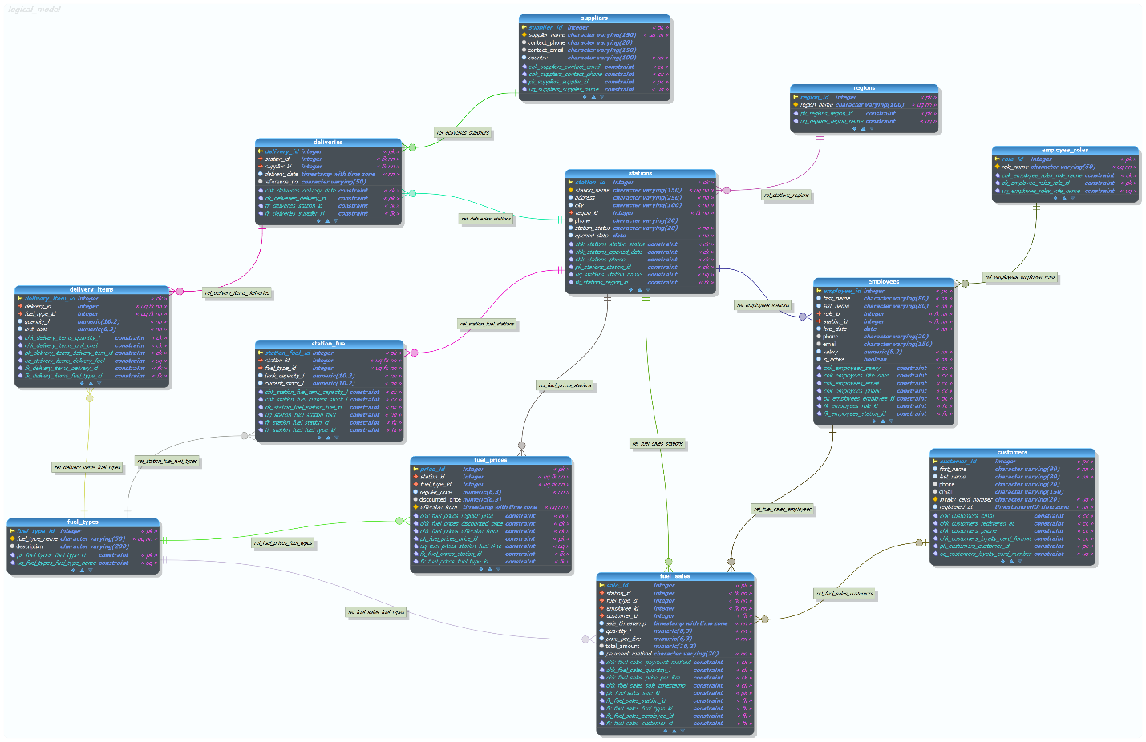

Physical Model
The physical model is implemented in the fuel_network schema of a PostgreSQL database. It maps directly to the logical model with PostgreSQL-specific additions:
SERIAL and GENERATED ALWAYS AS IDENTITY are used for surrogate PKs. employees.employee_id uses GENERATED ALWAYS AS IDENTITY (PostgreSQL 10+ standard syntax); all other PKs use SERIAL for compatibility.
GENERATED ALWAYS AS STORED is used for fuel_sales.total_amount = ROUND(quantity_l * price_per_litre, 2). This guarantees mathematical consistency between quantity and price without trusting the application layer. The column cannot be inserted or updated manually.
Five named CHECK constraints enforce business rules: (1) employee role names are limited to five predefined values, (2) station status is one of three states, (3) customer registration date must be >= 2026-01-01, (4) tank capacity must be > 0, (5) fuel price effective_from must be >= 2026-01-01.
A UNIQUE constraint is added to fuel_prices on (station_id, fuel_type_id, effective_from) to prevent duplicate price records for the same station, fuel, and timestamp.
TIMESTAMPTZ (timestamp with time zone) is used throughout for all timestamp columns because the network operates across Georgia (UTC+4). This avoids timezone ambiguity.
VARCHAR lengths are chosen to be permissive enough for realistic data but tight enough to catch obvious errors (e.g. VARCHAR(20) for phone numbers, VARCHAR(150) for email).
All FK and CHECK constraints are explicitly named following the pattern FK_<table>_<column> and CHK_<table>_<column>. This makes error messages meaningful and index management straightforward.

Key Design Decisions
Surrogate PK + Composite UNIQUE on bridge tables
station_fuel uses a surrogate PK (station_fuel_id) alongside a composite UNIQUE (station_id, fuel_type_id). The surrogate PK alone does not prevent duplicate bridge rows, the composite UNIQUE does. This pattern follows the reviewer feedback on the previous task, where bridge tables with surrogate PKs but no composite UNIQUE allowed duplicate entries.
Append-only fuel_prices (no current_status field)
The previous task's feedback highlighted the risk of storing the current state in two places (e.g. both a current_status column and a history table). The same principle is applied here: fuel_prices has no "is_current" flag. The current price for any (station, fuel_type) pair is always the row with the highest effective_from. This removes the dual-write risk entirely and keeps the table as a clean, auditable log.
Optional customer_id in fuel_sales
Not every pump transaction belongs to a registered loyalty customer. Anonymous / cash sales are a normal part of the business. customer_id is nullable, and the FK is defined with no ON DELETE action. Walk-in sales record NULL here, which is valid business logic and avoids the need for a dummy "anonymous customer" row.
Soft-delete for employees
Employees are never hard-deleted. is_active = FALSE marks a termination while keeping the row. This matters because fuel_sales references employee_id, and deleting a terminated employee would break the FK or require cascading nullification of historical sales records. The soft-delete approach preserves the full audit trail.
Dynamic quarter boundary in the analytics view
The view v_quarterly_sales_analytics derives its quarter boundaries dynamically from MAX(sale_timestamp) in the fuel_sales table. There are no hard-coded dates. This means the view automatically shows the correct quarter as new data is added, without any maintenance.

Step-by-Step Modeling Approach
Step 1: Identify entities and relationships (conceptual stage)
Listed the core real-world things the business needs to track: stations, fuel types, employees, customers, suppliers, deliveries, sales, and prices. Drew informal boxes and lines to capture which entities relate to which, and what kind of relationship (one-to-one, one-to-many, many-to-many).
Step 2: Resolve many-to-many relationships
Identified one explicit M:N: stations <-> fuel_types (a station sells multiple fuel types; a fuel type is sold at multiple stations). Resolved it with the station_fuel bridge table, which also carries the business attributes tank_capacity_l and current_stock_l that belong to the relationship, not to either entity alone.
Step 3: Assign primary keys
Chose surrogate SERIAL PKs for all tables. Natural keys (like station_name, loyalty_card_number) were given UNIQUE constraints but not used as PKs, because natural keys can change and are wider to join on. employee_id uses GENERATED ALWAYS AS IDENTITY (PostgreSQL 10+ standard) to demonstrate awareness of the newer syntax.
Step 4: Define foreign keys and normalise to 3NF
Every non-key attribute depends only on the PK of its own table. Checked for transitive dependencies: for example, region_name could have been stored on stations directly, but that would mean region_name depends on region_id which depends on station_id - a transitive dependency. Moving it to a separate regions table removes this and reaches 3NF.
Step 5: Apply constraints
Named all constraints explicitly. Added the five required CHECK constraints across tables. Added composite UNIQUE constraints on all bridge tables and on fuel_prices (to prevent duplicate price records). Used TIMESTAMPTZ everywhere for timestamps.
Step 6: Add the GENERATED column
Added total_amount GENERATED ALWAYS AS STORED to fuel_sales. This enforces mathematical consistency at the database level: total_amount is always ROUND(quantity_l * price_per_litre, 2) regardless of what any application layer does. It cannot be inserted or updated manually.
Step 7: Populate sample data
Inserted data covering January to April 2026 (the last 3 months relative to the task date). Used INSERT ... SELECT with VALUES sub-queries and JOIN on natural keys to resolve all surrogate IDs at runtime. Used ON CONFLICT DO NOTHING and WHERE NOT EXISTS to ensure the script is fully re-runnable. No surrogate key values are hardcoded anywhere in the DML.
Step 8: Create functions
Function 5.1 (update_fuel_sale_column): uses a dynamic EXECUTE with an allowed-column whitelist to prevent SQL injection via the column name parameter. Rejects columns not in the list and verifies the row exists before attempting the update. Function 5.2 (add_fuel_sale): resolves all FKs from natural keys internally so the caller never needs to know any surrogate ID. Handles the optional customer gracefully (NULL = anonymous sale).
Step 9: Create the analytics view
The view v_quarterly_sales_analytics uses a CTE to derive the current quarter boundary dynamically from MAX(sale_timestamp). A second CTE joins the sales to their station, region, fuel type, employee, and customer. The final SELECT aggregates by station and fuel type, showing sale count, total litres, total revenue, average price, and a breakdown of payment methods. No surrogate keys appear in the output.
Step 10: Create the read-only role
Created manager_readonly with LOGIN, NOSUPERUSER, NOCREATEDB, NOCREATEROLE, NOINHERIT, and a CONNECTION LIMIT. Granted USAGE on the schema and SELECT on all tables and the view. Added ALTER DEFAULT PRIVILEGES so future tables also grant SELECT automatically. Password is a placeholder with an explicit comment requiring it to be changed before production.

