INTRODUCTİON

Today, internet and computer technologies are used effectively. In our everyday life, it facilitates many of our work, providing many benefits to the user. At the same time, there are many disadvantages, especially for security reasons. Some personal information or confidential data belonging to institutions and organizations must be banned from unauthorized entries. At the same time, it is very important that this process can be performed correctly, reliably and quickly. These systems generally require information from the user, password / PIN number or other means of input. In this case, it is a waste of time and it is difficult to secure the login information and prevent unauthorized entry. There is also the risk of forgotten or lost information.

Individuals' own characteristics can be exploited to avoid security vulnerabilities. Biometric recognition systems allow an individual to perform an identity check using only his / her unique characteristics. It is forgotten about these systems or to provide a promise about someone else. In this way, systems such as identity cards, passports, driving licenses, etc., which will completely replace the cards, can be developed. Thus, systems that are both easier to use and difficult to overcome in terms of security, will emerge over time. For example, the use of an iris recognition system instead of the use of magnetic cards at the entrance of a unit will bring the security to the highest level because iris is even different in the twins. It will also make it easier to use because it is not forgotten or lost at the same time.

The general working principle of biometric systems; each method is based on analyzing the data received by its own input device and comparing and matching it with the previously entered values. The continuous increase in the number of transactions performed by computers in the unit time increases the speed of comparison of data received from biometric systems. Comparing hundreds of thousands of data within the generations to produce accurate results, these systems are now used in a variety of fields.

The oldest feature is fingerprint recognition, biometric features that people have in recognition of face recognition, DNA, hand geometry, and iris.

Among the advantages of biometric systems password forgotten and work troubles in the middle, positive and correct identification, high security level, compatible with mobile systems and difficult to copy, serving as a non-transferable key,

safe and user-friendly.

FUTURE OF BIOMETRIC SYSTEMS

With the rapid development of biometric systems along with evolving technology, individuals will completely recover from their identity cards, cards or passwords they have to remember. For example, people started to carry credit cards over time when they were carrying cash. Later, theft of credit cards caused many problems for banks and users. If biometric recognition methods are used in this area, it can be easily paid by fingerprint or facial recognition instead of credit card. In addition, unauthorized use is prevented and security vulnerabilities are closed. In such systems, since the information of the persons is fully recorded, the security of the databases in which the data are stored should also be at the highest level. It also offers a solution that is close to perfection, as it will prevent unauthorized access. If it is widespread enough, it will be a serious decline in crime rates.

USED ​​ALGORITHMS

The Haarcascade classifier you can find in the OpenCV library; It was created by Paul Viola and Michael Jones to solve this problem. Also known as the Viola and Jones object detection framework. In the most basic sense, objects desired to be found by a certain algorithm are first introduced to the computer, and then the images or video frames in which similar shapes are found are scanned to find that object.

First, let's talk about classifier training. There is a need for positive pictures that contain the object sought for education and negative pictures that the object does not exist. In classifier training, the objects in the positive pictures are scanned with the frames set in certain sizes as below, and the specific values ​​are generated by checking the dark luminance values ​​in the sum of the pixel values ​​in the black region and the white region in the frame.

[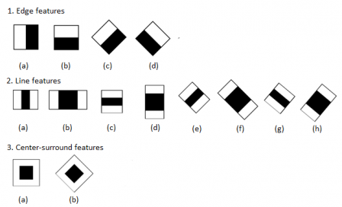](http://talhakoc.net/wp-content/uploads/1353646276_1594.png)

*Figure Frame Structure*

These frames, called Feature, are called weak classifiers. Because they can not be an accurate classifier by themselves. Many of these weak classifiers in an object and there are objects searched with great accuracy in the points where these weak classifiers are gathered. The classifier works this way with the most basic sense. The frames are scanned on sample positive images as follows.

[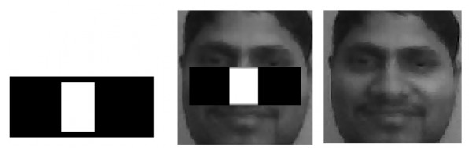](http://talhakoc.net/wp-content/uploads/haarcascade-nasil-yapilir.jpg)

*Figure Example Frame Structure*

For the above frame, the nose may be selected with the ratio of the cheeks being lower than the ratio of the brightness in the nose region.

[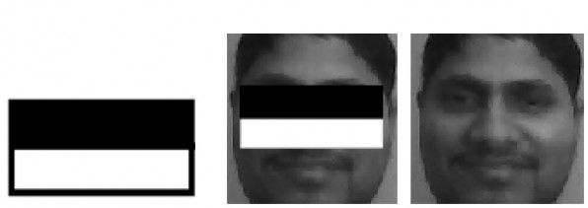](http://talhakoc.net/wp-content/uploads/nasil-cascade-siniflandirici-egitilir.jpg)

*Figure Frame Structure in Lighter Areas*

It is also one of these features that the eye area is darker than the white area. In the Haarcascade classifier, many similar properties are created by passing through the images of the object. For example, when scanning the face, many dark lighting features will be created in areas such as mouth, nose, forehead, hair. Target values ​​are generated from each of these. And this process is repeated in other stages by changing frame sizes.

When these frames (weak classifiers) are considered for each image size, hundreds of thousands of nuclei will form. Negative images will be scanned so that the majority of the frames that will not be used will be eliminated as there are no objects inside. In positive images, objects will be selected and the frames to be used in the object will be determined. For this, attention must be paid to the millimetric selection of the object in the positive pictures during the training. The large number of positive and negative image samples is important to get better results on the desired object.

It can be considered that these processes will be very tiring and the processes will take a long time to find both training and objects. Speed ​​is very important in real time image processing. In the Haarcascade classifier, the integrals of the pictures are taken first. Thus, rather than calculating individual sums of pixel values, it is calculated with an integral. Thus, a great deal of processing power will be removed from the computer.

Furthermore, in the process of finding objects, instead of being scanned repeatedly by each magnitude frame, only the parts matching the previous steps are scanned and a process load is reduced therefrom. It is seen that they are quite fast in terms of the angle and the work they are doing.

This rate varies depending on the type of training of the classifier, the number of samples, and so on. In order for the desired objects to be found, the classifier has a min hit rate and a max false alarm rate. the classifier tries to reach these values ​​every time with training with a certain training algorithm.

The minhitrate minimum hit ratio and the max false alarm rate indicate which error rate objects are to be displayed.

After the training, a file with the extension .xml will be created and the desired object can be found using this file with the openCV library.

PURPOSE OF DEVELOPED SOFTWARE

Every bank has a mobile banking system that it uses according to its own mission and vision. The method generally used in these systems provides access to the system via e-mail or SMS in addition to user account information.

The developed software is a mobile banking application. The first is to test the vitality of the pupil's movements, aiming at the human eye, following the random movement of the object on the phone screen. If the project succeeds, unauthorized access outside the real user will be blocked.

The purpose of the developed software is to prevent unauthorized access by preventing access to the application if the user's photo is captured. For this, the users who use the application are tested through their two-stage security check.

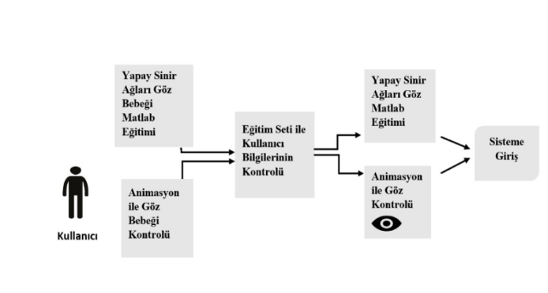*Figure Block Diagram*

Control stages of the developed software:

1-The user opens the mobile application.

2-The user first watches the active animation on the screen.

3-The pupilis affected by the light in the animation and grows or shrinks.

4-If the user's pupildoes not change, it is called again.

5 - If there is a change in the user's pupil, it passes the first stage of the viability test and goes to the second stage.

6-The user follows the movement of the random object on the screen in the second stage.

7- If the user does not follow the movement of the random object correctly, it will try again.

8- If the user follows the movement of the random object correctly, it is live and the bank transaction is directed to the screen.

INNOVATION INCLUDE IN THE DEVELOPED SOFTWARE

The most striking feature of the project is that it provides a more effective and efficient system solution for the users thanks to the software that tests whether the user is alive at the entrance with the movements of the eye baby.

One of the reasons for preferring the project is that unauthorized access to a photo or video image of a user will be minimized by minimizing unauthorized access as the object on the application screen will be random. The random movements of the object will be decided in advance using the weight and bias values obtained from the training of the sample data set in Matlab and the user can not instantly follow the object correctly. In addition, the active animation that is placed on the screen as a second control will make the user's eye baby grow and shrink. The application will be developed with Java and integrated into the android application. This will provide an efficient and reliable service to the users.

ENVIRONMENT USED IN THE DEVELOPED SOFTWARE

The developed software was implemented in the Android Studio IDE using OpenCV library using the Java programming language. Trainings were carried out in Matlab environment using Artificial Neural Networks.

ENVIRONMENT USED IN THE DEVELOPED SOFTWARE

The developed software was implemented in the Android Studio IDE using OpenCV library using the Java programming language. Trainings were carried out in Matlab environment using Artificial Neural Networks.

Pupil Control

Along with the Haar Cascade Classifier, the algorithm was utilized from the construct found in the xml template. This control has also been studied in the human eye, affected by light, and enlarged and reduced according to the light of the pupil. This will affect the phone screen for the display, the enlargement and reduction of the pupil. It causes movements to control and move the user. The user is held on the back face to make it clear.

When the animation was over, we always managed to train in the Artificial Neural Network. The threshold value was previously shown as 0.7. There is a problem of setting the threshold value to 0.7. Then, the meaninglessness that escapes from the verb 24 will be delayed. It is directed to the control screen together. More users are asked to pass through the non-living and snowy pupil control again.

This screen also controls whether the user can visually and accurately follow the random movements of the object. The object placed on the phone screen moves with random movements on the screen. It is expected that the user will correctly follow the random motion of the object on the screen. At the same time, since the camera will be open, the coordinates of the camera according to the position of the camera and the coordinates of the random movements of the object are also kept at the rear side during the movement of the object.

 After the movement of the object is finished, the coordinates of the eye and the object are instantaneously checked for 480 data thanks to the weight and bias values ​​obtained from the data previously trained in Artificial Neural Networks. The threshold value was previously set at 0.7. The reason for setting the threshold value to 0.7 is to make the control more secure. It is checked how many of the 480 verities obtained have passed the specified threshold value. If the number of buffers passing the threshold value is higher, it is determined that the user is alive and the user is directed to the screen where the bank transactions are. However, if the number of data that can not exceed the threshold value is higher, the user is not alive and the user is requested to follow the eye again.

Training the Pupil

During the training phase of the pupil, the user watches the moving animation on the screen and the instant baby's growth and shrinkage rates are recorded. This stage has been audited by different users so that learning and experiment clusters can be established. 70% of the obtained data were separated as learning clusters while 30% were reserved as experimental clusters. Each user received 24 data for this training. It has been decided that the pupil grows and shrinks according to the amount of increase or decrease in each example.

364.0 241.0 364.0 233.0 364.0 238.0 364.0 238.0

364.0 239.0 363.0 232.0 364.0 230.0 364.0 239.0

366.0 232.0 367.0 231.0 366.0 241.0 366.0 240.0

For the data, the increase number is 12, the decrease number is 11. The output was decided to be 1 because the increase is greater than the decrease in number.

241.0 369.0 233.0 366.0 240.0 369.0 240.0 369.0

240.0 242.0 372.0 241.0 369.0 239.0 368.0 241.0

370.0 242.0 371.0 249.0 371.0 240.0 370.0 234.0

The number of increases for the data is 11, and the number of decreases is 12. The output was decided to be 0 because the increase number is smaller than the decrease number. It is decided that the output should be 0 so that more accurate results can be obtained when the pupil is smaller than the pupil because the pupil generally grows in the users who try it although the pupil is a shrinking vitality indicator.

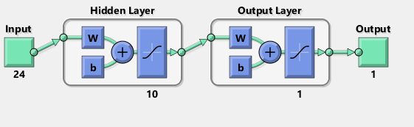

Figure: General Structure of Artificial Neural

Network

The artificial neural network consists of 10 hidden layers and one output for 24 input data. Feed-forward backprop algorithm is used for training. The log-sigmoid transfer function was used because there was no negative data in the training set. Training was completed in nine locations.

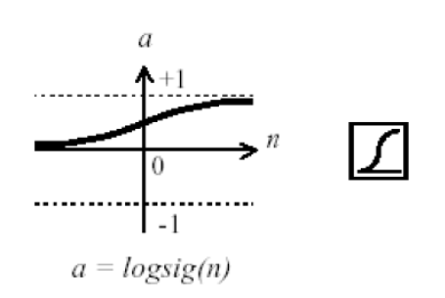

Figure: Log-Sigmoid Function

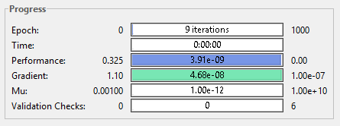

Figure: Training Outcome

Test data were also trained and compared with actual values. A success rate of 40% was obtained from the test data.

Eye Trainer Training

For eye-tracking training, the application screen is divided into five areas based on the width of the application screen. The object makes an average of 80 movements through a control. How many times these movements correspond to the region is shown on the histogram. In the same way, following the movement of the random object, the number of times the coordinate information coincides with the position of the eye is kept as a histogram. A total of 130 data were obtained for each sample from the object and eye coordinate data. These 130 data are given as input to Artificial Neural Networks. There are 2 neurons in the intermediate layer. As the number of inputs is high, the number of neurons in the interlayer can be increased to obtain more accurate and reliable results.

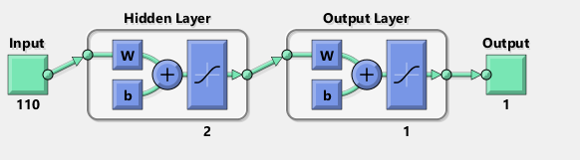

Figure:General Structure of Artificial Neural Network

It was decided that 70% of the samples obtained would be the training set and the remaining 30% would be the test set. The outputs of the samples are determined to be zero if the object can not follow 1 if the object can follow the random motion correctly.

Feed-forward backprop algorithm is used for training. The log-sigmoid transfer function was used because there was no negative data in the training set. Training was completed in nine locations.



Figure: Log-Sigmoid Function

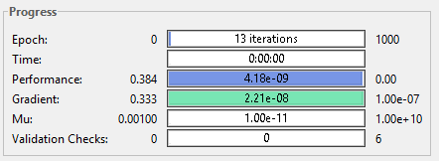

Figure: Training Outcome

The test data were also trained and compared with actual outputs. The comparison resulted in a 30% success rate.

THANK

During the course of our work, the IT-Coordination Directorate Project Manager Şerafettin ŞENTÜRK, who has benefited from his experiences, who has helped us with his material and spiritual support by supporting us with his valuable and timely meetings with us every week, organized and guided us through his project work, Our esteemed finishing adviser, Professor. Dr. Cemil ÖZ Hocamıza presents our endless gratitude to our precious families who have never lost their material and spiritual support from us during our research and are always with us.

REFERENCES

[1]

[2]

[3]

[4]



Tutku Ramazanoğlu was born on 21.12.1996 in Istanbul. Primary, secondary and high school education was completed in Istanbul. In 2014, he graduated from ECA Elginkan Anatolian High School, Digital Department. In 2014 he won the Department of Computer Engineering at Sakarya University. In 2017 Er-Yaz Bilişim Teknolojileri A.Ş. He has done software internship at his company. He worked as a volunteer trainee at Sakarya University Technopolis TRA Informatics in 2017.



Ravzanur KONUK was born in Tokat in 16.11.1997. He completed his primary, secondary and high school education in Istanbul. He graduated from Turk Telekom Anatolian High School, Numerical Department in 2014. In 2014, Sakarya University won the Department of Computer Engineering. In 2017,