

Project Part-A

Submitted to : Submitted by:

Ahmad Alhamed Tutku Ramazanoglu C0768385

First of all, project requirements are understood and then second steps, which is interface design started. Interface is projected by using tkinter library. For designing one interface is used but four classes are created in this way readability increase and program looks simpler. First class is designed for checking user type based on username and user password.

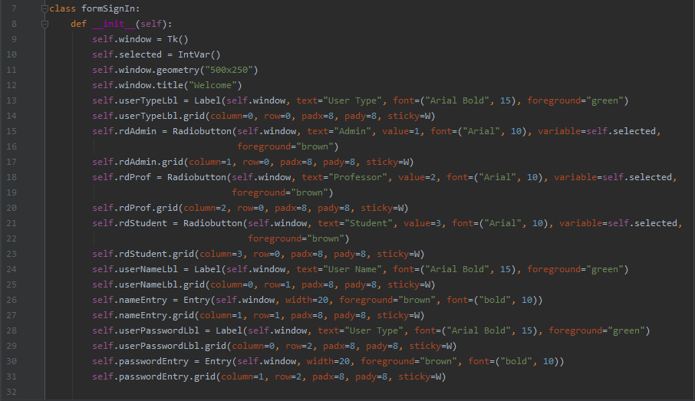

Figure : Widget 1

All python gui widgets defined __init__ function which is a private class. Line 11 and 12 assign window attributes such as name and size. This interface includes four different widgets which are label, entry, radio button and button. Line 13 is an example for label takes four parameters. First parameter shows, label belongs which container. Second parameter indicates label’s text. Third and fourth parameters display label’s design. Label’s text type is Arial bold; font is 15 and text color is green. Line 17 is an instance for radio button which takes six parameters. First parameter shows, radio button belongs which container. Second parameter indicates radio button’s text. Third parameter takes a number which shows when radio button is selected, the number return to fifth parameter. Fifth parameter’s value defined in line 10. IntVar() is a class from tkinter which is used to set and get variable’s value easily. Fourth and sixth parameters display radio button’s design. Radio button’s text type is Arial bold; font is 10 and text color is brown. Line 26 demonstrates entry which has four parameters. First parameter shows, entry belongs which container. Second parameter indicates entry ‘s width. Third and fourth parameters display entry’s design. Entry’s text type is bold; font is 10 and text color is brown.

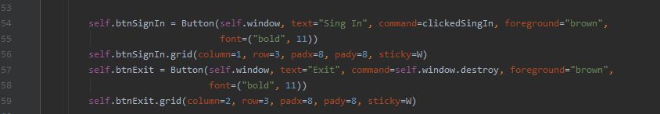

Figure : Widget 2

Figure 2 line 54 points out button which takes five parameters. First parameter shows, button belongs which container. Second parameter indicates button‘s text. Third parameter invoke when user click the button and programmer call the function. Fourth and fifth parameters display button ‘s design. button’s text type is bold; font is 11 and text color is brown. All widgets should add to window as an aligned. That is why grid function is used. Figure 2 line 59 is an example for grid function which takes five parameters. First two parameters show column and row. Third and fourth parameters demonstrate distances from x and y coordinates. Normally all widgets are centered in their cells but fifth parameter can change this option.

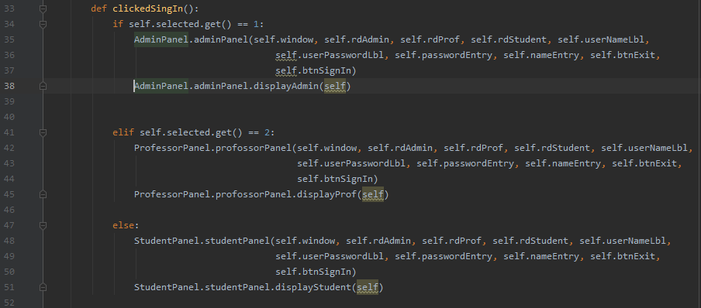

Figure Defined Others Panel

Figure 3 represent a function which defined figure 2 line 54. This function change widgets according to user type. User type controls with if-else statement. Line 34 gets value radio button which is assign figure 1 line 15, 18 and 21. Line 34 call adminPanel class if user type is a admin. Line 41 call professorPanel class if user type is a professor. Line 47 call studentPanel class if user type is a student. These three classes are import to file figure 4. Line 35, creating an object from adminPanel class and give parameters which are defined figure 1. Because all project has a one window and when user click the sign in button this function clears the old widgets and line 38 call function which create new widgets according to user type.



Figure Import Classes

AdminPanel is a Second class which has two functions. Figure 5 shows init function which clears old window expect radio buttons. After user type selection, radio buttons do not enable and new widgets create according to admin requirements. Between line 5 and line 21 old window’s widgets assigned this admin panel because the window is cleaned for new widgets. Also line 17, using radio button configure function, radio buttons are disabled.

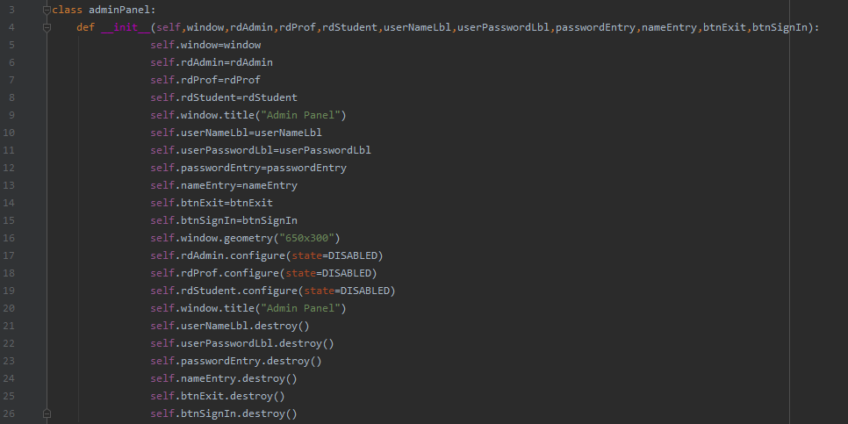

Figure init function for Admin Class

Figure 6 demonstrate second function of AdminPanel class which create new widgets for admin’s enter.

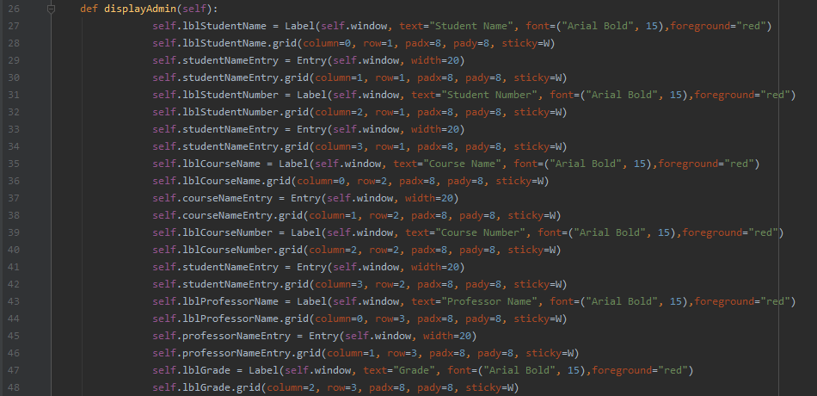

Figure Second Function of AdminPanel Class

Other two classes which are StudentPanel and pforosseforPanel classes is coded same mentality. Finally, all interfaces are represented in below:

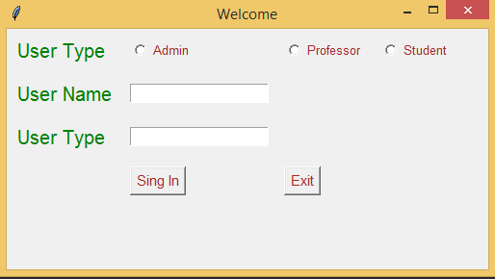

*Figure 7Log in Panel*

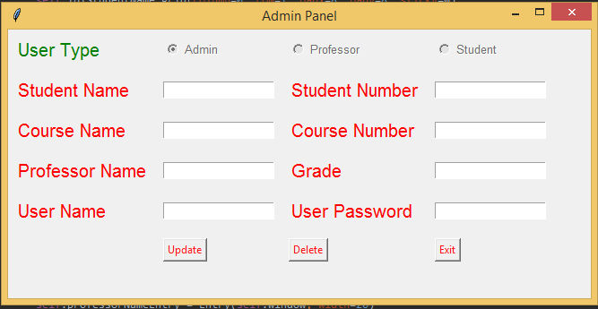

*Figure 8 Log in Panel*

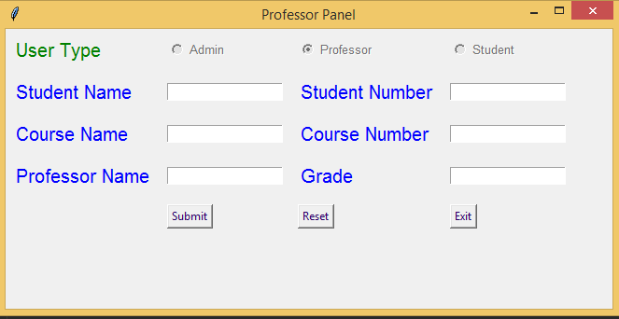

*Figure 9 Professor Panel*

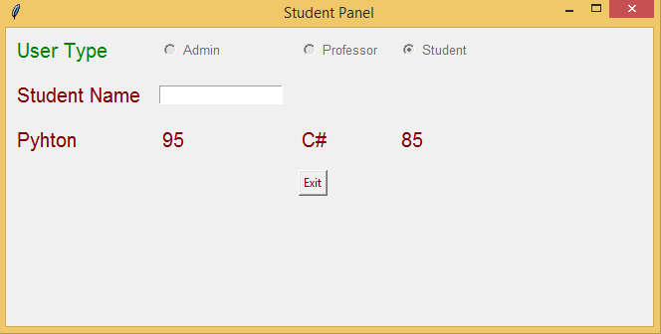

Figure Student Panel