- Ho Chi Minh City, December 2025 -

Capstone Project Document
Platform to support digital transformation for household businesses.
Project name | Platform to support digital transformation for household businesses.
Group members | Trần Long Tứ-tutl0371@ut.edu.vn-083205000371  Huỳnh Phạm Hưng Trung-trunghph1527@ut.edu.vn-083205001527  Phùng Thị Vân-vanpt8335@ut.edu.vn-026305008335  Nguyễn Ngọc Thái-thainn5326@ut.edu.vn-082205015326  Phạm Huy Đức Việt- vietphd1528@ut.edu.vn - 049205001528
Supervisor | Ths. Nguyễn Văn Chiến
Software type | Web application
Target market | Vietnamese household businesses
Version | 1.0

Table of Contents

Acknowledgement 3
Definition and Acronyms 4
I. Project Introduction 5
II. Project Management Plan 7
III. Software Requirement Specification 11
IV. Software Design Description 30
V. Software Testing Documentation 37
VI. Release Package & User Guides 40
Note: Page numbers are based on the current export. If you modify content, update this table accordingly.

Acknowledgement
We would like to express our sincere gratitude to our supervisor and all stakeholders who provided valuable feedback and domain insights throughout the development of this project. Their support helped us shape a solution that is practical for real-world retail operations and compliant with Vietnam’s accounting requirements for household businesses.

Definition and Acronyms
Acronym | Definition
AI | Artificial Intelligence
API | Application Programming Interface
BR | Business Rule
CRUD | Create, Read, Update, Delete
ERP | Enterprise Resource Planning
GUI | Graphical User Interface
LLM | Large Language Model
MTBF | Mean Time Between Failures
MTTR | Mean Time To Repair
NFR | Non-Functional Requirement
POS | Point of Sale
RBAC | Role-Based Access Control
SRS | Software Requirement Specification
SDD | Software Design Description
TT88 | Vietnam Ministry of Finance Circular 88/2021/TT-BTC (accounting regime for household businesses)
UAT | User Acceptance Test
UoM | Unit of Measure
SKU | Stock Keeping Unit
UUID | Universally Unique Identifier

I. Project Introduction

1. Overview

1.1 Project Information
This project proposes an AI-assisted Point-of-Sale (POS) system integrated with inventory management, loyalty, analytics, and automated bookkeeping compliant with Vietnam’s Circular 88/2021/TT-BTC (TT88) for household businesses.
The platform is designed for small retail stores that need fast at-counter checkout, simple workflows for low digital literacy users, and reliable compliance-oriented accounting outputs.

1.2 Objectives
- Reduce checkout time for walk-in customers with instant product search and keyboard shortcuts.
- Implement a tier-based loyalty program with real-time point accrual and redemption.
- Provide AI recommendations at checkout for promotional bundles and related products.
- Offer dashboards for sales, inventory, and employee performance.
- Automate bookkeeping and generate accounting books/reports aligned with TT88, with owner review and manual override.
- Ensure strict tenant data isolation and role-based access control for Employee, Owner, and Administrator roles.

2. Product Background
Many Vietnamese household businesses operate with thin margins, high daily transaction volume, and limited staff training. Traditional paper-based processes or spreadsheet tracking often lead to inventory inaccuracies, revenue leakage, and difficulty preparing tax-compliant accounting reports. A modern POS can solve operational issues, but adoption is hindered by complexity, lack of localized compliance, and limited insights for decision-making.

3. Existing Systems
Common solutions in the market include basic POS applications, standalone accounting software, and spreadsheet-based workflows. However, these tools often lack integrated AI-assisted recommendations, do not provide actionable analytics for micro-retail, and may not natively generate household-business accounting books aligned with TT88 without manual work.

4. Business Opportunity
A unified POS + Inventory + AI + Accounting platform creates value by reducing operational friction , increasing basket size through upsell recommendations , preventing stockouts , and minimizing compliance risks by automating legally compliant reporting as required by Circular 88/2021/TT-BTC.

5. Software Product Vision
To be the simplest and most reliable retail operating system for Vietnamese household businesses —enabling fast sales (via keyboard shortcuts and instant filtering) , transparent real-time inventory control , and compliant automated accounting with AI-powered insights for sales and operations.

6. Project Scope & Limitations

6.1 Major Features (Release 1.0)
Major features are grouped by roles, incorporating the detailed requirements:
- Employee (Cashier) Role:
  - Login/Logout.
  - Create at-counter orders with instant product filtering and keyboard shortcuts.
  - Member lookup and loyalty point accrual/redemption visibility, including multi-tiered discount values.
  - Payment handling (cash, bank transfer, QR, e-wallet, etc.).
  - Print receipts/invoices with predefined templates; orders are stored for retrieval.
  - AI suggestions for promotional bundles and related products at checkout.
- Owner (Store Owner) Role:
  - All Employee features.
  - Product catalog management (create, update, deactivate) , including defining multiple units of measure and pricing rules.
  - Inventory management: record stock imports , track stock levels in real-time , view history, and auto-deduct stock on confirmed orders.
  - Customer management (profiles, purchase history, payment logs).
  - Reports & analytics dashboards (daily/weekly/monthly revenue, top products, low-stock alerts).
  - Employee account management (create, reset password, deactivate) with audit logs for accountability.
  - System Features: Includes the ability to review, edit, or reject AI-generated draft orders.
- Administrator (Platform Admin) Role:
  - Manage store owner accounts (search, filter, activate/deactivate, view detailed profiles).
  - Manage subscription pricing for platform tiers.
  - Platform-level analytics dashboard (global health, active users, new registrations, platform revenue).
  - System & AI Configuration, including updating master templates for Circular 88/2021/TT-BTC reports and broadcasting system-wide announcements.

6.2 Limitations & Exclusions
- Advanced enterprise accounting features beyond the scope of Circular 88/2021/TT-BTC (e.g., multi-company consolidation).
- Complex warehouse routing and third-party logistics integration.
- Full e-commerce marketplace functionality (may be added in future releases).
- Hardware driver implementation beyond standard receipt printer integration (depends on deployment environment).
- Note: AI-generated orders/reports are subject to Owner/Employee review and editing , and the system can fall back to manual operation if the AI is unavailable.

II. Project Management Plan

1. Overview
The project is executed using an Iterative and Incremental development model. Each iteration delivers a usable subset of features, allowing stakeholders to provide early feedback and reducing risks.

1.1 Work Breakdown Structure (WBS) and Estimation (Sample)
WBS Item | Description | Complexity | Est. Effort  (man-days)
I. Foundations
1 | Initiation & Detailed Requirements Elicitation (including NFRs review) | Medium | 10
2 | UI/UX design for POS and dashboards | Medium | 5
3 | Authentication & RBAC | Medium | 8
II. Core POS & Sales
4 | Create At-Counter Orders (POS): Core sales logic, product filtering, keyboard shortcuts | Complex | 14
5 | Loyalty Points & Tiering: Accrual, redemption logic, tier-based discount calculation, and Employee view | Complex | 16
6 | Payment Handling & Print Sales Orders: Integration for Cash, Transfer, QR, E-wallet, and pre-designed template printing | Medium | 8
III. Owner Management & Inventory
7 | Product Catalog & Pricing Rules: CRUD, multiple units of measure, and configuration of pricing rules | Complex | 12
8 | Inventory Management: Stock imports, real-time tracking, auto-deduct on order confirmation, and history | Complex | 16
9 | Customer Management: CRUD, purchase history, and payment logs | Medium | 8
IV. Advanced & Compliance
10 | Automated Bookkeeping & TT88 Reports (Compliance): Accounting entries, official book generation, and continuous report template update | Highly Complex | 20
11 | Reports & Analytics Dashboards (Owner/Platform): Interactive visualization, top-selling products, low-stock alerts | Complex | 14
12 | AI Integration: Product Suggestion at checkout AND Natural Language to Draft Order (listening/reading) | Complex | 16
V. Platform Admin & Quality Assurance
13 | Admin Tools: Owner Account Management, Subscription Pricing, System Config & Announcements | Medium | 8
14 | Quality Assurance & Testing: Unit, integration, system, and UAT (including failover to manual mode) | Complex | 18
15 | Deployment, System Handover & User Guides (Vietnamese) | Medium | 5
Total Estimated Effort (Man-Days) |  | 178 (day)

2. Management Approach

2.1 Development Process
We will adopt an Iterative and Incremental Model combined with Time-Boxing to manage the broad and feature-rich scope. The project will be divided into 8 one-week sprints.
Prioritization Strategy (based on WBS):
- Foundation (W1): Authentication, RBAC, and core UI/UX.
- Core POS (W2-3): Primary sales workflow (order creation, rapid operations, payment, printing).
- Complex Business Logic (W3-4): Loyalty tiers, accrual/redemption logic, Product Catalog with multiple units, and pricing rules.
- Backend Core (W4-5): Real-time Inventory management (stock imports, auto-deduction) and Customer Management.
- Advanced Intelligence & Compliance (W5-6): Automated Bookkeeping and TT88 report generation, AI suggestion, and Natural Language conversion.
- Reporting & Platform Management (W6-7): Owner/Admin dashboards, platform analytics, and subscription pricing management.
- Quality & Deployment (W7-8): Final testing, bug fixing, and compliance validation.

2.2 Quality Management
Our Quality Management approach focuses on defect prevention and validating business-critical flows, especially those related to financial and legal compliance.
- Defect Prevention: Strict code reviews and static analysis are enforced, focusing particularly on areas affecting points calculation (Loyalty) and financial postings (Automated Bookkeeping).
- Continuous Integration (CI): Automated unit tests will cover all critical business logic, including:
  - Loyalty point accrual/redemption integrity.
  - Tier-based discount calculation accuracy.
  - Real-time stock deduction verification.
- Integration Testing: Validation of data flow between modules:
  - Checkout workflow: POS->rightarrow-> Inventory Deduction ->Accounting Posting ->Database Storage.
  - AI feature validation: Accuracy of AI Product Suggestion and the conversion of Natural Language to Draft Order.
- System Testing: End-to-end scenario validation and rigorous Strict Role-Based Access Control (RBAC) enforcement across Employee, Owner, and Admin roles. We will also test failover to manual operation if the AI services are unavailable.
- Compliance & Reporting Testing: Specific testing will ensure:
  - Reports (e.g., Revenue Detail Ledger) are accurately populated and legally compliant with Circular 88/2021/TT-BTC requirements.
  - The functionality allowing the Owner to review, edit, or reject AI-generated reports is robust.
- User Acceptance Testing (UAT): Conducted with store-owner-like users to validate the simplicity and responsiveness of the web/mobile UI and overall usability for those with low digital literacy.

2.3 Project Risks (Sample)
# | Risk | Impact / Likelihood | Mitigation
1 | AI recommendations produce irrelevant suggestions | Medium / Medium | Allow manual override; use rule-based fallback; continuous tuning with feedback logs.
2 | Accounting output mismatch with Circular 88/2021/TT-BTC templates | High / Medium | Implement template versioning; Owner review/edit workflow ; maintain update mechanism for official declaration forms.
3 | Performance degradation with large product catalogs | High / Medium | Use indexed search; caching; incremental product sync; optimize queries and pagination. Ensure the application is highly responsive.
4 | Data privacy breach across tenants (business households) | High / Low | Data privacy breach across tenants (business households)
5 | AI component failure impacting operations | Medium / Low | Implement fall back to manual operation if the AI is unavailable. Allow manual creation/editing of draft orders.
6 | Usability issues for users with low digital literacy | Medium / High. | Ensure a simple, responsive web/mobile UI and validate usability through UAT.

3. Project Deliverables
Deliverable | Due (Sample) | Notes
Sprint 1 Report (Foundation & Core UX) | End of Week 1 | Finalize requirements, Authentication, RBAC , and UI prototype.
Sprint 2 Report (Core POS & Loyalty) | End of Week 3 | Deliver functional POS order creation (shortcuts, filtering ), Payment Handling , and Loyalty Logic (accrual, tiers, redemption ).
Sprint 3 Report (Inventory & Catalog) | End of Week 4 | Deliver Product Catalog (multiple UoM, pricing rules ) and Inventory Management (imports, auto-deduction, real-time stock ).
Sprint 4 Report (Compliance & Analytics) | End of Week 6 | Deliver Automated Bookkeeping/TT88 Draft Reports , Owner Reports & Analytics (dashboards, alerts ), and Employee/Admin Management.
Sprint 5 Report (AI & QA) | End of Week 7 | Deliver AI Product Suggestion and Natural Language to Order features. Complete Integration Testing and System Testing (including RBAC, AI failover ).
Final Delivery Package | End of Week 8 | Final code, User Acceptance Testing (UAT) results, Final Report, and Vietnamese User Guides. Compliance validation complete.

4. Responsibility Assignments

D = Do, R = Review, S = Support, I = Informed
Work Item | Member A | Member B | Member C | Member D
Project planning & tracking | D | S | R | I
Requirements (SRS) | R | D | S | S
Design (SDD + DB) | S | R | D | S
POS & Loyalty Implementation | D | S | S | R
Inventory & Catalog Implementation | S | D | S | R
Automated Bookkeeping (TT88) & Compliance | S | S | D | R
Frontend/UX Implementation | D | S | S | R
Testing & Test Report (QA) | R | D | S | S
User guide & final report | S | R | D | S

5. Project Communications
Communication Item | Participants | Purpose | Frequency | Tool/Method
Weekly Team Meeting | All team members | Review sprint progress, plan next sprint, and address major risks. | Weekly | Offline/Online Meeting
Daily Standup | Developers | Sync on blockers and task progress. | Daily | Chat/Meet (max 15 min)
Stakeholder Review | Owner representative, Team Lead | Validate completed features, UAT feedback, and review design/UX²⁹. | Bi-weekly | Demo + Feedback Session
Bug Triage | Dev + QA | Prioritize and assign defects; ensure compliance issues are high priority. | Twice per week | Issue tracker
Compliance Check-in | Team Lead, Compliance Expert (if applicable) | Review automated TT88 outputs and template updates³⁰³⁰³⁰³⁰. | Monthly (or as needed) | Dedicated Call
System-Wide Announcement | Admin, All Stakeholders | Broadcasting system-wide updates/changes³¹. | Ad-hoc | Email/System Notification

6. Configuration Management

6.1 Document Management
Documents are stored in a shared drive with strict version naming conventions. Compliance templates (TT88) are versioned and stored separately under strict change control to manage continuous government updates.

6.2 Source Code Management
Source code is managed using Git with feature branches, and Pull Requests (PRs) are mandatory for all code changes. PRs must undergo peer review (Code Reviews) and pass automated CI tests before merging to the main branch. This aligns with the quality goal of

CLASS DIAGRAM EMPLOYEE ROLE LOGIN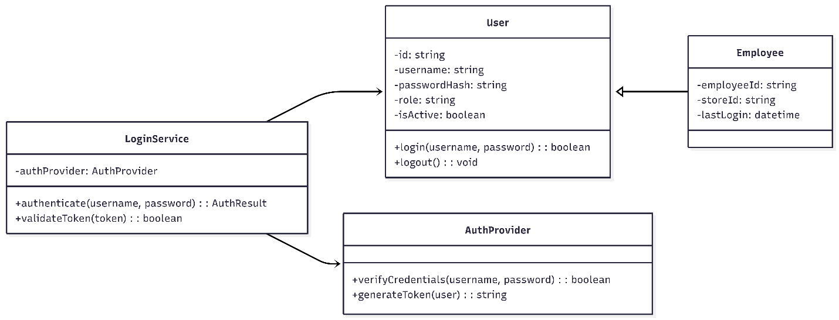

SEQUENCE DIAGRAM EMPLOYEE LOGIN
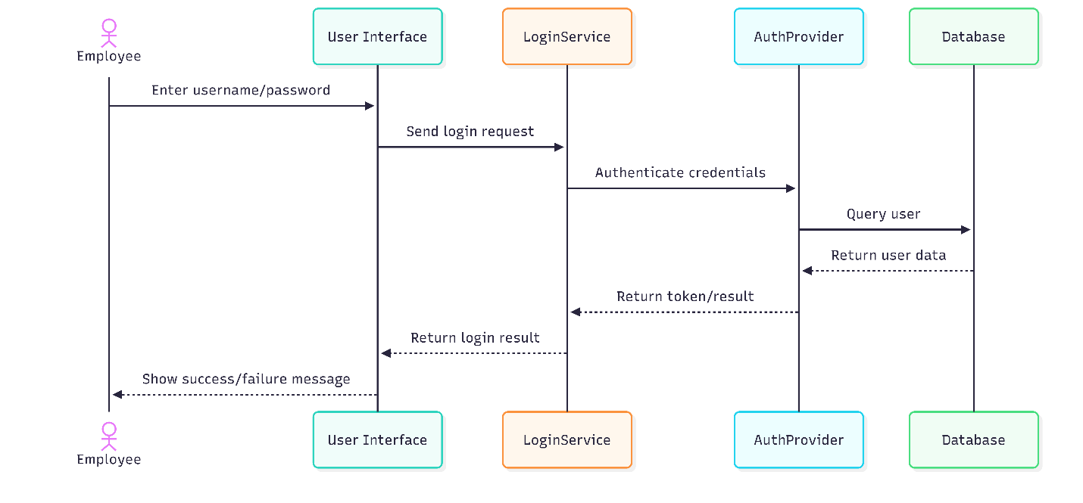

CLASS DIAGRAM OWNER ROLE MANAGE PRODUCT CATALOG
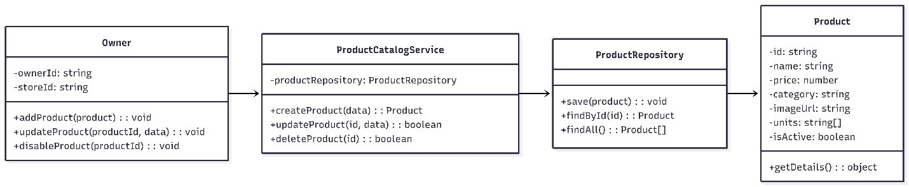

SEQUENCE DIAGRAM OWNER ROLE MANAGE PRODUCT CATALOG 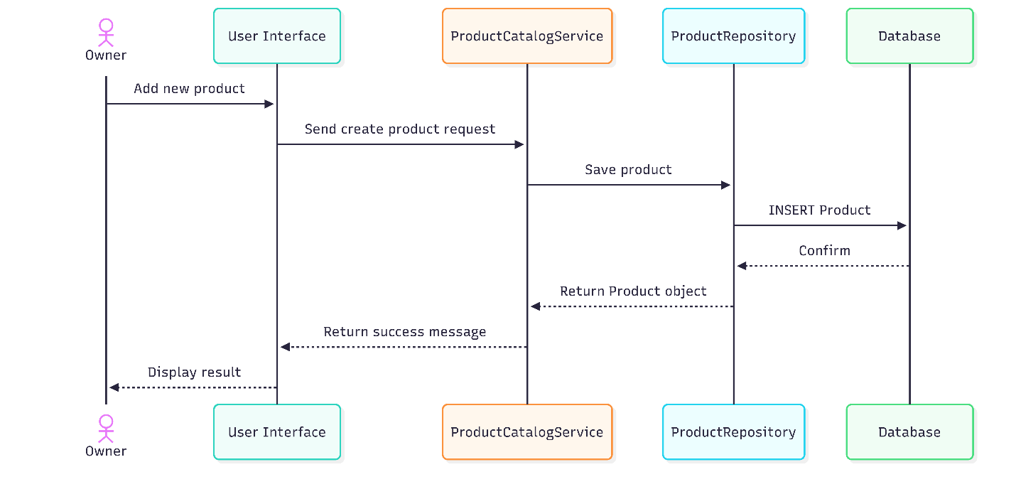

CLASS DIAGRAM ADMINISTRATOR ROLE-MANAGE SUBSCRIPTION PRICING
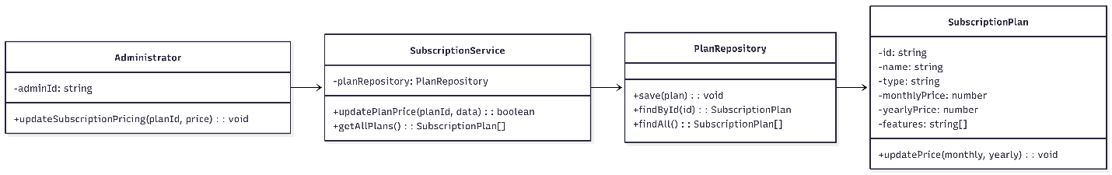

SEQUENCE DIAGRAM ADMINISTRATOR ROLE-MANAGE SUBSCRIPTION PRICING
