

Blazor Podcast AI

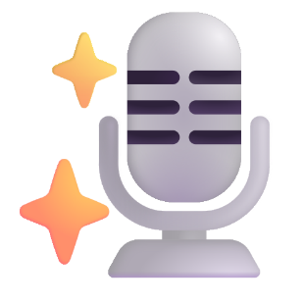

Contents

Setup & Start 2
Install .NET SDK 2
Create Project 5
Install Visual Studio Code 7
Launch Visual Studio Code 9
Update Project 11
Create GitHub Account 13
Get Personal Access Token 15
Launch Project in Browser 23
Implement 26
Provider Class 26
Item Component 32
Send Component 35
Home Component 41
Generate 45
Podcast Assistant 45
Custom Assistant 49

Setup & Start

Install .NET SDK
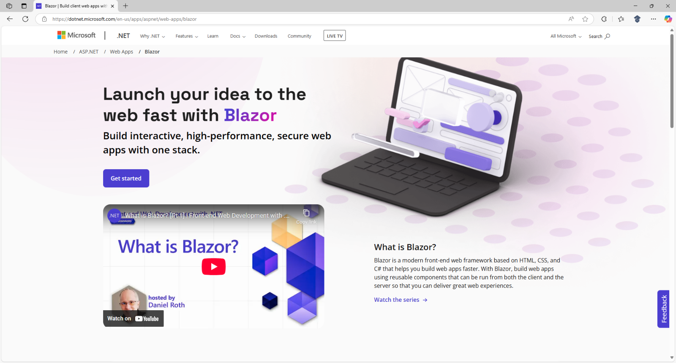

Information - Blazor is the front-end framework from Microsoft based on HTML, CSS and C# using .NET to build web or hybrid mobile and desktop applications. To find out more about Blazor visit blazor.net.

First you will need to Download the latest .NET SDK, do so use a Browser and visit the Website at dot.net.

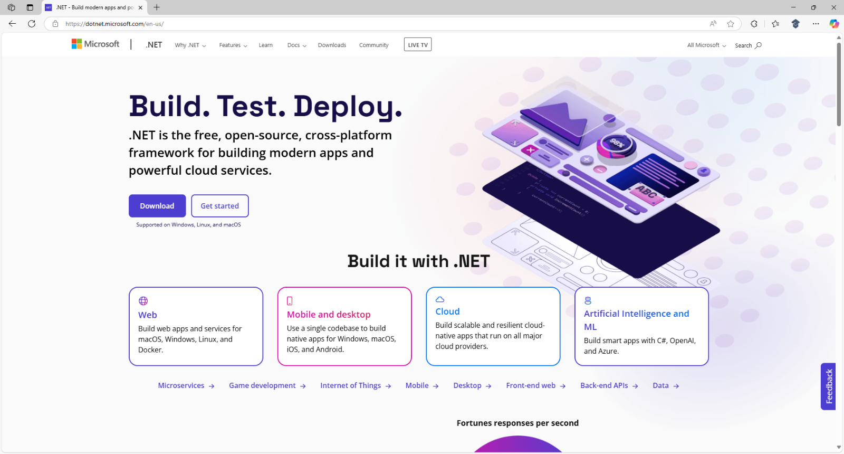

Information - .NET is the is the free, open-source framework from Microsoft to build modern applications for web with Blazor and ASP.NET Core, for mobile with .NET MAUI, for cloud with .NET Aspire and more.
Then choose Download which should display the .NET SDK for your platform of Windows or Mac.

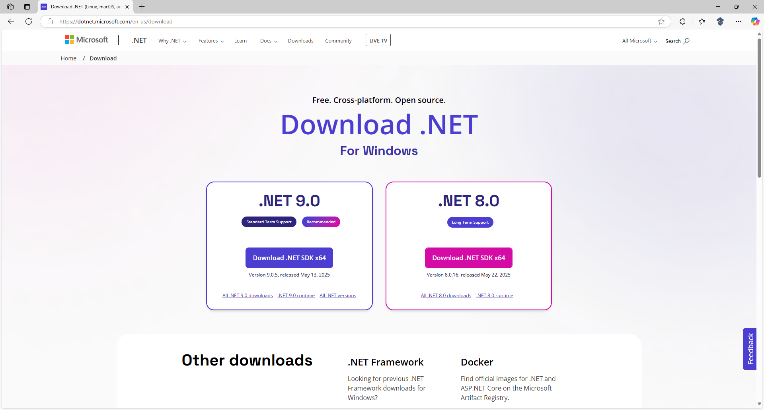

Next select Download for the .NET SDK for .NET 9.0 which varies based on your exact platform of Mac or Windows for example Download .NET SDK x64 although your exact Version may be different or newer.

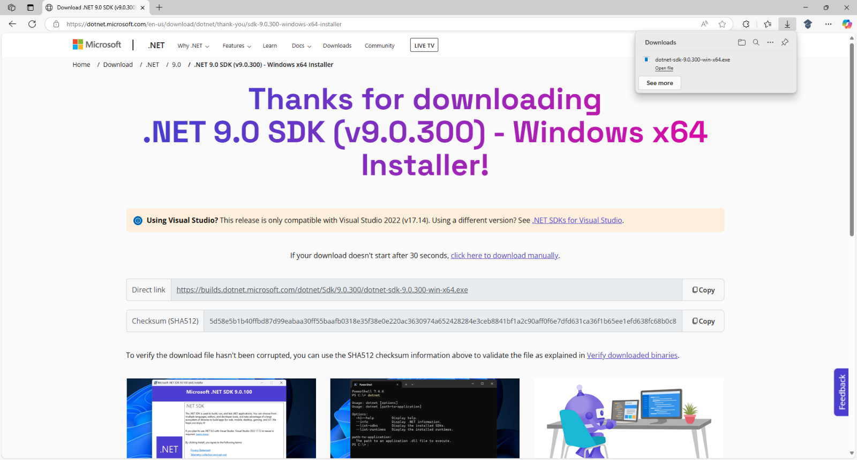

Information - .NET 9.0 SDK here is v9.0.300 for Windows x64 which was the one used for this Workshop.
Then the Installer for .NET SDK will begin Downloading and once it has been Downloaded it will show in Downloads for your Browser where you can Open it to launch the Installer for .NET SDK as follows:

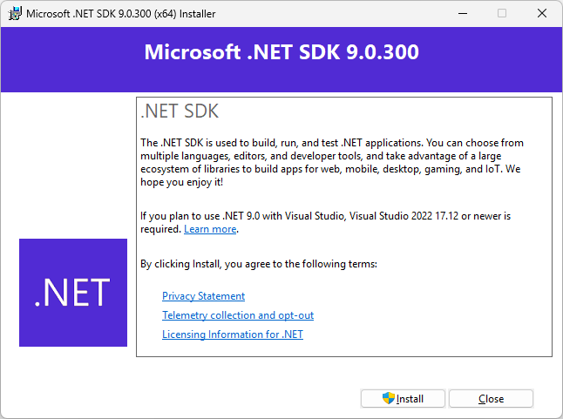

After Opening the Installer for the .NET SDK select Install to begin the installation process for .NET SDK.

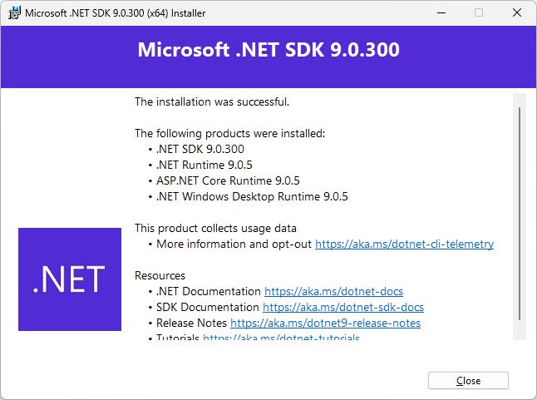

Finally, when installation has completed for the .NET SDK, you can select Close in the Installer as this completes the process of Downloading and Installing the .NET SDK for Windows or Mac.

Create Project
Once .NET SDK has been Installed you will need to create a Project using Blazor, to do this, if using Mac you need to go to Finder, search for Terminal and then select it to Open it, or if using Windows you need to go to Start, search for Command Prompt and then select it to Open it as follows:

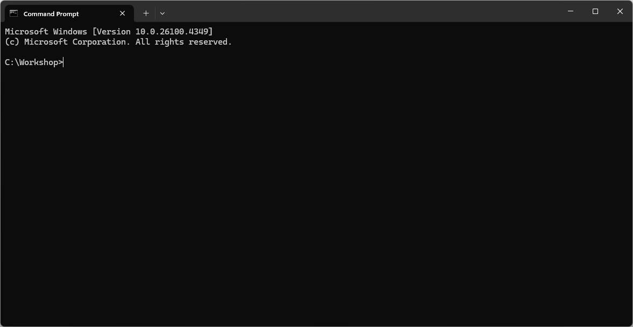

Information – You can choose a different location for the Project in Terminal on Mac or Command Prompt on Windows if needed, but the default location should be fine for the Workshop.

Then you will need to create the Project using the .NET SDK, to do this from the Terminal on Mac or Command Prompt on Windows you need to Copy and Paste the following Command then press Enter:

dotnet new blazorwasm -o Blazor.Podcast.AI

Information – This will create a Project using Blazor WebAssembly called Blazor.Podcast.AI which is a special kind of application using Blazor that runs in your Browser.

Once the Project for Blazor.Podcast.AI which uses the template Blazor WebAssembly Standalone App has been created successfully, then within the Terminal on Mac or Command Prompt on Windows you need to switch to the Folder for the Project of Blazor.Podcast.AI. To do this Copy and Paste the following Command and then press Enter:

cd Blazor.Podcast.AI

Information – The Command of cd means change directory which is common to both the Terminal on Mac and Command Prompt on Windows to switch to a specified Folder.

Once done you should have switched to the Folder for the Project of Blazor.Podcast.AI as follows:

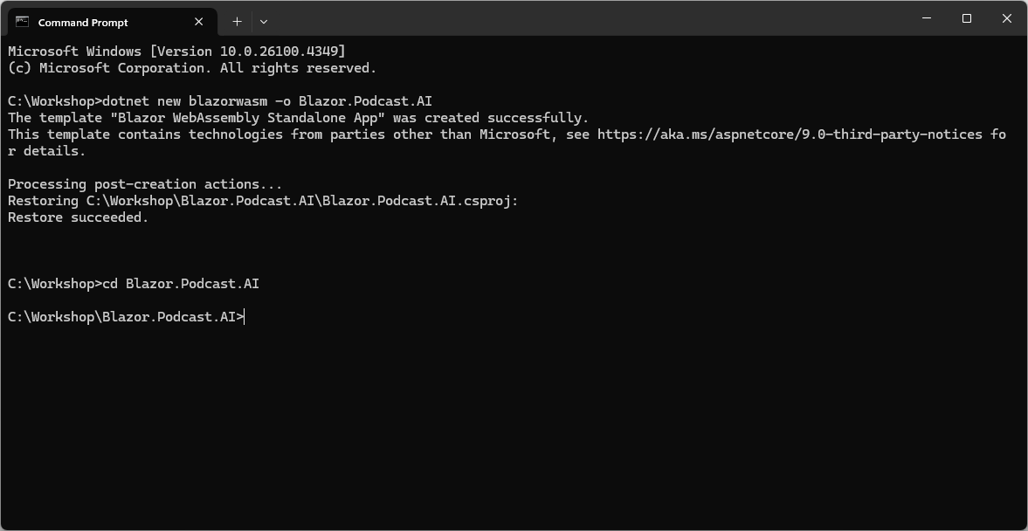

Then to add the Package for Microsoft.Extensions.AI.OpenAI you need to Copy and Paste the following Command and then press Enter:

dotnet add package Microsoft.Extensions.AI.OpenAI --prerelease

Information – This will add the Package for Microsoft.Extensions.AI.OpenAI allowing it to be used within the Project for the Blazor application. This Package integrates AI Models from OpenAI and is part of the broader Microsoft.Extensions.AI ecosystem that provides a unified way of working with AI services in .NET. To find out more about the Package you can visit nuget.org/packages/Microsoft.Extensions.AI.OpenAI.

Don’t Close the Terminal on Mac or Command Prompt on Windows as you’ll need it throughout the Workshop and to know what Folder to Open later in the Workshop, for example in this case it would be C:\Workshop\Blazor.Podcast.AI.

Once the Command has completed in Terminal on Mac or Command Prompt on Windows this completes the process of creating the Project of Blazor.Podcast.AI and adding the Package.

Install Visual Studio Code
You will need to Download the latest Visual Studio Code for Windows or Mac, to do this use a Browser and visit the Website at code.visualstudio.com where you’ll also find out more about Visual Studio Code.

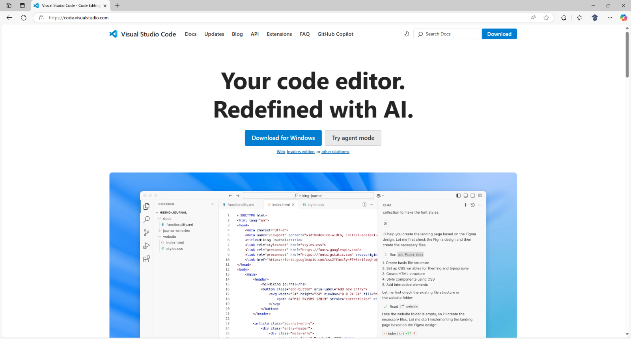

Information – Visual Studio Code is the free and open-source code editor with support for every major programming language including C# which is used with .NET and with optional support for AI features.

Next select the Download for Windows option in this case for Windows or the option to Download for Mac although your exact Version of Visual Studio Code may be different or newer.

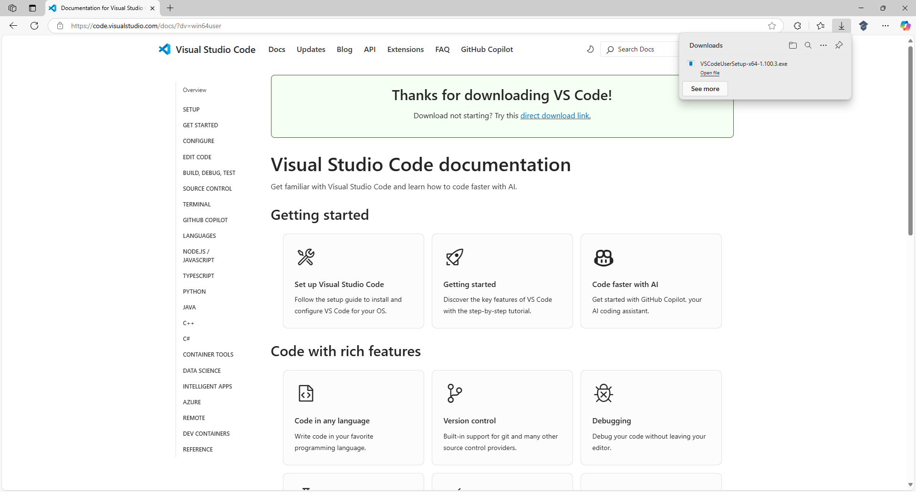
The Installer for Visual Studio Code will begin Downloading and once it has been Downloaded it will show in Downloads in your Browser where you can Open it to launch the Installer as follows:

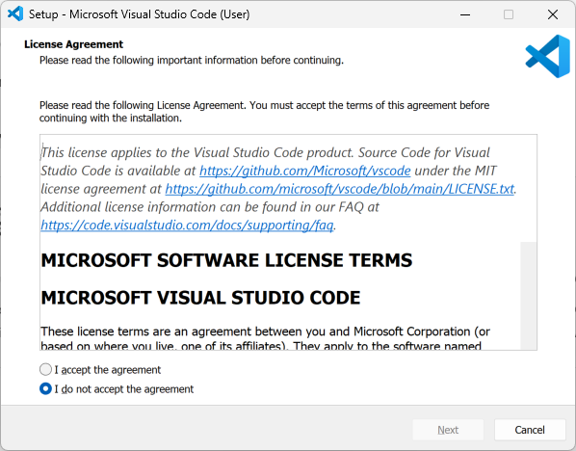

You will need to select I accept the agreement and then select Next and keep selecting Next for the rest of the Installer as you don’t need to change anything, once you get to the end select Finish as follows:

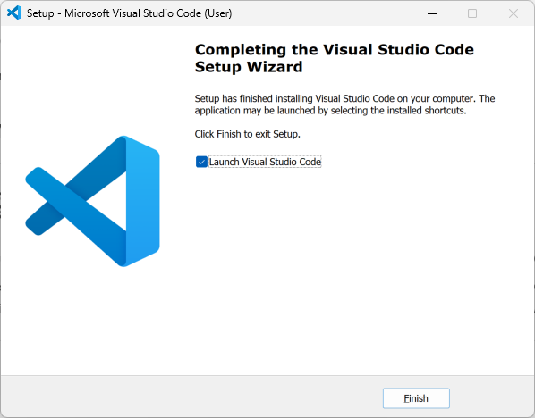

Launch Visual Studio Code
Once you have installed Visual Studio Code the Installer will have launched Visual Studio Code, but if Visual Studio Code was already Installed, then on Mac you need to go to Finder and then search for Visual Studio Code and then select it to Launch it, or if using Windows you need to go to Start, and then search for Visual Studio Code and then select it to Launch it as follows:

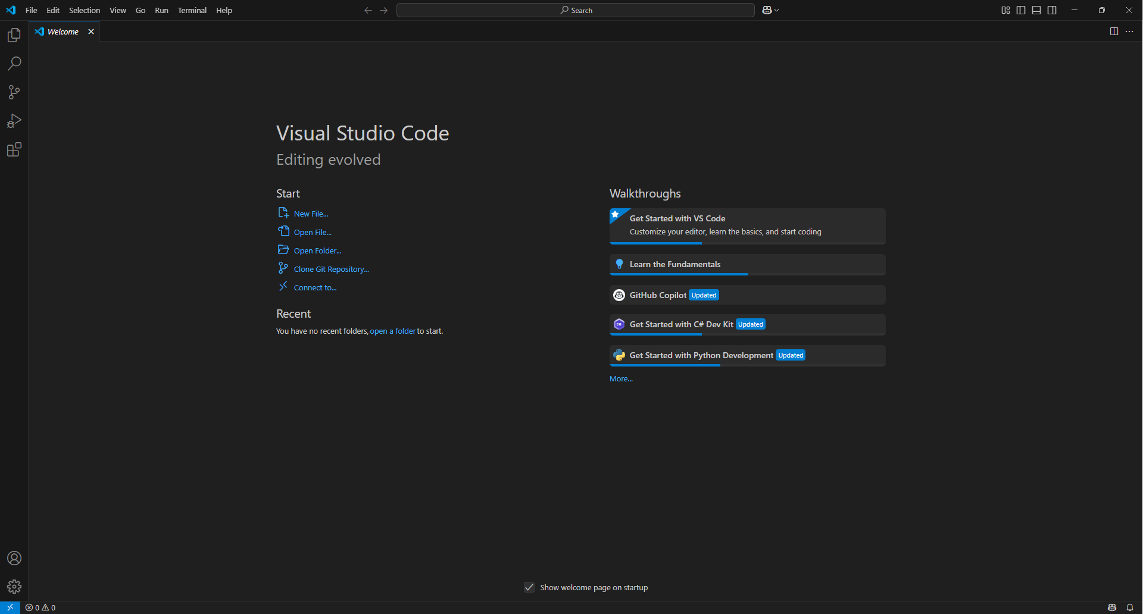

Then in Visual Studio Code from the Side Bar select the top option of Explorer as follows:

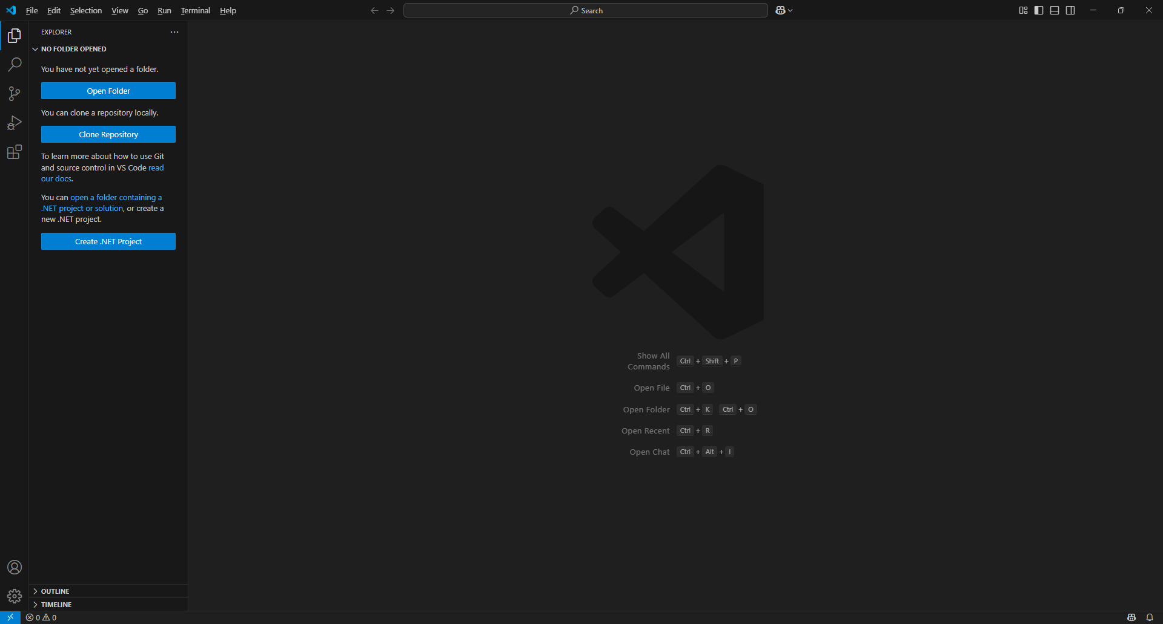

Next in Visual Studio Code within Explorer select Open Folder and locate the Folder for your Project, this will be the one in Terminal on Mac or Command Prompt on Windows e.g. C:\Workshop\Blazor.Podcast.AI and then choose Select Folder or if you cannot find it Type in the Terminal on Mac or Command Prompt on Windows the Command of code . followed by Enter, which should open the Folder as follows:

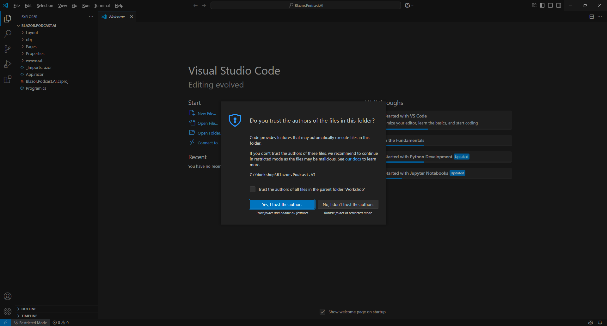

Then choose Yes, I trust the authors in Do you trust the authors of the files in this folder? as this is the Folder for the Project you created and then once done select Program.cs from Explorer as follows:

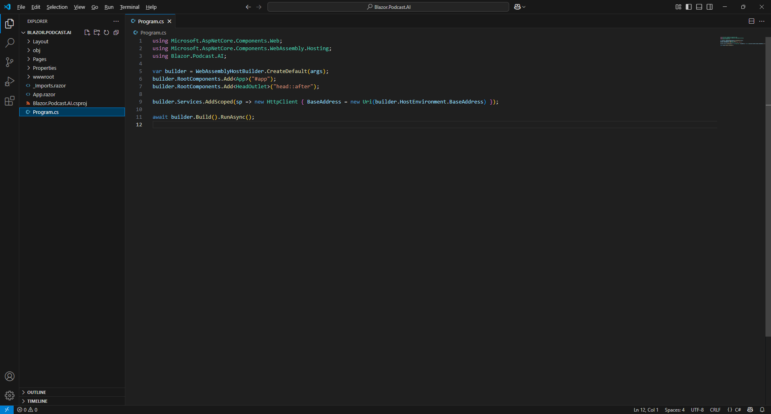

Information – Program.cs is where the application is Initialised you will see using statements at the top for features in .NET or Packages along with WebAssemblyHostBuilder which is set up by default.

Update Project
Return to Visual Studio Code and with Program.cs selected in Explorer you will need to add some using statements, so below the line of using Blazor.Podcast.AI or the last using statement you need to Copy and Paste the following Usings:

using OpenAI;
using System.ClientModel;
using Microsoft.Extensions.AI;

Information – The first using statement will include functionality to use OpenAI, the next is needed for the Credentials and the last for functionality needed from the Package of Microsoft.Extensions.AI.OpenAI.

Then within Program.cs above the line of await builder.Build().RunAsync(); you need to Copy and Paste the following Code:

var credential = new ApiKeyCredential("PersonalAccessToken");
var options = new OpenAIClientOptions()
{
Endpoint = new Uri("https://models.inference.ai.azure.com")
};
var client = new OpenAIClient(credential, options);
var chat = client.GetChatClient("gpt-4o-mini").AsIChatClient();
builder.Services.AddSingleton(chat);
// Register Provider

Information – This Code is for the Client needed to use GitHub Models, starting with ApiKeyCredential with a placeholder for a Personal Access Token to be provided later in the Workshop. This is followed by an OpenAIClientOptions created with the Endpoint needed to access GitHub Models. Then there is an OpenAIClient using ApiKeyCredential and OpenAIClientOptions used to set up IChatClient which will use the AI Model from OpenAI of GPT-4o Mini. This is Registered with Dependency Injection where functionality such as IChatClient can be provided where it is needed. Finally, there is a Comment for Register Provider in Program.cs which will be returned to later when the Provider has been Implemented in the Workshop to Register it for Dependency Injection.

Once you have updated Program.cs with Usings and Code in Visual Studio Code it should be as follows:

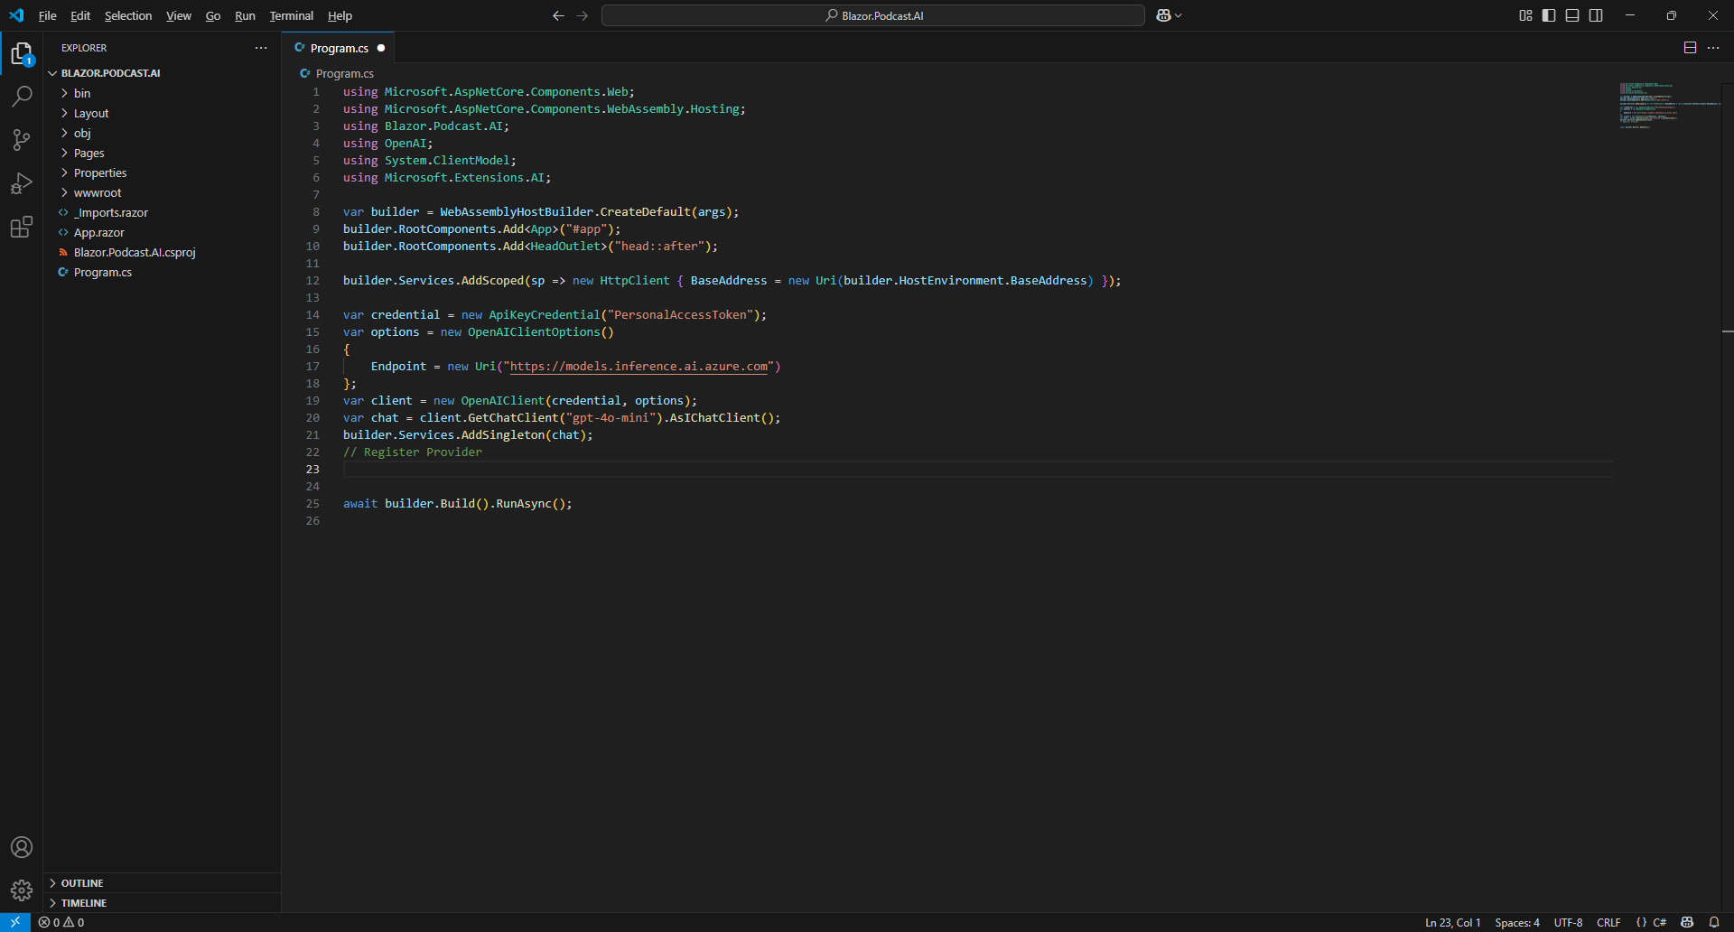

Visual Studio Code will need to be kept Open throughout the Workshop but don’t worry if you Close it by mistake as you can just Launch it again by, if using a Mac you need to go to Finder, search for Visual Studio Code and then select it, or if using Windows you need to go to Start, search for Visual Studio Code and select it so that Visual Studio Code is Opened again. Then from Welcome in Visual Studio Code select Blazor.Podcast.AI from Recent and then select Program.cs from Explorer.

This completes Visual Studio Code being Installed and / or Launched for Windows or Mac along with opening the Project for Blazor.Podcast.AI and updating Program.cs as needed for GitHub Models.

Create GitHub Account
If you don’t have an existing GitHub Account you will need to Sign up for one, to do so use a Browser and visit the Website at github.com which also includes more about GitHub.
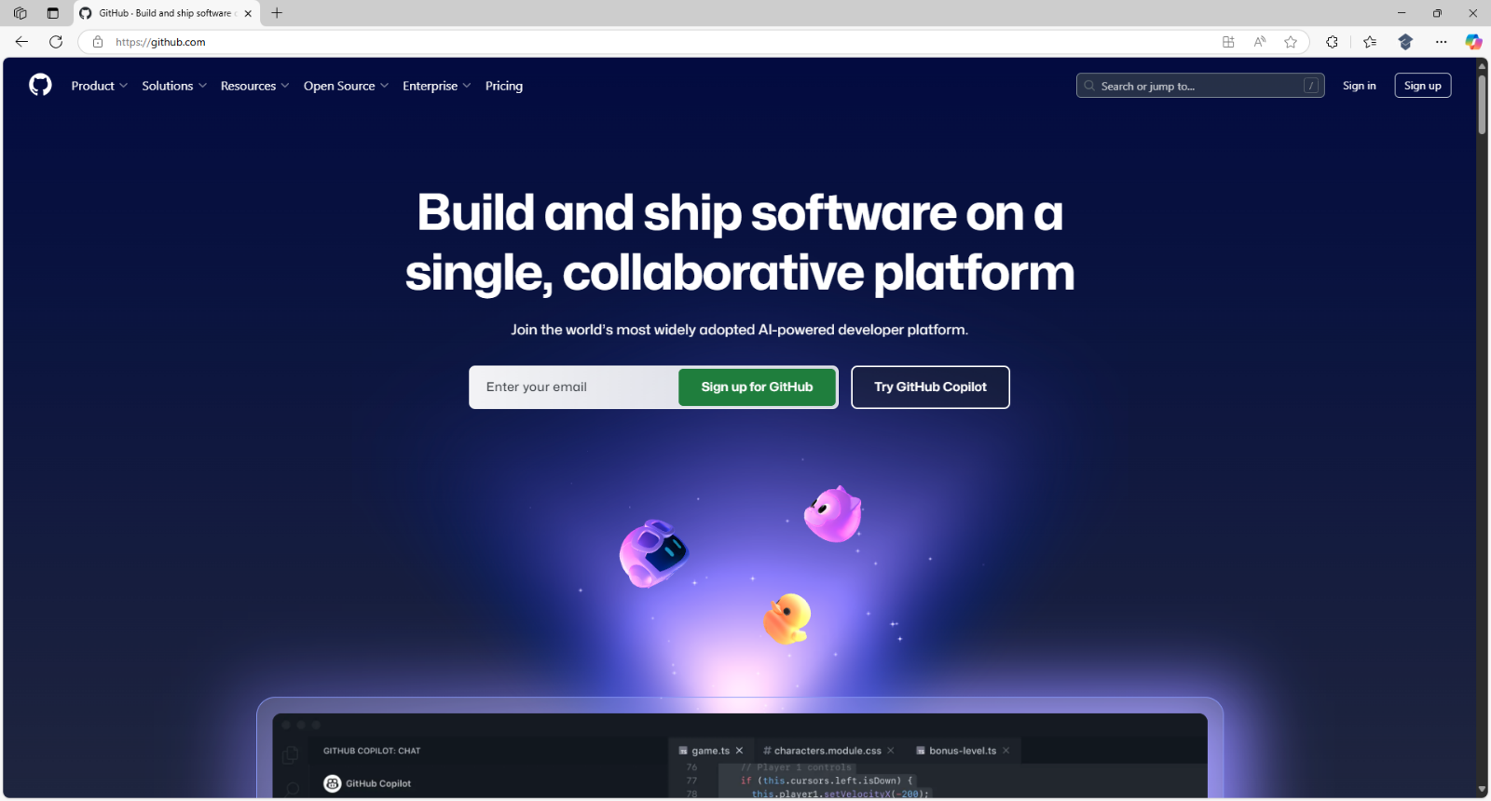

Information – GitHub is where you can collaboratively store and share code for any language or platform such as .NET with Repositories where you can track and propose changes to help build and ship software.

Then select Sign up where you can input your Email then a Password and Username to use for GitHub along with your Country/Region such as United Kingdom and then select Continue.

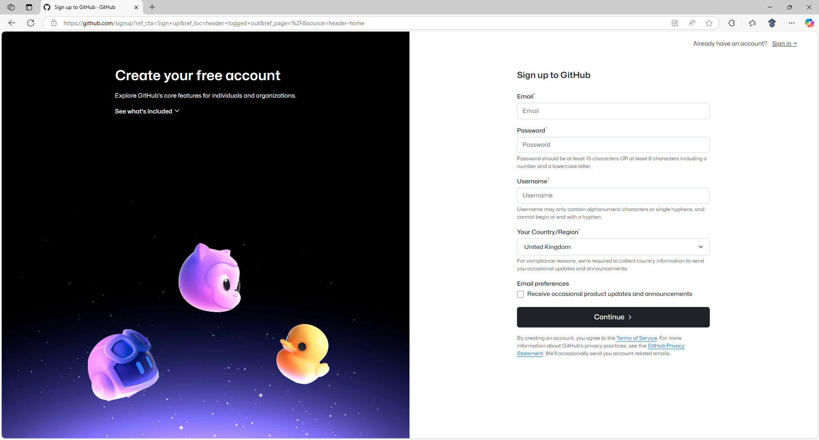

Then you may be asked to Verify your Account and then to Confirm the Email Address for your Account.

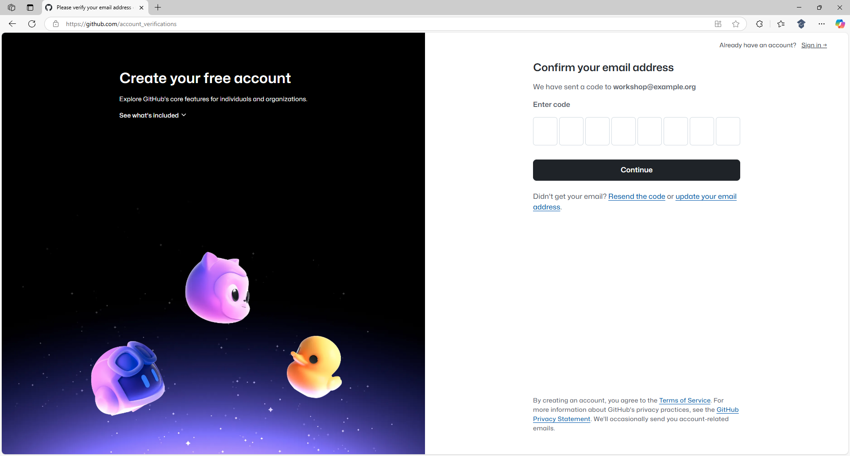

Next you need to check your Email for one for Your GitHub launch code that would have been Sent to the Email Address you provided for your new Account which you can then Copy and Paste below Enter Code on the Confirm your email address and then select Continue to create your GitHub Account.

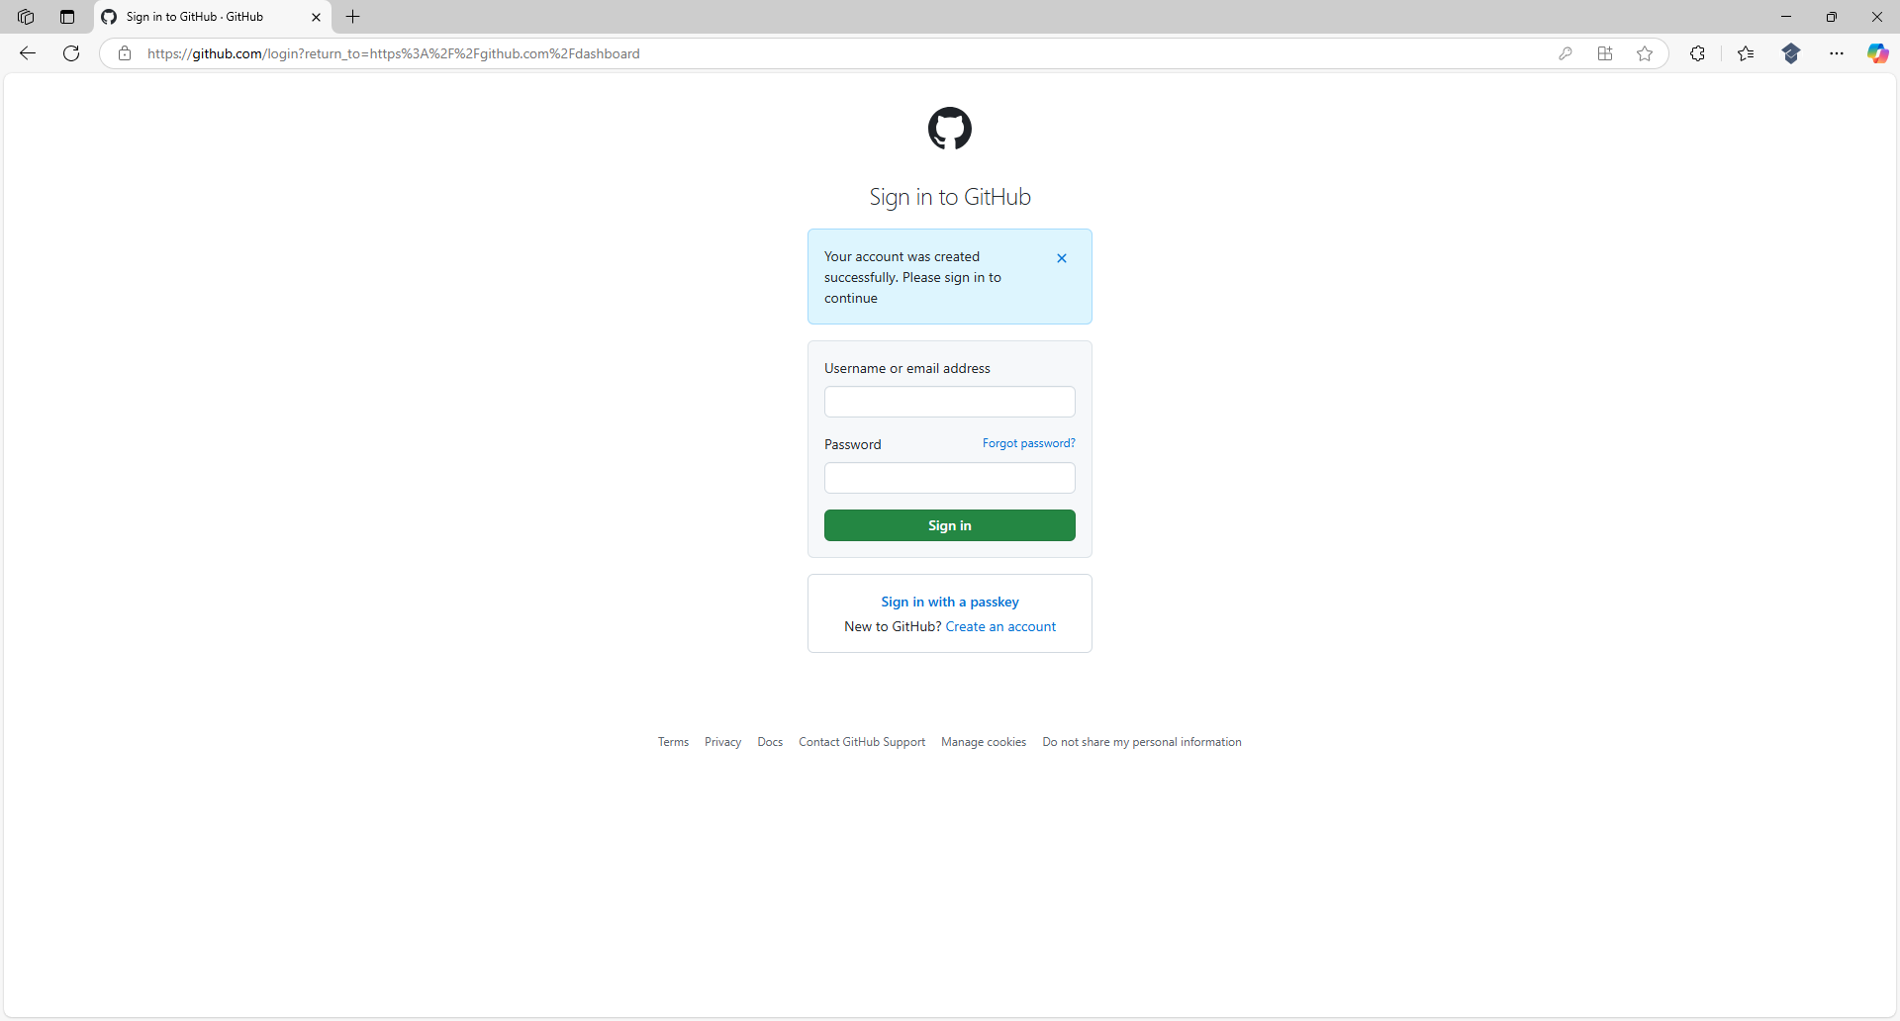

Information – This completes creating a new GitHub Account than can then be used to get a Personal Access Token to access GitHub Models.

Get Personal Access Token
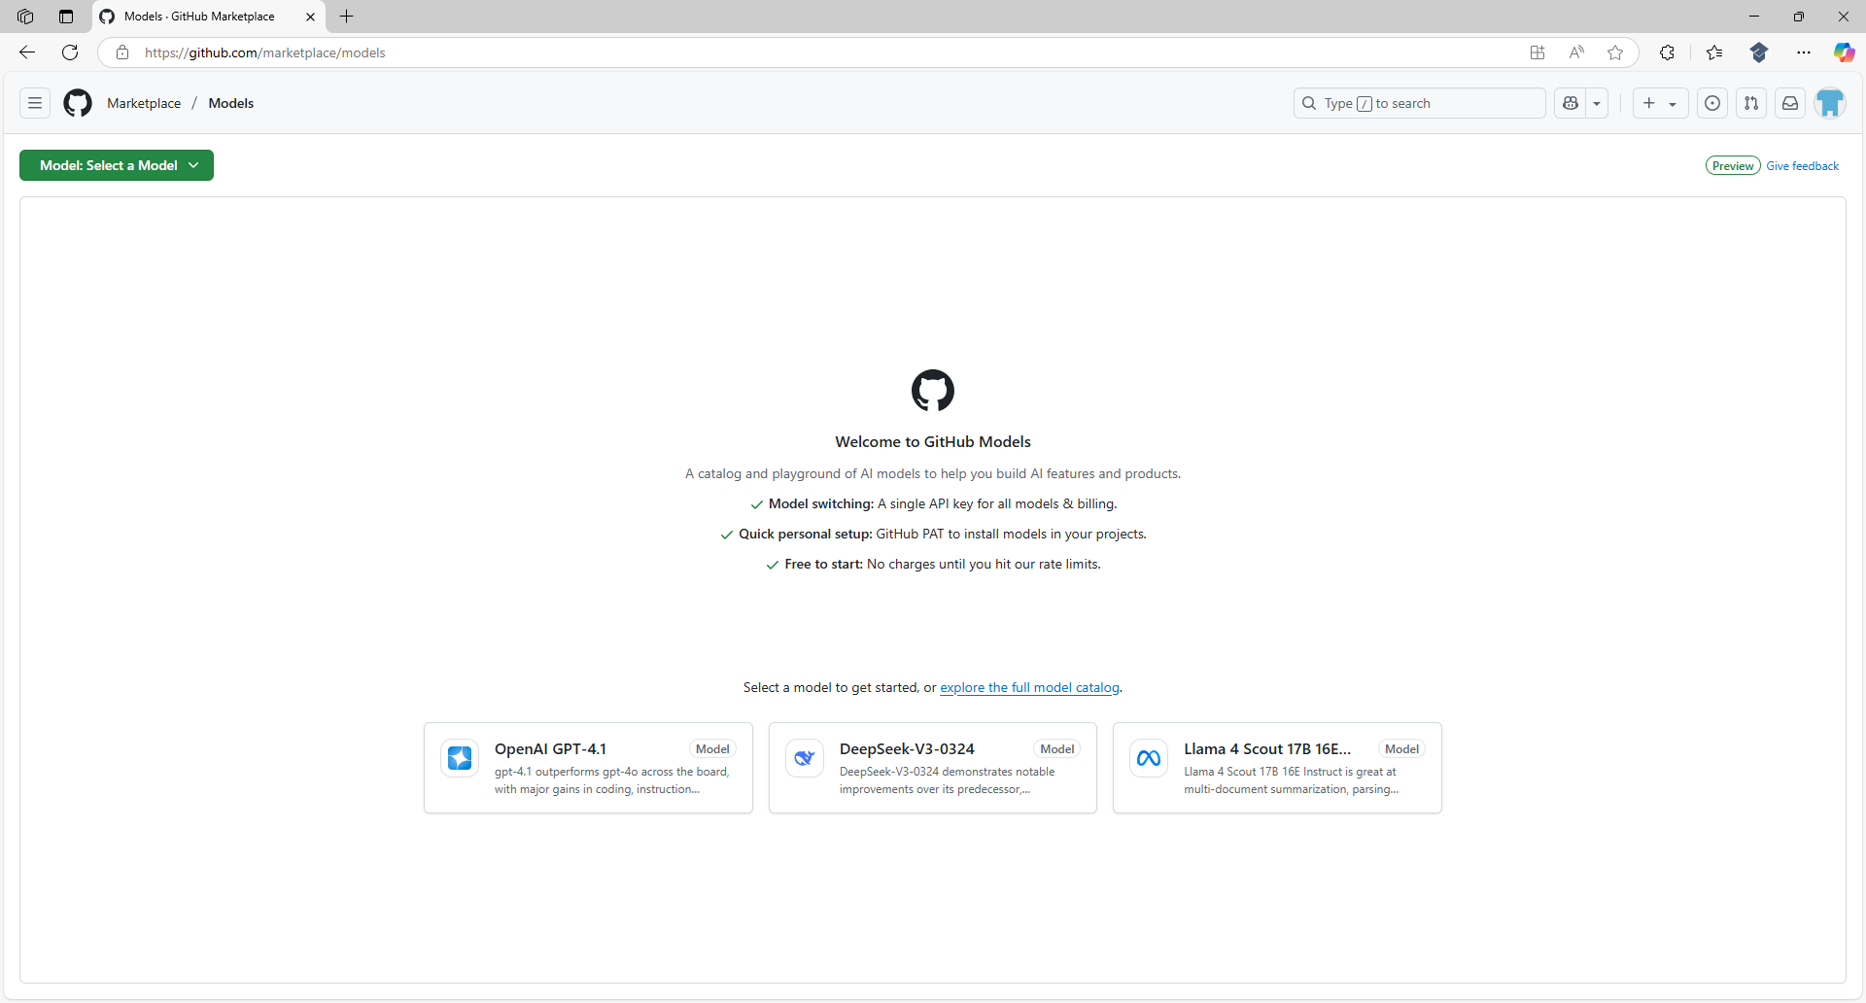

Information – GitHub Models is a catalogue and playground for AI Models including those from OpenAI to help build AI features and products easily accessed using a single Endpoint and Personal Access Token from GitHub. You can find out more about GitHub Models or try them out at github.com/models.

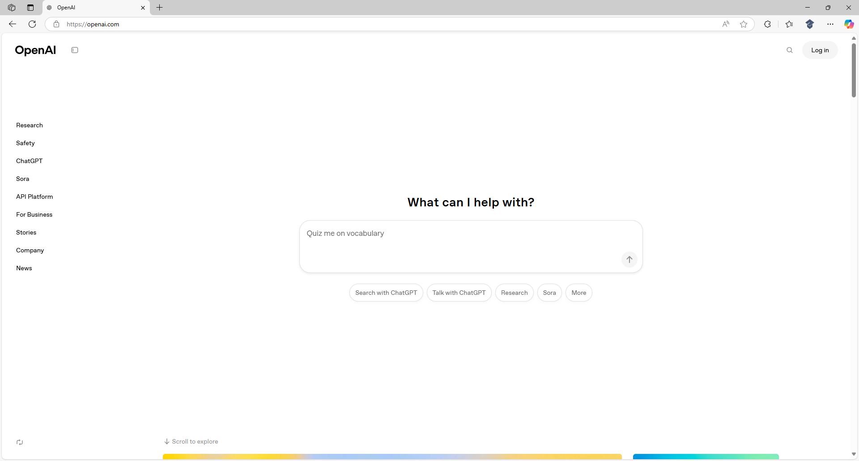

Information - OpenAI develops advanced AI Models including GPT or Generative Pre-trained Transformer that powers services such as ChatGPT that can understand and generate human-like text or DALL·E that can be used to create realistic images from text descriptions. To find out more about OpenAI visit openai.com.

If you have a GitHub Account, use a Browser and visit the Website at github.com and select Sign in, or once you have created your GitHub Account input your Username or email address and Password.

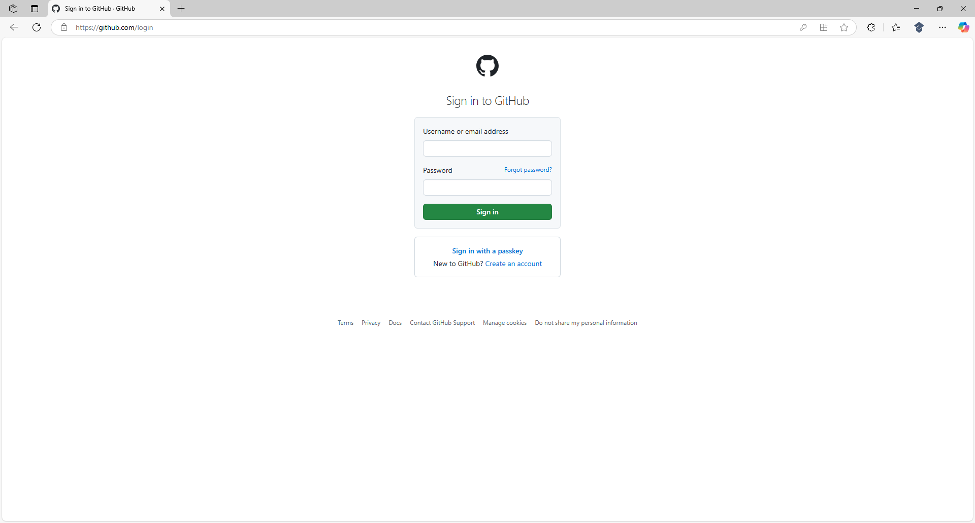

Then select Sign in to your GitHub Account and once done you will be taken to the Dashboard as follows:

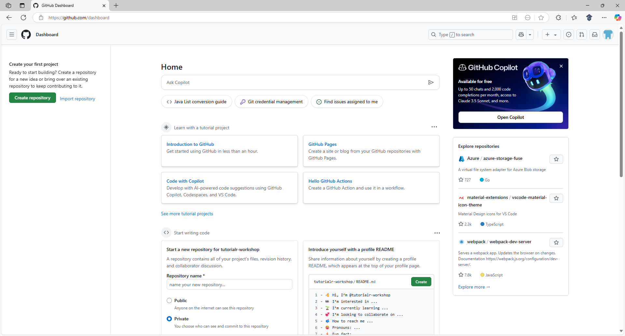

Information – Dashboard is where you get started with GitHub including being able to create your own Repositories where you can store and share any Code including being able to collaborate with others or contribute Code to others on GitHub.
Once in the Dashboard for your GitHub Account select the Avatar from the top of the Dashboard to display the Account Menu as follows:

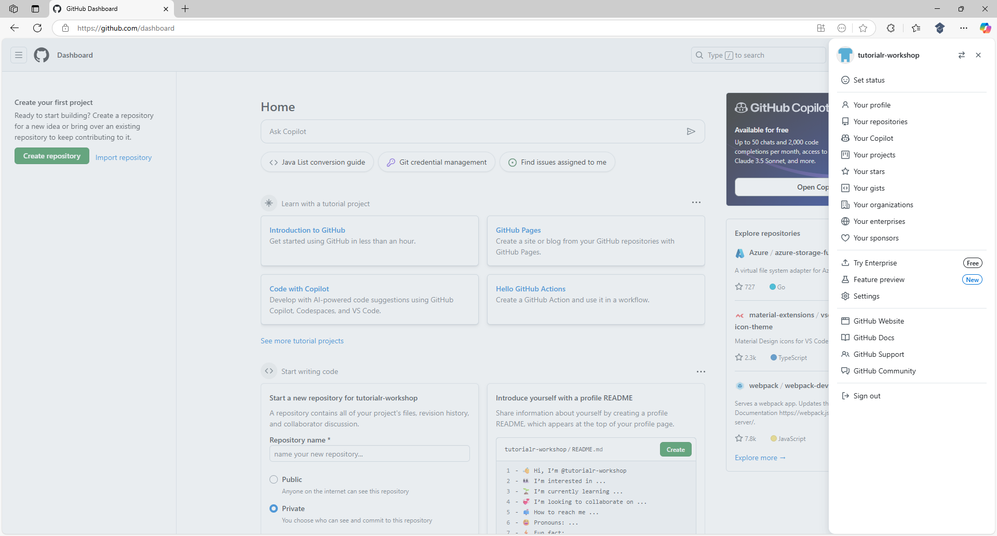

Then from the Account Menu select Settings to display the Settings for your GitHub Account.

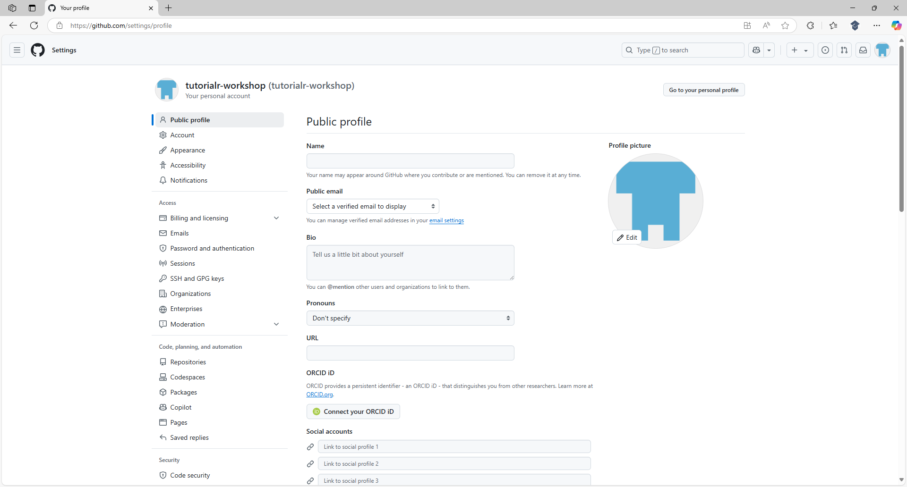
Next from Settings select Developer settings from the bottom of the options that includes Public profile.

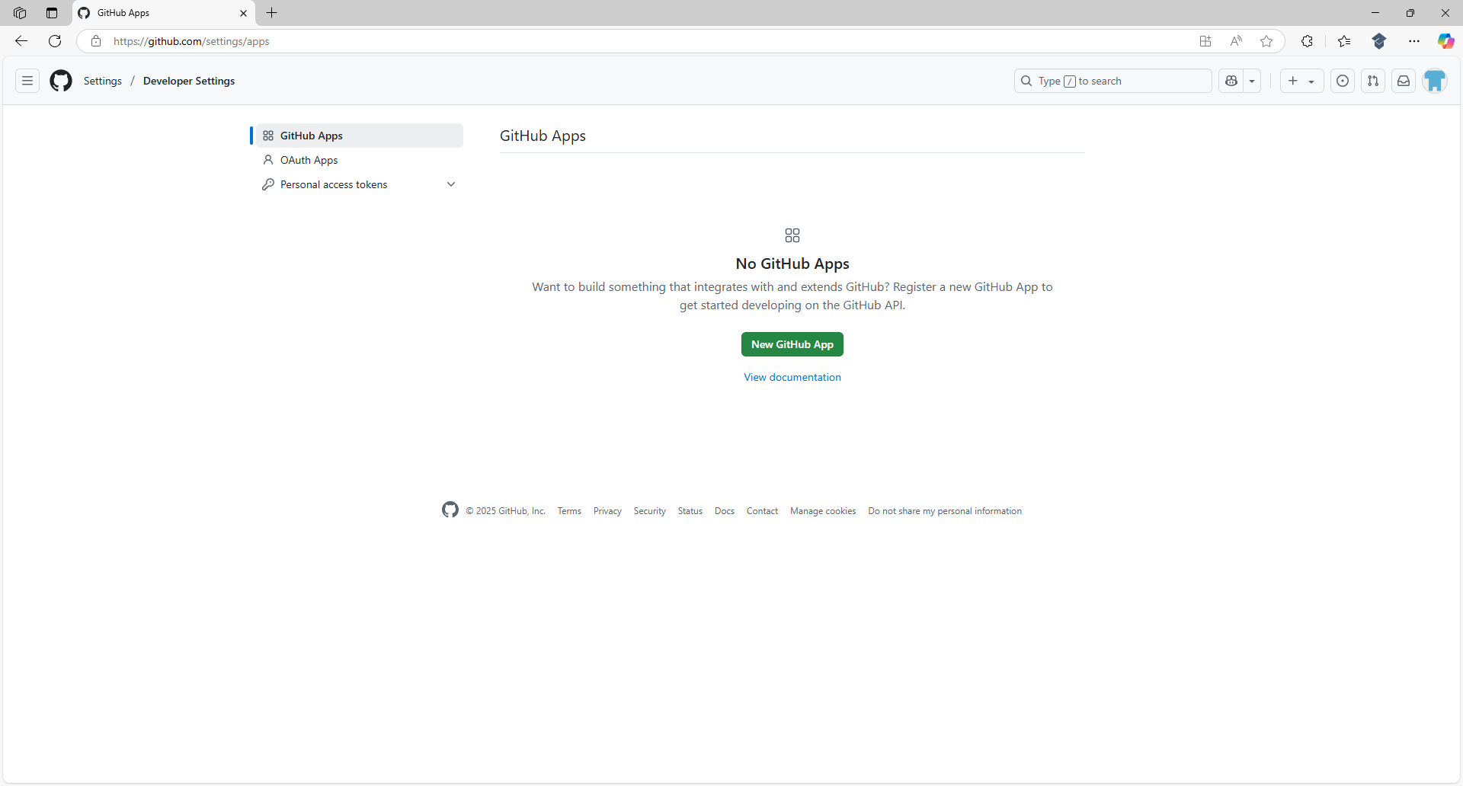

Then in Developer Settings select Personal access tokens and then select Fine-grained tokens.

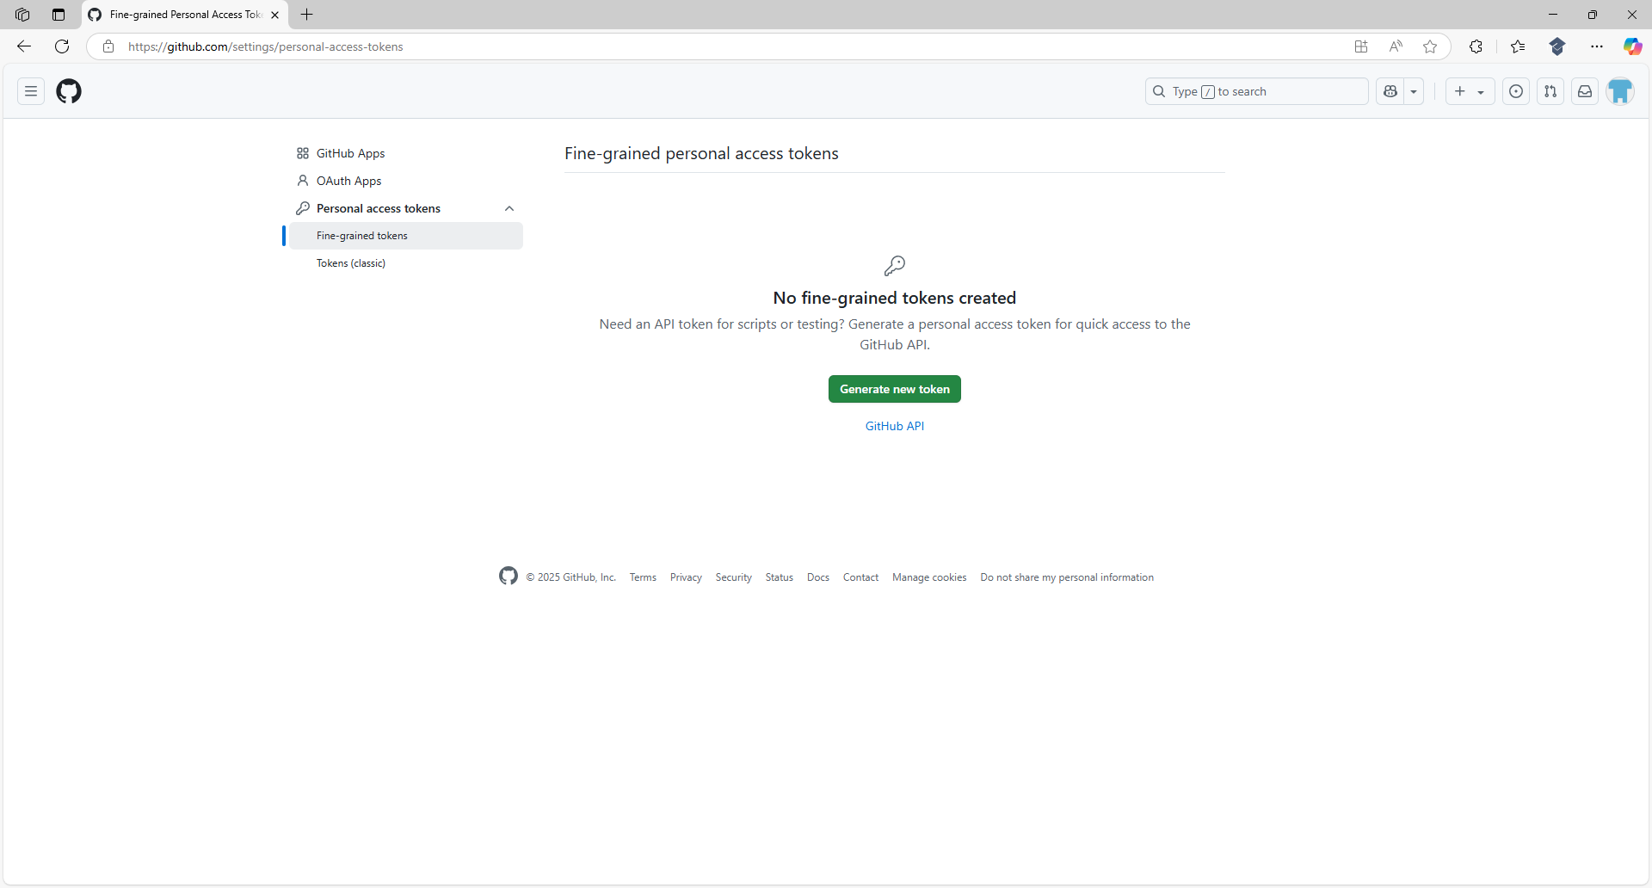

Information – This is where Personal Access Tokens are created needed to access GitHub Models.
Next in Fine-grained tokens select Generate new token and then enter a Token name which can be anything unique to your GitHub Account, for example GitHub Models, as follows:

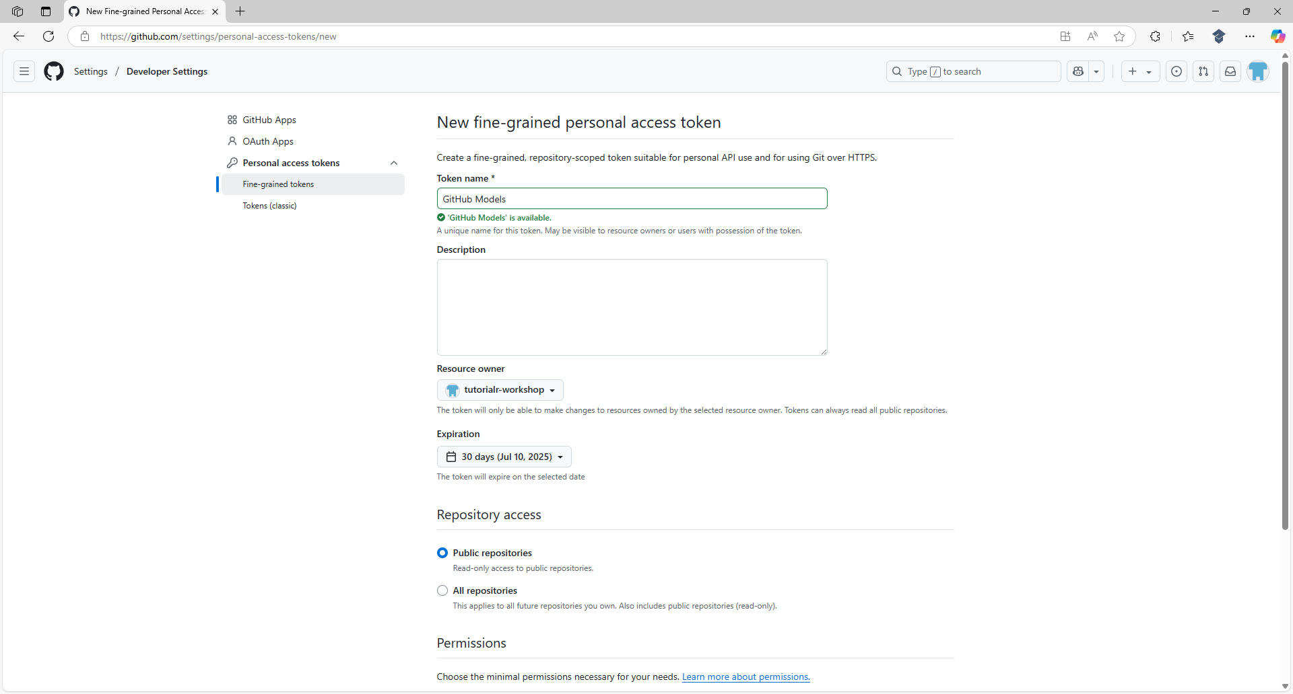

Then at the bottom of New fine-grained personal access token select Account permissions and then next to Models select Access and choose the Read-only option as follows:

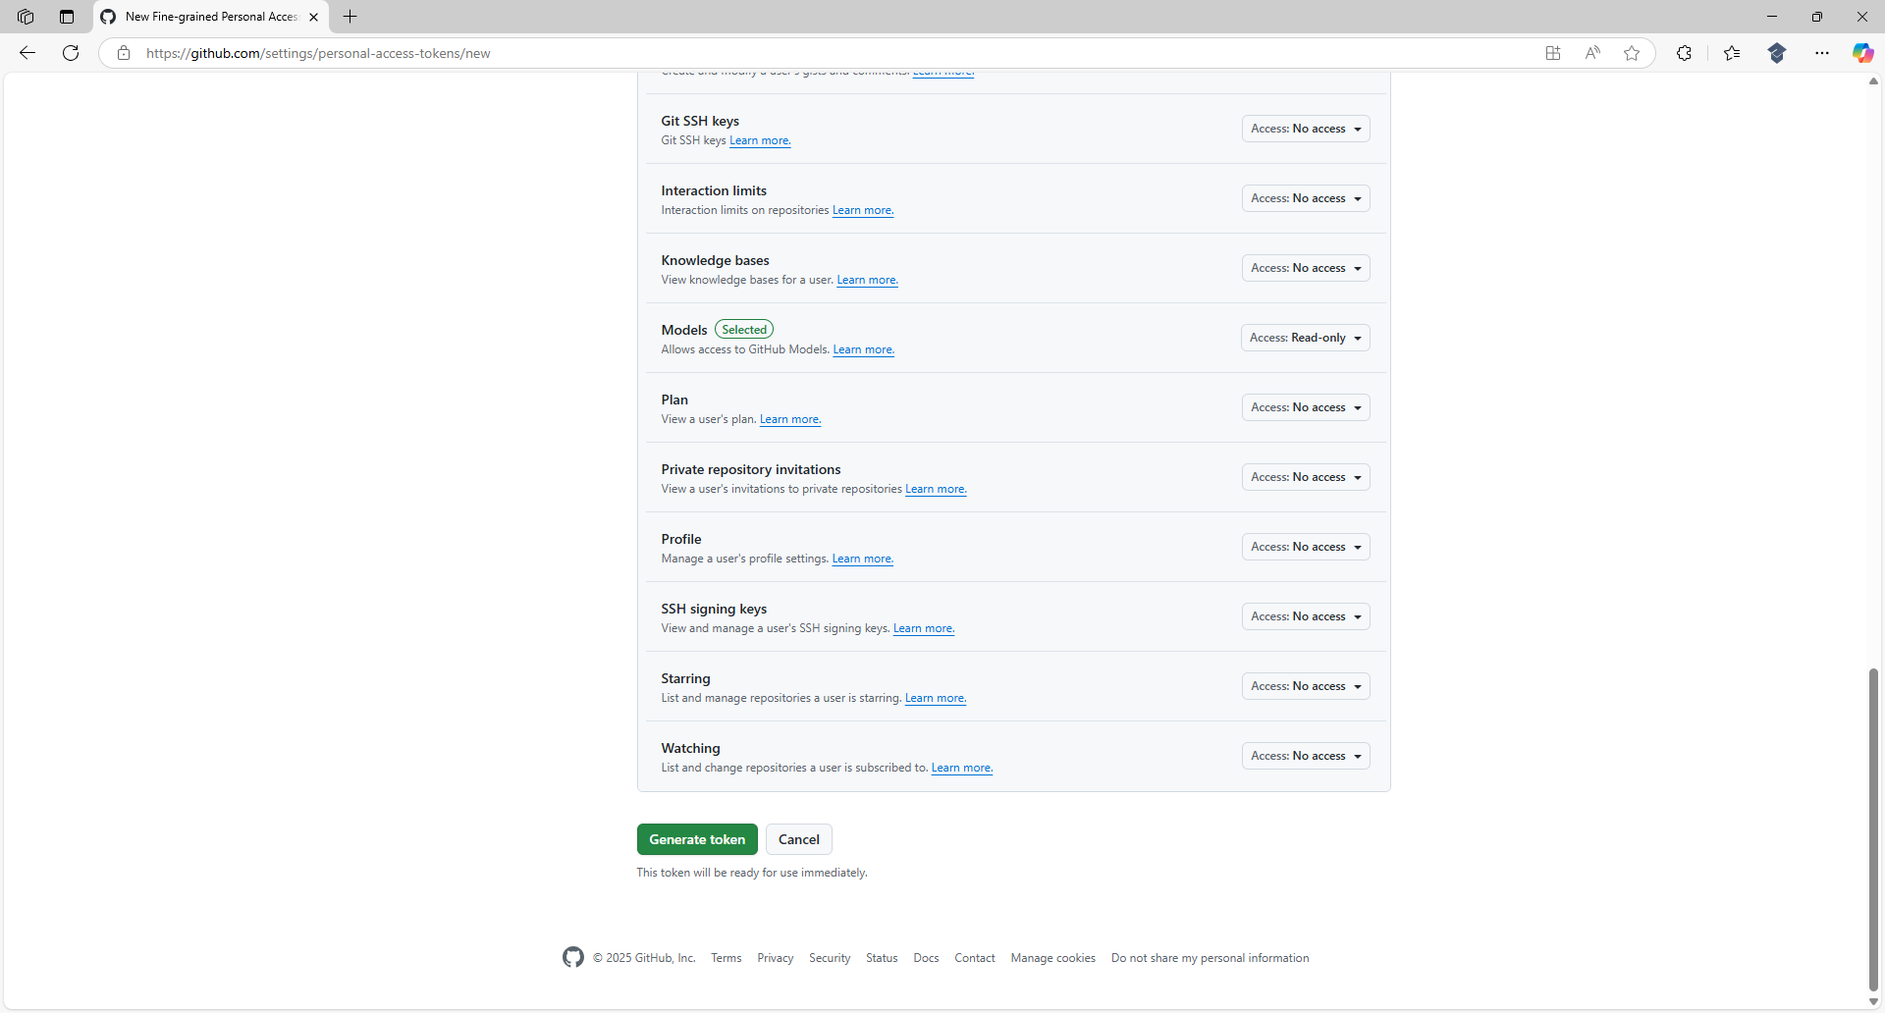

Information – This will give the Personal Access Token to be created Permission to use GitHub Models.

Next at the bottom of New fine-grained personal access token select Generate token and in New personal access token select Generate token as follows:

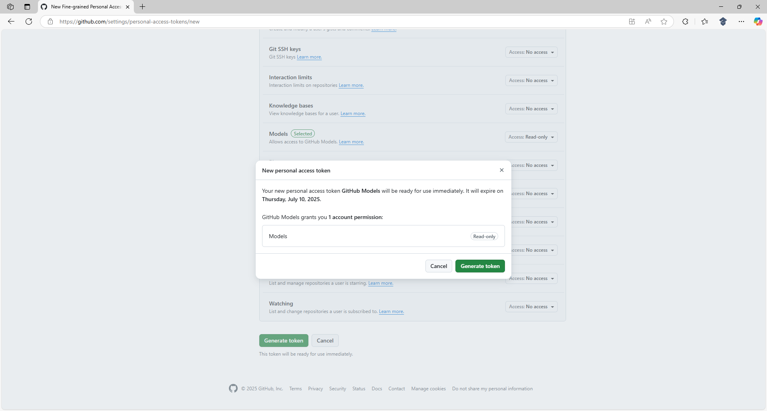

Once Generate token has been selected the Personal Access Token will be created as follows:

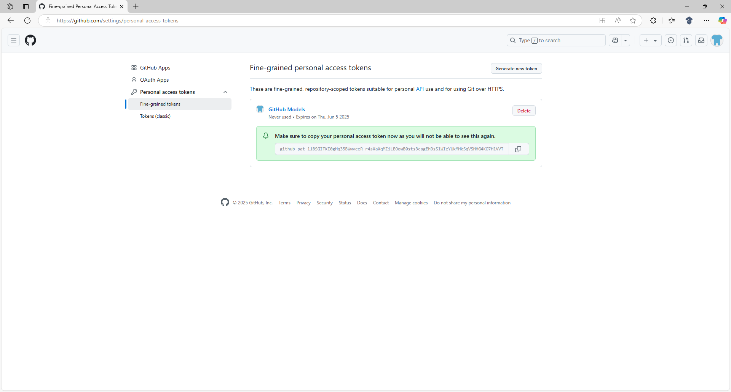

Information – This Personal Access Token only has Permission to access GitHub Models so it won’t be able to do anything to your GitHub Account, but you should keep it secret and not share it with anyone.
Then you need to Copy the Personal Access Token from Fine-grained personal access tokens and return to Visual Studio Code where Program.cs should be selected in Explorer as follows:

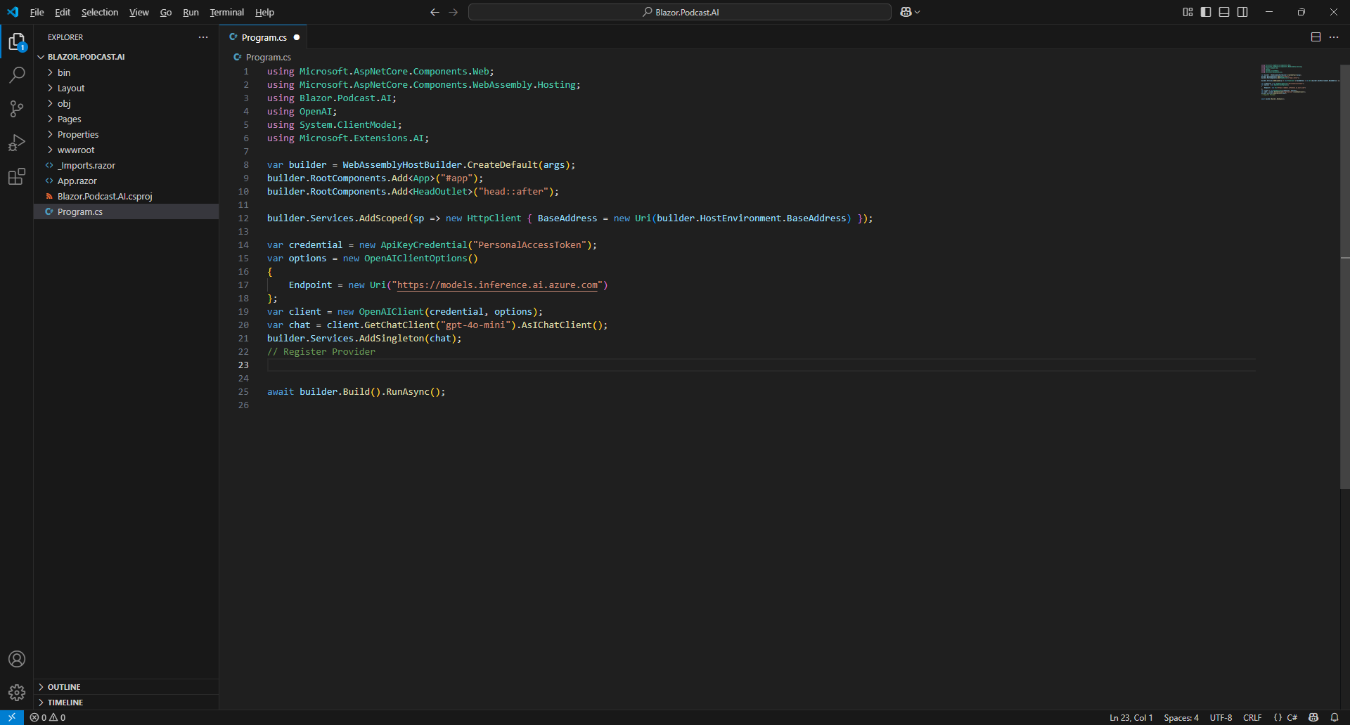

Then within Program.cs you will need to replace the placeholder of PersonalAccessToken by Pasting the Personal Access Token that you Copied from Fine-grained personal access tokens in GitHub.

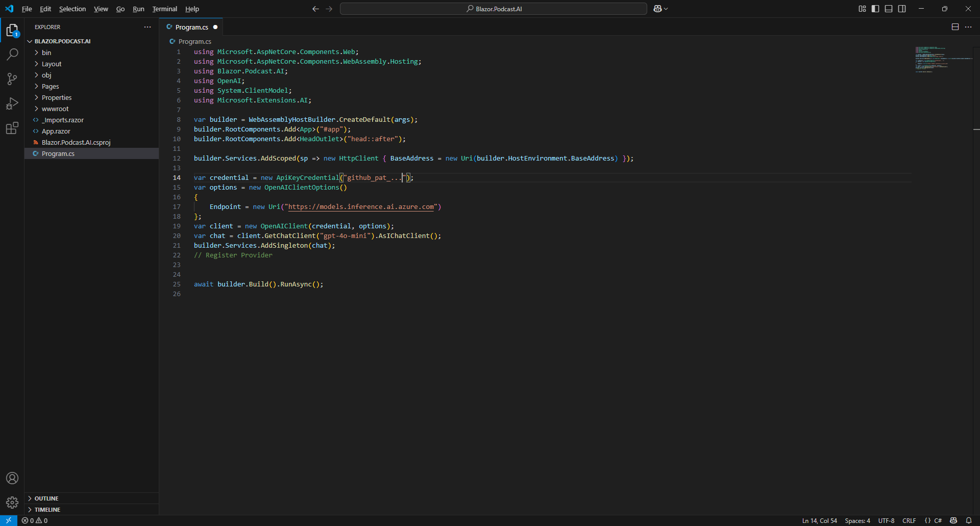

Information – Your Personal Access Token can be used here like this as it will just be used on your Mac or Windows computer but should be it back to PersonalAccessToken if sharing anywhere including GitHub.

Next, within Visual Studio Code from the Menu select File and then Save as follows:

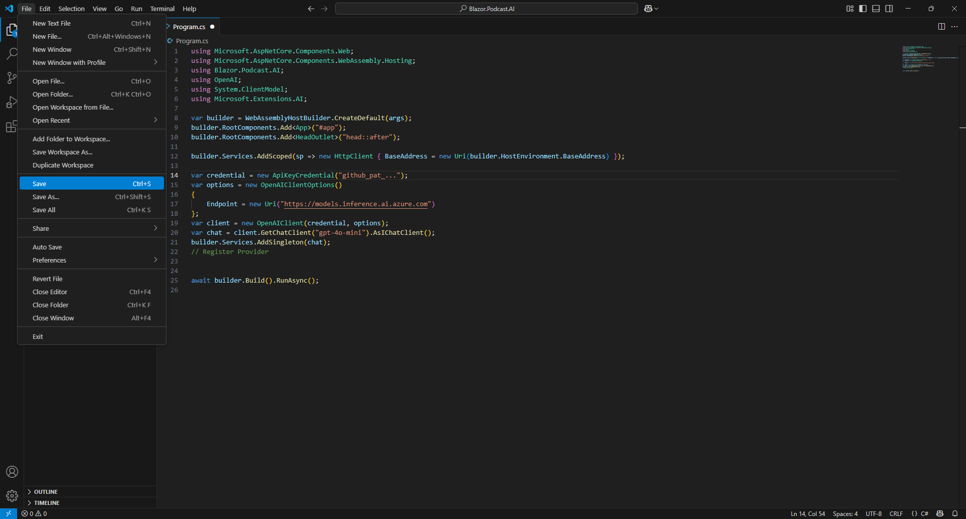

Information – This will Save the changes you have made to Program.cs which includes the Usings and Code added for the Client along with the Personal Access Token to use GitHub Models.

This completes the process of getting a Personal Access Token from a GitHub Account and updating Program.cs in the Project for Blazor.Podcast.AI to include the Personal Access Token to be able to access GitHub Models.

Launch Project in Browser
Return to the Terminal on Mac or Command Prompt on Windows that was opened earlier as follows:

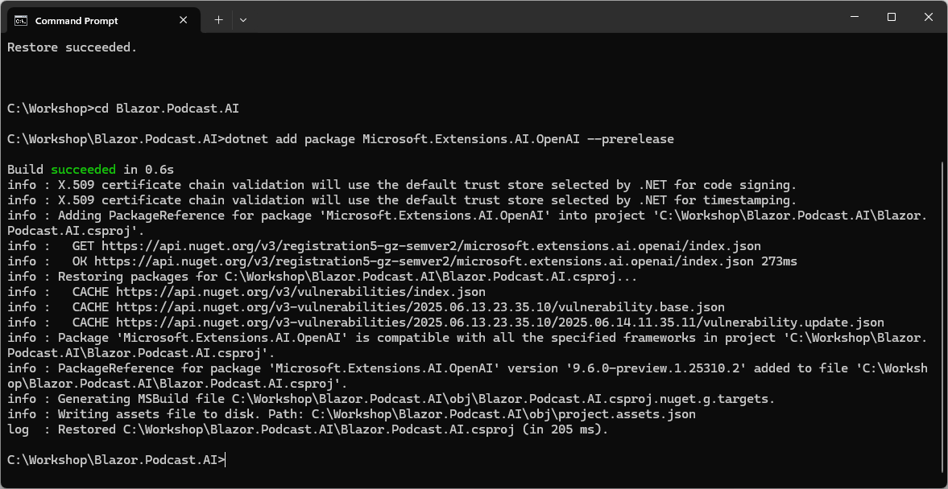

Information – If you closed the Terminal on Mac then you need to go to Finder, search for Terminal and then select it to Open it, or if you closed the Command Prompt on Windows you need to go to Start, search for Command Prompt and then select it to Open it. Then once opened you need to change directory using cd to the location for your Project, for example cd Blazor.Podcast.AI.

Then in Terminal on Mac or Command Prompt on Windows you then need to Copy and Paste the following Command and then press Enter:

dotnet watch

Information – If Terminal on Mac or Command Prompt on Windows displays any Errors, then make sure that everything was entered correctly into Program.cs by going over the previous Steps to double check it matches what you have but once any corrections have been made and Saved or there are no Errors then the Build should proceed.

Once the Command has completed successfully the Terminal on Mac or Command Prompt on Windows should display as follows:

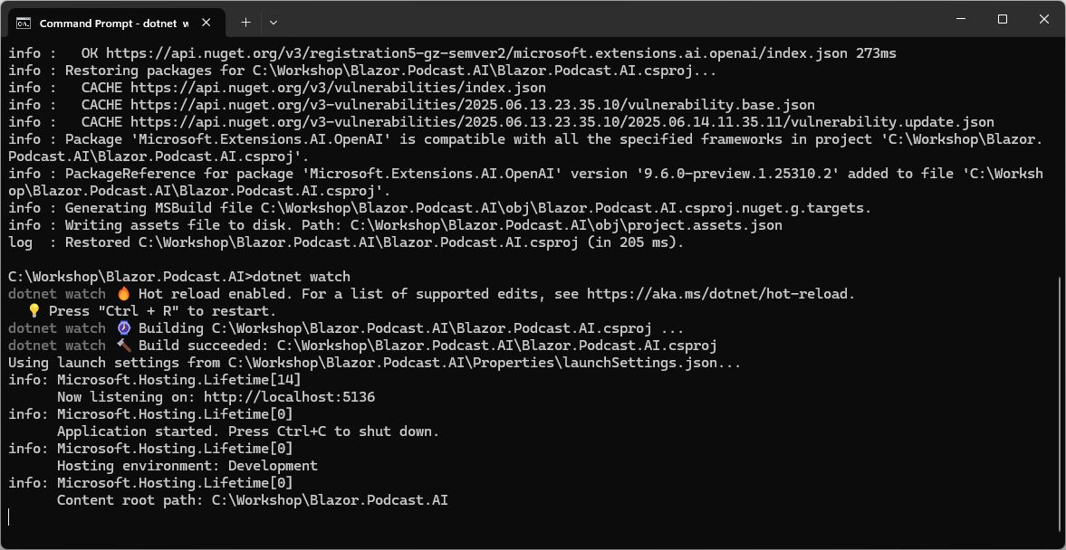

Information – You will be using Copy and Paste for each piece of Code but to avoid any issues the key thing to remember in C# is balance, so a Curly Brace of { will always have a counterpart of } also applies to Square Brackets which should have both [ and ] and Brackets which should have always have ( and ) along with Double Quotes which should be in pairs so if see " at the start there should be another " at the end. Also make sure where you see any Semi-Colons or ; to include them where needed as it can often be the smallest mistake that is easiest to fix makes your Code work when corrected although any indentation including Tabs won’t affect any behaviour. Errors will give you an idea where to look including the line number of the File which will make them easier to find and give you some idea of what you did wrong so you can correct any mistake.

Also once the Command has completed in the Terminal on Mac or Command Prompt on Windows and there are no Errors then the following will be displayed in a Browser:

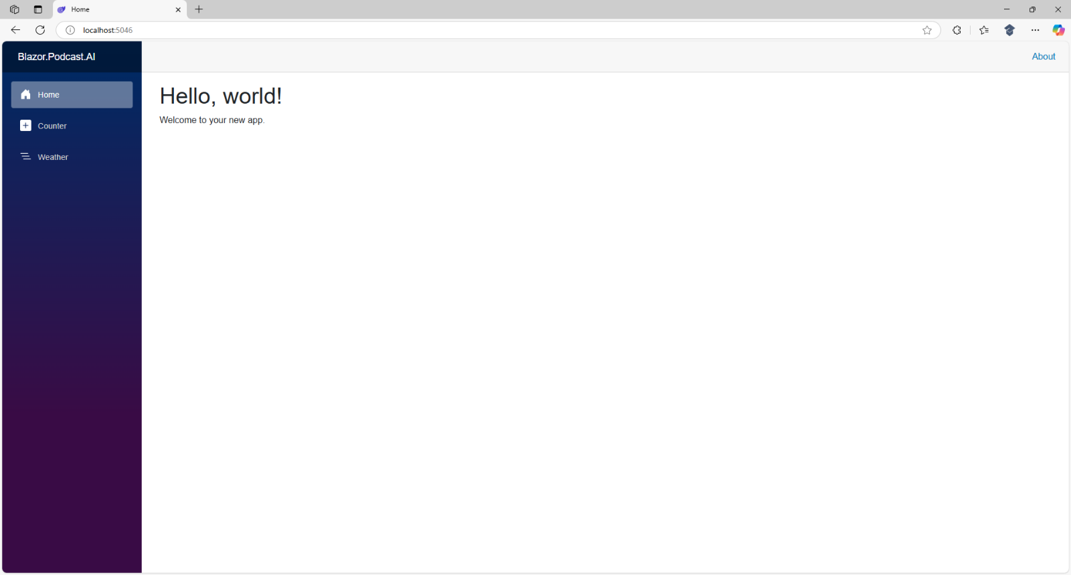

Information – If you don’t see anything like this in a Browser then check anything you might have missed in the Workshop. Otherwise, this already is your first or working Blazor application that you can even use and interact with, including Counter and Weather, although it doesn’t yet perform any of the actions specific to Blazor.Podcast.AI.

Don’t Close the Visual Studio Code for your Project of Blazor.Podcast.AI but if Visual Studio Code is Closed, then if using a Mac you need to go to Finder, search for Visual Studio Code and then select it to Open it again, or if using Windows you need to go to Start, search for Visual Studio Code and select it so it is Open again. Then from Welcome in Visual Studio Code select Blazor.Podcast.AI from Recent.

Don’t Close the Command Prompt on Windows or Terminal on Mac but if it is Closed then you need to go to Finder, search for Terminal and then select it to Open it, or if you Closed the Command Prompt on Windows you need to go to Start, search for Command Prompt and then select it to Open it. Then once opened you need to change directory using cd to the location for your Project, for example cd Blazor.Podcast.AI and then you need to type dotnet watch followed by Enter.

Don’t Close the Browser but if it is Closed within Terminal on Mac or Command Prompt on Windows press the Ctrl key along with C on your Keyboard or on a Mac press Command along with C and then type dotnet watch followed by Enter which should relaunch the Browser.

This completes the process of launching the Project of Blazor.Podcast.AI in a Browser.

Implement

Provider Class
In Visual Studio Code select Program.cs in Explorer then choose New File… next to Blazor.Podcast.AI.

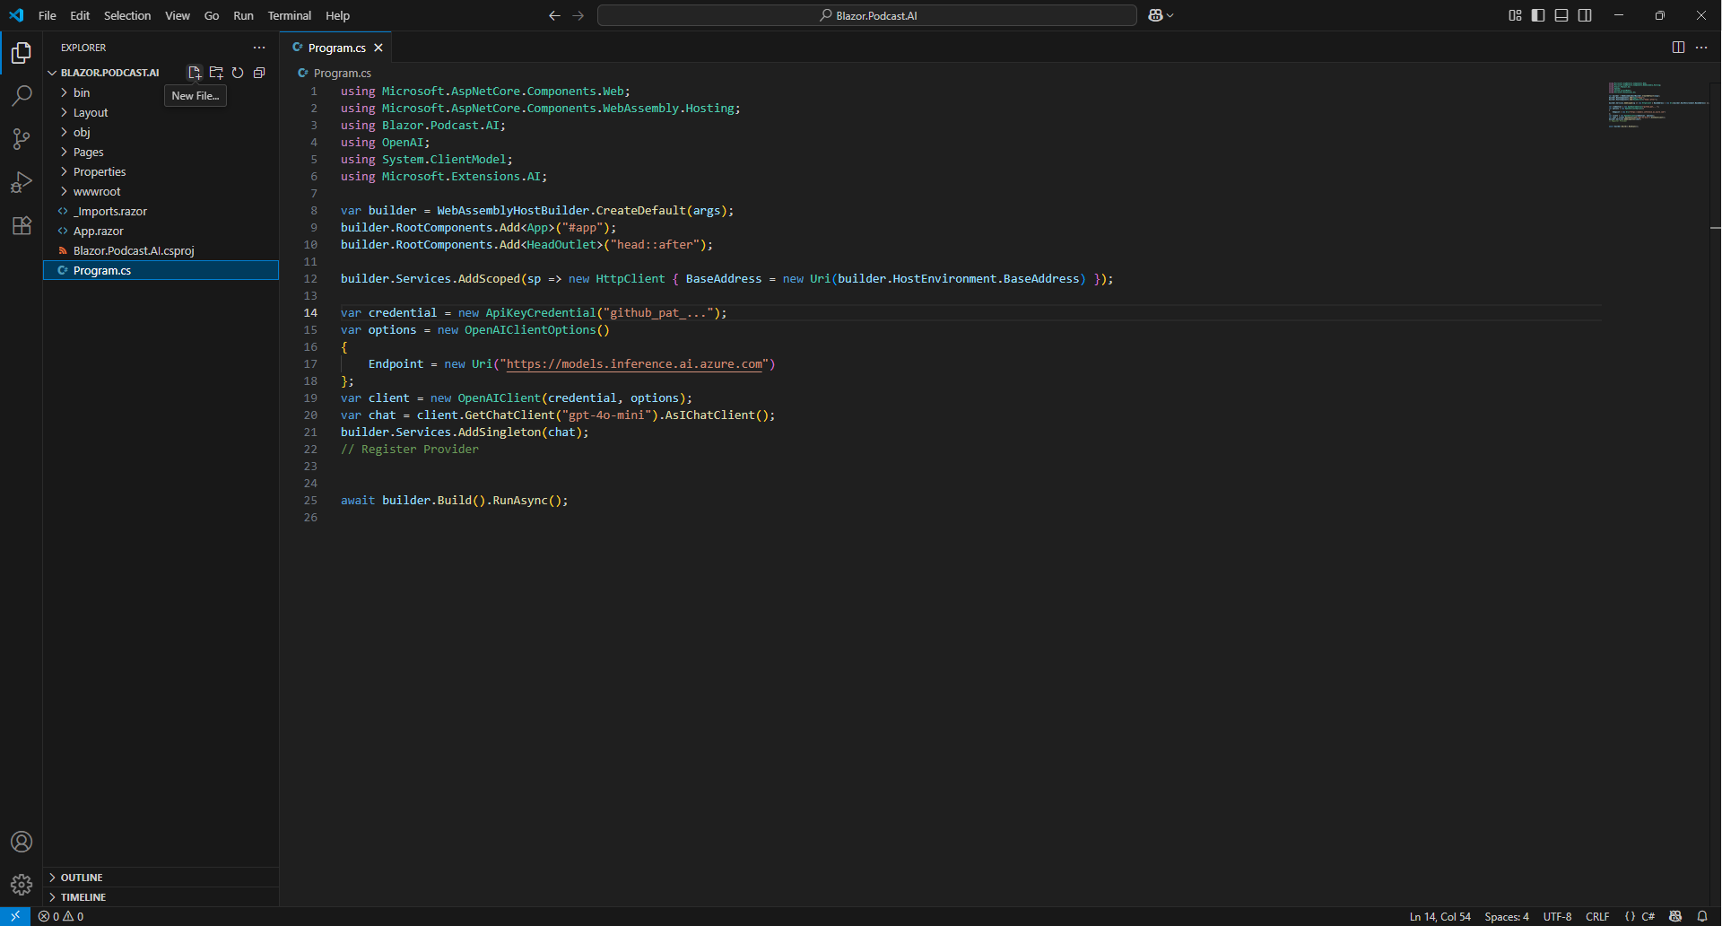

Then Type in the following Name and press Enter after which you should see or select a blank Provider.cs in Explorer within Visual Studio Code.

Provider.cs

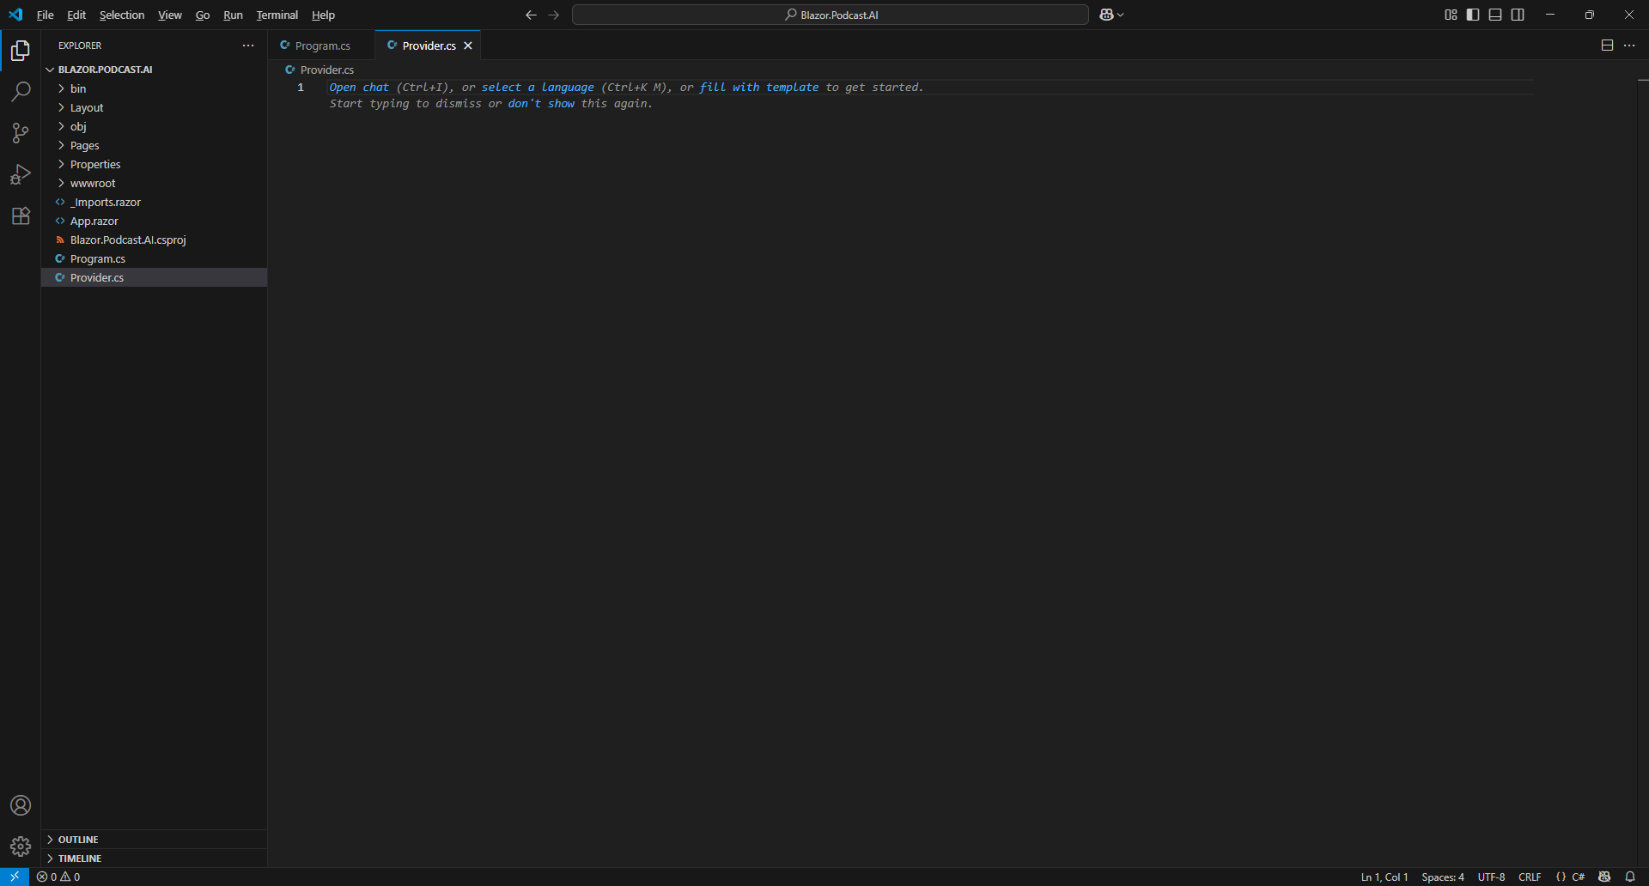
Then within Visual Studio Code in Provider.cs you need to Copy and Paste the following Code:

using Microsoft.Extensions.AI;

namespace Blazor.Podcast.AI;

public class Provider(IChatClient chat)
{
// System Prompt

// Cancellation

// Properties

// Send Method

// Cancel & New Methods

}

Information – This forms the outline of a class for Provider, a Class is used to group together Code or can be used to represent an Object. The first line is a using for functionality needed from the Package of Microsoft.Extensions.AI.OpenAI. Then there is a namespace for Blazor.Podcast.AI which is followed by the class which is defined for Provider including IChatClient which was Registered in Program.cs which is provided to the class with Dependency Injection in a Primary Constructor which is used to provide anything needed for a class in a concise readable manner. There are also Comments which are the lines starting with // which will help you place Code from the next few Steps of the Workshop.

Next within Visual Studio Code in Provider.cs underneath // System Prompt you need to Copy and Paste the following Code:

private const string system = @"
You are a friendly and useful assistant that will help with podcast planning
that is based on answers to questions, always state detailed opinions on
anything asked of you then suggest title and short description for
the podcast, segments for each episode, first five episode ideas,
ideas to make it unique and generate a script for a trailer.
Only use simple html and no markdown to format responses";

Information – This Code defines a Constant or const which is something that does not change when your application is running and is private as it is only used within the class of Provider. It is a string which is a Types which defines the kind of data I can have which in this case is text for a System Prompt within a pair of Double Quotes and ending with a Semi-Colon. A System Prompt is a set of instructions given to an AI Model that acts as a set of rules to guide how it behaves and responds along with any capabilities. In this case it will be a friendly and useful assistant that will help with Podcast planning including suggesting titles, description, segments, episode ideas, how to make it unique plus a generate a script for a trailer. The System Prompt can also be used to control how the Response will be formatted which normally uses Markdown, a special language for formatting text, but instead we want to use simple HTML which is used to format output for a Browser.

Then within Visual Studio Code in Provider.cs underneath // Cancellation you need to Copy and Paste the following Code:

private CancellationTokenSource? cancel;

Information – This Code defines a Variable which is something that does change when your application is running and is private as it is only used within the class of Provider, these kinds of Variable within a class are also known as Members. This Variable is a Type of CancellationTokenSource which will be used to provide a Cancellation Token to Cancel any Response and it is followed by a Question Mark or ? meaning that it is Nullable which means it can have no Value before it is given one with new() later.

Next within Visual Studio Code in Provider.cs underneath // Properties you need to Copy and Paste the following Code:

public string Title { get; } = "Blazor Podcast AI";

public string Label { get; } = "Optionally refine with details or questions";

public Dictionary<string, List<string>> Questions { get; } = new()
{
{ "Podcast is about", [string.Empty] },
{ "Host of podcast is", [string.Empty] },
{ "Listener of podcast is", [string.Empty] },
{ "Format of podcast is",
["Solo", "Interview", "Cohosted", "Roundtable", "Audiobook"] },
{ "Purpose of podcast is",
["Community", "Discussion", "Education", "Experience", "Entertainment"] }
};

public List<ChatMessage> Messages { get; set; } = [new(ChatRole.System, system)];

public bool IsQuestions { get; set; } = true;

public bool IsGenerating { get; set; } = false;

Information – The first Property, which are normally public meaning they can be used inside and outside the class of Provider, is a string for a Title only has a get as it just returns the Value, the second Property is for a string for a Label which also only has a get, then this is followed by set of Questions which also just returns a Value and the Type of this Property is a Dictionary which is used to store a Value which in this case it is a List of text or string using a Key. The Keys are items such as "Podcast is about" and the Values for the List are set using Square Brackets to a set with one string such as string.Empty representing a Value that is blank or a multiple string values such as "Solo" which will define an Answer to a Question. The second Property represents a List of ChatMessage from Package of Microsoft.Extensions.AI.OpenAI which defines Requests or Responses set to a ChatMessage using Square Brackets to the System Prompt using ChatRole.System. The final two Properties with a Type known as a Boolean or bool which can be true or false will control when Questions or Generating should be displayed.

While still within Provider.cs in Visual Studio Code underneath // Send Method you need to Copy and Paste the following Code:

public async Task Send(string message)
{
cancel = new();
IsGenerating = true;
IsQuestions = false;

Messages.Add(new ChatMessage(ChatRole.User, message));

var response = await chat.GetResponseAsync([.. Messages], null, cancel.Token);
var assistant = new TextContent(response.Text);

Messages.Add(new ChatMessage(ChatRole.Assistant, [assistant]));

IsGenerating = false;
}

Information – Send is a Method, which is a way to create a reusable block of Code, they can be provided with Values known as Parameters which will be a string for message, and it is public which means it can be used outside the class of Provider. This Method also Returns a Task, used for Code that runs in the background, within the Method the Member of cancel is Initialised with new() and below this the two Properties of IsGenerating and IsQuestions are set as needed. The message that was provided to the Method is added to the Property of the List of ChatMessage as ChatRole.User which represents any Requests. Then a Variable of response is set using await which is Code that will run in the background to the result of the Method of GetResponseAsync for getting the Response using IChatClient that was provided to the class with Parameters for the List of ChatMessage, an unused Parameter provided with null and then a Token from the Cancellation Token. Then a Variable with the Type of TextContent of assistant is created using the Value of response which is added to the List of ChatMessage as ChatRole.Assistant which represents Responses, and IsGenerating set to false to indicate Generating has completed.
Next within Provider.cs in Visual Studio Code underneath // Cancel & New Methods you need to Copy and Paste the following Code:

public void Cancel()
{
cancel?.Cancel();
IsGenerating = false;
}

public void New()
{
Cancel();
IsQuestions = true;
Messages = [new(ChatRole.System, system)];
}

Information – Theses Methods don’t Return any values, so they are void and are public which means they can be used outside the class of Provider. The first Method of Cancel is used to stop any current Response from the AI Model and the Method of New will start a new conversation with the AI Model which includes resetting the Property for the List of ChatMessage to the System Prompt.

Next, within Visual Studio Code from the Menu select File and then Save as follows:

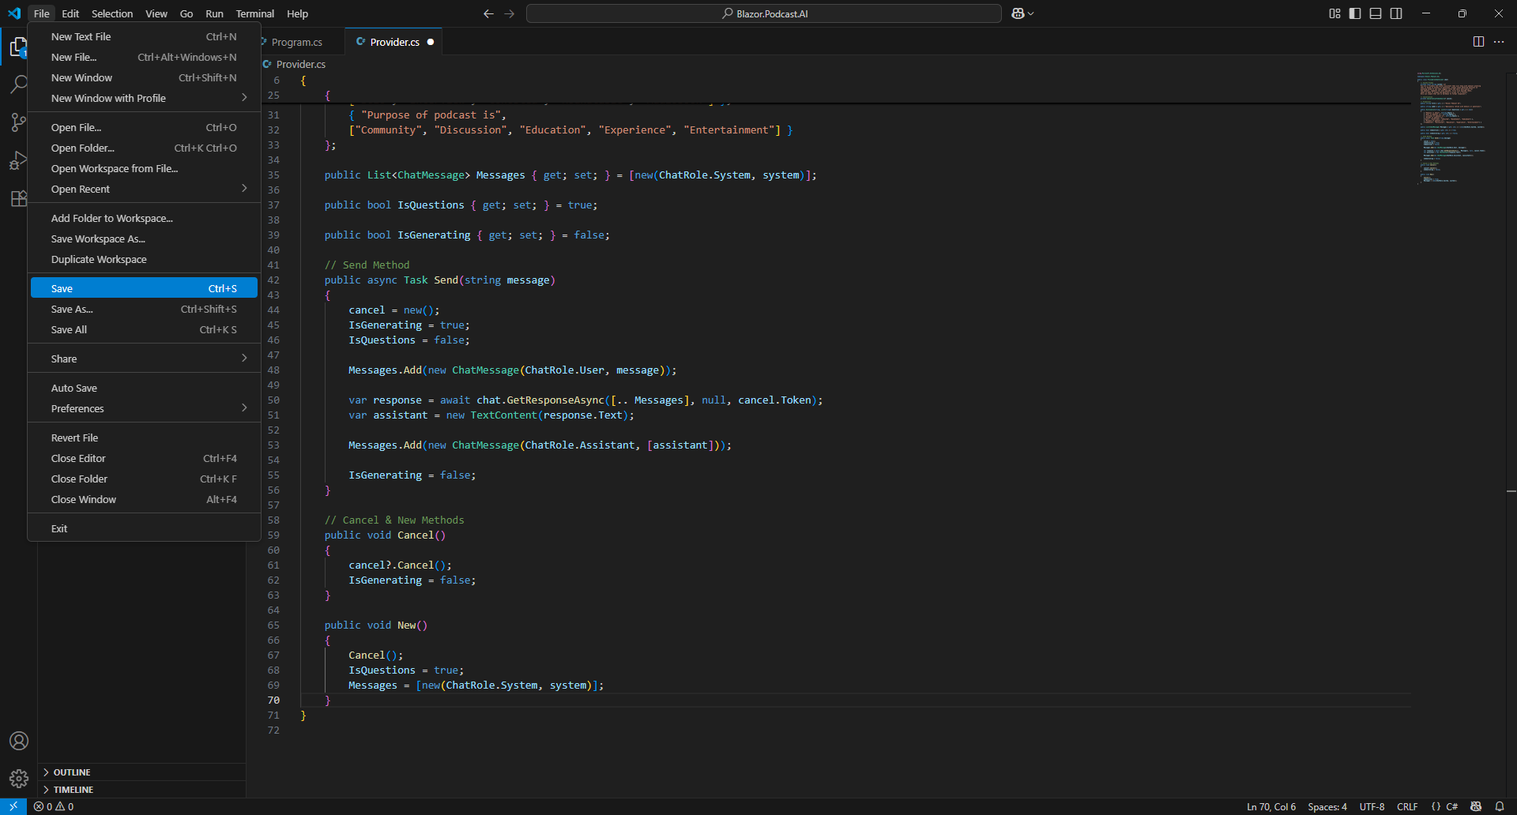

Information – If the Terminal on Mac or Command Prompt on Windows displays any Errors, then make sure that everything was entered correctly into Provider.cs by going over previous Steps to double check it matches what you have but once any corrections have been made and Saved or there are no Errors then the Build should proceed.

Then within Visual Studio Code select Program.cs from Explorer as follows:

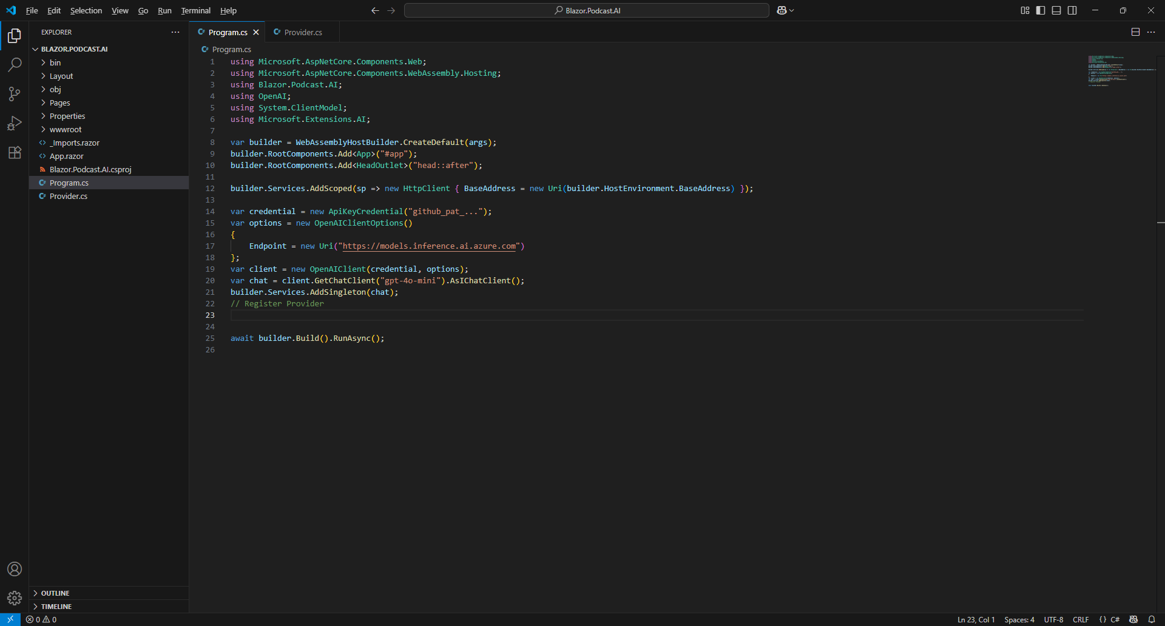

In Program.cs below Comment of // Register Provider need to Copy and Paste the following Code:

builder.Services.AddSingleton<Provider>();

Finally, within Visual Studio Code from the Menu select File and then Save as follows:

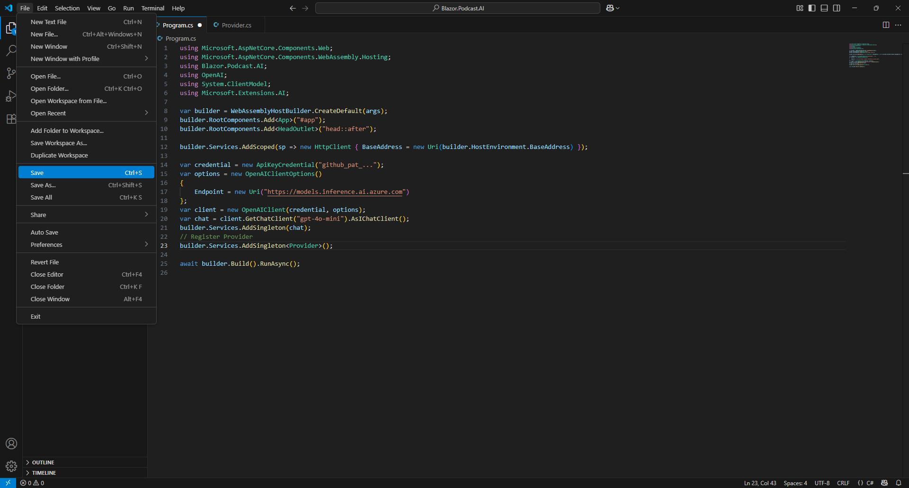

This completes the process in Visual Studio Code of creating and Registering the Provider.

Item Component
In Visual Studio Code select Program.cs in Explorer then choose New File… next to Blazor.Podcast.AI.

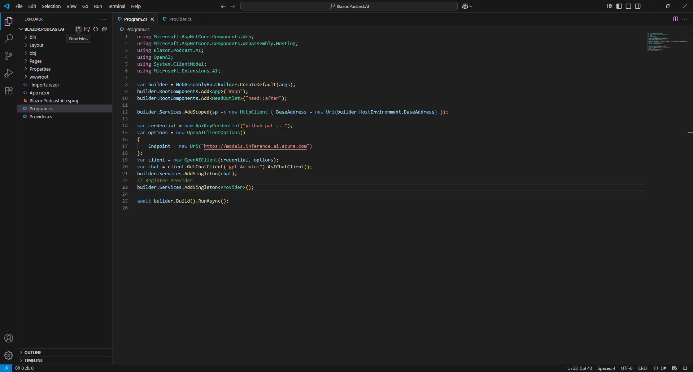

Then Type in the following Name and press Enter after which you should see or select a blank Item.razor in Explorer within Visual Studio Code.

Item.razor

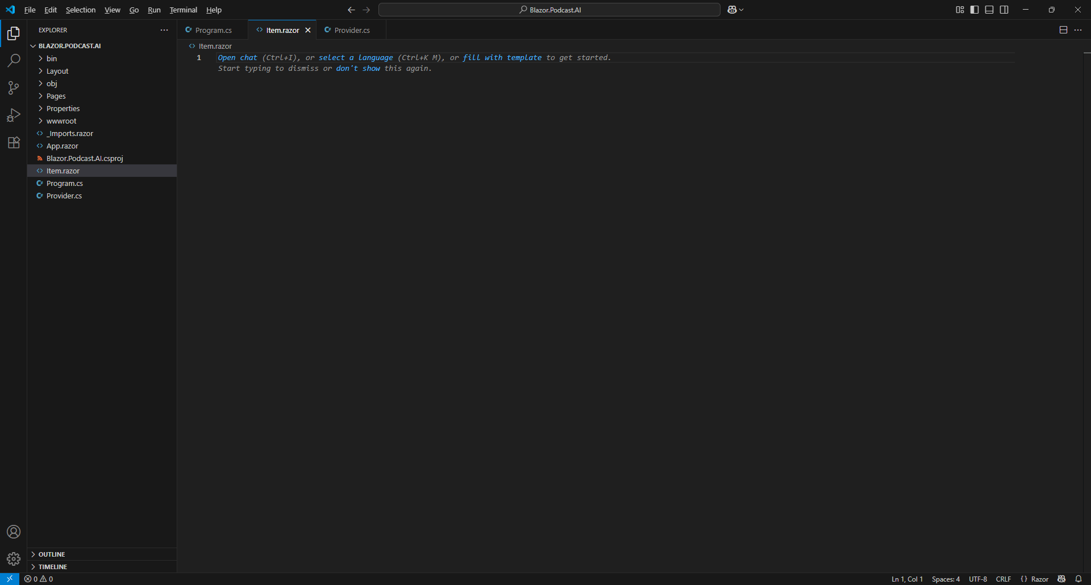

Then within Visual Studio Code in Item.razor you need to Copy and Paste the following Razor:

@using Microsoft.Extensions.AI

@* Messages *@

@code {
[Parameter]
public required ChatMessage Message { get; set; }
}

Information – This forms the outline of a Component in Razor which combines HTML used to output in a Browser with C# in Blazor. The first line of using is for functionality needed in the Component from the Package of Microsoft.Extensions.AI.OpenAI. There is also a Comment which in Razor starts with @* and ends with *@ and code with the Property of ChatMessage which will be a Parameter of the Component.

Then within Visual Studio Code in Item.razor underneath @* Messages *@ you need to Copy and Paste the following Razor:

@if (Message.Role == ChatRole.User)
{
<div class="card text-white bg-info m-2">
<div class="card-header">User</div>
<div class="card-body">
@Message.Text
</div>
</div>
}
else if(Message.Role == ChatRole.Assistant)
{
foreach (var content in Message.Contents)
{
if (content is TextContent { Text: { Length: > 0 } text })
{
<div class="card bg-light m-2">
<div class="card-header">Assistant</div>
<div class="card-body">
@((MarkupString)text)
</div>
</div>
}
}
}

Information – This will be used to output a ChatMessage for ChatRole.User or ChatRole.Assistant using an if statement to check it is Equal with == to the Role from ChatMessage. Should the Role be ChatRole.User then the first block of Razor will be output for a Request otherwise with else if the Role is ChatRole.Assistant then the second block of Razor will be output for a Response and only if this is TextContent with a Length greater than 0 using > and this will be in HTML so MarkupString will convert it so that it can be output correctly in the Browser.

Next, within Visual Studio Code from the Menu select File and then Save as follows:

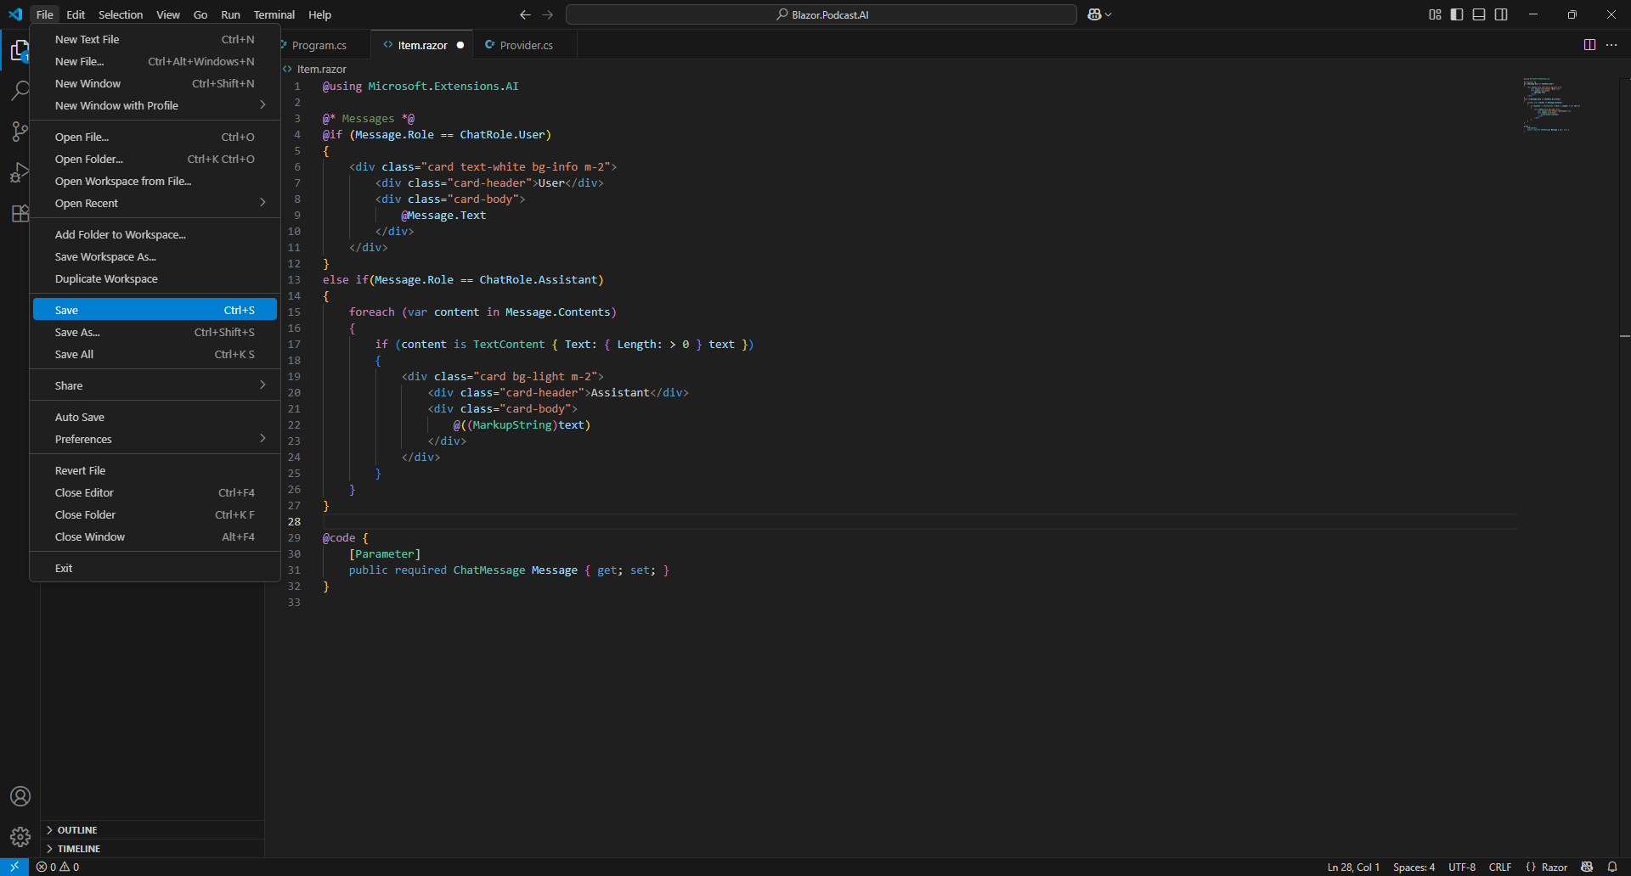

You should double check that everything was entered correctly as if the Terminal on Mac or Command Prompt on Windows displays any Errors this will be only for any Code that was entered into Item.razor, so go over the previous Steps to double check it matches what you have but once any corrections have been made and Saved or there are no Errors then the Build should proceed.

This completes the Component of Item to be used to output each Message for a Request or Response.

Send Component
In Visual Studio Code select Program.cs in Explorer then choose New File… next to Blazor.Podcast.AI.

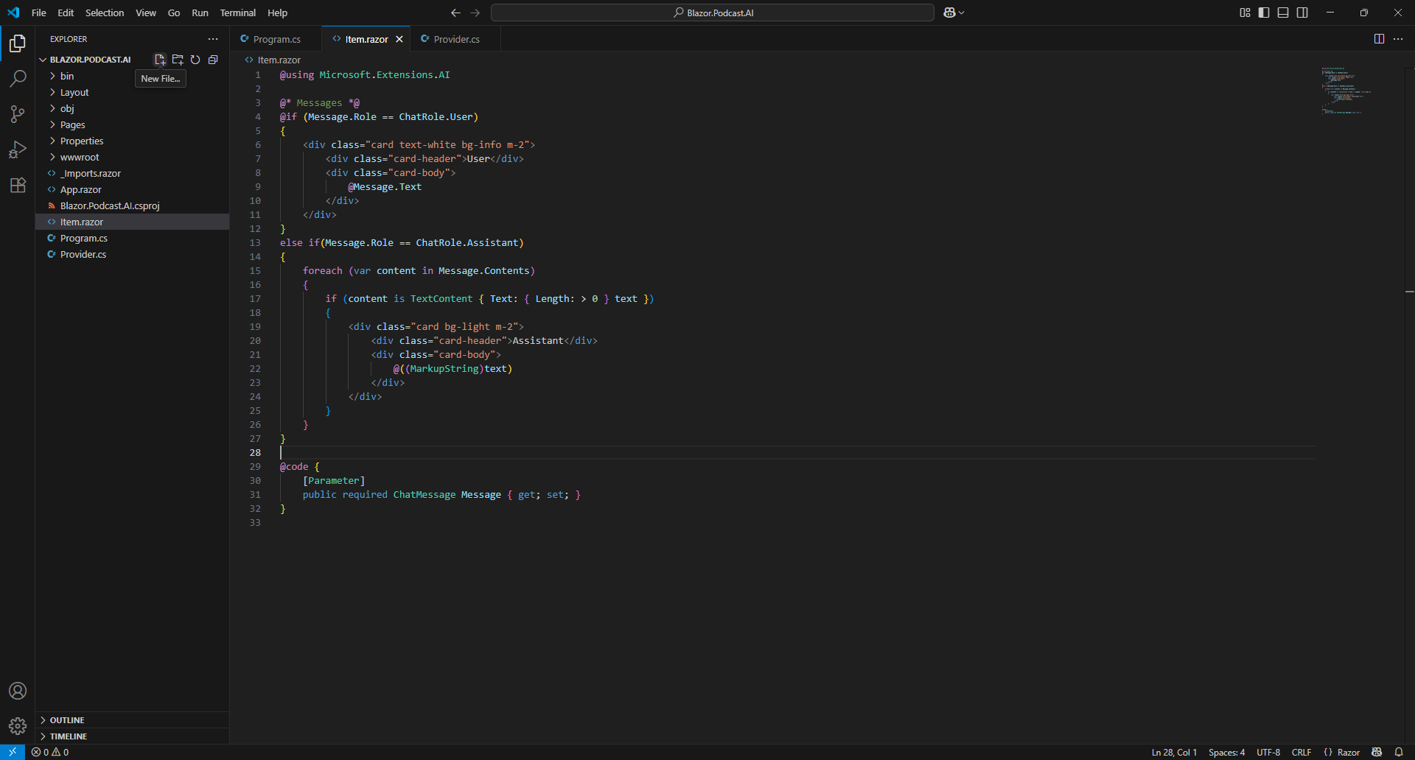

Then Type in the following Name and press Enter after which you should see or select a blank Send.razor in Explorer within Visual Studio Code.

Send.razor

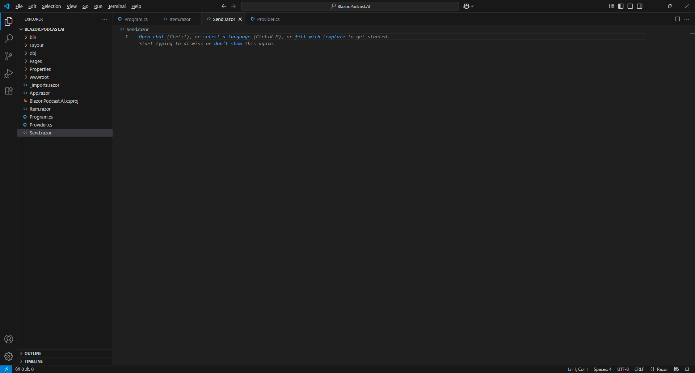

Then within Visual Studio Code in Send.razor you need to Copy and Paste the following Razor:

@* Edit Form *@

@code {
// Members

// Parameters

// Submit Method

// OnInitialized Method

}

Information – This forms the outline of a Component in Razor which combines HTML used to output in a Browser with C# in Blazor. There is a Comment which in Razor starts with @* and ends with *@ along with a code section with Comments starting with // which will help you place Code for the next few Steps.

While within Visual Studio Code in Send.razor below the Comment of // Members you need to Copy and Paste the following Code:

private Dictionary<string, string> answers = new();
private string? message;

Information – These Members will only be used within the Component so they are private, the first Member is a Dictionary where the Key will match the ones from any Questions but there will be only a single Answer, so the Value is just a single string. The second Member is a string? that can be nothing.

Next within Visual Studio Code in Send.razor below the Comment of // Parameters you need to Copy and Paste the following Code:

[Parameter]
public string? TextAreaLabel { get; set; }

[Parameter]
public bool IsQuestions { get; set; }

[Parameter]
public Dictionary<string, List<string>> Questions { get; set; } = new();

[Parameter]
public EventCallback<string> OnSend { get; set; }

Information – These Parameters will be provided to the Component and include a string? to be used for the Label of a Text Area and a bool to control whether the Questions will be shown or not. There is also a Parameter for Questions which is the same Type as that defined in the Provider and there is a Parameter for an EventCallback which will notify another Component when a Message needs to be Sent from this Component.
Then within Visual Studio Code in Send.razor below the Comment of // Submit Method you need to Copy and Paste the following Code:

private async Task Submit()
{
if (IsQuestions)
{
if (message?.Length > 0)
{
answers.Add(string.Empty, message);
}
if (answers.Values.All(a => !string.IsNullOrWhiteSpace(a)))
{
message = string.Join(",",
answers.Select(value => $"{value.Key} {value.Value}"));
}
}
if (message is { Length: > 0 } text)
{
message = null;
await OnSend.InvokeAsync(text);
}
}

Information – The Method of Submit is used to Send a Message, this could be the Questions, which will be indicated if the value of IsQuestions is true. Should this be the case then if there was a message also Sent with the Questions this will be added to answers with a Key that is blank. This is followed by another if that check to make sure that all Questions have been Answered using All which is a special Method using LINQ and it checks to make sure All values are !IsNullOrWhiteSpace which means not null, blank or any other whitespace, if they are they are combined into message using another Method using LINQ of Select into one long Message separated by a Comma using the Method of Join for a string. Finally, there is a check to see if the message has any contents using the Length which produces a Value of text and then message is reset and OnSend is triggered with the Value of text.

Next within Visual Studio Code in Send.razor below the Comment of // OnInitialized Method you need to Copy and Paste the following Code:

protected override void OnInitialized() =>
answers = Questions.ToDictionary(kvp => kvp.Key, kvp => string.Empty);

Information – This is a special Method as it replaces the Method normally used to set up a Component of OnInitialized to perform any custom setup, in this case it is setting up answers by converting Questions into the correct kind of Dictionary that it needs with the Method of ToDictionary with the same Keys but a blank value to become an Answer to a Question that will be input or selected in Blazor Podcast AI.
Then within Visual Studio Code in Item.razor underneath @* Edit Form *@ you need to Copy and Paste the following Razor:

<EditForm Model="@this" OnValidSubmit="@Submit" class="m-2">
@if(IsQuestions)
{
@foreach (var question in Questions.Keys)
{
<div class="form-group">
<label class="form-label">@question</label>
@if (Questions[question].Count > 1)
{
<select class="form-control mb-2" @bind="@answers[question]">
<option value="">Select Option</option>
@foreach (var answer in Questions[question])
{
<option value="@answer">@answer</option>
}
</select>
}
else
{
<textarea class="form-control mb-2" rows="1"
@bind="@answers[question]" />
}
</div>
}
}
<div class="form-group">
<label class="form-label">@TextAreaLabel</label>
<textarea class="form-control mb-2" rows="2" @bind="@message" />
</div>
<button type="submit" class="btn btn-primary mb-2">
Send
</button>
<button type="reset" class="btn btn-secondary mb-2">
Reset
</button>
</EditForm>

Information – EditForm is used for input, if the Value of IsQuestions is true it will Loop through the Questions with the foreach and if the Answers for a Question is more 1 than using > then it will use the Select from HTML to produce a Dropdown with the Answers to choose from, getting each Answer from the Dictionary by Key using the Square Brackets, if there is just one Answer then it will use a TextArea from HTML instead where you can input Text. This is then followed by another TextArea which has a Label from HTML using the Parameter of TextAreaLabel and finally there is a button of Submit which will trigger the Method of Submit set in the EditForm and a button to Reset the EditForm.
Next, within Visual Studio Code from the Menu select File and then Save as follows:

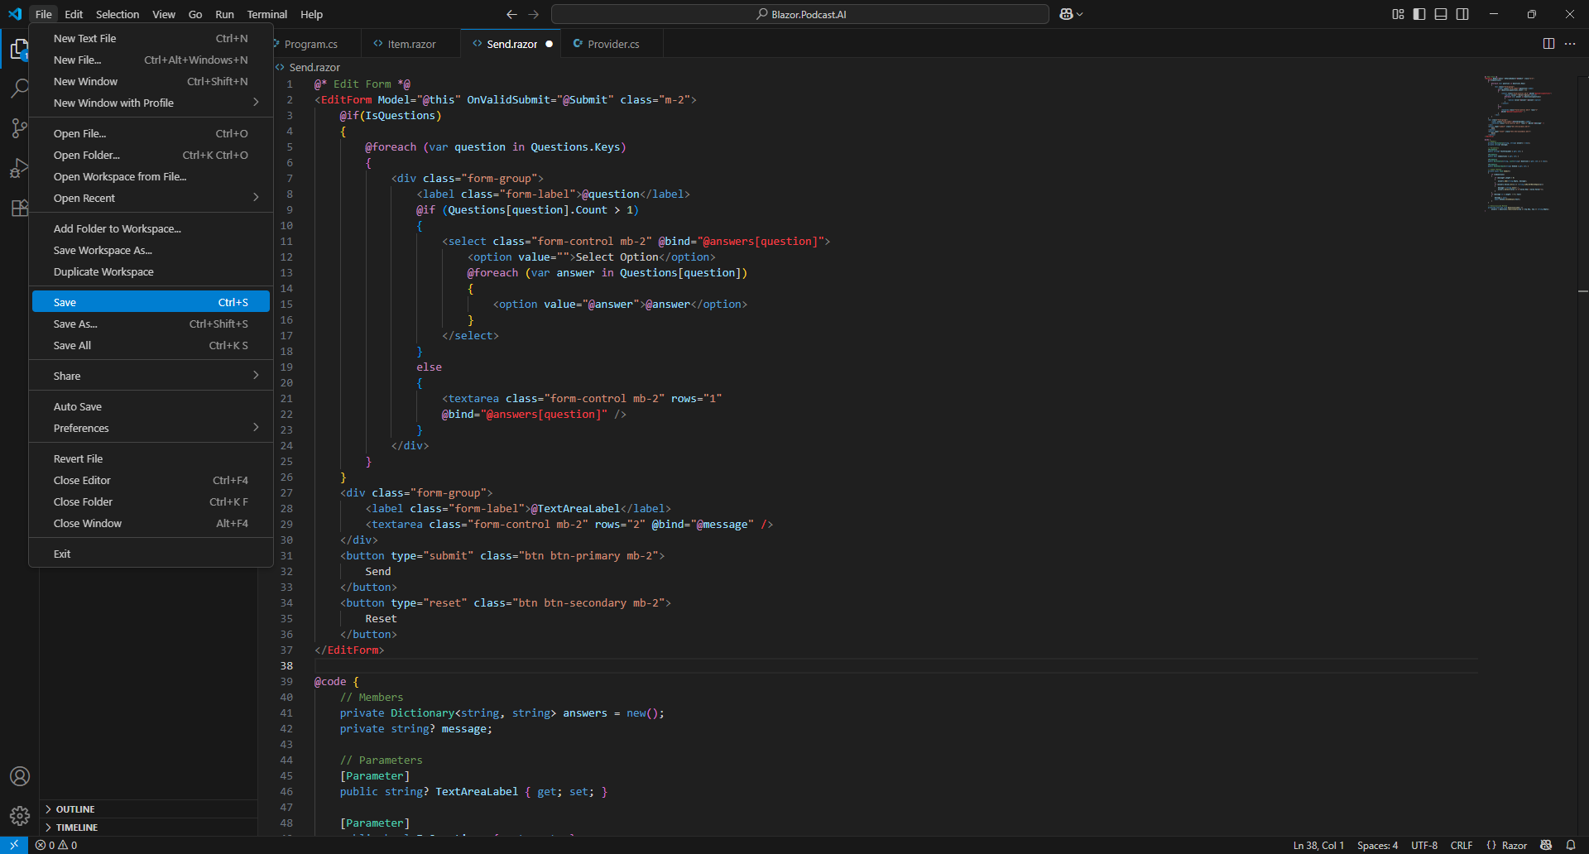

Once Saved then return to the Terminal on Mac or Command Prompt on Windows and you will see an Error that Adding an abstract method or overriding an inherited method requires restarting the application, and it will ask Do you want to restart your app? Yes (y) / No (n) / Always (a) / Never (v) if you Type in y this will restart the application and reload your Browser.

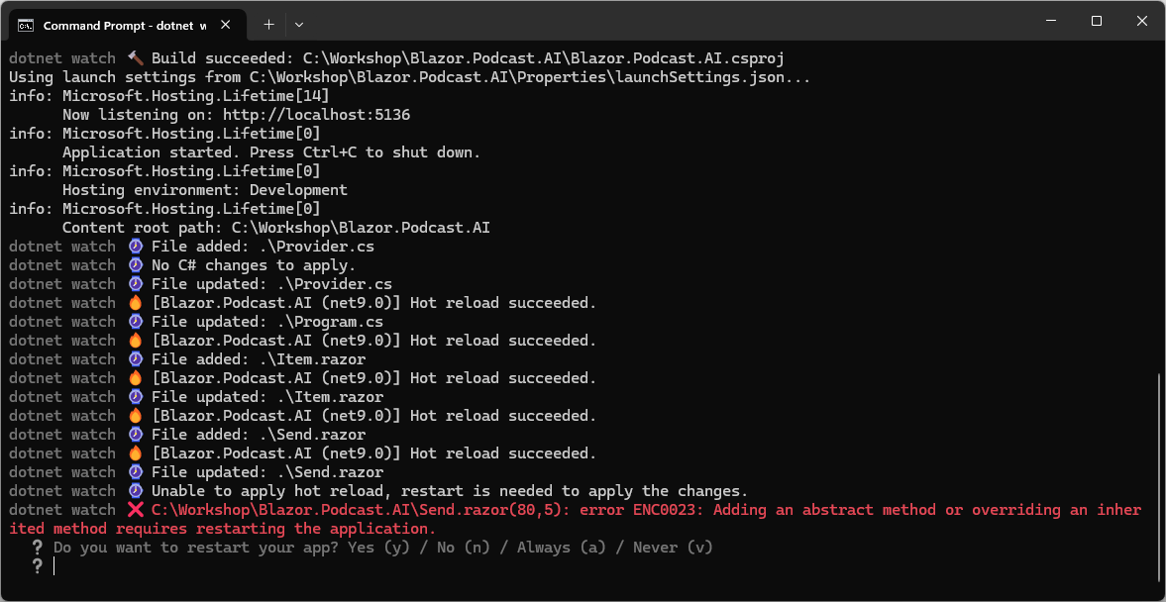

Information – If you look out for Hot reload succeeded in Terminal on Mac or Command Prompt on Windows this will indicate that there are no more Errors.

However, if the Terminal on Mac or Command Prompt on Windows still displays any Errors other than that one and Exited with error code -1 after restarting then you should double check everything was entered correctly as any Errors will only for any Code that was entered into Send.razor, so go over the previous Steps to double check it matches what you have but once any corrections have been made and Saved or there are no Errors then the Build should proceed as follows:

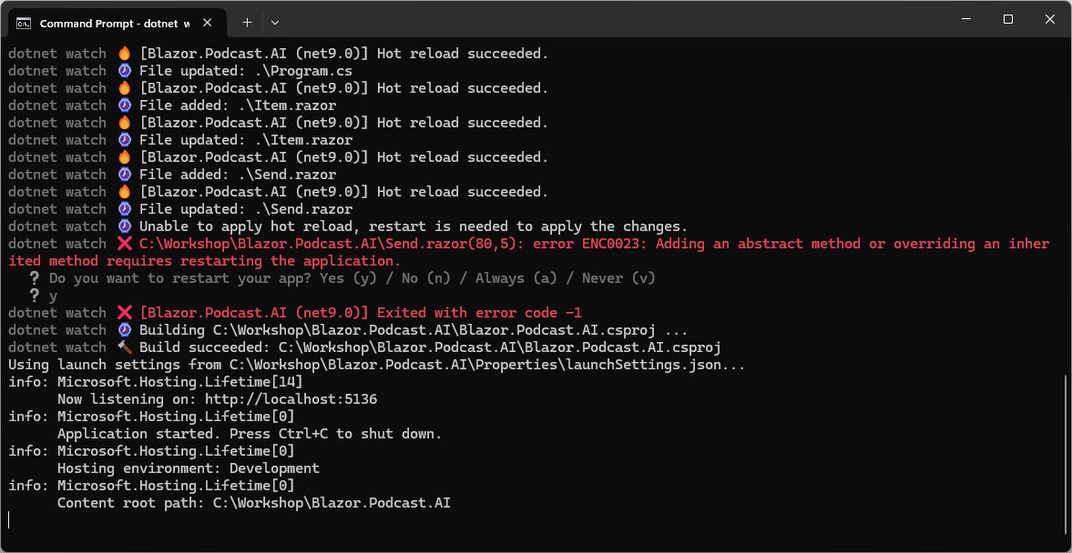

This completes the Component that will be used to Send a Request including the initial set of Questions.

Home Component
In Visual Studio Code in Explorer select Pages and then select Home.razor as follows:

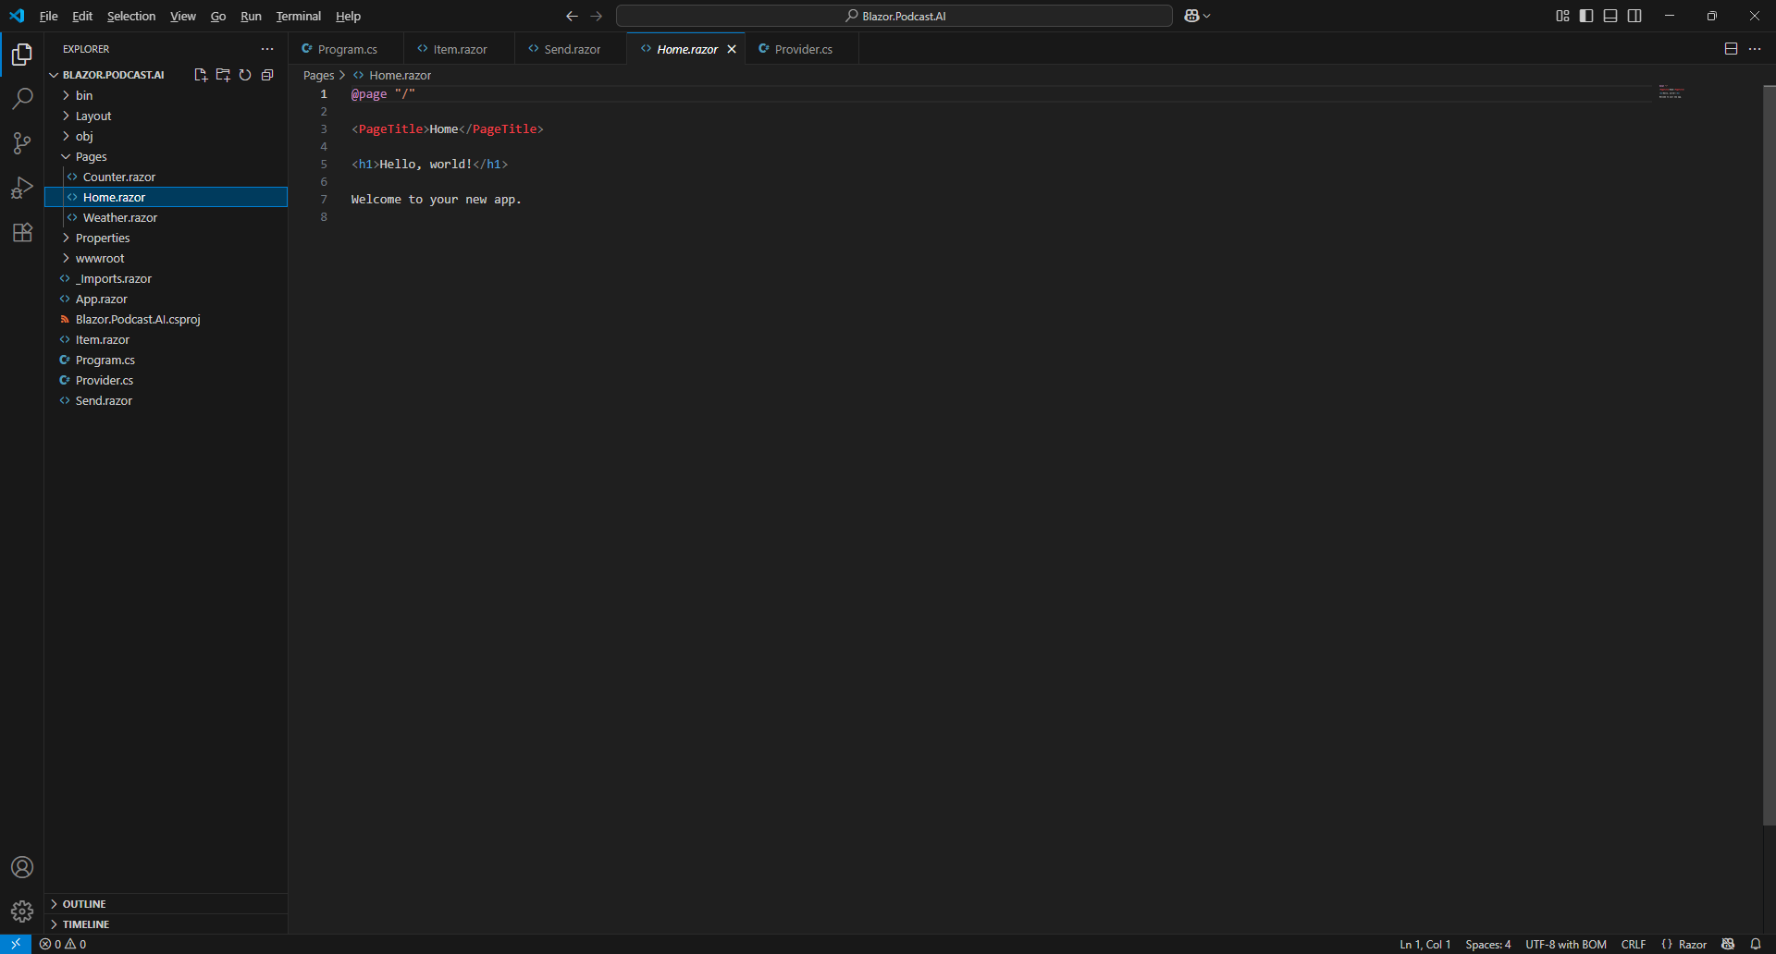

Information – This defines the Content for the Page that is displayed in your Browser using Razor.

Then you need to remove everything from Home.razor so it appears as follows:

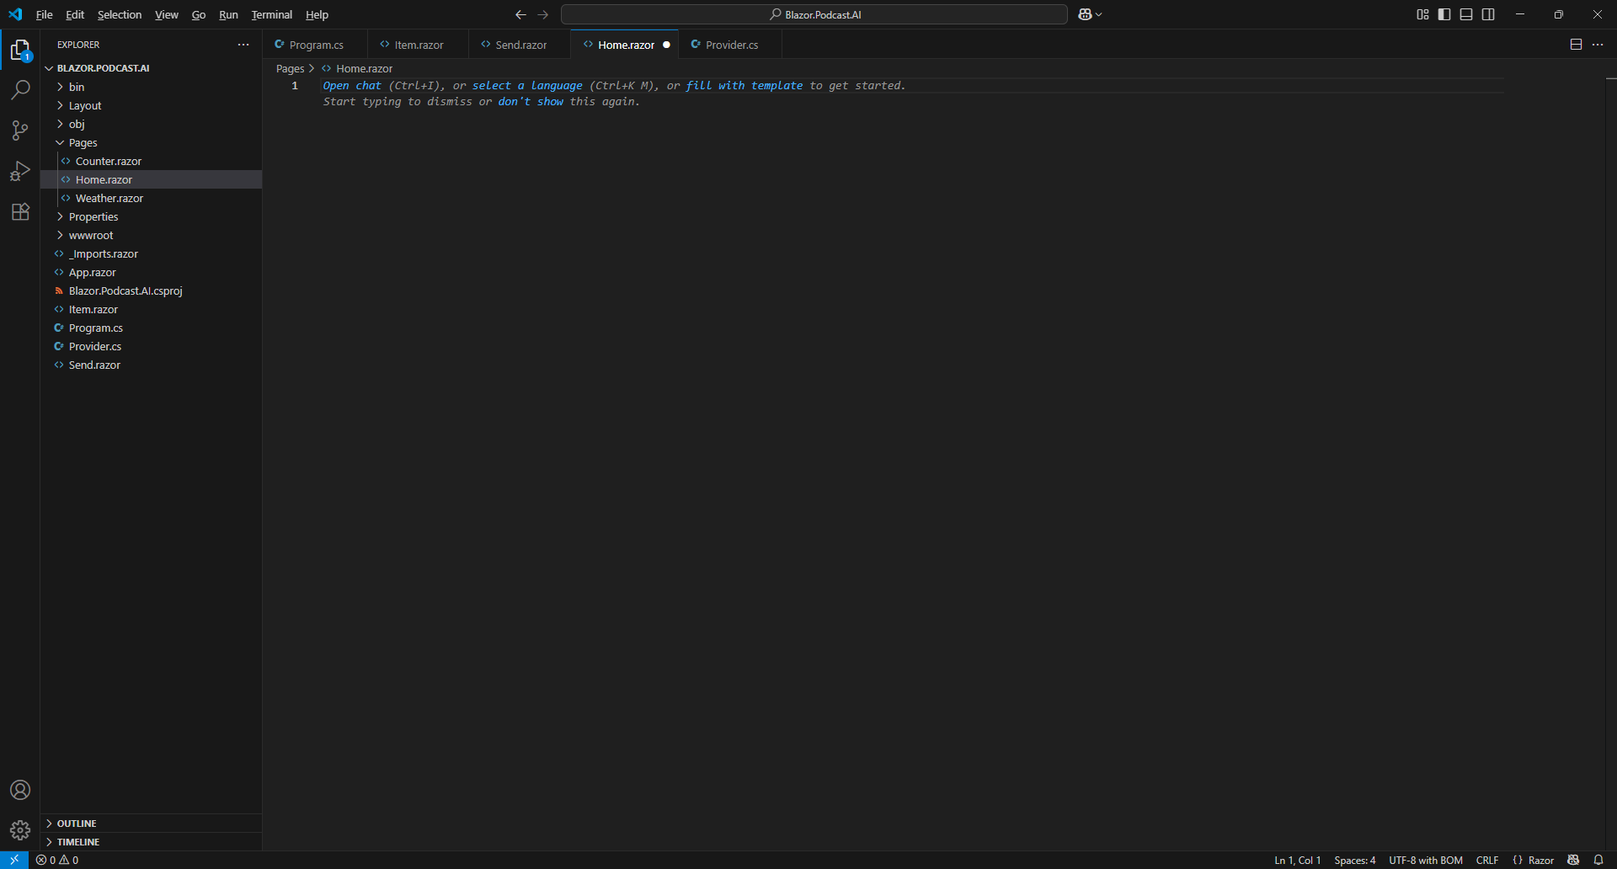

Once within Home.razor in Visual Studio Code you need to Copy and Paste the following Razor:

@page "/"
@inject Provider provider

<PageTitle>@provider.Title</PageTitle>

<h1>@provider.Title</h1>

@* New & Items *@

@* Output *@

Information – This forms the outline of a Page in Razor which combines HTML used to output in Browser with C# in Blazor which is indicated with the Directive of page at the top which is then followed by the Provider which is provided by Dependency Injection with the Directive of inject. There is a new PageTitle and H1 which uses Title from the Provider, followed by Comments which in Razor start with @* and end with *@ which will help you place Code from the next few Steps.

Then within Visual Studio Code in Home.razor underneath @* New & Items *@ you need to Copy and Paste the following Razor:

<button class="btn btn-outline-primary m-2" @onclick="@provider.New">
New
</button>

@foreach (var message in @provider.Messages)
{
<Item @key="@message" Message="@message" />
}

Information – There is a Button in HTML for New which when Clicked will trigger the Method of New in the Provider using onclick. This is followed by a foreach which will Loop through each Message in the Property of Messages in the Provider and then use the Component of Item to output each Message.

Then within Visual Studio Code in Home.razor underneath @* Output *@ you need to Copy and Paste the following Razor:

@if (provider.IsGenerating)
{

<div class="card bg-light m-2">
<div class="card-header">Generating</div>
<div class="card-body">
<div class="spinner-border text-black" role="status">
<span class="sr-only"></span>
</div>
</div>
<div class="card-footer">
<button class="btn btn-secondary m-2" @onclick="@provider.Cancel">
Cancel
</button>
</div>
</div>
}
else
{
<Send IsQuestions="@provider.IsQuestions"
Questions="@provider.Questions" OnSend="@provider.Send"
TextAreaLabel="@provider.Label"/>
}

Information – When IsGenerating is true then it will output the block of Razor that also includes a button to Cancel which will trigger the Method of Cancel in the Provider using onclick. However, when IsGenerating is false it will output the Component of Send and will provide the Parameters from the Provider including IsQuestions and Questions along with when OnSend is triggered that this is handled by the Method of Send in the Provider and set the TextAreaLabel to Label.
Finally, within Visual Studio Code from the Menu select File and then Save as follows:

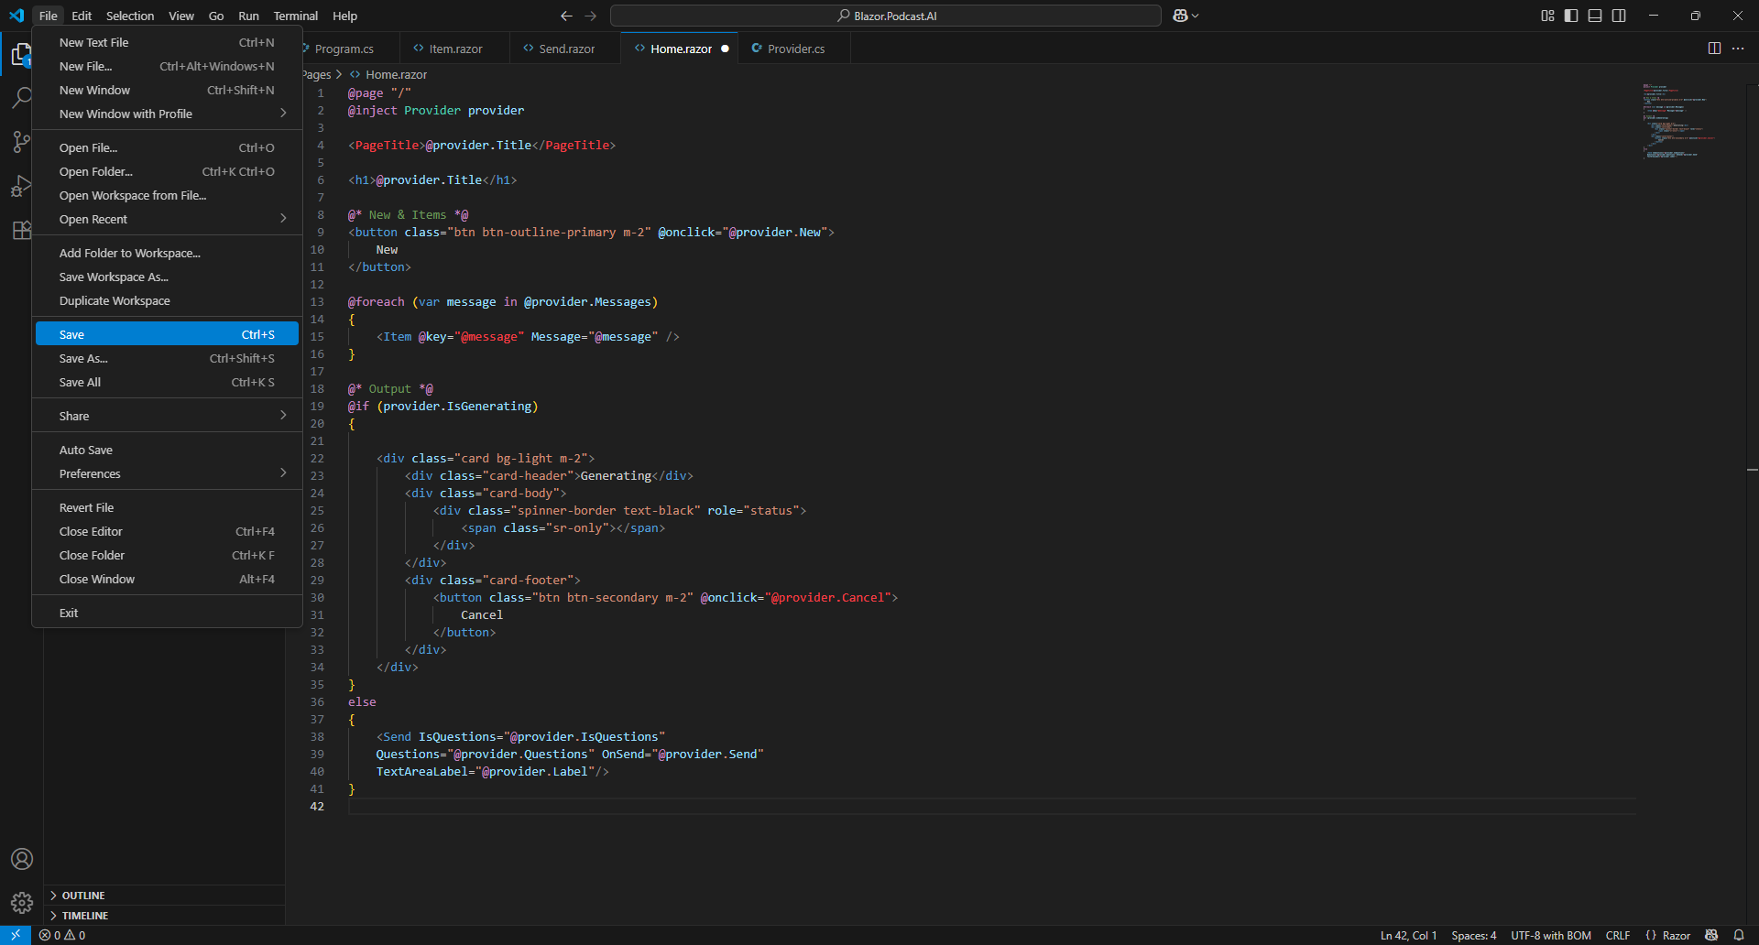

You should double check that everything was entered correctly as if the Terminal on Mac or Command Prompt on Windows displays any Errors this will be only for any Code that was entered into Home.razor, so go over the previous Steps to double check it matches what you have but once any corrections have been made and Saved or there are no Errors then the Build should proceed.

Don’t Close the Visual Studio Code for your Project of Blazor.Podcast.AI but if Visual Studio Code is Closed, then if using a Mac you need to go to Finder, search for Visual Studio Code and then select it to Open it again, or if using Windows you need to go to Start, search for Visual Studio Code and select it so it is Open again. Then from Welcome in Visual Studio Code select Blazor.Podcast.AI from Recent.

Don’t Close the Command Prompt on Windows or Terminal on Mac but if it is Closed then you need to go to Finder, search for Terminal and then select it to Open it, or if you Closed the Command Prompt on Windows you need to go to Start, search for Command Prompt and then select it to Open it. Then once opened you need to change directory using cd to the location for your Project, for example cd Blazor.Podcast.AI and then you need to type dotnet watch followed by Enter.

Don’t Close the Browser but if it is Closed within Terminal on Mac or Command Prompt on Windows press the Ctrl key along with C on your Keyboard or on a Mac press Command along with C and then type dotnet watch again followed by Enter which should relaunch the Browser.

This completes the Page of Home that will be used to output or input any Messages including Questions and this also completes creating a Podcast Assistant in Blazor using GitHub Models for the Workshop.

Generate

Podcast Assistant
Switch over to the Browser that would have been opened by the Terminal on Mac or Command Prompt on Windows as follows:

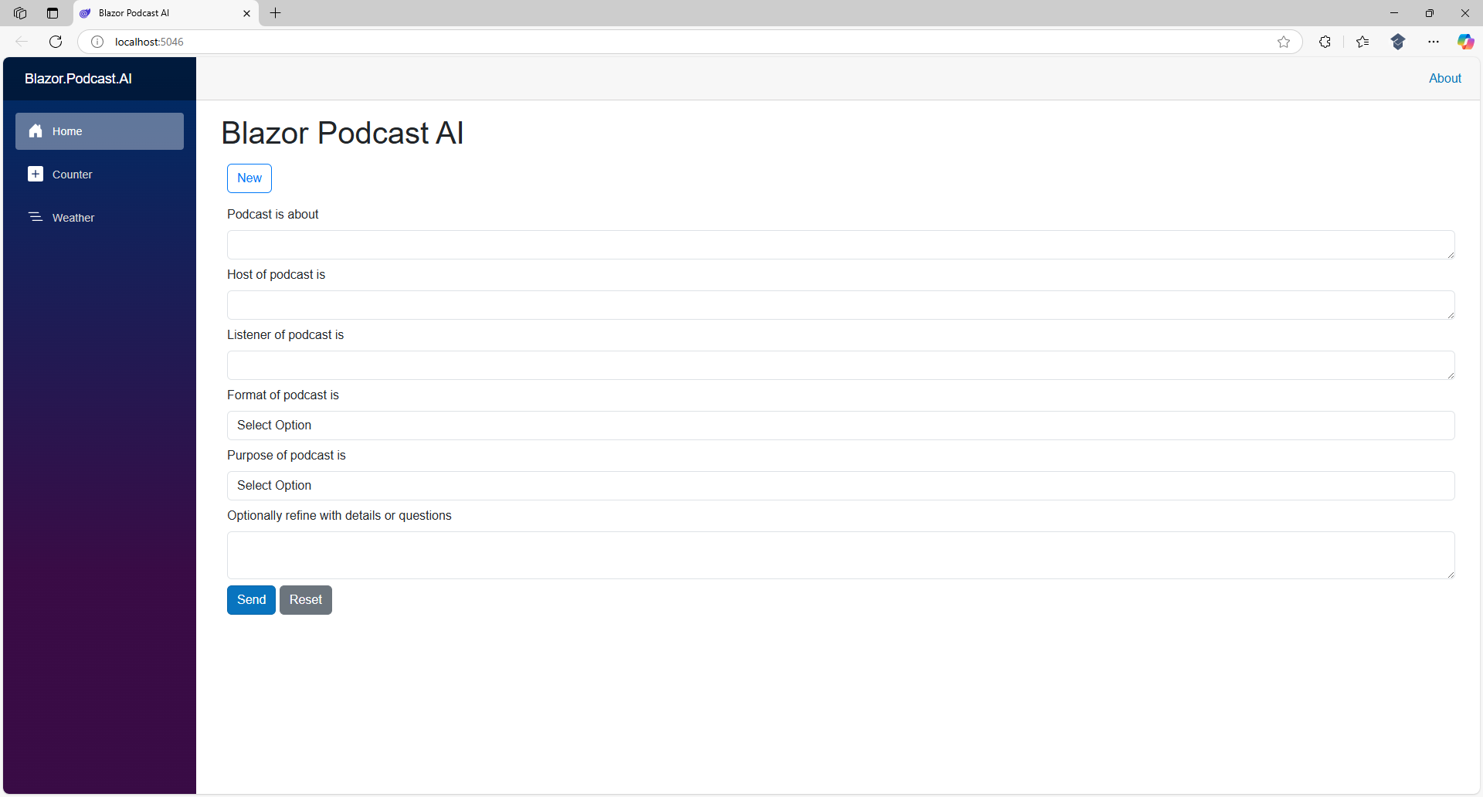

Information – If your Home in the Browser does not look like this then Refresh. If it still does not look like this then go through the previous Steps in the Workshop to see if you missed anything or got anything wrong, pay particular attention to any Razor as this may not have triggered an Error but could be incorrect or in the wrong place.

You can start a new Conversation with New or Cancel any Response being Generated. GitHub Models does limit any Requests that are Sent and Responses that are Generated each day as it is free to use. When you do hit the limit then Blazor Podcast AI will stop working but it will start working again after twenty-four hours as the limit will be reset for GitHub Models.

Information – GitHub Models can be replaced by paid-for AI Models that can be used as often as you want, although they cost money depending on how many Requests are made or how large they are along with how many Responses are Generated and how large those are. These costs vary depending on the Model used but generally they can be quite small, but this can add up but when experimenting then using them for free is ideal such as with GitHub Models.

Once in the Browser for Blazor Podcast AI start by Answering the Questions, the first Podcast is about can be answered with any topic such as Blazor, GitHub Models or anything you want, the second Host of podcast is can be answered with your name and the third Listener of podcast is can be the kind of listener such as beginner or details about the person you’re aiming to reach. There are also Questions for Format of podcast is, and Purpose of podcast is where you can pick from a set of Answers in a Dropdown to pick the format or purpose that you think would make a good podcast. Optionally you can refine with more information, but you can leave it blank, but you must Answer the Questions for example as follows:

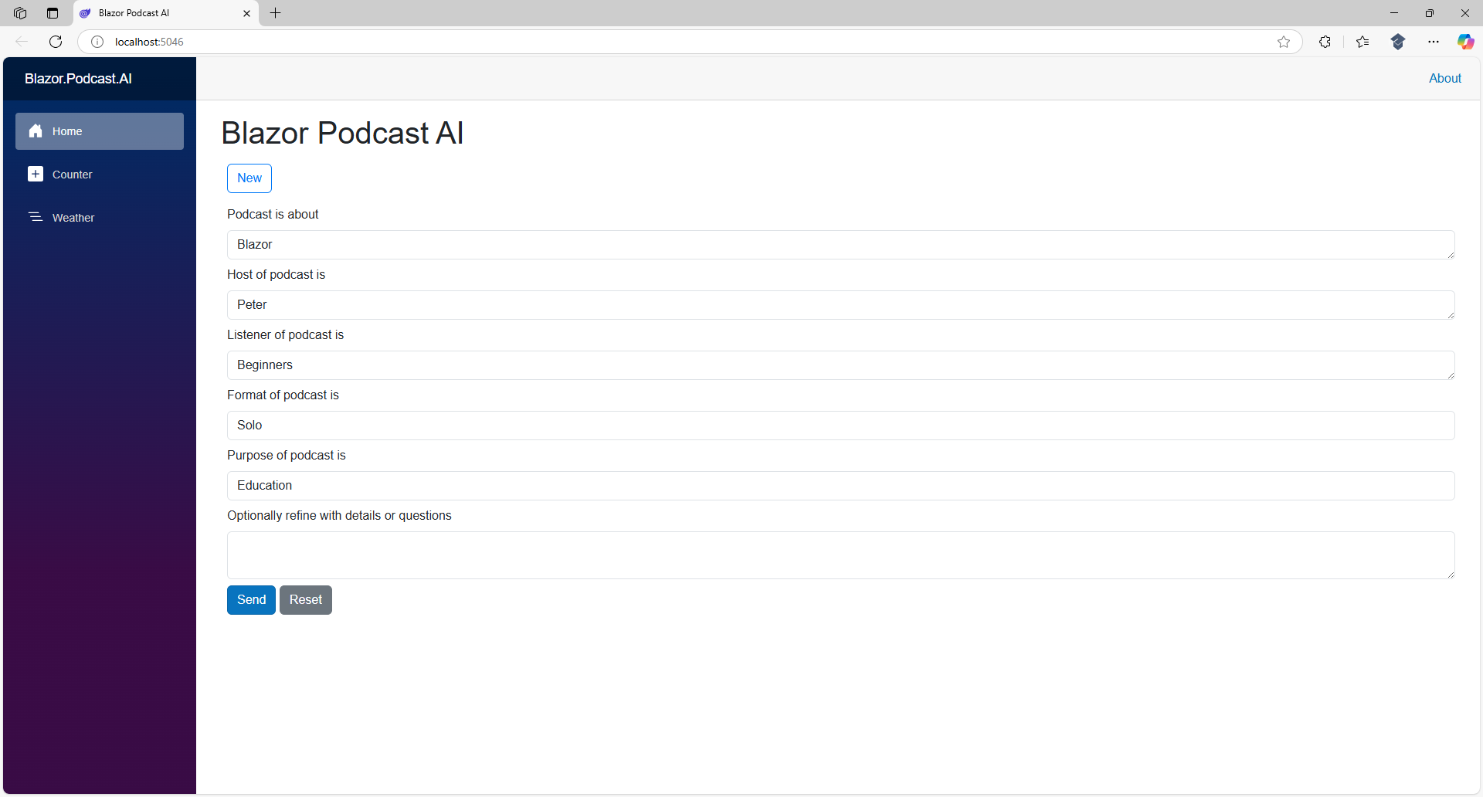

Then in the Browser for Blazor Podcast AI select Send to start Generating as follows:

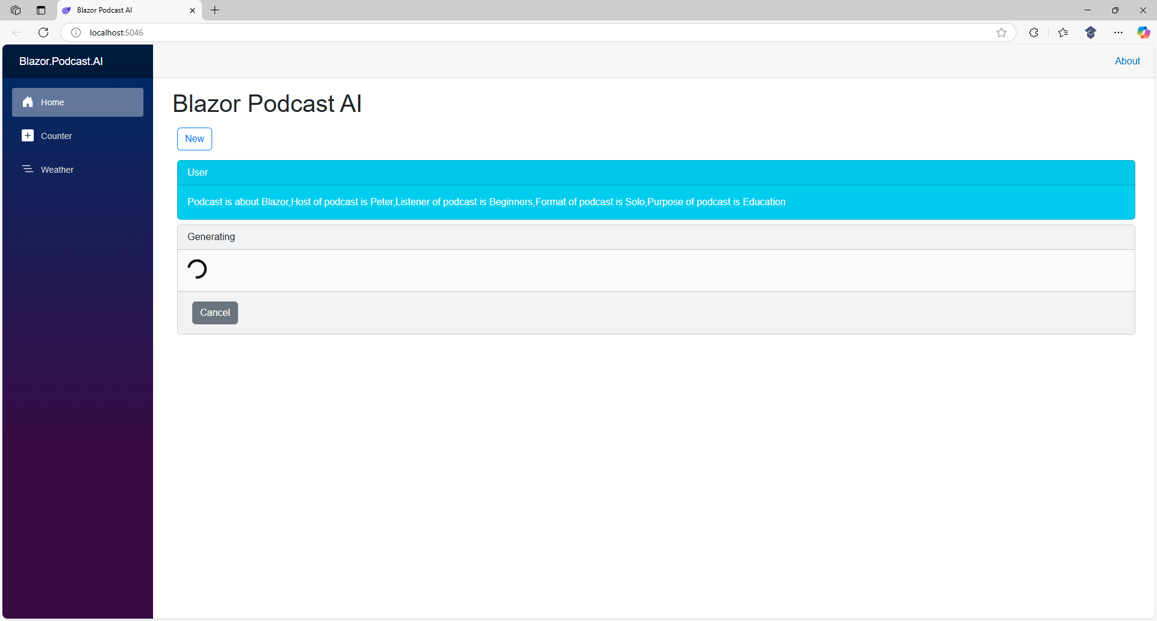

Once Generating has completed in the Browser for Blazor Podcast AI you will see a Response from the Assistant which for example will be as follows:

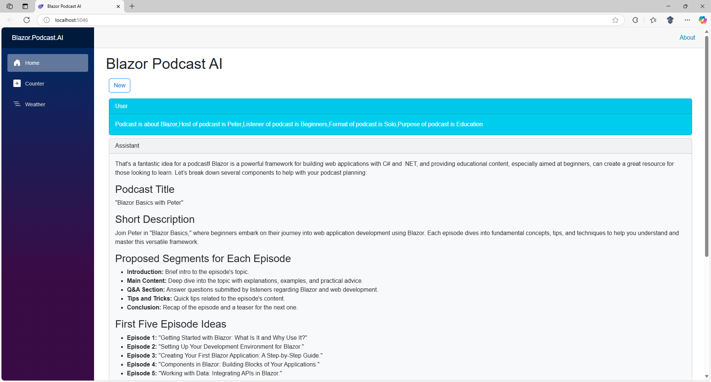

Response may be just want you want but generally when using AI, you need to amend or adjust until you get what you want by asking questions or providing information to refine a Response, you can do this by Scrolling down the Page and then select the Text Area for Optionally refine with details or questions and for example you may have changed your mind about the topic so Type in Make it about .NET instead or anything else you want to change as follows:

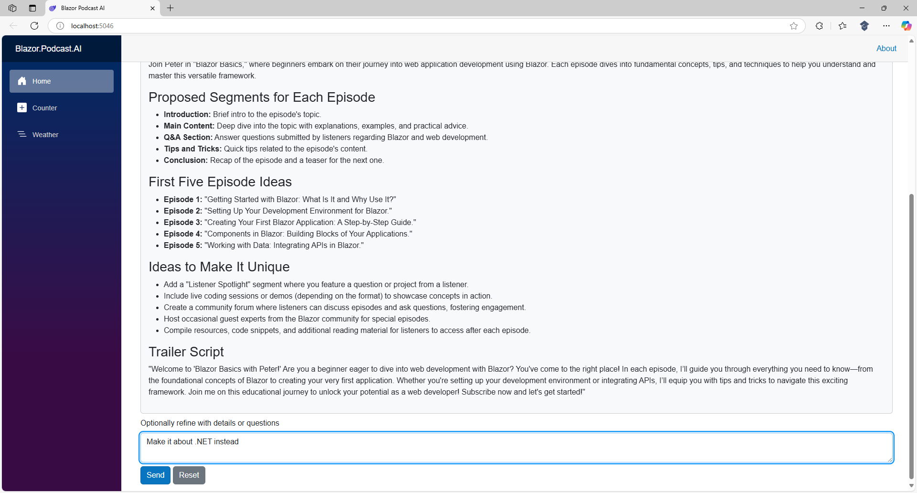

Then in the Browser for Blazor Podcast AI select Send to start Generating and once completed you should see your refined output for example the podcast will now be about .NET as follows:

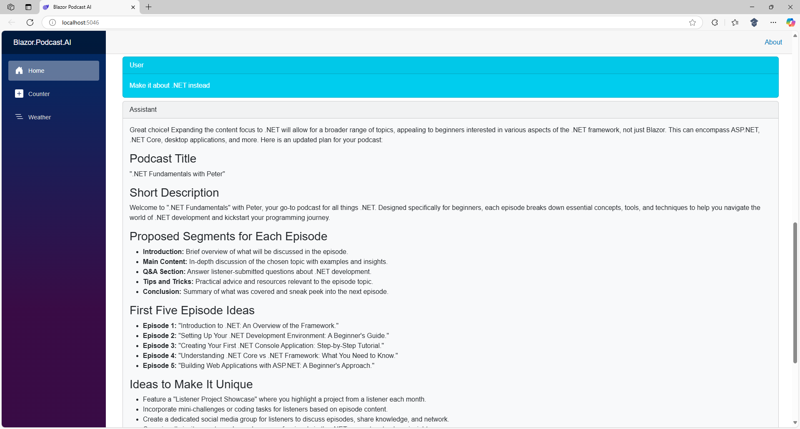

You could also expand on suggestions for example by Typing in Can you expand on episode one? in the Text Area for Optionally refine with details or questions and then select Send and once Generating has completed you can then review any Response for example as follows:

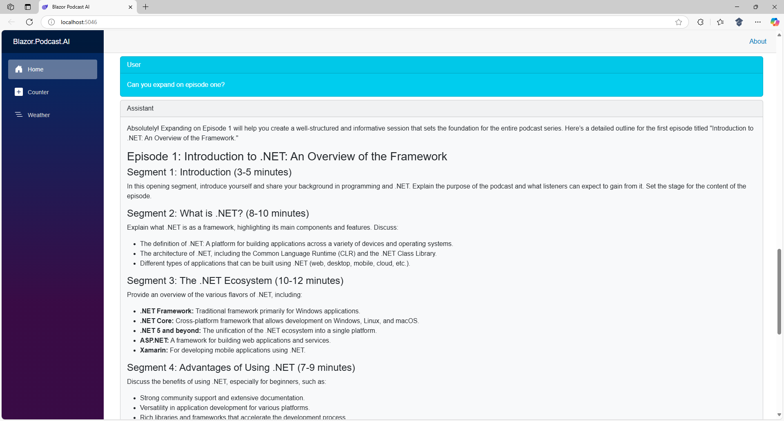

This completes using the Podcast Assistant in Blazor with GitHub Models for the Workshop.

Custom Assistant
Podcast Assistant allows you to get started with you own Podcast, but with some modifications you can create a Custom Assistant that can do anything else, so return to Visual Studio Code as follows:

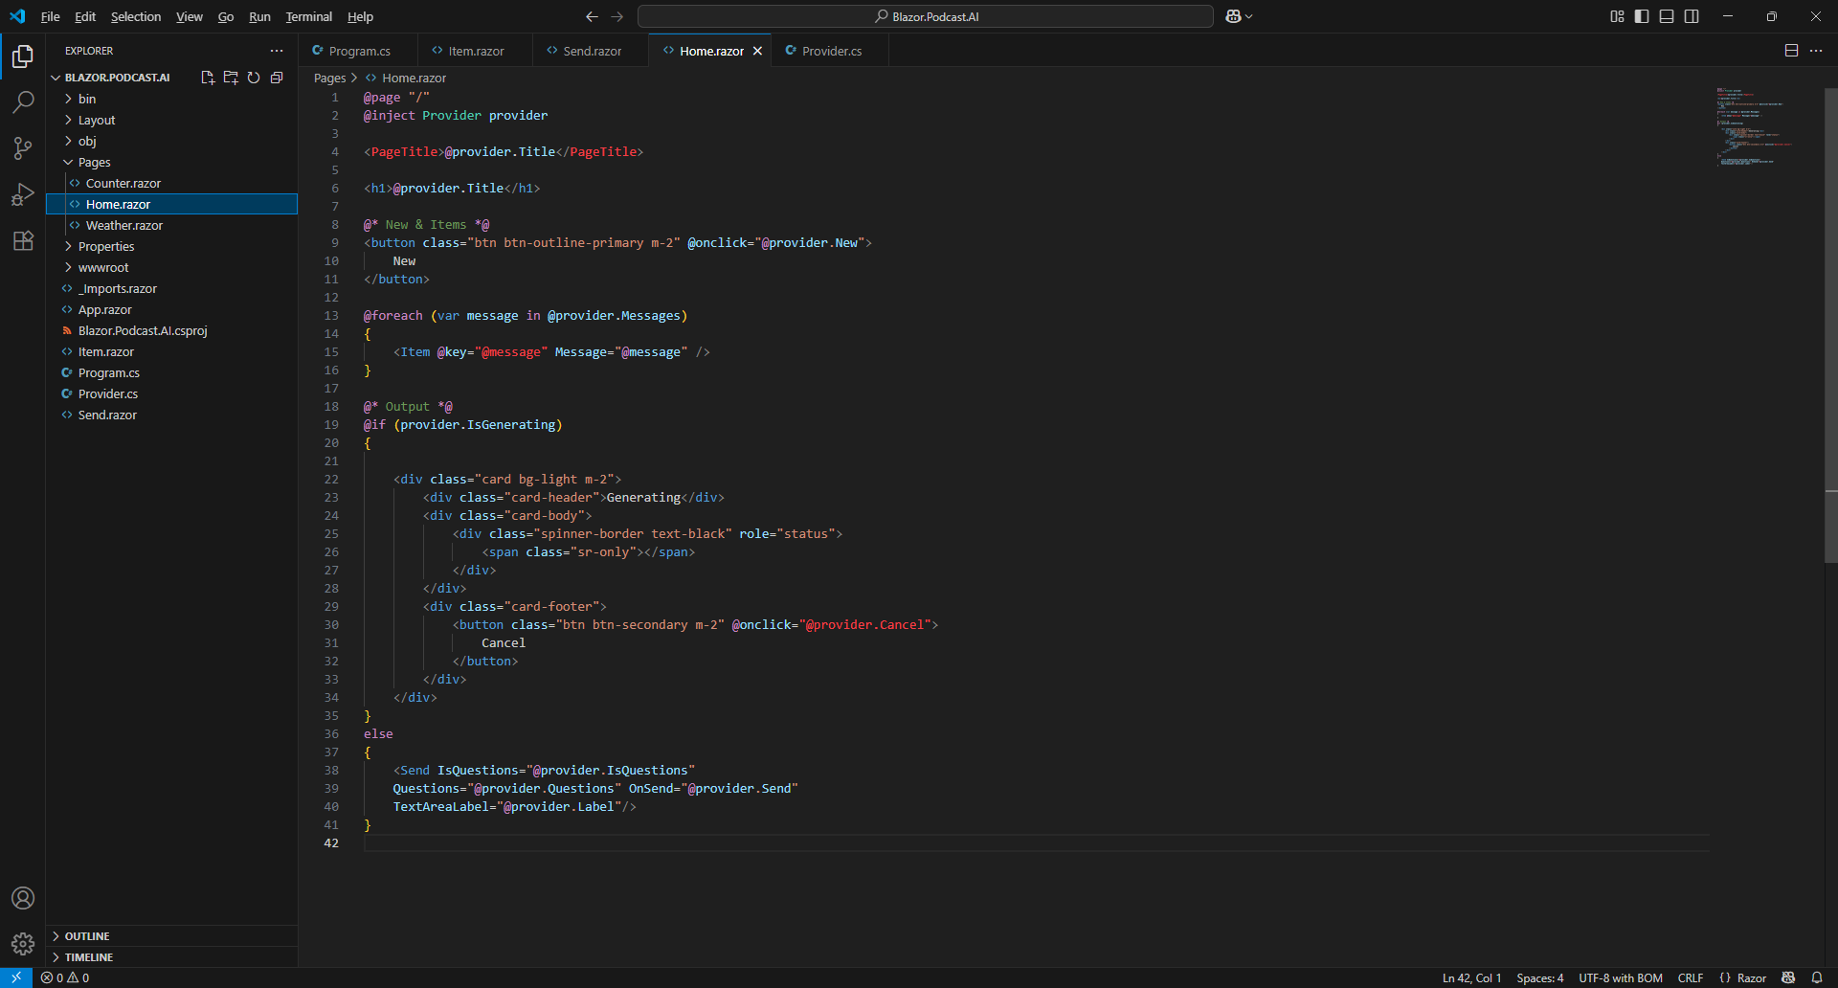

Next from Explorer in Visual Studio Code select Provider.cs as follows:

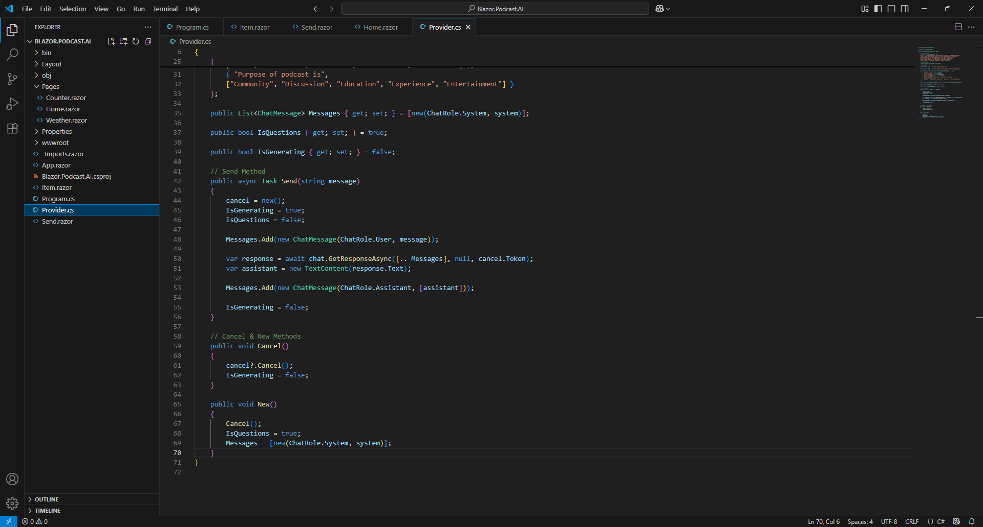

Information – You can also select Provider.cs from the Tabs at the top of Visual Studio Code.

Then in Visual Studio Code within Provider.cs in the Method of New you need to change IsQuestions from being assigned to true to being assigned to false instead, so the Method of New is as follows:

public void New()
{
Cancel();
IsQuestions = false;
Messages = [new(ChatRole.System, system)];
}

Information – This change will make sure that the Questions are not shown when choosing New in the Browser as this is only needed for the Podcast Assistant.

Next in Visual Studio Code within Provider.cs you need to change the Property of IsQuestions from it being initialised from true to false instead, so the Property of IsQuestions is as follows:

public bool IsQuestions { get; set; } = false;

Information – This change will make sure that the Questions are not shown when starting the application in the Browser as this is only needed for the Podcast Assistant.

Then in Visual Studio Code within Provider.cs you need to change the Property of Label from it being initialised from Optionally refine with details or questions to the following:

Provide content for social media or questions

The Property of Label should now be as follows:

public string Label { get; } = "Optionally refine with details or questions";

Information – This can be anything that makes sense for your Custom Assistant, so people know what to do when using it for the first time or using it throughout to Generate what they need.

Next in Visual Studio Code within Provider.cs you need to change the Property of Title from it being initialised from Blazor Podcast AI to the following:

Social Media AI

The Property of Title should now be as follows:

public string Title { get; } = "Social Media AI";

Information – This can be changed to anything that makes sense for your Custom Assistant.
Then you need to update the System Prompt, this is the const for the string of system near the top of the Provider to change the behaviour from a Podcast Assistant to your own Custom Assistant, you should leave the You are a friendly and useful assistant part of the System Prompt along with Only use simple html and no markdown to format responses but otherwise you can change the System Prompt to behave like anything such as a Social Media Assistant as follows:

private const string system = @"
You are a friendly and useful assistant that will help with social media
to create engaging posts adapted for main social media platforms also
include any suitable hashtags, offer advice on content scheduling,
latest trends and any best practices to maximise visibility.
Only use simple html and no markdown to format responses";

Information – You can define any behaviour using a System Prompt for your Custom Assistant in this case it is one that helps with social media to create engaging posts for the main social media platforms and include any suitable hashtags along with offering advice on scheduling content plus latest trends and best practices to maximise visibility. Your Custom Assistant could be a creative catalyst for suggesting ideas, provoke challenging conversations or it could be a specialised expert in a specific area to offer guidance. You can even have fun, what would happen if you added talk like a pirate to your System Prompt?

Finally, within Visual Studio Code from the Menu select File and then Save as follows:

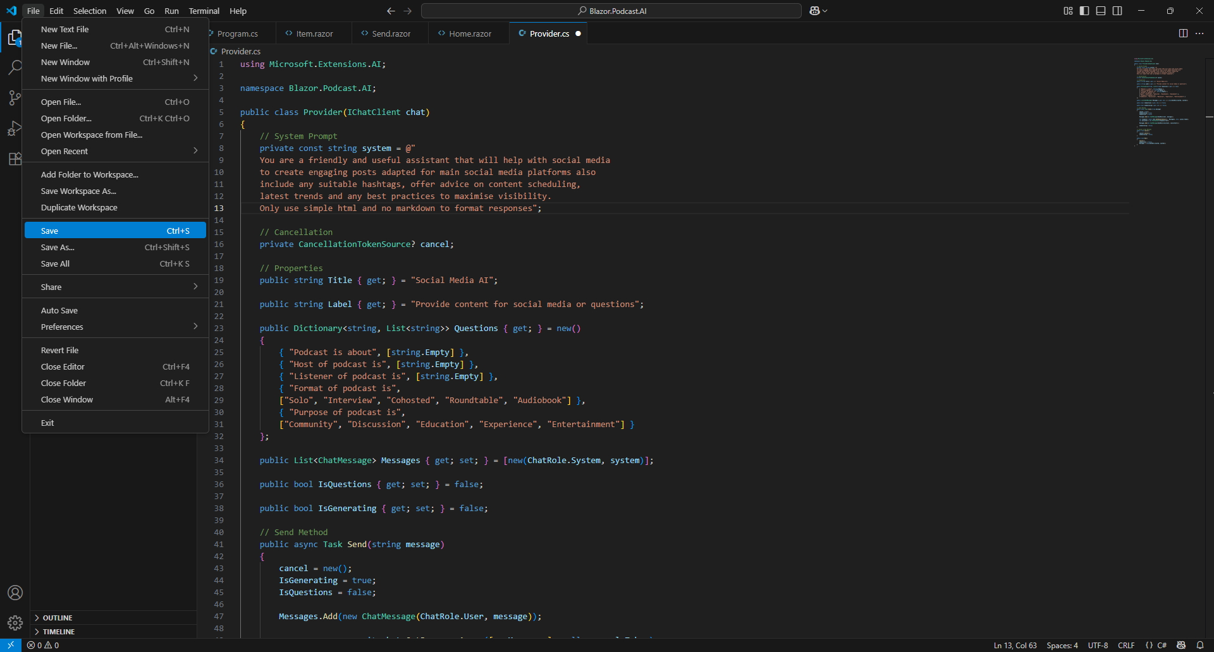

Once Saved then return to the Terminal on Mac or Command Prompt on Windows and you will see an Error that Adding an abstract method or overriding an inherited method requires restarting the application, and it will ask Do you want to restart your app? Yes (y) / No (n) / Always (a) / Never (v) if you Type in y this will restart the application and reload your Browser.

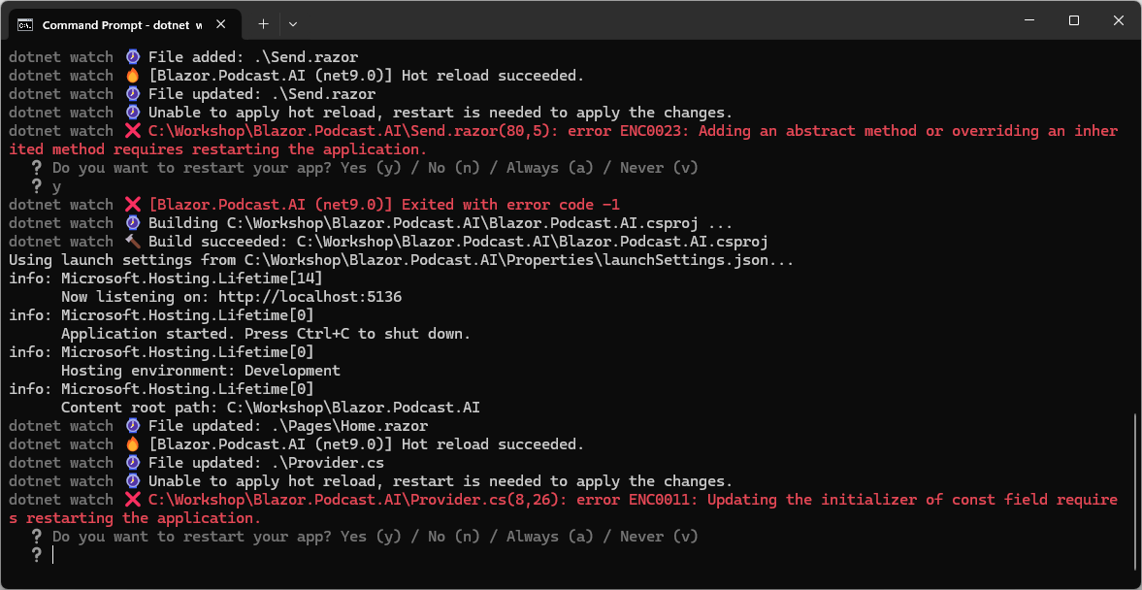

If the Terminal on Mac or Command Prompt on Windows still displays any Errors other than that one and Exited with error code -1 after restarting, then you should double check everything was updated correctly in Provider.cs from the previous Steps of the Workshop, or if there are no other Errors then the Build should proceed as follows:

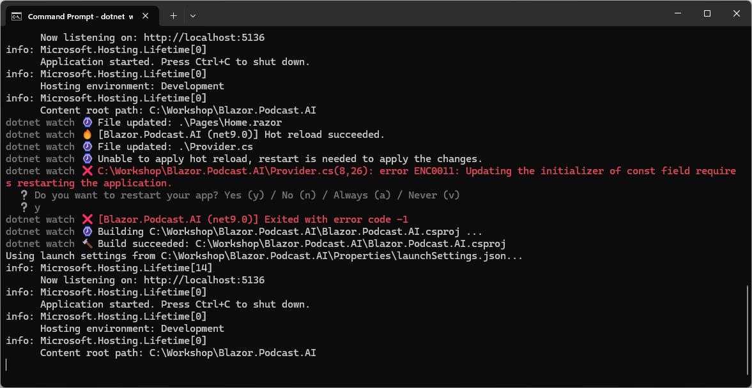
In Visual Studio Code you have completed everything for your Custom Assistant so now you can switch over to the Browser that would have been opened by the Terminal on Mac or Command Prompt on Windows as follows:

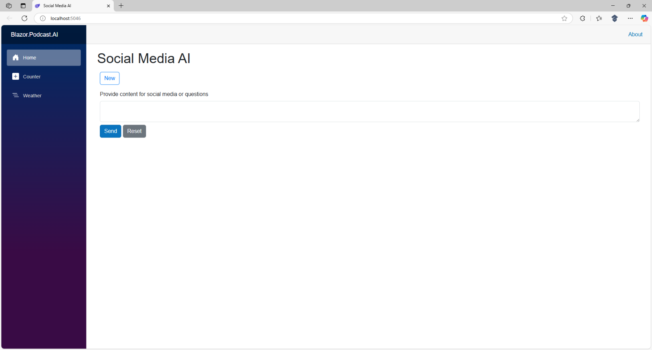

Information – It should display something like this in the Browser depending on what Custom Assistant you create and in the Text Area for Provide content for social media or questions you can Type in something such as GitHub Models, select Send and once Generating has completed will be like as follows:

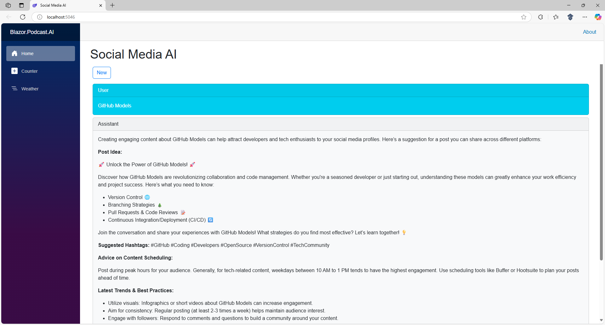

This completes creating a Custom Assistant in Blazor with GitHub Models and concludes the Workshop so you can close Visual Studio Code, Browser and Terminal on Mac or Command Prompt on Windows.

