# About & Start

## About

**micro:bit** is a pocket-sized computer that you can code, customise and control to bring all sorts of cool creations to life from robots to musical instruments. **micro:bit** measures 4cm by 5cm and has 25 red LEDs to display messages, two programmable buttons for uses such as controlling games or skipping songs in playlist, it can detect motion and tell which direction it is pointing and can use Bluetooth to communicate with other devices and the Internet.

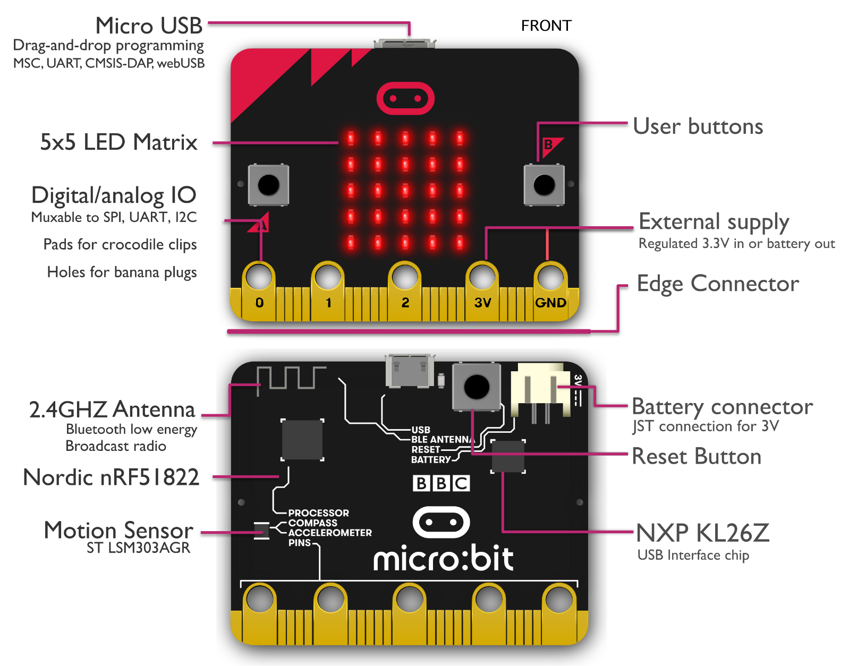

## Start

To get started with **micro:bit** and to find out more about it visit [**microbit.org**](http://microbit.org)

Next to get started with coding with **micro:bit**, once on the website select the **Let’s Code** option

Then from the **Let’s Code** page select the **Let’s Code** button in the **MakeCode Editor** section

Finally, in the **MakeCode Editor** page select the **New Project** button and then select the **JavaScript** tab

To run an example on a real **micro:bit** select the **Download** button and follow the instructions

