# Hello World

## Step 1

|  |  |
| --- | --- |
|  | Go to [**microbit.org**](http://microbit.org), then select the **Let’s Code** option, next in the **MakeCode** **Editor** section select the **Let’s Code** button, finally select the **New Project** button and select the **JavaScript** tab |

## Step 2

With the **JavaScript** tab selected in the **MakeCode Editor** you should see the following code:

|  |
| --- |
| basic.forever(() => {  }) |

Within this you should type the following code:

|  |
| --- |
| basic.showString("Hello World!") |

## Step 3

Once done the **MakeCode Editor** should appear as follows:

## Step 4

In the **MakeCode Editor** you can also select the **Blocks** tab, which is an easy to use drag-and-drop style of programming for younger or less experienced coders

## Step 5

|  |  |
| --- | --- |
|  | That completes the **micro:bit** example, if not done already you can select the **Start the simulator** button |

## Step 6

When running on the virtual **micro:bit** the LEDs will scroll through the text **Hello World**

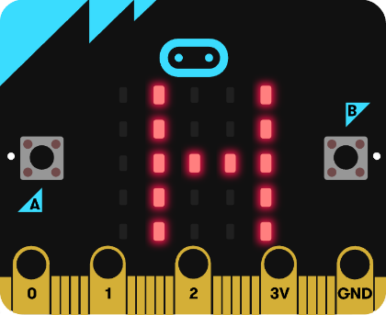

You can also run the example on an actual **micro:bit** by connecting one to your computer and then choosing the **Download** option in the **MakeCode Editor** to download the example to your computer. Once downloaded you can then copy the **.hex** file from where you’ve downloaded it to the **micro:bit** the same way you’d copy to another drive or device connected to your computer, then once the example has been copied to the **micro:bit** it should start automatically.