|  |
| --- |
|  |
| Spotify for Developers  Artists, Albums  & Tracks |
| |  |  |  | | --- | --- | --- | |  |  |  | |

## Get Multiple Artists

Get Spotify catalogue information for several artists based on their Spotify Ids.

|  |  |
| --- | --- |
| GET https://api.spotify.com/v1/artists | |
| Header | |
| Authorization | Valid Access Token from Spotify Accounts service |
| Query Parameter | |
| ids | Maximum of 50 comma-separated list of artist Spotify Ids |

|  |  |
| --- | --- |
| Header | Response |
| Success | |
| HTTP Status 200 OK | Artists as Array of Artist Objects |
| Error | |
| Error Code | Error Object |

### Step 1

|  |  |
| --- | --- |
|  | In **Windows 10** choose **Start**, and then from the **Start Menu** find and select **Visual Studio 2019** |
|  | Once done, from the **Get started** screen for **Visual Studio 2019** select **Open a project or solution** |
|  | Then locate and select **SpotifyForDevelopers.sln** and select **Open** if you don’t have this file already then please follow the previous parts of the workshop including **Getting Started**, **Authorisation Guide**, **Search** **&** **Browse** |

### Step 2

|  |  |
| --- | --- |
|  | Once opened, in the **Solution Explorer** open the **Pages** section, then open the **Index.cshtml** section and select **Index.cshtml.cs** |

### Step 3

|  |  |
| --- | --- |
|  | Then from the **Menu** choose **View** and then **Open** |

### Step 4

In the **Code View** for **Index.cshtml.cs** below the **method** for public async Task<IActionResult> OnPostGetAllFeaturedPlaylistsAsync() { ... } enter the following **method**:

|  |
| --- |
| public async Task<IActionResult> OnPostGetMultipleArtistsAsync(string value)  {  LoadToken();  var values = value.Split(",").ToList();  var results = await Api.GetMultipleArtistsAsync(values);  if (results != null)  {  Results = results.Select(result => new Result()  {  Id = result.Id,  Name = result.Name,  Image = result?.Images?.FirstOrDefault()?.Url  });  }  return Page(); } |

The **method** for OnPostGetMultipleArtistsAsync is used to get **artists** by multiple **Artist Id** on Spotify with the value and populate the **property** for Results accordingly.

### Step 5

|  |  |
| --- | --- |
|  | In the **Solution Explorer** in the **Pages** section select **Index.cshtml** |

### Step 6

|  |  |
| --- | --- |
|  | Then from the **Menu** choose **View** and then **Open** |

### Step 7

Once in the **Code View** for **Index.cshtml** above <!-- Spotify Web API App Authorisation --> enter the following:

|  |
| --- |
| <ul class="list-group mb-2">  <li class="list-group-item list-group-item-primary">  <h5 class="list-group-item-heading">Artists</h5>  </li>  <li class="list-group-item">  <form **asp-page-handler**="GetMultipleArtists" method="post">  <input **asp-for**="Value" placeholder="Artist Ids" class="form-control mb-2" />  <button class="btn btn-primary mb-2">  Get Multiple Artists  </button>  </form>  </li>  <!-- Artists -->  </ul> |

This form will **post** to the **method** for OnPostGetMultipleArtistsAsync with the Value as the **Artist Ids** and will output to the **Results**.

### Step 8

|  |  |
| --- | --- |
|  | Finally, in **Visual Studio 2019** select **IIS Application** to run the **Web Application** |

### Step 9

Once the **Web Application** is running and you select **Client Credentials Flow Login** and scroll down you should see something like the following:

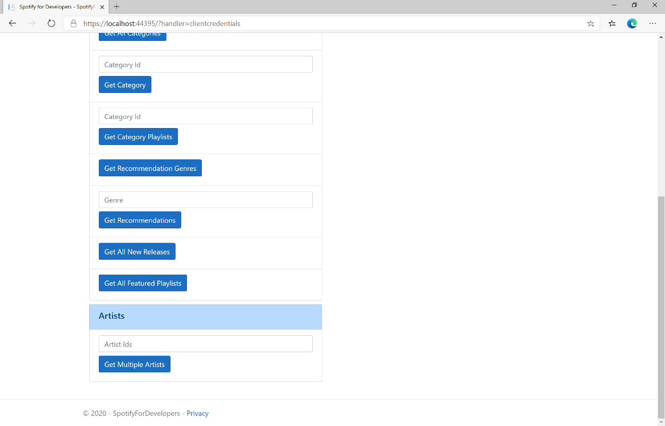

### Step 10

You can then enter an **Artist Id** or if multiple ones separate them with a **comma** from **Get All New Releases** and select **Get Multiple Artists** and scroll down to view **Results** like the following:

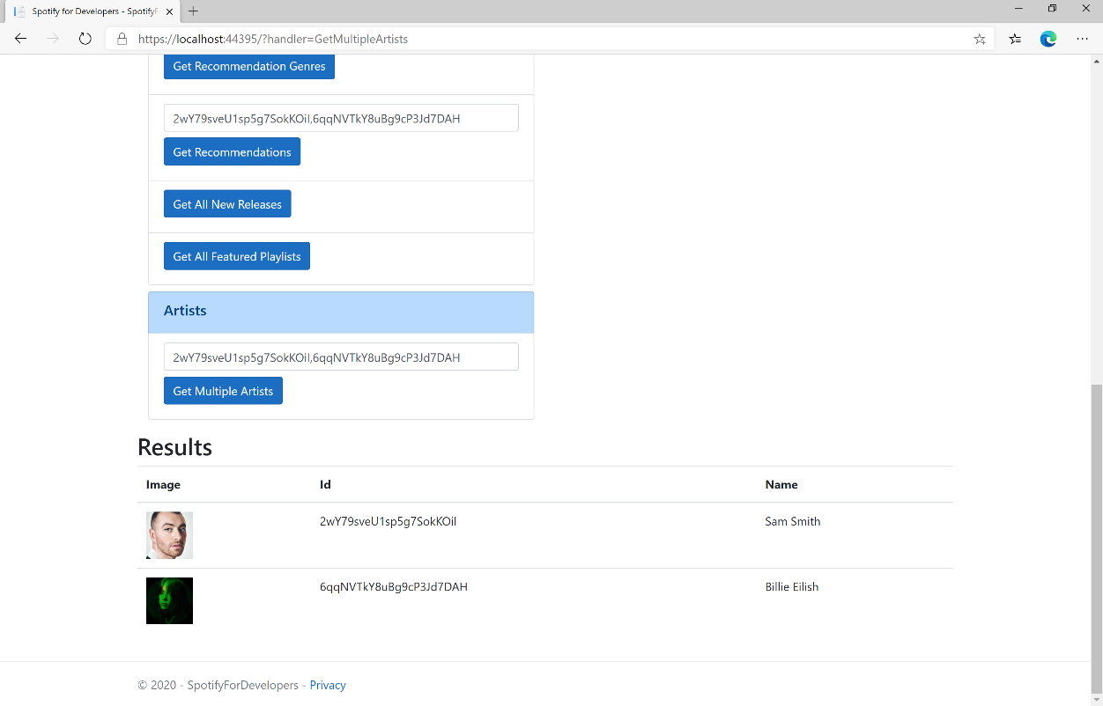

### Step 11

|  |  |
| --- | --- |
|  | You can stop the **web application** in **Visual Studio 2019** by selecting the **Stop debugging** button |

### Step 12

|  |  |
| --- | --- |
|  | You can exit **Visual Studio 2019** by selecting the **Close** button in the top right of the **application** as that completes thispart of the workshop |

## Get an Artist

Get Spotify catalogue information for a single artist identified by their unique Spotify Id.

|  |  |
| --- | --- |
| GET https://api.spotify.com/v1/artists/{id} | |
| Header | |
| Authorization | Valid Access Token from Spotify Accounts service |
| Path Parameter | |
| id | Spotify Id of the artist |

|  |  |
| --- | --- |
| Header | Response |
| Success | |
| HTTP Status 200 OK | Artist Object |
| Error | |
| Error Code | Error Object |

### Step 1

|  |  |
| --- | --- |
|  | If you chose to close **Visual Studio 2019** previously, in **Windows 10** choose **Start**, and then from the **Start Menu** find and select **Visual Studio 2019** |
|  | Once done, from the **Get started** screen for **Visual Studio 2019** select **Open a project or solution** |
|  | Then locate and select **SpotifyForDevelopers.sln** and select **Open** if you don’t have this file already then please follow the previous parts of the workshop including **Getting Started**, **Authorisation Guide**, **Search** **&** **Browse** and **Artists, Albums & Tracks** |

### Step 2

|  |  |
| --- | --- |
|  | Once opened, in the **Solution Explorer** open the **Pages** section, then open the **Index.cshtml** section and select **Index.cshtml.cs** |

### Step 3

|  |  |
| --- | --- |
|  | Then from the **Menu** choose **View** and then **Open** |

### Step 4

In the **Code View** for **Index.cshtml.cs** below the **method** for public async Task<IActionResult> OnPostGetMultipleArtistsAsync(...) { ... } enter the following **method**:

|  |
| --- |
| public async Task<IActionResult> OnPostGetArtistAsync(string value)  {  LoadToken();  var result = await Api.GetArtistAsync(value);  if (result != null)  {  Results = new List<Result> { new Result()  {  Id = result.Id,  Name = result.Name,  Image = result?.Images?.FirstOrDefault()?.Url  }};  }  return Page();  } |

The **method** for OnPostGetArtistAsync is used to get an **artist** by **Artist Id** on Spotify with the value and populate the **property** for Results accordingly.

### Step 5

|  |  |
| --- | --- |
|  | In the **Solution Explorer** in the **Pages** section select **Index.cshtml** |

### Step 6

|  |  |
| --- | --- |
|  | Then from the **Menu** choose **View** and then **Open** |

### Step 7

Once in the **Code View** for **Index.cshtml** above <!-- Artists --> enter the following:

|  |
| --- |
| <li class="list-group-item">  <form **asp-page-handler**="GetArtist" method="post">  <input **asp-for**="Value" placeholder="Artist Id" class="form-control mb-2" />  <button class="btn btn-primary mb-2">  Get an Artist  </button>  </form>  </li> |

This form will **post** to the **method** for OnPostGetArtistAsync with the Value as the **Artist Id** and will output to the **Results**.

### Step 8

|  |  |
| --- | --- |
|  | Finally, in **Visual Studio 2019** select **IIS Application** to run the **Web Application** |

### Step 9

Once the **Web Application** is running and you select **Client Credentials Flow Login** and scroll down you should see something like the following:

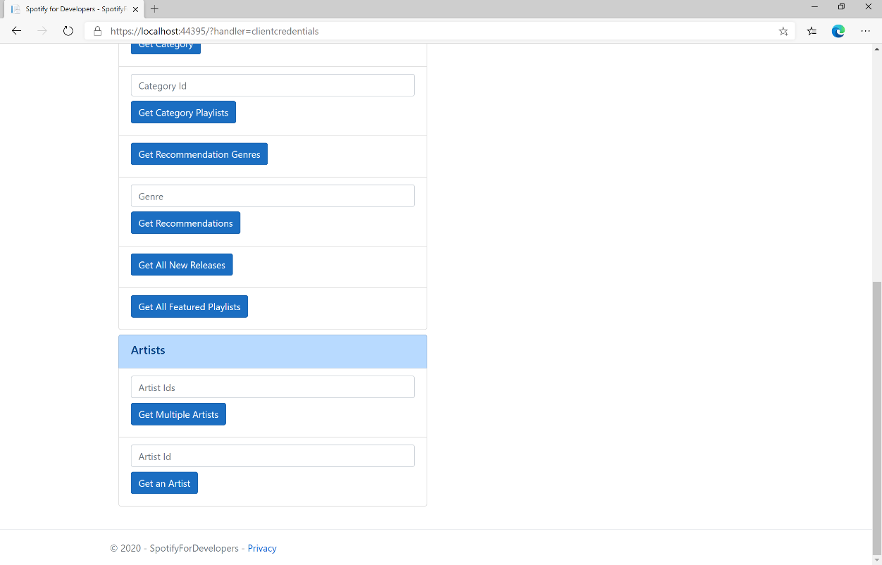

### Step 10

You can then enter an **Artist Id** from **Get All New Releases** and select **Get an Artist** and scroll down to view **Results** like the following:

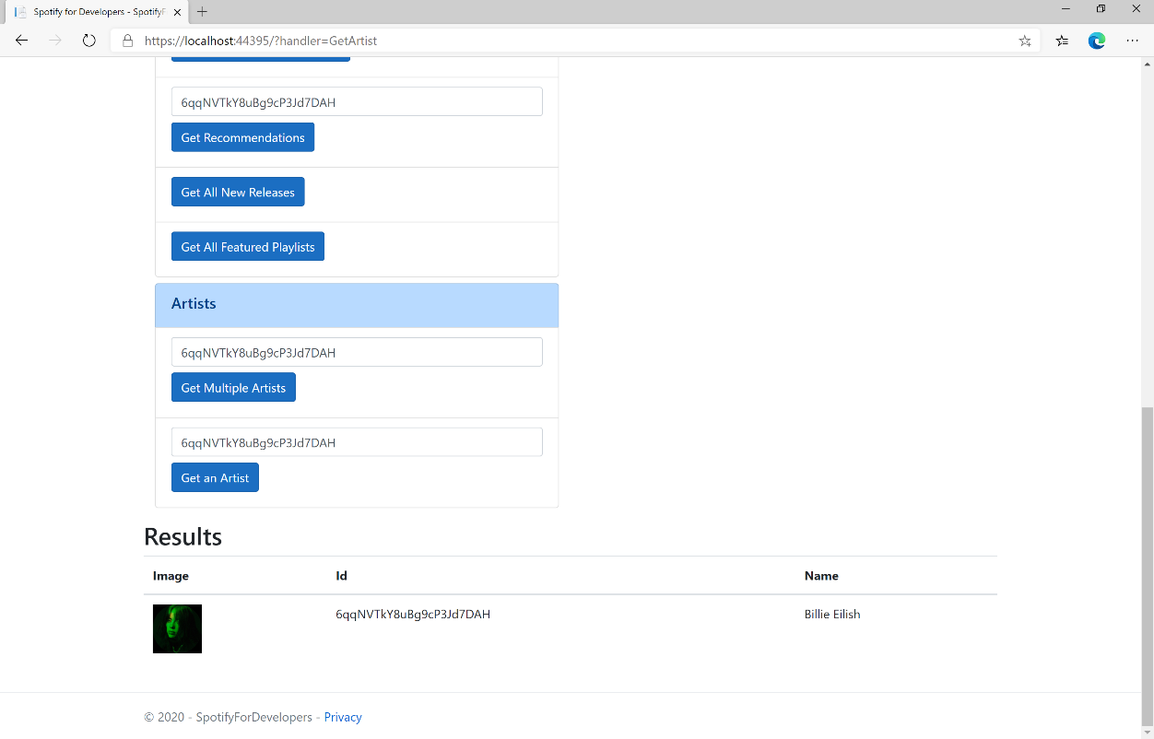

### Step 11

|  |  |
| --- | --- |
|  | You can stop the **web application** in **Visual Studio 2019** by selecting the **Stop debugging** button |

### Step 12

|  |  |
| --- | --- |
|  | You can choose to exit **Visual Studio 2019** by selecting the **Close** button in the top right of the **application** as that completes thispart of the workshop |

## Get an Artist's Albums

Get Spotify catalogue information about an artist’s albums. Optional parameters can be specified to filter and sort the response.

|  |  |
| --- | --- |
| GET https://api.spotify.com/v1/artists/{id}/albums | |
| Header | |
| Authorization | Valid Access Token from Spotify Accounts service |
| Path Parameter | |
| id | Spotify ID of the artist |
| Query Parameters | |
| include_groups | Comma-separated list of keywords that will be used to filter the response from: album, single, appears_on and compilation |
| market | ISO 3166-1 alpha-2 country code e.g. “GB” or “from_token” if omitted all releases for all countries will be returned which may include duplicates |
| limit | Maximum number of results to return |
| offset | Index of first result to return |

|  |  |
| --- | --- |
| Header | Response |
| Success | |
| HTTP Status 200 OK | Array of Simplified Album Objects wrapped in a Paging Object |
| Error | |
| Error Code | Error Object |

### Step 1

|  |  |
| --- | --- |
|  | If you chose to close **Visual Studio 2019** previously, in **Windows 10** choose **Start**, and then from the **Start Menu** find and select **Visual Studio 2019** |
|  | Once done, from the **Get started** screen for **Visual Studio 2019** select **Open a project or solution** |
|  | Then locate and select **SpotifyForDevelopers.sln** and select **Open** if you don’t have this file already then please follow the previous parts of the workshop including **Getting Started**, **Authorisation Guide**, **Search** **&** **Browse** and **Artists, Albums & Tracks** |

### Step 2

|  |  |
| --- | --- |
|  | Once opened, in the **Solution Explorer** open the **Pages** section, then open the **Index.cshtml** section and select **Index.cshtml.cs** |

### Step 3

|  |  |
| --- | --- |
|  | Then from the **Menu** choose **View** and then **Open** |

### Step 4

In the **Code View** for **Index.cshtml.cs** below the **method** for public async Task<IActionResult> OnPostGetArtistAsync(...) { ... } enter the following **method**:

|  |
| --- |
| public async Task<IActionResult> OnPostGetArtistAlbumsAsync(string value)  {  LoadToken();  var results = await Api.GetArtistAlbumsAsync(value);  if (results?.Items != null)  {  Results = results.Items.Select(result => new Result()  {  Id = result.Id,  Name = result.Name,  Image = result?.Images?.FirstOrDefault()?.Url  });  }  return Page();  } |

The **method** for OnPostGetArtistAlbumsAsync is used to get the **albums** of an **artist** by **Artist Id** on Spotify with the value and populate the **property** for Results accordingly.

### Step 5

|  |  |
| --- | --- |
|  | In the **Solution Explorer** in the **Pages** section select **Index.cshtml** |

### Step 6

|  |  |
| --- | --- |
|  | Then from the **Menu** choose **View** and then **Open** |

### Step 7

Once in the **Code View** for **Index.cshtml** above <!-- Artists --> enter the following:

|  |
| --- |
| <li class="list-group-item">  <form **asp-page-handler**="GetArtistAlbums" method="post">  <input **asp-for**="Value" placeholder="Artist Id" class="form-control mb-2" />  <button class="btn btn-primary mb-2">  Get an Artist's Albums  </button>  </form>  </li> |

This form will **post** to the **method** for OnPostGetArtistAlbumsAsync with the Value as the **Artist Id** and will output to the **Results**.

### Step 8

|  |  |
| --- | --- |
|  | Finally, in **Visual Studio 2019** select **IIS Application** to run the **Web Application** |

### Step 9

Once the **Web Application** is running and you select **Client Credentials Flow Login** and scroll down you should see something like the following:

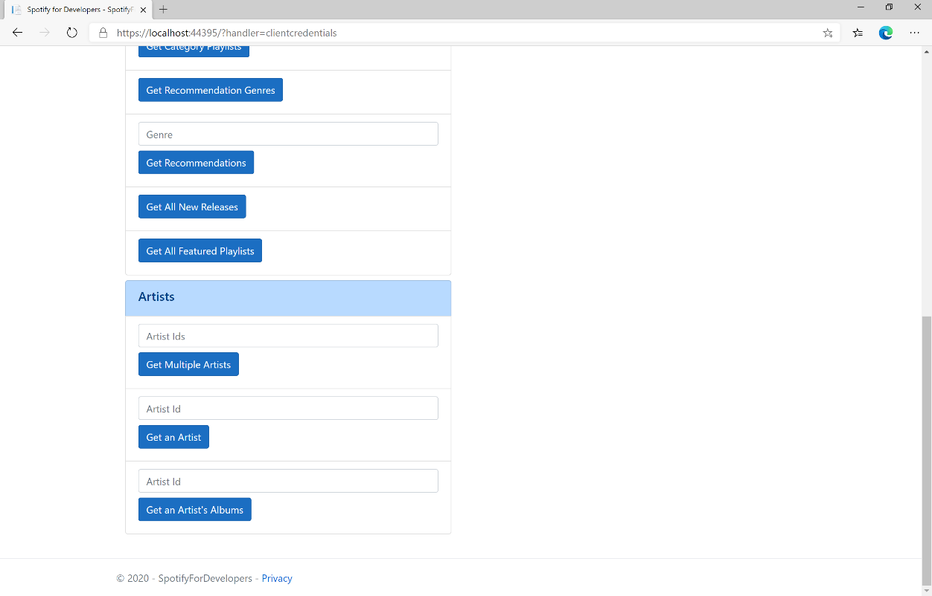

### Step 10

You can then enter an **Artist Id** from **Get All New Releases** and select **Get an Artist's Albums** and scroll down to view **Results** like the following:

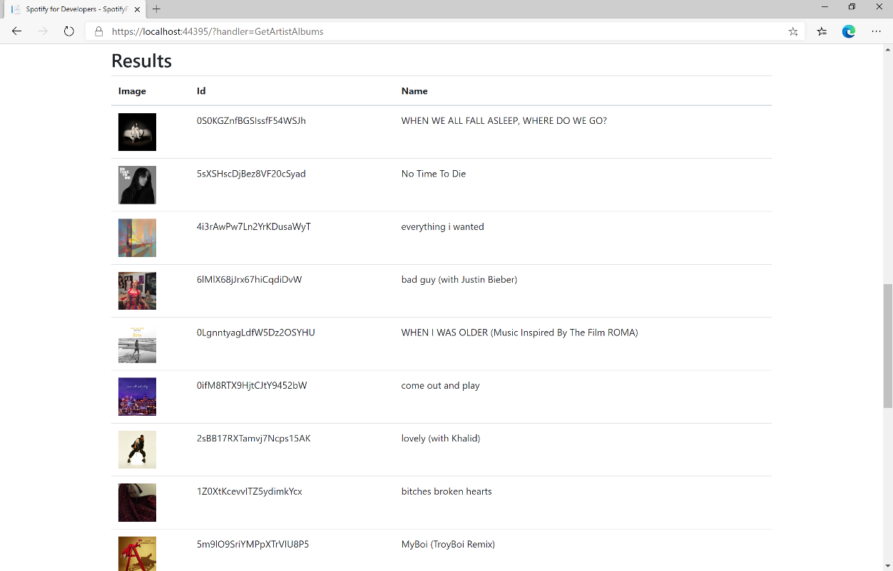

### Step 11

|  |  |
| --- | --- |
|  | You can stop the **web application** in **Visual Studio 2019** by selecting the **Stop debugging** button |

### Step 12

|  |  |
| --- | --- |
|  | You can choose to exit **Visual Studio 2019** by selecting the **Close** button in the top right of the **application** as that completes thispart of the workshop |

## Get an Artist's Top Tracks

Get Spotify catalogue information about an artist’s top tracks by country.

|  |  |
| --- | --- |
| GET https://api.spotify.com/v1/artists/{id}/top-tracks | |
| Header | |
| Authorization | Valid Access Token from Spotify Accounts service |
| Path Parameter | |
| id | Spotify Id of the artist |
| Query Parameters | |
| market | ISO 3166-1 alpha-2 country code e.g. “GB” or “from_token” |

|  |  |
| --- | --- |
| Header | Response |
| Success | |
| HTTP Status 200 OK | Tracks as Array of up to 10 Track Objects |
| Error | |
| Error Code | Error Object |

### Step 1

|  |  |
| --- | --- |
|  | If you chose to close **Visual Studio 2019** previously, in **Windows 10** choose **Start**, and then from the **Start Menu** find and select **Visual Studio 2019** |
|  | Once done, from the **Get started** screen for **Visual Studio 2019** select **Open a project or solution** |
|  | Then locate and select **SpotifyForDevelopers.sln** and select **Open** if you don’t have this file already then please follow the previous parts of the workshop including **Getting Started**, **Authorisation Guide**, **Search** **&** **Browse** and **Artists, Albums & Tracks** |

### Step 2

|  |  |
| --- | --- |
|  | Once opened, in the **Solution Explorer** open the **Pages** section, then open the **Index.cshtml** section and select **Index.cshtml.cs** |

### Step 3

|  |  |
| --- | --- |
|  | Then from the **Menu** choose **View** and then **Open** |

### Step 4

In the **Code View** for **Index.cshtml.cs** below the **method** for public async Task<IActionResult> OnPostGetArtistAlbumsAsync(...) { ... } enter the following **method**:

|  |
| --- |
| public async Task<IActionResult> OnPostGetArtistTopTracksAsync(string value)  {  LoadToken();  var results = await Api.GetArtistTopTracksAsync(value, country);  if (results != null)  {  Results = results.Select(result => new Result()  {  Id = result.Id,  Name = result.Name,  Image = result?.Album?.Images?.FirstOrDefault()?.Url,  Inner = new Result()  {  Id = result?.Album?.Id,  Name = result?.Album?.Name  }  });  }  return Page();  } |

The **method** for OnPostGetArtistTopTracksAsync is used to get the top **tracks** of an **artist** by **Artist Id** on Spotify with the value and populate the **property** for Results accordingly.

### Step 5

|  |  |
| --- | --- |
|  | In the **Solution Explorer** in the **Pages** section select **Index.cshtml** |

### Step 6

|  |  |
| --- | --- |
|  | Then from the **Menu** choose **View** and then **Open** |

### Step 7

Once in the **Code View** for **Index.cshtml** above <!-- Artists --> enter the following:

|  |
| --- |
| <li class="list-group-item">  <form **asp-page-handler**="GetArtistTopTracks" method="post">  <input **asp-for**="Value" placeholder="Artist Id" class="form-control mb-2" />  <button class="btn btn-primary mb-2">  Get an Artist's Top Tracks  </button>  </form>  </li> |

This form will **post** to the **method** for OnPostGetArtistTopTracksAsync with the Value as the **Artist Id** and will output to the **Results**.

### Step 8

|  |  |
| --- | --- |
|  | Finally, in **Visual Studio 2019** select **IIS Application** to run the **Web Application** |

### Step 9

Once the **Web Application** is running and you select **Client Credentials Flow Login** and scroll down you should see something like the following:

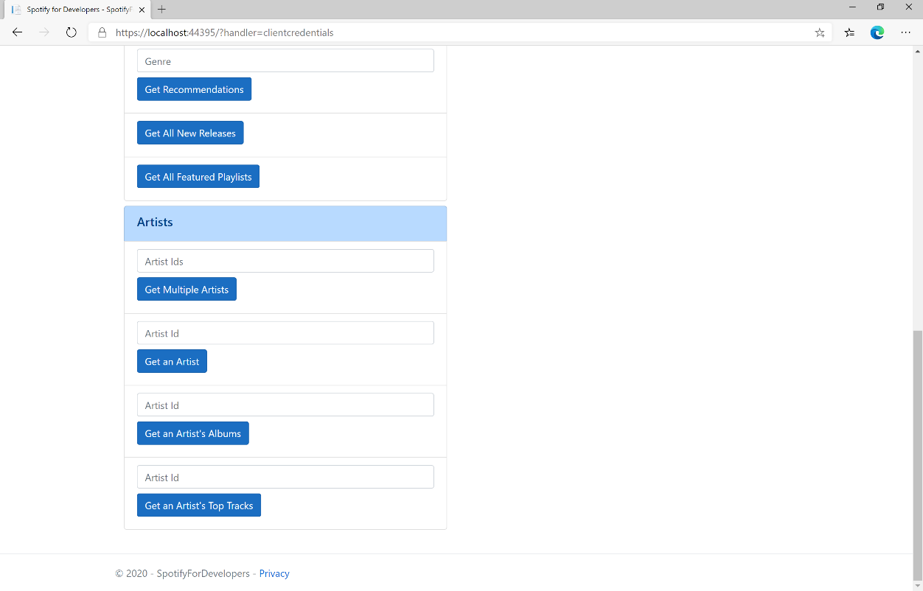

### Step 10

You can then enter an **Artist Id** from **Get All New Releases** and select **Get an Artist's Top Tracks** and scroll down to view **Results** like the following:

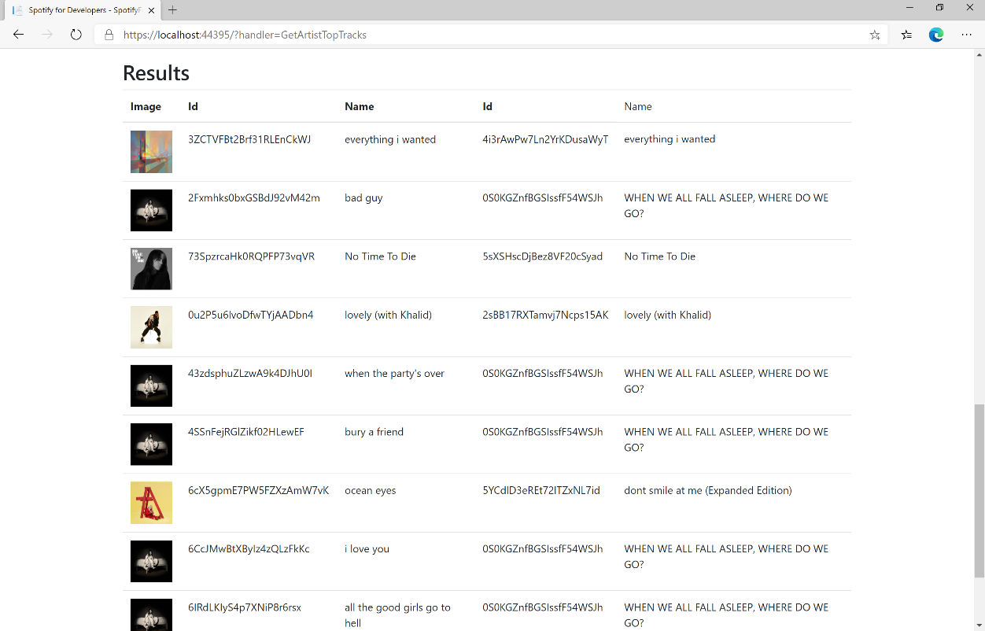

### Step 11

|  |  |
| --- | --- |
|  | You can stop the **web application** in **Visual Studio 2019** by selecting the **Stop debugging** button |

### Step 12

|  |  |
| --- | --- |
|  | You can choose to exit **Visual Studio 2019** by selecting the **Close** button in the top right of the **application** as that completes thispart of the workshop |

## Get an Artist's Related Artists

Get Spotify catalogue information about artists like a given artist. Similarity is based on analysis of the Spotify community’s listening history.

|  |  |
| --- | --- |
| GET https://api.spotify.com/v1/artists/{id}/top-tracks | |
| Header | |
| Authorization | Valid Access Token from Spotify Accounts service |
| Path Parameter | |
| id | Spotify Id of the artist |

|  |  |
| --- | --- |
| Header | Response |
| Success | |
| HTTP Status 200 OK | Artists as Array of up to 20 Artist Objects |
| Error | |
| Error Code | Error Object |

### Step 1

|  |  |
| --- | --- |
|  | If you chose to close **Visual Studio 2019** previously, in **Windows 10** choose **Start**, and then from the **Start Menu** find and select **Visual Studio 2019** |
|  | Once done, from the **Get started** screen for **Visual Studio 2019** select **Open a project or solution** |
|  | Then locate and select **SpotifyForDevelopers.sln** and select **Open** if you don’t have this file already then please follow the previous parts of the workshop including **Getting Started**, **Authorisation Guide**, **Search** **&** **Browse** and **Artists, Albums & Tracks** |

### Step 2

|  |  |
| --- | --- |
|  | Once opened, in the **Solution Explorer** open the **Pages** section, then open the **Index.cshtml** section and select **Index.cshtml.cs** |

### Step 3

|  |  |
| --- | --- |
|  | Then from the **Menu** choose **View** and then **Open** |

### Step 4

In the **Code View** for **Index.cshtml.cs** below the **method** for public async Task<IActionResult> OnPostGetArtistTopTracksAsync(...) { ... } enter the following **method**:

|  |
| --- |
| public async Task<IActionResult> OnPostGetArtistRelatedArtistsAsync(string value)  {  LoadToken();  var results = await Api.GetArtistRelatedArtistsAsync(value);  if (results != null)  {  Results = results.Select(result => new Result()  {  Id = result.Id,  Name = result.Name,  Image = result?.Images?.FirstOrDefault()?.Url  });  }  return Page();  } |

The **method** for OnPostGetArtistRelatedArtistsAsync is used to get the related **artists** of an **artist** by **Artist Id** on Spotify with the value and populate the **property** for Results accordingly.

### Step 5

|  |  |
| --- | --- |
|  | In the **Solution Explorer** in the **Pages** section select **Index.cshtml** |

### Step 6

|  |  |
| --- | --- |
|  | Then from the **Menu** choose **View** and then **Open** |

### Step 7

Once in the **Code View** for **Index.cshtml** above <!-- Artists --> enter the following:

|  |
| --- |
| <li class="list-group-item">  <form **asp-page-handler**="GetArtistRelatedArtists" method="post">  <input **asp-for**="Value" placeholder="Artist Id" class="form-control mb-2" />  <button class="btn btn-primary mb-2">  Get an Artist's Related Artists  </button>  </form>  </li> |

This form will **post** to the **method** for OnPostGetArtistRelatedArtistsAsync with the Value as the **Artist Id** and will output to the **Results**.

### Step 8

|  |  |
| --- | --- |
|  | Finally, in **Visual Studio 2019** select **IIS Application** to run the **Web Application** |

### Step 9

Once the **Web Application** is running and you select **Client Credentials Flow Login** and scroll down you should see something like the following:

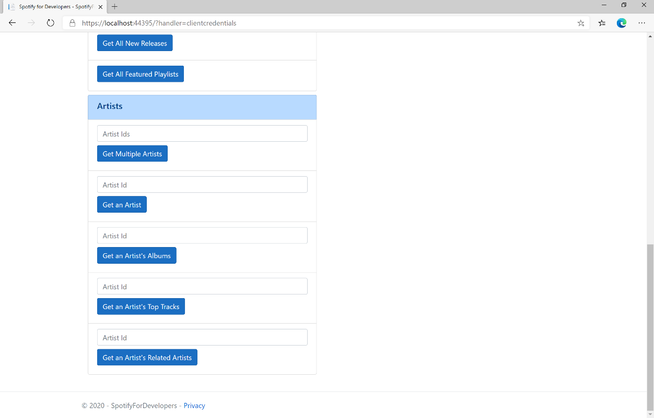

### Step 10

You can then enter an **Artist Id** from **Get All New Releases** and select **Get an Artist's Related Artists** and scroll down to view **Results** like the following:

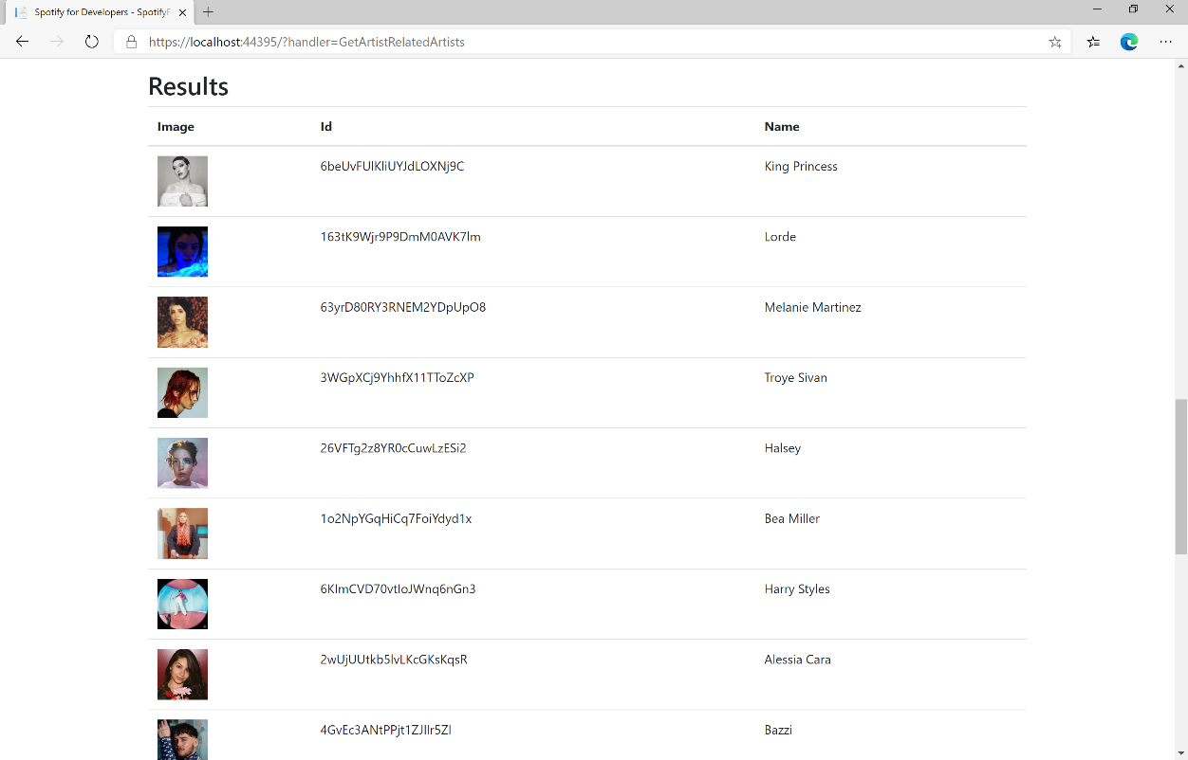

### Step 11

|  |  |
| --- | --- |
|  | You can stop the **web application** in **Visual Studio 2019** by selecting the **Stop debugging** button |

### Step 12

|  |  |
| --- | --- |
|  | You can choose to exit **Visual Studio 2019** by selecting the **Close** button in the top right of the **application** as that completes thispart of the workshop |

## Get Multiple Albums

Get Spotify catalogue information for several albums based on their Spotify Ids.

|  |  |
| --- | --- |
| GET https://api.spotify.com/v1/albums | |
| Header | |
| Authorization | Valid Access Token from Spotify Accounts service |
| Query Parameter | |
| ids | Maximum of 20 comma-separated list of album Spotify Ids |
| market | ISO 3166-1 alpha-2 country code or “from_token” Provide to apply Track Relinking. |

|  |  |
| --- | --- |
| Header | Response |
| Success | |
| HTTP Status 200 OK | Albums as Array of Album Objects |
| Error | |
| Error Code | Error Object |

### Step 1

|  |  |
| --- | --- |
|  | If you chose to close **Visual Studio 2019** previously, in **Windows 10** choose **Start**, and then from the **Start Menu** find and select **Visual Studio 2019** |
|  | Once done, from the **Get started** screen for **Visual Studio 2019** select **Open a project or solution** |
|  | Then locate and select **SpotifyForDevelopers.sln** and select **Open** if you don’t have this file already then please follow the previous parts of the workshop including **Getting Started**, **Authorisation Guide**, **Search** **&** **Browse** and **Artists, Albums & Tracks** |

### Step 2

|  |  |
| --- | --- |
|  | Once opened, in the **Solution Explorer** open the **Pages** section, then open the **Index.cshtml** section and select **Index.cshtml.cs** |

### Step 3

|  |  |
| --- | --- |
|  | Then from the **Menu** choose **View** and then **Open** |

### Step 4

In the **Code View** for **Index.cshtml.cs** below the **method** for public async Task<IActionResult> OnPostGetArtistRelatedArtistsAsync(...) { ... } enter the following **method**:

|  |
| --- |
| public async Task<IActionResult> OnPostGetMultipleAlbumsAsync(string value)  {  LoadToken();  var values = value.Split(",").ToList();  var results = await Api.GetMultipleAlbumsAsync(values);  if (results != null)  {  Results = results.Select(result => new Result()  {  Id = result.Id,  Name = result.Name,  Image = result?.Images?.FirstOrDefault()?.Url  });  }  return Page();  } |

The **method** for OnPostGetMultipleAlbumsAsync is used to get **albums** by multiple **Album Id** on Spotify with the value and populate the **property** for Results accordingly.

### Step 5

|  |  |
| --- | --- |
|  | In the **Solution Explorer** in the **Pages** section select **Index.cshtml** |

### Step 6

|  |  |
| --- | --- |
|  | Then from the **Menu** choose **View** and then **Open** |

### Step 7

Once in the **Code View** for **Index.cshtml** above <!-- Spotify Web API App Authorisation --> enter the following:

|  |
| --- |
| <ul class="list-group mb-2">  <li class="list-group-item list-group-item-primary">  <h5 class="list-group-item-heading">Albums</h5>  </li>  <li class="list-group-item">  <form **asp-page-handler**="GetMultipleAlbums" method="post">  <input **asp-for**="Value" placeholder="Album Ids" class="form-control mb-2" />  <button class="btn btn-primary mb-2">  Get Multiple Albums  </button>  </form>  </li>  <!-- Albums -->  </ul> |

This form will **post** to the **method** for OnPostGetMultipleAlbumsAsync with the Value as the **Album Ids** and will output to the **Results**.

### Step 8

|  |  |
| --- | --- |
|  | Finally, in **Visual Studio 2019** select **IIS Application** to run the **Web Application** |

### Step 9

Once the **Web Application** is running and you select **Client Credentials Flow Login** and scroll down you should see something like the following:

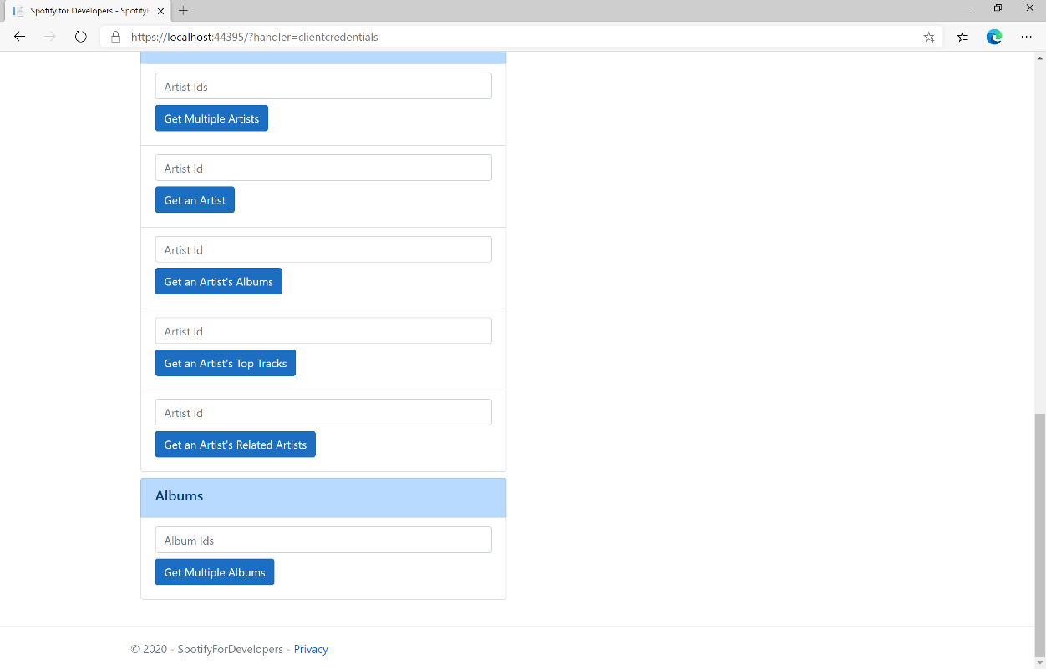

### Step 10

You can then enter an **Album Id** or if multiple ones separate them with a **comma** from **Get All New Releases** and select **Get Multiple Albums** and scroll down to view **Results** like the following:

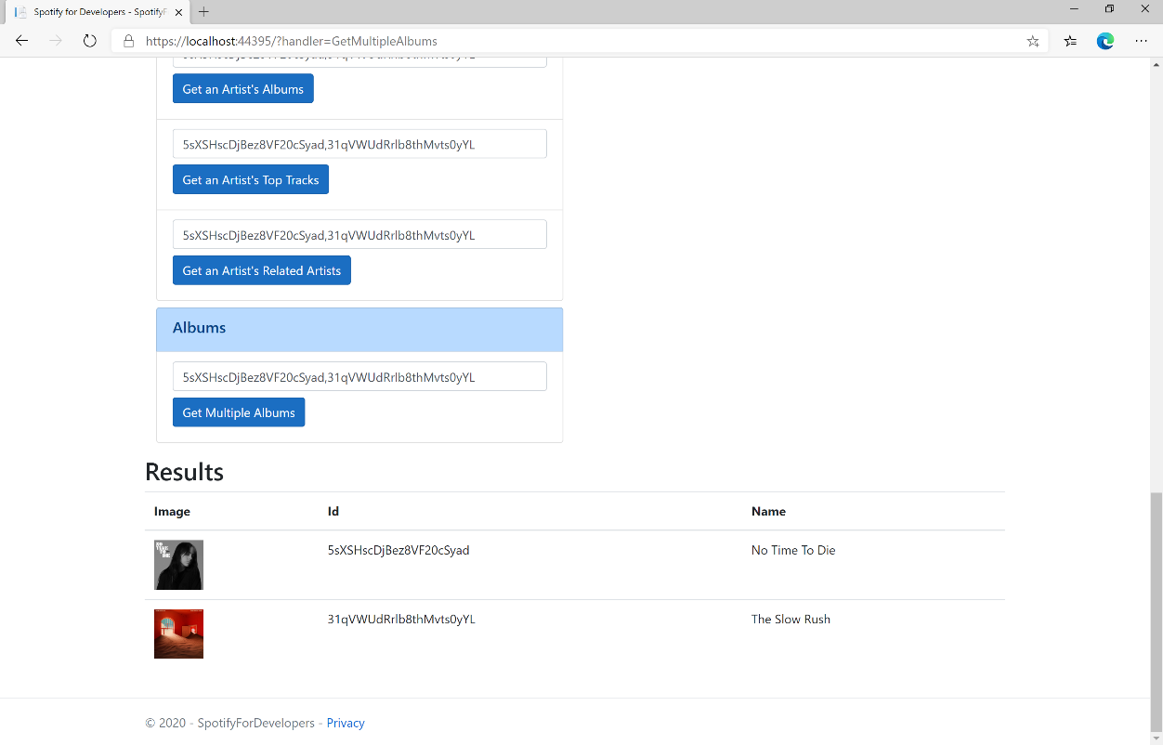

### Step 11

|  |  |
| --- | --- |
|  | You can stop the **web application** in **Visual Studio 2019** by selecting the **Stop debugging** button |

### Step 12

|  |  |
| --- | --- |
|  | You can choose to exit **Visual Studio 2019** by selecting the **Close** button in the top right of the **application** as that completes thispart of the workshop |

## Get an Album

Get Spotify catalogue information for a single album identified by its unique Spotify Id.

|  |  |
| --- | --- |
| GET https://api.spotify.com/v1/albums/{id} | |
| Header | |
| Authorization | Valid Access Token from Spotify Accounts service |
| Path Parameter | |
| id | Spotify Id of the album |
| market | ISO 3166-1 alpha-2 country code e.g. “GB” |

|  |  |
| --- | --- |
| Header | Response |
| Success | |
| HTTP Status 200 OK | Album Object |
| Error | |
| Error Code | Error Object |

### Step 1

|  |  |
| --- | --- |
|  | If you chose to close **Visual Studio 2019** previously, in **Windows 10** choose **Start**, and then from the **Start Menu** find and select **Visual Studio 2019** |
|  | Once done, from the **Get started** screen for **Visual Studio 2019** select **Open a project or solution** |
|  | Then locate and select **SpotifyForDevelopers.sln** and select **Open** if you don’t have this file already then please follow the previous parts of the workshop including **Getting Started**, **Authorisation Guide**, **Search** **&** **Browse** and **Artists, Albums & Tracks** |

### Step 2

|  |  |
| --- | --- |
|  | Once opened, in the **Solution Explorer** open the **Pages** section, then open the **Index.cshtml** section and select **Index.cshtml.cs** |

### Step 3

|  |  |
| --- | --- |
|  | Then from the **Menu** choose **View** and then **Open** |

### Step 4

In the **Code View** for **Index.cshtml.cs** below the **method** for public async Task<IActionResult> OnPostGetMultipleAlbumsAsync(...) { ... } enter the following **method**:

|  |
| --- |
| public async Task<IActionResult> OnPostGetAlbumAsync(string value)  {  LoadToken();  var result = await Api.GetAlbumAsync(value);  if (result != null)  {  Results = new List<Result> { new Result()  {  Id = result.Id,  Name = result.Name,  Image = result?.Images?.FirstOrDefault()?.Url,  Inner = new Result()  {  Id = result?.Artists?.FirstOrDefault()?.Id,  Name = result?.Artists?.FirstOrDefault()?.Name  }  }};  }  return Page();  } |

The **method** for OnPostGetAlbumAsync is used to get an **album** by **Album Id** on Spotify with the value and populate the **property** for Results accordingly.

### Step 5

|  |  |
| --- | --- |
|  | In the **Solution Explorer** in the **Pages** section select **Index.cshtml** |

### Step 6

|  |  |
| --- | --- |
|  | Then from the **Menu** choose **View** and then **Open** |

### Step 7

Once in the **Code View** for **Index.cshtml** above <!-- Albums --> enter the following:

|  |
| --- |
| <li class="list-group-item">  <form **asp-page-handler**="GetAlbum" method="post">  <input **asp-for**="Value" placeholder="Album Id" class="form-control mb-2" />  <button class="btn btn-primary mb-2">  Get an Album  </button>  </form>  </li> |

This form will **post** to the **method** for OnPostGetAlbumAsync with the Value as the **Album Id** and will output to the **Results**.

### Step 8

|  |  |
| --- | --- |
|  | Finally, in **Visual Studio 2019** select **IIS Application** to run the **Web Application** |

### Step 9

Once the **Web Application** is running and you select **Client Credentials Flow Login** and scroll down you should see something like the following:

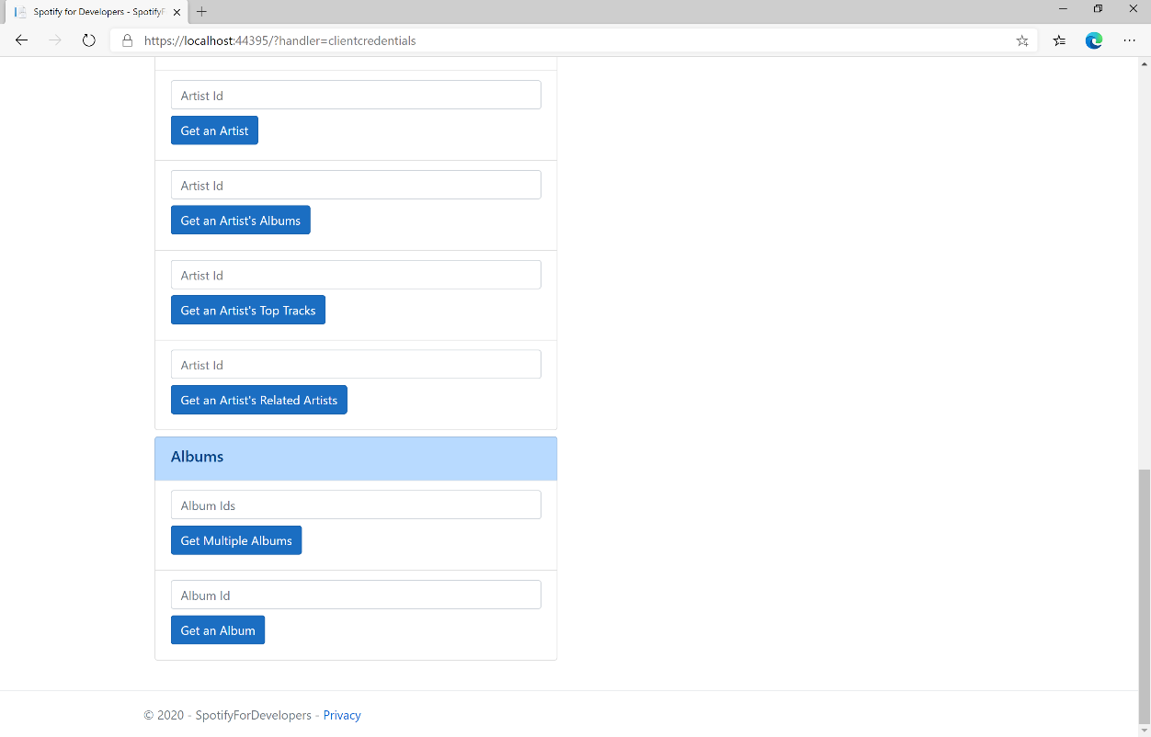

### Step 10

You can then enter an **Album Id** from **Get All New Releases** and select **Get an Album** and scroll down to view **Results** like the following:

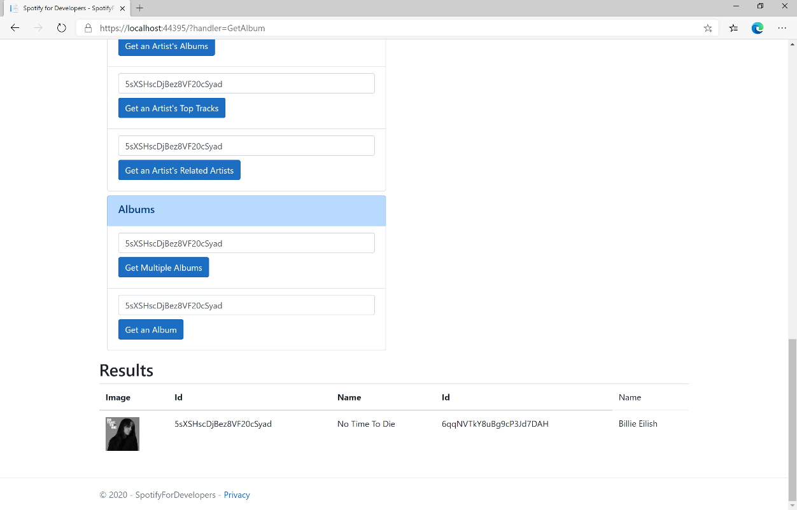

### Step 11

|  |  |
| --- | --- |
|  | You can stop the **web application** in **Visual Studio 2019** by selecting the **Stop debugging** button |

### Step 12

|  |  |
| --- | --- |
|  | You can choose to exit **Visual Studio 2019** by selecting the **Close** button in the top right of the **application** as that completes thispart of the workshop |

## Get an Album's Tracks

Get Spotify catalogue information about an album’s tracks. Optional parameters can be used to limit the number of tracks returned.

|  |  |
| --- | --- |
| GET https://api.spotify.com/v1/albums/{id}/tracks | |
| Header | |
| Authorization | Valid Access Token from Spotify Accounts service |
| Path Parameter | |
| id | Spotify Id of the album |
| Query Parameters | |
| limit | Maximum number of results to return |
| offset | Index of first result to return |
| market | ISO 3166-1 alpha-2 country code e.g. “GB” or “from_token”.  Provide to apply Track Relinking |

|  |  |
| --- | --- |
| Header | Response |
| Success | |
| HTTP Status 200 OK | Array of Simplified Track Objects wrapped in a Paging Object |
| Error | |
| Error Code | Error Object |

### Step 1

|  |  |
| --- | --- |
|  | If you chose to close **Visual Studio 2019** previously, in **Windows 10** choose **Start**, and then from the **Start Menu** find and select **Visual Studio 2019** |
|  | Once done, from the **Get started** screen for **Visual Studio 2019** select **Open a project or solution** |
|  | Then locate and select **SpotifyForDevelopers.sln** and select **Open** if you don’t have this file already then please follow the previous parts of the workshop including **Getting Started**, **Authorisation Guide**, **Search** **&** **Browse** and **Artists, Albums & Tracks** |

### Step 2

|  |  |
| --- | --- |
|  | Once opened, in the **Solution Explorer** open the **Pages** section, then open the **Index.cshtml** section and select **Index.cshtml.cs** |

### Step 3

|  |  |
| --- | --- |
|  | Then from the **Menu** choose **View** and then **Open** |

### Step 4

In the **Code View** for **Index.cshtml.cs** below the **method** for public async Task<IActionResult> OnPostGetAlbumAsync(...) { ... } enter the following **method**:

|  |
| --- |
| public async Task<IActionResult> OnPostGetAlbumTracksAsync(string value)  {  LoadToken();  var results = await Api.GetAlbumTracksAsync(value, country);  if (results?.Items != null)  {  Results = results.Items.Select(result => new Result()  {  Id = result.Id,  Name = result.Name,  Image = result?.Album?.Images?.FirstOrDefault()?.Url,  Inner = new Result()  {  Id = result?.Artists?.FirstOrDefault()?.Id,  Name = result?.Artists?.FirstOrDefault()?.Name  }  });  }  return Page();  } |

The **method** for OnPostGetAlbumTracksAsync is used to get the **tracks** of an **album** by **Album Id** on Spotify with the value and populate the **property** for Results accordingly.

### Step 5

|  |  |
| --- | --- |
|  | In the **Solution Explorer** in the **Pages** section select **Index.cshtml** |

### Step 6

|  |  |
| --- | --- |
|  | Then from the **Menu** choose **View** and then **Open** |

### Step 7

Once in the **Code View** for **Index.cshtml** above <!-- Albums --> enter the following:

|  |
| --- |
| <li class="list-group-item">  <form **asp-page-handler**="GetAlbumTracks" method="post">  <input **asp-for**="Value" placeholder="Album Id" class="form-control mb-2" />  <button class="btn btn-primary mb-2">  Get an Album's Tracks  </button>  </form>  </li> |

This form will **post** to the **method** for OnPostGetAlbumTracksAsync with the Value as the **Album Id** and will output to the **Results**.

### Step 8

|  |  |
| --- | --- |
|  | Finally, in **Visual Studio 2019** select **IIS Application** to run the **Web Application** |

### Step 9

Once the **Web Application** is running and you select **Client Credentials Flow Login** and scroll down you should see something like the following:

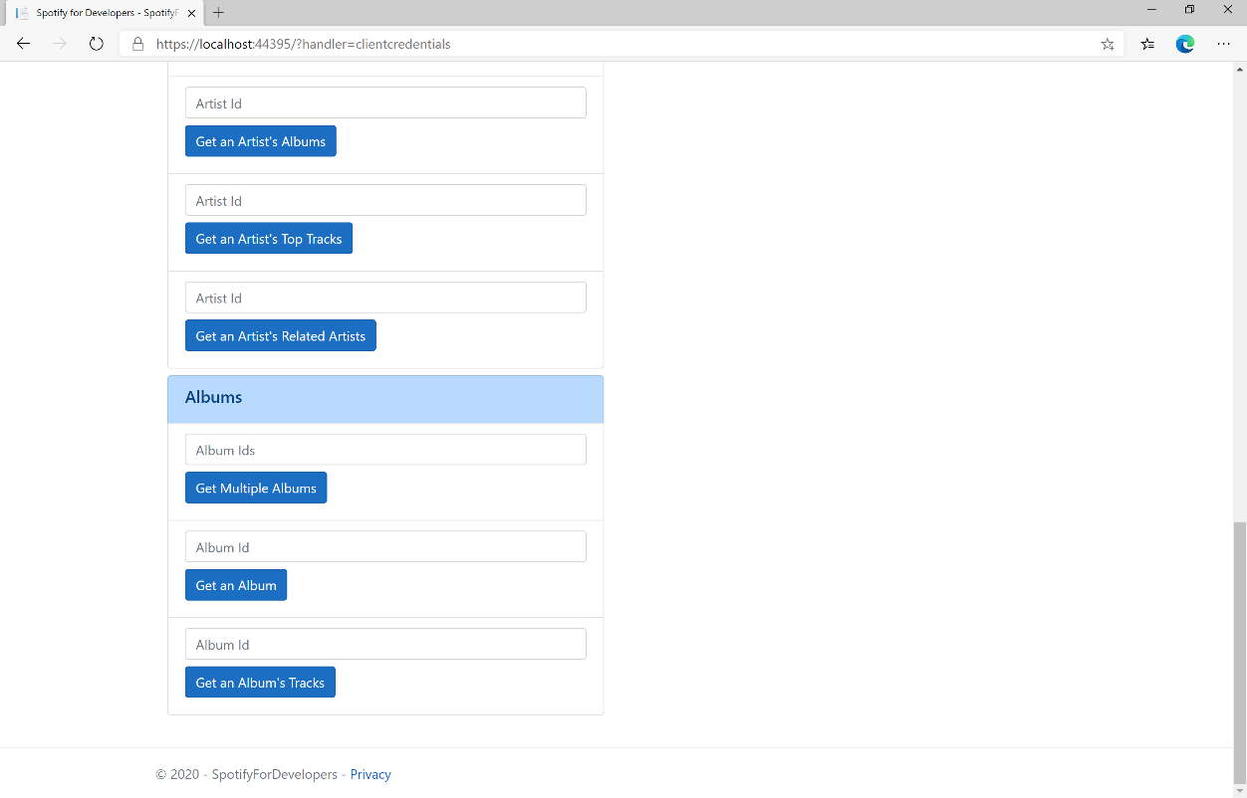

### Step 10

You can then enter an **Album Id** from **Get All New Releases** and select **Get an Album's Tracks** and scroll down to view **Results** like the following:

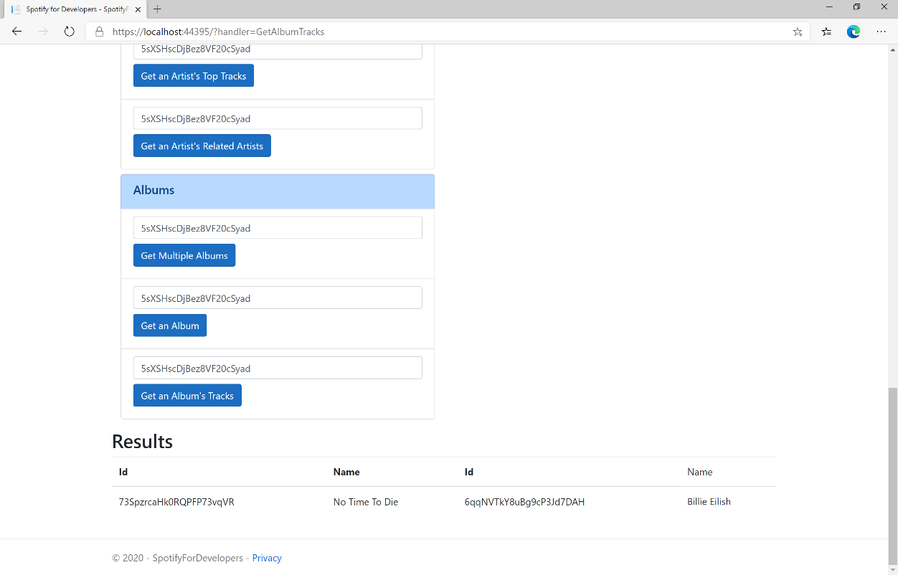

### Step 11

|  |  |
| --- | --- |
|  | You can stop the **web application** in **Visual Studio 2019** by selecting the **Stop debugging** button |

### Step 12

|  |  |
| --- | --- |
|  | You can choose to exit **Visual Studio 2019** by selecting the **Close** button in the top right of the **application** as that completes thispart of the workshop |

## Get Multiple Tracks

Get Spotify catalogue information for multiple tracks based on their Spotify Ids.

|  |  |
| --- | --- |
| GET https://api.spotify.com/v1/tracks | |
| Header | |
| Authorization | Valid Access Token from Spotify Accounts service |
| Query Parameter | |
| ids | Maximum of 50 comma-separated list of track Spotify Ids |
| market | ISO 3166-1 alpha-2 country code e.g. “GB”. Provide to apply Track Relinking |

|  |  |
| --- | --- |
| Header | Response |
| Success | |
| HTTP Status 200 OK | Tracks as Array of Track Objects |
| Error | |
| Error Code | Error Object |

### Step 1

|  |  |
| --- | --- |
|  | If you chose to close **Visual Studio 2019** previously, in **Windows 10** choose **Start**, and then from the **Start Menu** find and select **Visual Studio 2019** |
|  | Once done, from the **Get started** screen for **Visual Studio 2019** select **Open a project or solution** |
|  | Then locate and select **SpotifyForDevelopers.sln** and select **Open** if you don’t have this file already then please follow the previous parts of the workshop including **Getting Started**, **Authorisation Guide**, **Search** **&** **Browse** and **Artists, Albums & Tracks** |

### Step 2

|  |  |
| --- | --- |
|  | Once opened, in the **Solution Explorer** open the **Pages** section, then open the **Index.cshtml** section and select **Index.cshtml.cs** |

### Step 3

|  |  |
| --- | --- |
|  | Then from the **Menu** choose **View** and then **Open** |

### Step 4

In the **Code View** for **Index.cshtml.cs** below the **method** for public async Task<IActionResult> OnPostGetAlbumTracksAsync(...) { ... } enter the following **method**:

|  |
| --- |
| public async Task<IActionResult> OnPostGetSeveralTracksAsync(string value)  {  LoadToken();  var values = value.Split(",").ToList();  var results = await Api.GetSeveralTracksAsync(values);  if (results != null)  {  Results = results.Select(result => new Result()  {  Id = result.Id,  Name = result.Name,  Image = result?.Album?.Images?.FirstOrDefault()?.Url  });  }  return Page(); } |

The **method** for OnPostGetSeveralTracksAsync is used to get **tracks** by multiple **Track Ids** on Spotify with the value and populate the **property** for Results accordingly.

### Step 5

|  |  |
| --- | --- |
|  | In the **Solution Explorer** in the **Pages** section select **Index.cshtml** |

### Step 6

|  |  |
| --- | --- |
|  | Then from the **Menu** choose **View** and then **Open** |

### Step 7

Once in the **Code View** for **Index.cshtml** above <!-- Spotify Web API App Authorisation --> enter the following:

|  |
| --- |
| <ul class="list-group mb-2">  <li class="list-group-item list-group-item-primary">  <h5 class="list-group-item-heading">Tracks</h5>  </li>  <li class="list-group-item">  <form **asp-page-handler**="GetSeveralTracks" method="post">  <input **asp-for**="Value" placeholder="Track Ids" class="form-control mb-2" />  <button class="btn btn-primary mb-2">  Get Multiple Tracks  </button>  </form>  </li>  <!-- Tracks --> </ul> |

This form will **post** to the **method** for OnPostGetSeveralTracksAsync with the Value as the **Track Ids** and will output to the **Results**.

### Step 8

|  |  |
| --- | --- |
|  | Finally, in **Visual Studio 2019** select **IIS Application** to run the **Web Application** |

### Step 9

Once the **Web Application** is running and you select **Client Credentials Flow Login** and scroll down you should see something like the following:

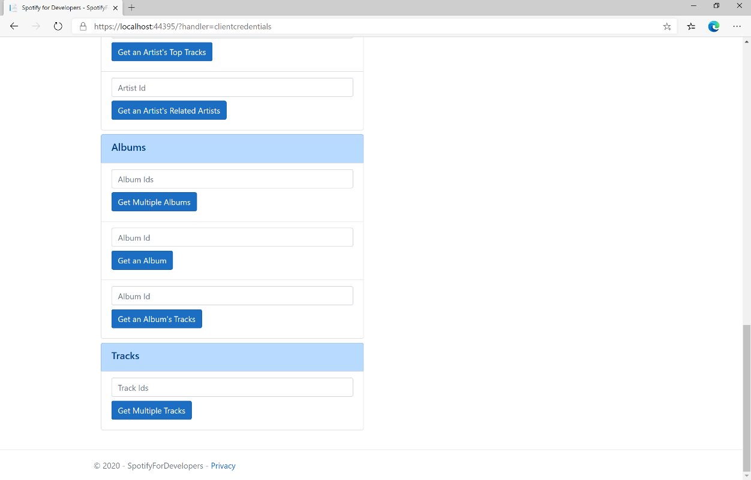

### Step 10

You can then enter an **Album Id** from **Get All New Releases** select **Get an Album's Tracks** and copy some **Track Ids** to use and select **Get Multiple Tracks** and scroll down to view **Results** like the following:

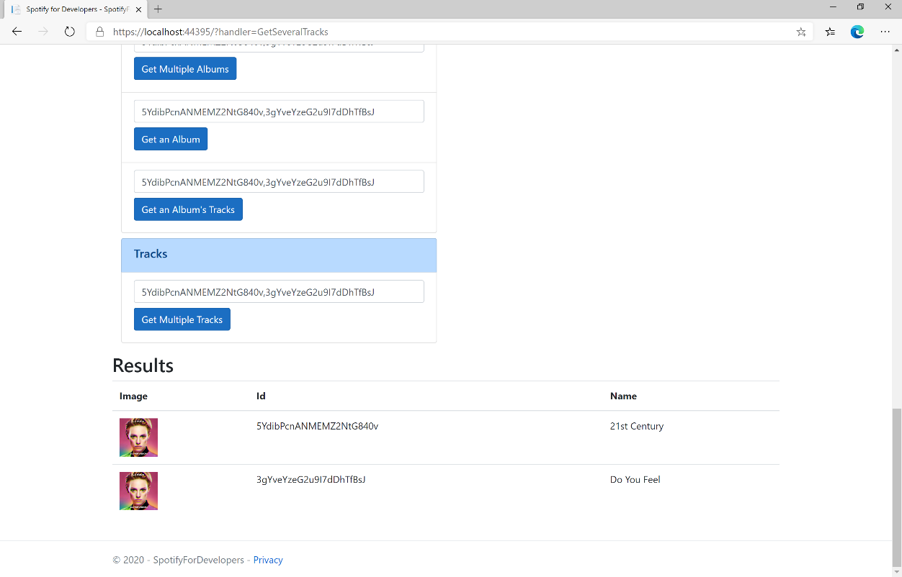

### Step 11

|  |  |
| --- | --- |
|  | You can stop the **web application** in **Visual Studio 2019** by selecting the **Stop debugging** button |

### Step 12

|  |  |
| --- | --- |
|  | You can choose to exit **Visual Studio 2019** by selecting the **Close** button in the top right of the **application** as that completes thispart of the workshop |

## Get a Track

Get Spotify catalogue information for a single track identified by its unique Spotify Id.

|  |  |
| --- | --- |
| GET https://api.spotify.com/v1/tracks/{id} | |
| Header | |
| Authorization | Valid Access Token from Spotify Accounts service |
| Path Parameter | |
| id | Spotify Id of the track |
| market | ISO 3166-1 alpha-2 country code e.g. “GB”. Provide to apply Track Relinking |

|  |  |
| --- | --- |
| Header | Response |
| Success | |
| HTTP Status 200 OK | Track Object |
| Error | |
| Error Code | Error Object |

### Step 1

|  |  |
| --- | --- |
|  | If you chose to close **Visual Studio 2019** previously, in **Windows 10** choose **Start**, and then from the **Start Menu** find and select **Visual Studio 2019** |
|  | Once done, from the **Get started** screen for **Visual Studio 2019** select **Open a project or solution** |
|  | Then locate and select **SpotifyForDevelopers.sln** and select **Open** if you don’t have this file already then please follow the previous parts of the workshop including **Getting Started**, **Authorisation Guide**, **Search** **&** **Browse** and **Artists, Albums & Tracks** |

### Step 2

|  |  |
| --- | --- |
|  | Once opened, in the **Solution Explorer** open the **Pages** section, then open the **Index.cshtml** section and select **Index.cshtml.cs** |

### Step 3

|  |  |
| --- | --- |
|  | Then from the **Menu** choose **View** and then **Open** |

### Step 4

In the **Code View** for **Index.cshtml.cs** below the **method** for public async Task<IActionResult> OnPostGetSeveralTracksAsync(...) { ... } enter the following **method**:

|  |
| --- |
| public async Task<IActionResult> OnPostGetTrackAsync(string value)  {  LoadToken();  var result = await Api.GetTrackAsync(value);  if (result != null)  {  Results = new List<Result> { new Result()  {  Id = result.Id,  Name = result.Name,  Image = result?.Album?.Images?.FirstOrDefault()?.Url,  Inner = new Result()  {  Id = result?.Artists?.FirstOrDefault()?.Id,  Name = result?.Artists?.FirstOrDefault()?.Name  }  }};  }  return Page(); } |

The **method** for OnPostGetTrackAsync is used to get a **track** by **Track Id** on Spotify with the value and populate the **property** for Results accordingly.

### Step 5

|  |  |
| --- | --- |
|  | In the **Solution Explorer** in the **Pages** section select **Index.cshtml** |

### Step 6

|  |  |
| --- | --- |
|  | Then from the **Menu** choose **View** and then **Open** |

### Step 7

Once in the **Code View** for **Index.cshtml** above <!-- Tracks --> enter the following:

|  |
| --- |
| <li class="list-group-item">  <form **asp-page-handler**="GetTrack" method="post">  <input **asp-for**="Value" placeholder="Track Id" class="form-control mb-2" />  <button class="btn btn-primary mb-2">  Get a Track  </button>  </form> </li> |

This form will **post** to the **method** for OnPostGetTrackAsync with the Value as the **Track Id** and will output to the **Results**.

### Step 8

|  |  |
| --- | --- |
|  | Finally, in **Visual Studio 2019** select **IIS Application** to run the **Web Application** |

### Step 9

Once the **Web Application** is running and you select **Client Credentials Flow Login** and scroll down you should see something like the following:

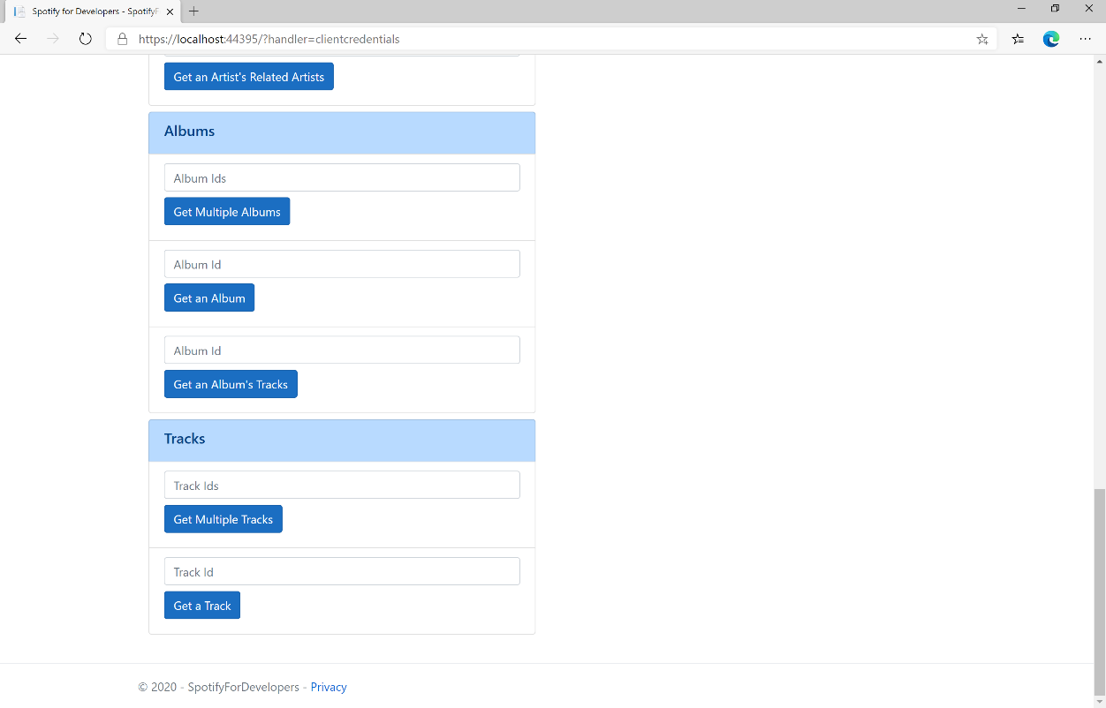

### Step 10

You can then enter an **Album Id** from **Get All New Releases** select **Get an Album's Tracks** and copy a **Track Id** to use and select **Get a Track** and scroll down to view **Results** like the following:

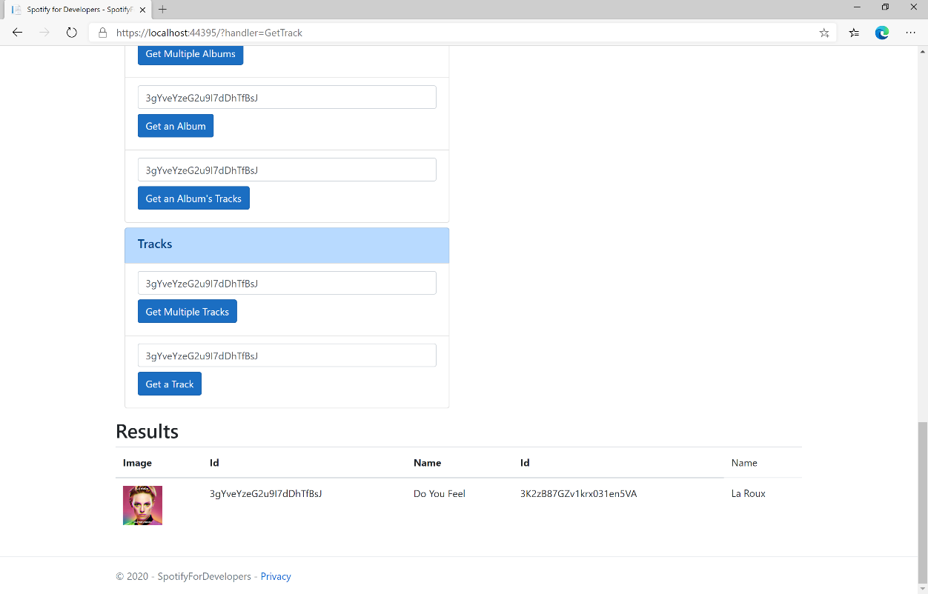

### Step 11

|  |  |
| --- | --- |
|  | You can stop the **web application** in **Visual Studio 2019** by selecting the **Stop debugging** button |

### Step 12

|  |  |
| --- | --- |
|  | You can choose to exit **Visual Studio 2019** by selecting the **Close** button in the top right of the **application** as that completes thispart of the workshop |

## Get Audio Features for Several Tracks

Get audio feature information for a single track identified by its unique Spotify Id.

|  |  |
| --- | --- |
| https://api.spotify.com/v1/audio-features | |
| Header | |
| Authorization | Valid Access Token from Spotify Accounts service |
| Path Parameter | |
| ids | Maximum of 100 comma-separated list of track Spotify Ids |

|  |  |
| --- | --- |
| Header | Response |
| Success | |
| HTTP Status 200 OK | Audio Features with Array of Audio Features Object |
| Error | |
| Error Code | Error Object |

### Step 1

|  |  |
| --- | --- |
|  | If you chose to close **Visual Studio 2019** previously, in **Windows 10** choose **Start**, and then from the **Start Menu** find and select **Visual Studio 2019** |
|  | Once done, from the **Get started** screen for **Visual Studio 2019** select **Open a project or solution** |
|  | Then locate and select **SpotifyForDevelopers.sln** and select **Open** if you don’t have this file already then please follow the previous parts of the workshop including **Getting Started**, **Authorisation Guide**, **Search** **&** **Browse** and **Artists, Albums & Tracks** |

### Step 2

|  |  |
| --- | --- |
|  | Once opened, in the **Solution Explorer** open the **Pages** section, then open the **Index.cshtml** section and select **Index.cshtml.cs** |

### Step 3

|  |  |
| --- | --- |
|  | Then from the **Menu** choose **View** and then **Open** |

### Step 4

In the **Code View** for **Index.cshtml.cs** below the **method** for public async Task<IActionResult> OnPostGetTrackAsync(...) { ... } enter the following **method**:

|  |
| --- |
| public async Task<IActionResult> OnPostGetAudioFeaturesForSeveralTracksAsync(string value)  {  LoadToken();  var values = value.Split(",").ToList();  var results = await Api.GetSeveralTracksAudioFeaturesAsync(values);  if (results != null)  {  Results = results.Select(result => new Result()  {  Name = System.Text.Json.JsonSerializer.Serialize(result,  new System.Text.Json.JsonSerializerOptions()  { WriteIndented = true })  });  }  return Page(); } |

The **method** for OnPostGetAudioFeaturesForSeveralTracksAsync is used to get **audio features** for **tracks** by multiple **Track Ids** on Spotify with the value and populate the **property** for Results accordingly.

### Step 5

|  |  |
| --- | --- |
|  | In the **Solution Explorer** in the **Pages** section select **Index.cshtml** |

### Step 6

|  |  |
| --- | --- |
|  | Then from the **Menu** choose **View** and then **Open** |

### Step 7

Once in the **Code View** for **Index.cshtml** above <!-- Tracks --> enter the following:

|  |
| --- |
| <li class="list-group-item">  <form **asp-page-handler**="GetAudioFeaturesForSeveralTracks" method="post">  <input **asp-for**="Value" placeholder="Track Ids" class="form-control mb-2" />  <button class="btn btn-primary mb-2">  Get Audio Features for Several Tracks  </button>  </form> </li> |

This form will **post** to the **method** for GetAudioFeaturesForSeveralTracks with the Value as the **Track Ids** and will output to the **Results**.

### Step 8

|  |  |
| --- | --- |
|  | Finally, in **Visual Studio 2019** select **IIS Application** to run the **Web Application** |

### Step 9

Once the **Web Application** is running and you select **Client Credentials Flow Login** and scroll down you should see something like the following:

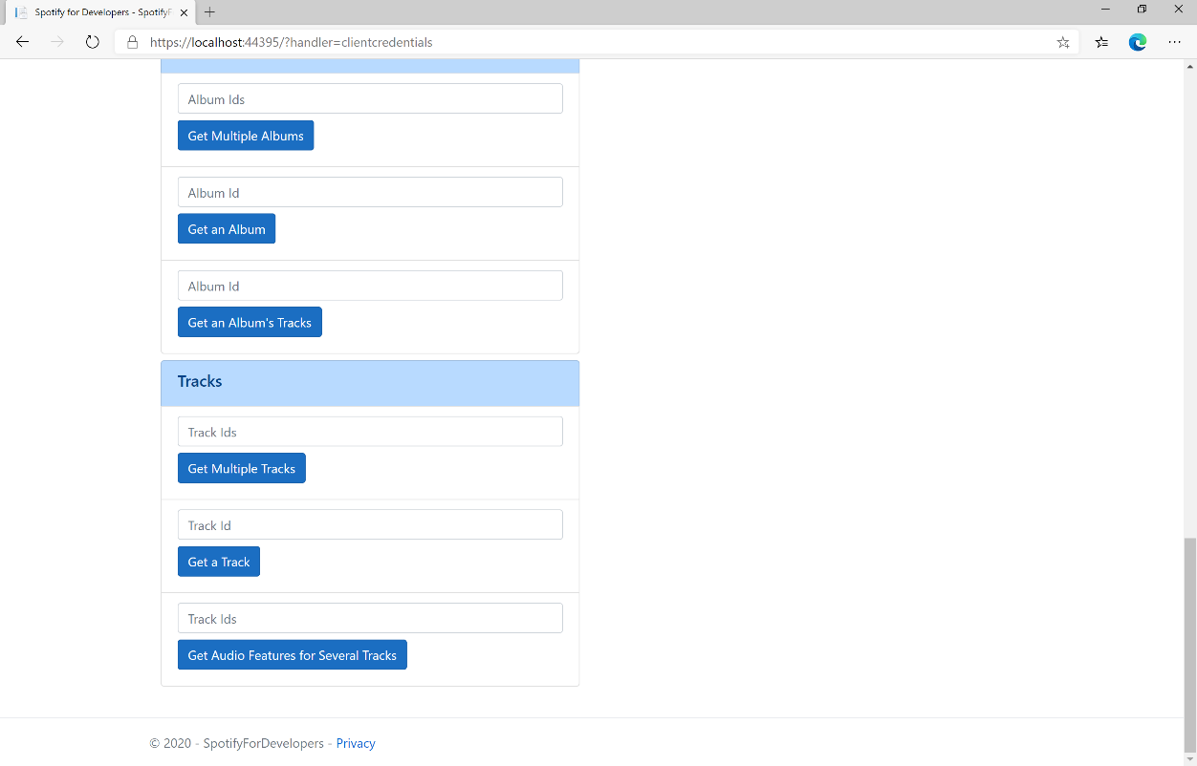

### Step 10

You can then enter an **Album Id** from **Get All New Releases** select **Get an Album's Tracks** and copy some **Track Ids** to use and select **Get Audio Features for Several Tracks** and scroll down to view **Results** like the following:

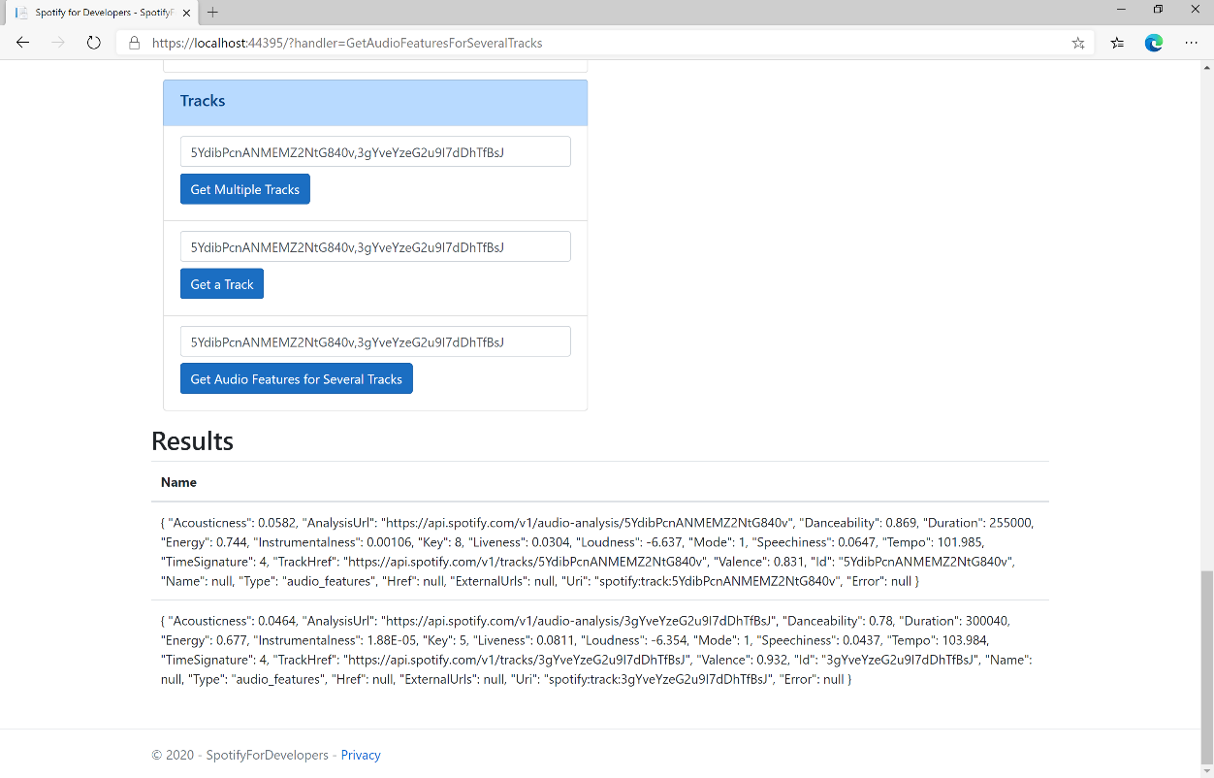

### Step 11

|  |  |
| --- | --- |
|  | You can stop the **web application** in **Visual Studio 2019** by selecting the **Stop debugging** button |

### Step 12

|  |  |
| --- | --- |
|  | You can choose to exit **Visual Studio 2019** by selecting the **Close** button in the top right of the **application** as that completes thispart of the workshop |

## Get Audio Features for a Track

Get audio feature information for a single track identified by its unique Spotify Id.

|  |  |
| --- | --- |
| GET https://api.spotify.com/v1/audio-features/{id} | |
| Header | |
| Authorization | Valid Access Token from Spotify Accounts service |
| Path Parameter | |
| id | Spotify Id of the track |

|  |  |
| --- | --- |
| Header | Response |
| Success | |
| HTTP Status 200 OK | Audio Features Object |
| Error | |
| Error Code | Error Object |

### Step 1

|  |  |
| --- | --- |
|  | If you chose to close **Visual Studio 2019** previously, in **Windows 10** choose **Start**, and then from the **Start Menu** find and select **Visual Studio 2019** |
|  | Once done, from the **Get started** screen for **Visual Studio 2019** select **Open a project or solution** |
|  | Then locate and select **SpotifyForDevelopers.sln** and select **Open** if you don’t have this file already then please follow the previous parts of the workshop including **Getting Started**, **Authorisation Guide**, **Search** **&** **Browse** and **Artists, Albums & Tracks** |

### Step 2

|  |  |
| --- | --- |
|  | Once opened, in the **Solution Explorer** open the **Pages** section, then open the **Index.cshtml** section and select **Index.cshtml.cs** |

### Step 3

|  |  |
| --- | --- |
|  | Then from the **Menu** choose **View** and then **Open** |

### Step 4

In the **Code View** for **Index.cshtml.cs** below the **method** for public async Task<IActionResult> OnPostGetAudioFeaturesForSeveralTracksAsync(...) { ... } enter the following **method**:

|  |
| --- |
| public async Task<IActionResult> OnPostGetAudioFeaturesForTrackAsync(string value)  {  LoadToken();  var result = await Api.GetTrackAudioFeaturesAsync(value);  if (result != null)  {  Results = new List<Result>() { new Result()  {  Name = System.Text.Json.JsonSerializer.Serialize(result,  new System.Text.Json.JsonSerializerOptions()  { WriteIndented = true })  }};  }  return Page(); } |

The **method** for OnPostGetAudioFeaturesForTrackAsync is used to get **audio features** for **track** by **Track Id** on Spotify with the value and populate the **property** for Results accordingly.

### Step 5

|  |  |
| --- | --- |
|  | In the **Solution Explorer** in the **Pages** section select **Index.cshtml** |

### Step 6

|  |  |
| --- | --- |
|  | Then from the **Menu** choose **View** and then **Open** |

### Step 7

Once in the **Code View** for **Index.cshtml** above <!-- Tracks --> enter the following:

|  |
| --- |
| <li class="list-group-item">  <form **asp-page-handler**="GetAudioFeaturesForTrack" method="post">  <input **asp-for**="Value" placeholder="Track Id" class="form-control mb-2" />  <button class="btn btn-primary mb-2">  Get Audio Features for a Track  </button>  </form> </li> |

This form will **post** to the **method** for OnPostGetAudioFeaturesForTrackAsync with the Value as **Track Id** and will output to the **Results**.

### Step 8

|  |  |
| --- | --- |
|  | Finally, in **Visual Studio 2019** select **IIS Application** to run the **Web Application** |

### Step 9

Once the **Web Application** is running and you select **Client Credentials Flow Login** and scroll down you should see something like the following:

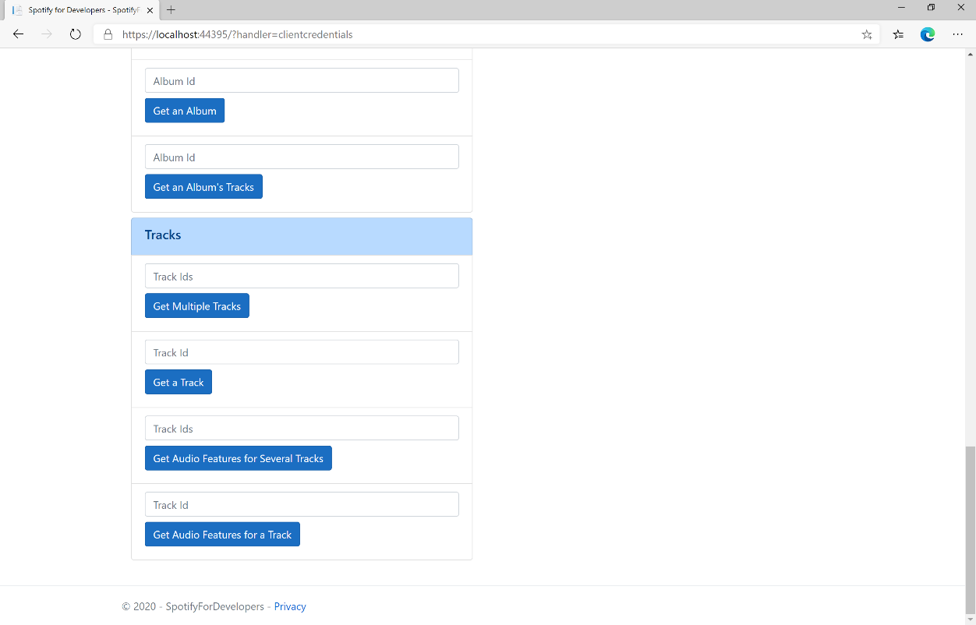

### Step 10

You can then enter an **Album Id** from **Get All New Releases** select **Get an Album's Tracks** and copy a **Track Id** to use and select **Get Audio Features for a Track** and scroll down to view **Results** like the following:

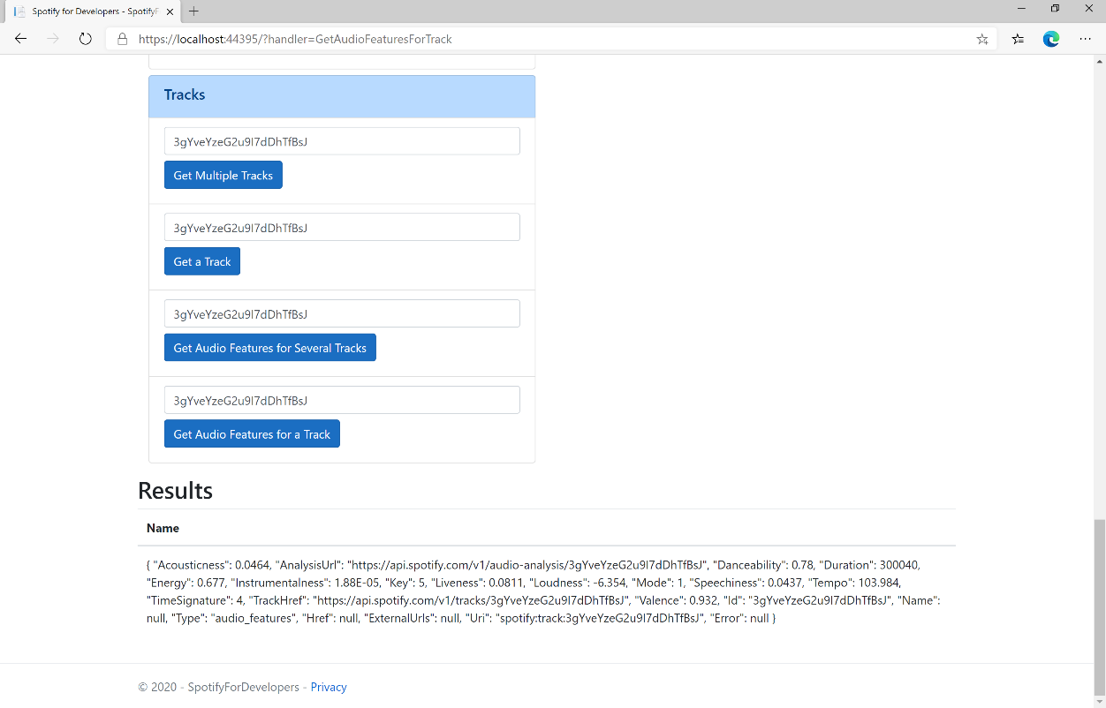

### Step 11

|  |  |
| --- | --- |
|  | You can stop the **web application** in **Visual Studio 2019** by selecting the **Stop debugging** button |

### Step 12

|  |  |
| --- | --- |
|  | You can choose to exit **Visual Studio 2019** by selecting the **Close** button in the top right of the **application** as that completes thispart of the workshop |

## Get Audio Analysis for a Track

Get a detailed audio analysis for a single track identified by its unique Spotify Id.

|  |  |
| --- | --- |
| GET https://api.spotify.com/v1/audio-analysis/{id} | |
| Header | |
| Authorization | Valid Access Token from Spotify Accounts service |
| Path Parameter | |
| id | Spotify Id of the track |

|  |  |
| --- | --- |
| Header | Response |
| Success | |
| HTTP Status 200 OK | Audio Analysis Object |
| Error | |
| Error Code | Error Object |

### Step 1

|  |  |
| --- | --- |
|  | If you chose to close **Visual Studio 2019** previously, in **Windows 10** choose **Start**, and then from the **Start Menu** find and select **Visual Studio 2019** |
|  | Once done, from the **Get started** screen for **Visual Studio 2019** select **Open a project or solution** |
|  | Then locate and select **SpotifyForDevelopers.sln** and select **Open** if you don’t have this file already then please follow the previous parts of the workshop including **Getting Started**, **Authorisation Guide**, **Search** **&** **Browse** and **Artists, Albums & Tracks** |

### Step 2

|  |  |
| --- | --- |
|  | Once opened, in the **Solution Explorer** open the **Pages** section, then open the **Index.cshtml** section and select **Index.cshtml.cs** |

### Step 3

|  |  |
| --- | --- |
|  | Then from the **Menu** choose **View** and then **Open** |

### Step 4

In the **Code View** for **Index.cshtml.cs** below the **method** for public async Task<IActionResult> OnPostGetAudioFeaturesForTrackAsync(...) { ... } enter the following **method**:

|  |
| --- |
| public async Task<IActionResult> OnPostGetTrackAudioAnalysisAsync(string value)  {  LoadToken();  var result = await Api.GetTrackAudioAnalysisAsync(value);  if (result != null)  {  Results = new List<Result>() { new Result()  {  Name = System.Text.Json.JsonSerializer.Serialize(result,  new System.Text.Json.JsonSerializerOptions()  { WriteIndented = true })  }};  }  return Page();  } |

The **method** for OnPostGetTrackAudioAnalysisAsync is used to get **audio analysis** for **track** by **Track Id** on Spotify with the value and populate the **property** for Results accordingly.

### Step 5

|  |  |
| --- | --- |
|  | In the **Solution Explorer** in the **Pages** section select **Index.cshtml** |

### Step 6

|  |  |
| --- | --- |
|  | Then from the **Menu** choose **View** and then **Open** |

### Step 7

Once in the **Code View** for **Index.cshtml** above <!-- Tracks --> enter the following:

|  |
| --- |
| <li class="list-group-item">  <form **asp-page-handler**="GetTrackAudioAnalysis" method="post">  <input **asp-for**="Value" placeholder="Track Id" class="form-control mb-2" />  <button class="btn btn-primary mb-2">  Get Audio Analysis for a Track  </button>  </form>  </li> |

This form will **post** to the **method** for GetTrackAudioAnalysis with the Value as **Track Id** and will output to the **Results**.

### Step 8

|  |  |
| --- | --- |
|  | Finally, in **Visual Studio 2019** select **IIS Application** to run the **Web Application** |

### Step 9

Once the **Web Application** is running and you select **Client Credentials Flow Login** and scroll down you should see something like the following:

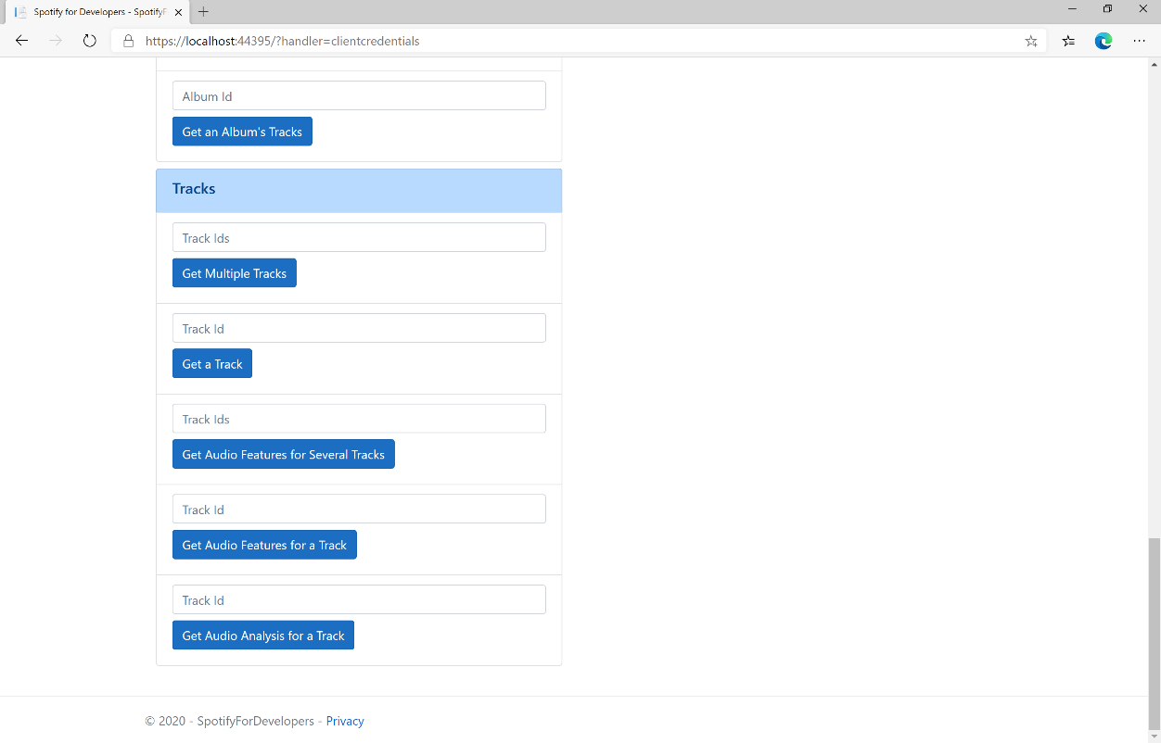

### Step 10

You can then enter an **Album Id** from **Get All New Releases** select **Get an Album's Tracks** and copy a **Track Id** to use and select **Get Audio Analysis for a Track** and scroll down to view **Results** like the following:

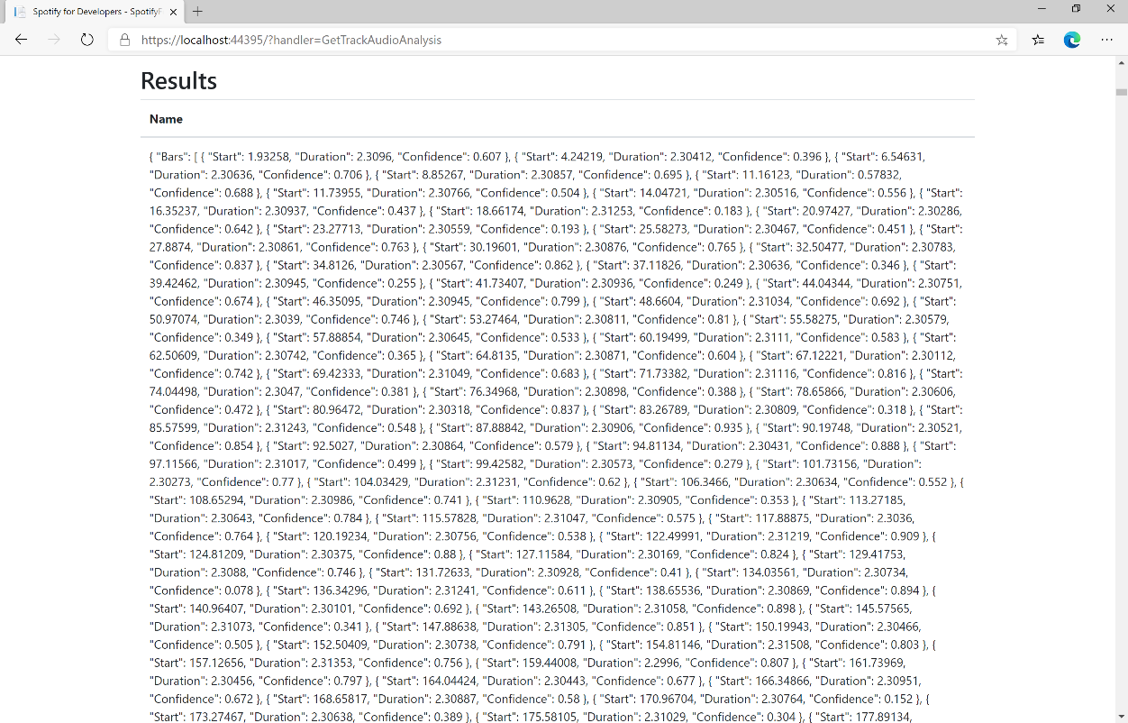

### Step 11

|  |  |
| --- | --- |
|  | You can stop the **web application** in **Visual Studio 2019** by selecting the **Stop debugging** button |

### Step 12

|  |  |
| --- | --- |
|  | You can exit **Visual Studio 2019** by selecting the **Close** button in the top right of the **application** as that completes thispart of the workshop |