|  |
| --- |
|  |
| Spotify for Developers  Follow |
| |  |  |  | | --- | --- | --- | |  |  |  | |

## Follow Artists or Users

Add the current user as a follower of one or more artists or other Spotify users.

|  |  |
| --- | --- |
| PUT https://api.spotify.com/v1/me/following | |
| Header | |
| Authorization | User Token from Spotify Accounts service with **user-follow-modify** scope |
| Query Parameter | |
| type | Type of artist or user |
| ids | Comma-separated list of the artist or the user Spotify Ids - maximum 50 |

|  |  |
| --- | --- |
| Header | Response |
| Success | |
| HTTP Status 204  No Content | Empty Response Body |
| Error | |
| Error Code | Error Object |

### Step 1

|  |  |
| --- | --- |
|  | In **Windows 10** choose **Start**, and then from the **Start Menu** find and select **Visual Studio 2019** |
|  | Once done, from the **Get started** screen for **Visual Studio 2019** select **Open a project or solution** |
|  | Then locate and select **SpotifyForDevelopers.sln** and select **Open** if you don’t have this file already then please follow the previous parts of the workshop including **Getting Started**, **Authorisation Guide**, **Search & Browse**, **Playlists & Artists**, **Albums & Tracks** and **Episodes & Shows** |

### Step 2

|  |  |
| --- | --- |
|  | Once opened, in the **Solution Explorer** open the **Pages** section, then open the **Index.cshtml** section and select **Index.cshtml.cs** |

### Step 3

|  |  |
| --- | --- |
|  | Then from the **Menu** choose **View** and then **Open** |

### Step 4

In the **Code View** for **Index.cshtml.cs** below the **method** for public async Task<IActionResult> OnPostGetShowEpisodesAsync(...) { ... } enter the following **method**:

|  |
| --- |
| public async Task<IActionResult> OnPostFollowArtistsOrUsersAsync(string value, FollowType option)  {  LoadToken();  var values = value.Split(",").ToList();  var result = await Api.FollowArtistsOrUsersAsync(values, option);  if (result != null)  {  Results = new List<Result>() { new Result()  {  Name = result.Success.ToString()  }};  }  return Page();  } |

The **method** for OnPostFollowArtistsOrUsersAsync is used to set the **following state** for an **artist** or **user** by **Artist Id** or **User Id** on Spotify with the value and selected option and populate the **property** for Results accordingly with the **success** of the operation.

### Step 5

|  |  |
| --- | --- |
|  | In the **Solution Explorer** in the **Pages** section select **Index.cshtml** |

### Step 6

|  |  |
| --- | --- |
|  | Then from the **Menu** choose **View** and then **Open** |

### Step 7

Once in the **Code View** for **Index.cshtml** above <!-- Spotify Web API User Authorisation --> enter the following:

|  |
| --- |
| <ul class="list-group mb-2">  <li class="list-group-item list-group-item-primary">  <h5 class="list-group-item-heading">Follow</h5>  </li>  <li class="list-group-item">  <form **asp-page-handler**="FollowArtistsOrUsers" method="post">  <select **asp-for**="Option" class="form-control mb-2"  **asp-items**="Html.GetEnumSelectList<Spotify.NetStandard.Enums.FollowType>()">  </select>  <input **asp-for**="Value" placeholder="Ids" class="form-control mb-2" />  <button class="btn btn-primary mb-2">  Follow Artists or Users  </button>  </form>  </li>  <!-- Follow -->  </ul> |

This form will **post** to the **method** for FollowArtistsOrUsers with the Value of the **Ids** and the Option for the **Artist** or **User** and will output to the **Results**.

### Step 8

|  |  |
| --- | --- |
|  | Finally, in **Visual Studio 2019** select **IIS Application** to run the **Web Application** |

### Step 9

Once the **Web Application** is running and you select **Authorisation Code Flow Login** or **Implicit Grant Flow Login** you should see something like the following:

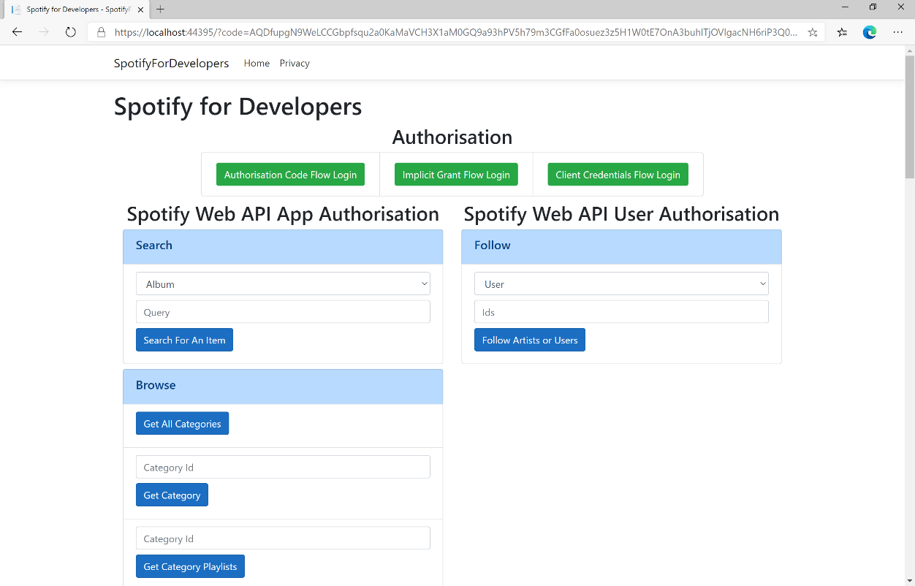

### Step 10

You can then enter an **Artist Id** from **Get All New Releases** and copy an **Artist Id** to use and above **Follow Artists or Users** choose **Artist** and then select **Follow Artists or Users** and scroll down to view **Results** like the following:

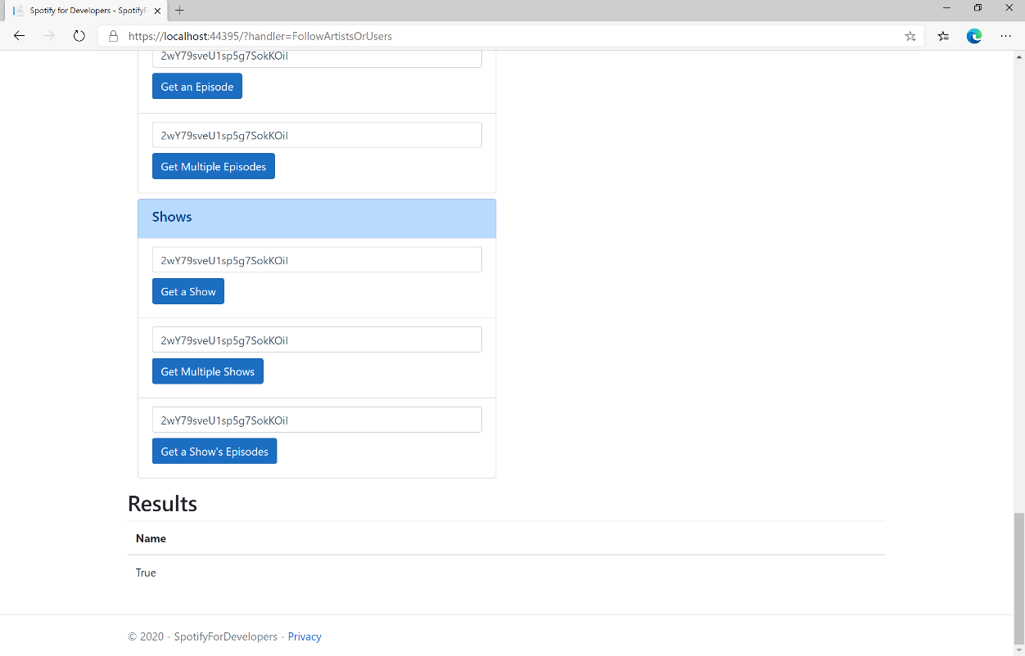

### Step 11

|  |  |
| --- | --- |
|  | You can stop the **web application** in **Visual Studio 2019** by selecting the **Stop debugging** button |

### Step 12

|  |  |
| --- | --- |
|  | You can choose to exit **Visual Studio 2019** by selecting the **Close** button in the top right of the **application** as that completes thispart of the workshop |

## Follow a Playlist

Add the current user as a follower of a playlist.

|  |  |
| --- | --- |
| PUT https://api.spotify.com/v1/playlists/{playlist_id}/followers | |
| Header | |
| Authorization | User Token from Spotify Accounts service with **user-follow-modify** scope |
| Path Parameter | |
| playlist_id | Spotify Id of the playlist |
| Body Parameter | |
| public | Defaults to true. If true the Playlist will be included in the User’s public Playlists, if false it will remain private |

|  |  |
| --- | --- |
| Header | Response |
| Success | |
| HTTP Status 200 OK | Empty Response Body |
| Error | |
| Error Code | Error Object |

### Step 1

|  |  |
| --- | --- |
|  | If you chose to close **Visual Studio 2019** previously, in **Windows 10** choose **Start**, and then from the **Start Menu** find and select **Visual Studio 2019** |
|  | Once done, from the **Get started** screen for **Visual Studio 2019** select **Open a project or solution** |
|  | Then locate and select **SpotifyForDevelopers.sln** and select **Open** if you don’t have this file already then please follow the previous parts of the workshop including **Getting Started**, **Authorisation Guide**, **Search & Browse**, **Playlists & Artists**, **Albums & Tracks**, **Episodes & Shows** and **Follow** |

### Step 2

|  |  |
| --- | --- |
|  | Once opened, in the **Solution Explorer** open the **Pages** section, then open the **Index.cshtml** section and select **Index.cshtml.cs** |

### Step 3

|  |  |
| --- | --- |
|  | Then from the **Menu** choose **View** and then **Open** |

### Step 4

In the **Code View** for **Index.cshtml.cs** below the **method** for public async Task<IActionResult> OnPostFollowArtistsOrUsersAsync(...) { ... } enter the following **method**:

|  |
| --- |
| public async Task<IActionResult> OnPostFollowPlaylistAsync(string value)  {  LoadToken();  var result = await Api.FollowPlaylistAsync(value);  if (result != null)  {  Results = new List<Result>() { new Result()  {  Name = result.Success.ToString()  }};  }  return Page();  } |

The **method** for OnPostFollowPlaylistAsync is used to set the **following state** for a **playlist** by **Playlist Id** on Spotify with the value and populate the **property** for Results accordingly with the **success** of the operation.

### Step 5

|  |  |
| --- | --- |
|  | In the **Solution Explorer** in the **Pages** section select **Index.cshtml** |

### Step 6

|  |  |
| --- | --- |
|  | Then from the **Menu** choose **View** and then **Open** |

### Step 7

Once in the **Code View** for **Index.cshtml** above <!-- Follow --> enter the following:

|  |
| --- |
| <li class="list-group-item">  <form **asp-page-handler**="FollowPlaylist" method="post">  <input **asp-for**="Value" placeholder="Playlist Id" class="form-control mb-2" />  <button class="btn btn-primary mb-2">  Follow a Playlist  </button>  </form>  </li> |

This form will **post** to the **method** for FollowPlaylist with the Value of the **Playlist Id** and will output to the **Results**.

### Step 8

|  |  |
| --- | --- |
|  | Finally, in **Visual Studio 2019** select **IIS Application** to run the **Web Application** |

### Step 9

Once the **Web Application** is running and you select **Authorisation Code Flow Login** or **Implicit Grant Flow Login** you should see something like the following:

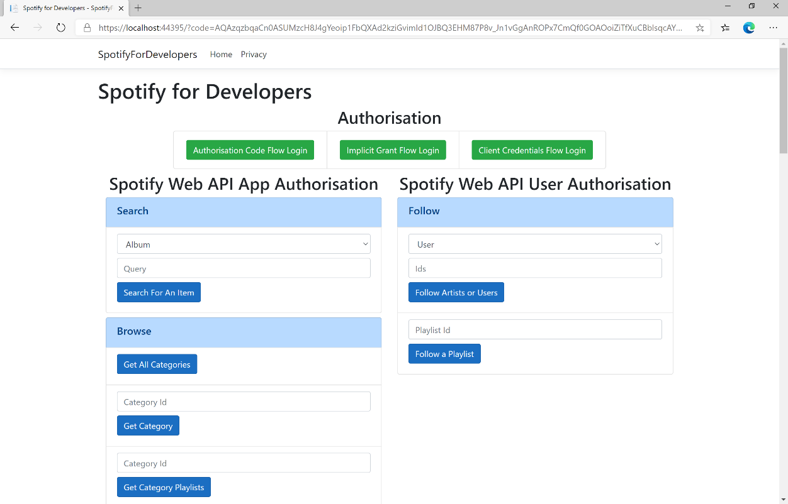

### Step 10

You can then enter a **Playlist Id** from **Get All Featured Playlists** and copy a **Playlist Id** to use and select **Follow a Playlist** and scroll down to view **Results** like the following:

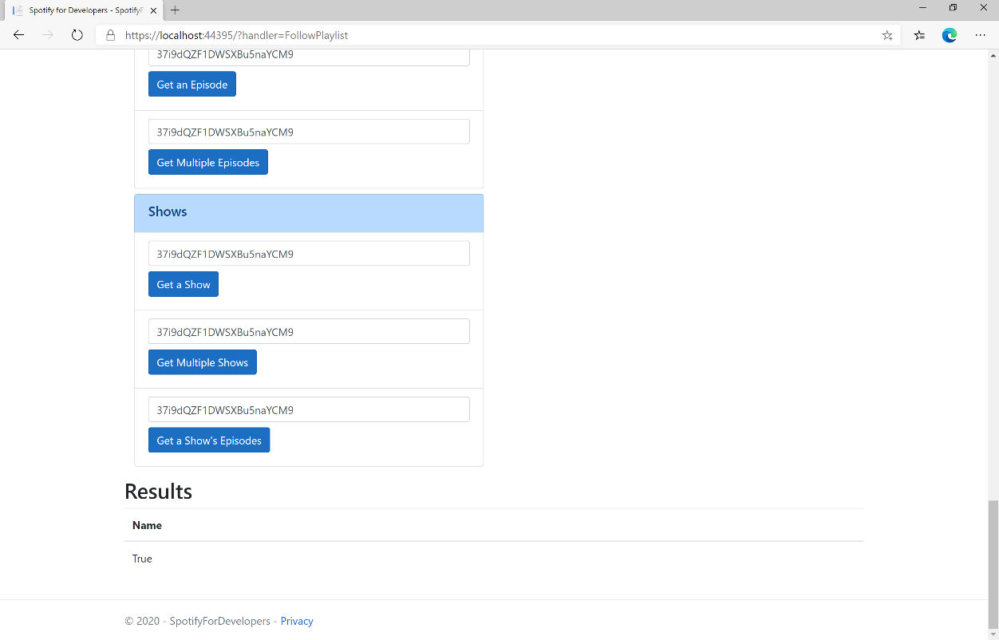

### Step 11

|  |  |
| --- | --- |
|  | You can stop the **web application** in **Visual Studio 2019** by selecting the **Stop debugging** button |

### Step 12

|  |  |
| --- | --- |
|  | You can choose to exit **Visual Studio 2019** by selecting the **Close** button in the top right of the **application** as that completes thispart of the workshop |

## Get Following State for Artists/Users

Check to see if the current user is following one or more artists or other Spotify users.

|  |  |
| --- | --- |
| GET https://api.spotify.com/v1/me/following/contains | |
| Header | |
| Authorization | User Token from Spotify Accounts service with **user-follow-read** scope |
| Query Parameter | |
| type | Type of artist or user |
| ids | Comma-separated list of the artist or the user Spotify Ids to check |

|  |  |
| --- | --- |
| Header | Response |
| Success | |
| HTTP Status 200 OK | Array of true or false values in same order as in which the Ids were provided |
| Error | |
| Error Code | Error Object |

### Step 1

|  |  |
| --- | --- |
|  | If you chose to close **Visual Studio 2019** previously, in **Windows 10** choose **Start**, and then from the **Start Menu** find and select **Visual Studio 2019** |
|  | Once done, from the **Get started** screen for **Visual Studio 2019** select **Open a project or solution** |
|  | Then locate and select **SpotifyForDevelopers.sln** and select **Open** if you don’t have this file already then please follow the previous parts of the workshop including **Getting Started**, **Authorisation Guide**, **Search & Browse**, **Playlists & Artists**, **Albums & Tracks**, **Episodes & Shows** and **Follow** |

### Step 2

|  |  |
| --- | --- |
|  | Once opened, in the **Solution Explorer** open the **Pages** section, then open the **Index.cshtml** section and select **Index.cshtml.cs** |

### Step 3

|  |  |
| --- | --- |
|  | Then from the **Menu** choose **View** and then **Open** |

### Step 4

In the **Code View** for **Index.cshtml.cs** below the **method** for public async Task<IActionResult> OnPostFollowPlaylistAsync(...) { ... } enter the following **method**:

|  |
| --- |
| public async Task<IActionResult> OnPostGetFollowingStateForArtistsOrUsersAsync(string value, FollowType option)  {  LoadToken();  var values = value.Split(",").ToList();  var results = await Api.GetFollowingStateForArtistsOrUsersAsync(values, option);  if (results != null)  {  Results = results.Select(result => new Result()  {  Name = result.ToString()  });  }  return Page();  } |

The **method** for OnPostGetFollowingStateForArtistsOrUsersAsync is used to get the **following state** for a **artist** or **user** by **Artist Id** or **User Id** on Spotify with the value and selected option and populate the **property** for Results accordingly.

### Step 5

|  |  |
| --- | --- |
|  | In the **Solution Explorer** in the **Pages** section select **Index.cshtml** |

### Step 6

|  |  |
| --- | --- |
|  | Then from the **Menu** choose **View** and then **Open** |

### Step 7

Once in the **Code View** for **Index.cshtml** above <!-- Follow --> enter the following:

|  |
| --- |
| <li class="list-group-item">  <form **asp-page-handler**="GetFollowingStateForArtistsOrUsers" method="post">  <select **asp-for**="Option" class="form-control mb-2"  **asp-items**="Html.GetEnumSelectList<Spotify.NetStandard.Enums.FollowType>()">  </select>  <input **asp-for**="Value" placeholder="Ids" class="form-control mb-2" />  <button class="btn btn-primary mb-2">  Get Following State for Artists or Users  </button>  </form>  </li> |

This form will **post** to the **method** for GetFollowingStateForArtistsOrUsers with the Value of the **Ids** and the Option for the **Artist** or **User** and will output to the **Results**.

### Step 8

|  |  |
| --- | --- |
|  | Finally, in **Visual Studio 2019** select **IIS Application** to run the **Web Application** |

### Step 9

Once the **Web Application** is running and you select **Authorisation Code Flow Login** or **Implicit Grant Flow Login** you should see something like the following:

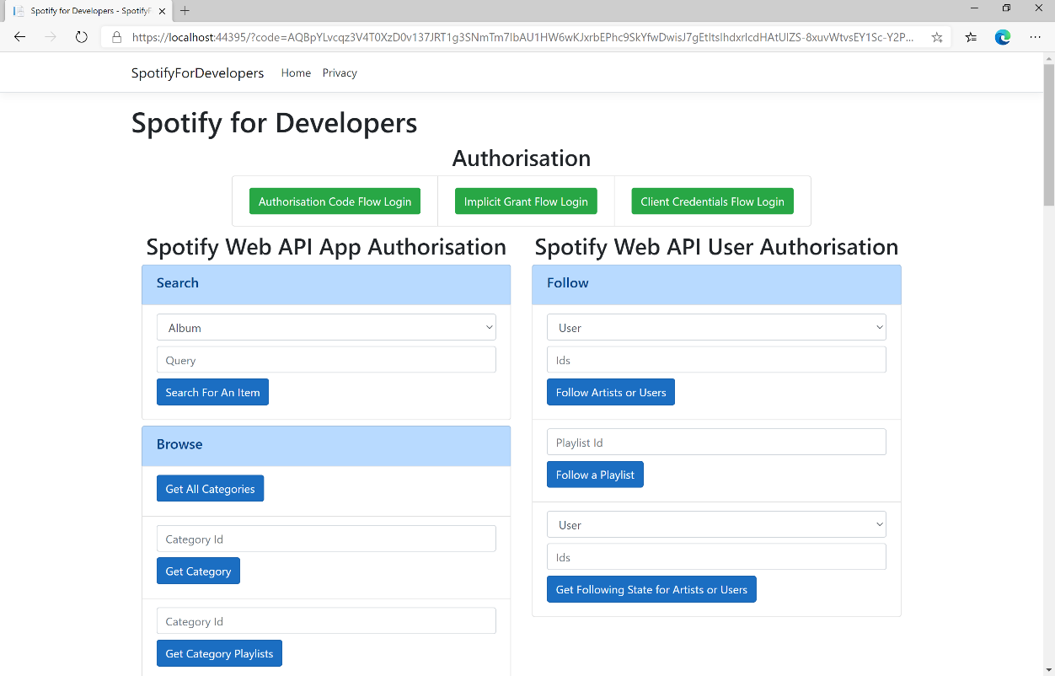

### Step 10

You can then enter an **Artist Id** from **Get All New Releases** or copy the same **Artist Id** from **Follow Artists or Users** to use and above **Get Following State for Artists or Users** choose **Artist** and then select **Get Following State for Artists or Users** and scroll down to view **Results** like the following:

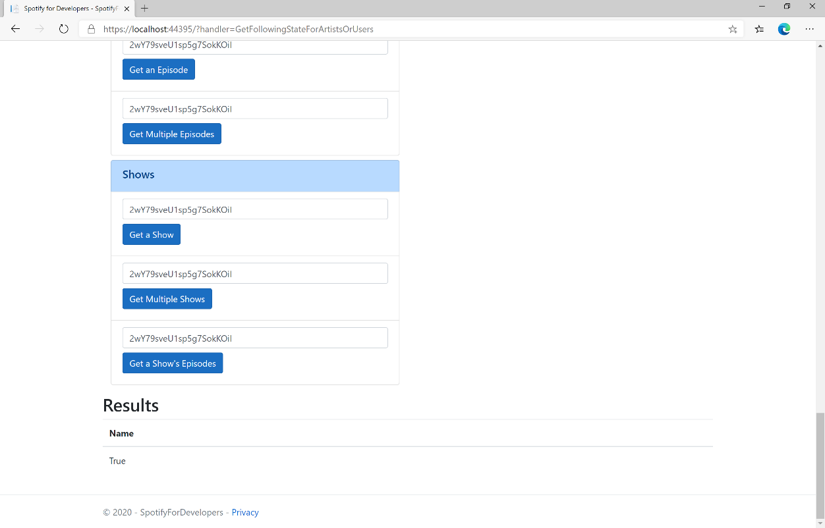

### Step 11

|  |  |
| --- | --- |
|  | You can stop the **web application** in **Visual Studio 2019** by selecting the **Stop debugging** button |

### Step 12

|  |  |
| --- | --- |
|  | You can choose to exit **Visual Studio 2019** by selecting the **Close** button in the top right of the **application** as that completes thispart of the workshop |

## Check if Users Follow a Playlist

Check to see if one or more Spotify users are following a specified playlist.

|  |  |
| --- | --- |
| GET https://api.spotify.com/v1/playlists/{playlist_id}/followers/contains | |
| Header | |
| Authorization | User Token from Spotify Accounts service with **playlist-read-private** scope if a private playlist is requested |
| Path Parameter | |
| playlist_id | Spotify Id of the playlist. |
| Query Parameter | |
| ids | Comma-separated list of Spotify User Ids you want to check to see if they follow the playlist |

|  |  |
| --- | --- |
| Header | Response |
| Success | |
| HTTP Status 200 OK | Array of true or false values in same order as in which the Ids were provided |
| Error | |
| Error Code | Error Object |

### Step 1

|  |  |
| --- | --- |
|  | If you chose to close **Visual Studio 2019** previously, in **Windows 10** choose **Start**, and then from the **Start Menu** find and select **Visual Studio 2019** |
|  | Once done, from the **Get started** screen for **Visual Studio 2019** select **Open a project or solution** |
|  | Then locate and select **SpotifyForDevelopers.sln** and select **Open** if you don’t have this file already then please follow the previous parts of the workshop including **Getting Started**, **Authorisation Guide**, **Search & Browse**, **Playlists & Artists**, **Albums & Tracks**, **Episodes & Shows** and **Follow** |

### Step 2

|  |  |
| --- | --- |
|  | Once opened, in the **Solution Explorer** open the **Pages** section, then open the **Index.cshtml** section and select **Index.cshtml.cs** |

### Step 3

|  |  |
| --- | --- |
|  | Then from the **Menu** choose **View** and then **Open** |

### Step 4

In the **Code View** for **Index.cshtml.cs** below the **method** for public async Task<IActionResult> OnPostGetFollowingStateForArtistsOrUsersAsync(...) { ... } enter the following **method**:

|  |
| --- |
| public async Task<IActionResult> OnPostCheckUsersFollowingPlaylistAsync(string value, string option)  {  LoadToken();  var values = value.Split(",").ToList();  var results = await Api.CheckUsersFollowingPlaylistAsync(values, option);  if (results != null)  {  Results = results.Select(result => new Result()  {  Name = result.ToString()  });  }  return Page();  } |

The **method** for OnPostCheckUsersFollowingPlaylistAsync is used to get the **following state** for a **playlist** by **Artist Id** for the **users** by **User Id** on Spotify with the value and option and populate the **property** for Results accordingly.

### Step 5

|  |  |
| --- | --- |
|  | In the **Solution Explorer** in the **Pages** section select **Index.cshtml** |

### Step 6

|  |  |
| --- | --- |
|  | Then from the **Menu** choose **View** and then **Open** |

### Step 7

Once in the **Code View** for **Index.cshtml** above <!-- Follow --> enter the following:

|  |
| --- |
| <li class="list-group-item">  <form **asp-page-handler**="CheckUsersFollowingPlaylist" method="post">  <input **asp-for**="Option" placeholder="Playlist Id" class="form-control mb-2" />  <input **asp-for**="Value" placeholder="User Ids" class="form-control mb-2" />  <button class="btn btn-primary mb-2">  Check if Users Follow a Playlist  </button>  </form>  </li> |

This form will **post** to the **method** for CheckUsersFollowingPlaylist with the Value of the **Playlist Id** and the Option for the **User Id** and will output to the **Results**.

### Step 8

|  |  |
| --- | --- |
|  | Finally, in **Visual Studio 2019** select **IIS Application** to run the **Web Application** |

### Step 9

Once the **Web Application** is running and you select **Authorisation Code Flow Login** or **Implicit Grant Flow Login** and scroll down you should see something like the following:

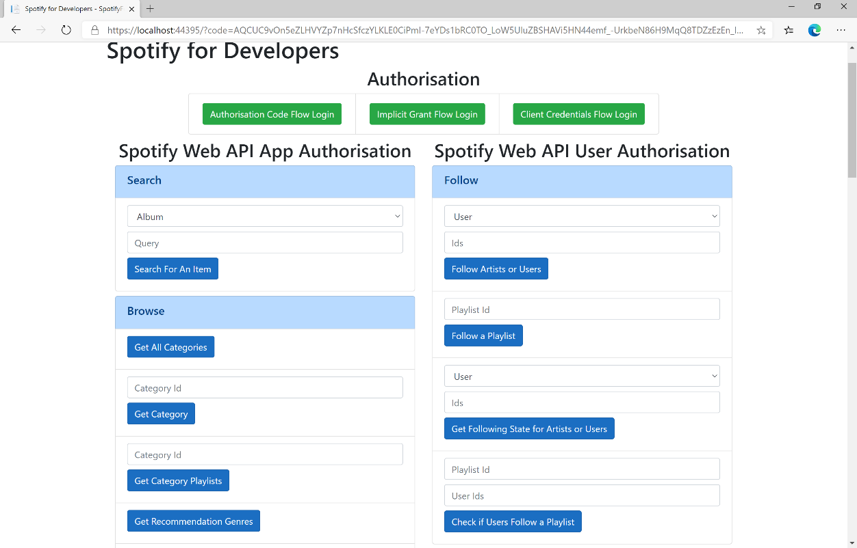

### Step 10

Use the same **Playlist Id** from **Follow a Playlist** and use your own **User Id**, to get this in **Spotify** select your **Username** then **...** and **Copy Spotify URI** your **User Id** will be after **spotify:user:** then enter this above **Check if Users Follow a Playlist** and then select **Check if Users Follow a Playlist** and scroll down to view **Results** like the following:

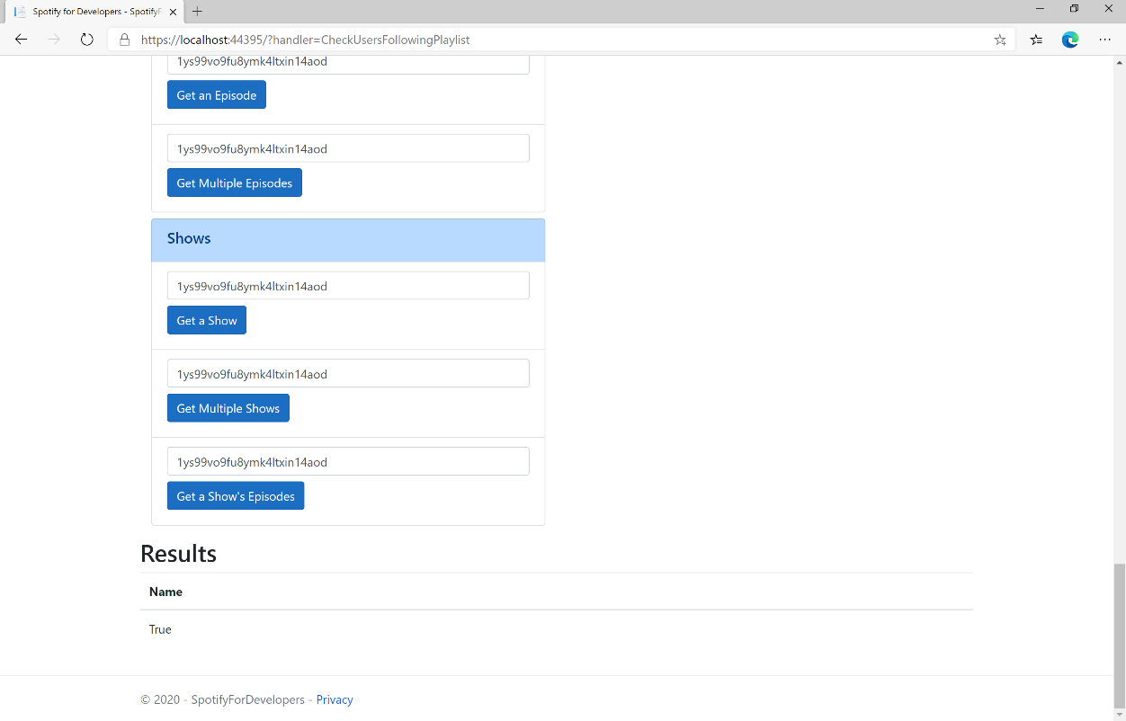

### Step 11

|  |  |
| --- | --- |
|  | You can stop the **web application** in **Visual Studio 2019** by selecting the **Stop debugging** button |

### Step 12

|  |  |
| --- | --- |
|  | You can choose to exit **Visual Studio 2019** by selecting the **Close** button in the top right of the **application** as that completes thispart of the workshop |

## Get User's Followed Artists

Get the current user’s followed artists.

|  |  |
| --- | --- |
| GET https://api.spotify.com/v1/me/following | |
| Header | |
| Authorization | User Token from Spotify Accounts service with **user-follow-modify** scope |
| Query Parameter | |
| type | Id type, only artist is currently supported |
| limit | Maximum number of items to return. Default: 20. Minimum: 1. Maximum: 50. |
| after | Last artist Id retrieved from the previous request. |

|  |  |
| --- | --- |
| Header | Response |
| Success | |
| HTTP Status 200 OK | Object containing a cursor-based paging object of Artist Objects |
| Error | |
| Error Code | Error Object |

### Step 1

|  |  |
| --- | --- |
|  | If you chose to close **Visual Studio 2019** previously, in **Windows 10** choose **Start**, and then from the **Start Menu** find and select **Visual Studio 2019** |
|  | Once done, from the **Get started** screen for **Visual Studio 2019** select **Open a project or solution** |
|  | Then locate and select **SpotifyForDevelopers.sln** and select **Open** if you don’t have this file already then please follow the previous parts of the workshop including **Getting Started**, **Authorisation Guide**, **Search & Browse**, **Playlists & Artists**, **Albums & Tracks**, **Episodes & Shows** and **Follow** |

### Step 2

|  |  |
| --- | --- |
|  | Once opened, in the **Solution Explorer** open the **Pages** section, then open the **Index.cshtml** section and select **Index.cshtml.cs** |

### Step 3

|  |  |
| --- | --- |
|  | Then from the **Menu** choose **View** and then **Open** |

### Step 4

In the **Code View** for **Index.cshtml.cs** below the **method** for public async Task<IActionResult> OnPostCheckUsersFollowingPlaylistAsync(...) { ... } enter the following **method**:

|  |
| --- |
| public async Task<IActionResult> OnPostGetUsersFollowedArtistsAsync()  {  LoadToken();  var results = await Api.GetUsersFollowedArtistsAsync();  if (results != null)  {  Results = results.Items.Select(result => new Result()  {  Id = result.Id,  Name = result.Name,  Image = result?.Images?.FirstOrDefault()?.Url  });  }  return Page();  } |

The **method** for OnPostGetUsersFollowedArtistsAsync is used to get the **followed artists** for the logged in **user** and populate the **property** for Results accordingly.

### Step 5

|  |  |
| --- | --- |
|  | In the **Solution Explorer** in the **Pages** section select **Index.cshtml** |

### Step 6

|  |  |
| --- | --- |
|  | Then from the **Menu** choose **View** and then **Open** |

### Step 7

Once in the **Code View** for **Index.cshtml** above <!-- Follow --> enter the following:

|  |
| --- |
| <li class="list-group-item">  <form **asp-page-handler**="GetUsersFollowedArtists" method="post">  <button class="btn btn-primary mb-2">  Get User's Followed Artists  </button>  </form>  </li> |

This form will **post** to the **method** for GetUsersFollowedArtists and will output to the **Results**.

### Step 8

|  |  |
| --- | --- |
|  | Finally, in **Visual Studio 2019** select **IIS Application** to run the **Web Application** |

### Step 9

Once the **Web Application** is running and you select **Authorisation Code Flow Login** or **Implicit Grant Flow Login** and scroll down you should see something like the following:

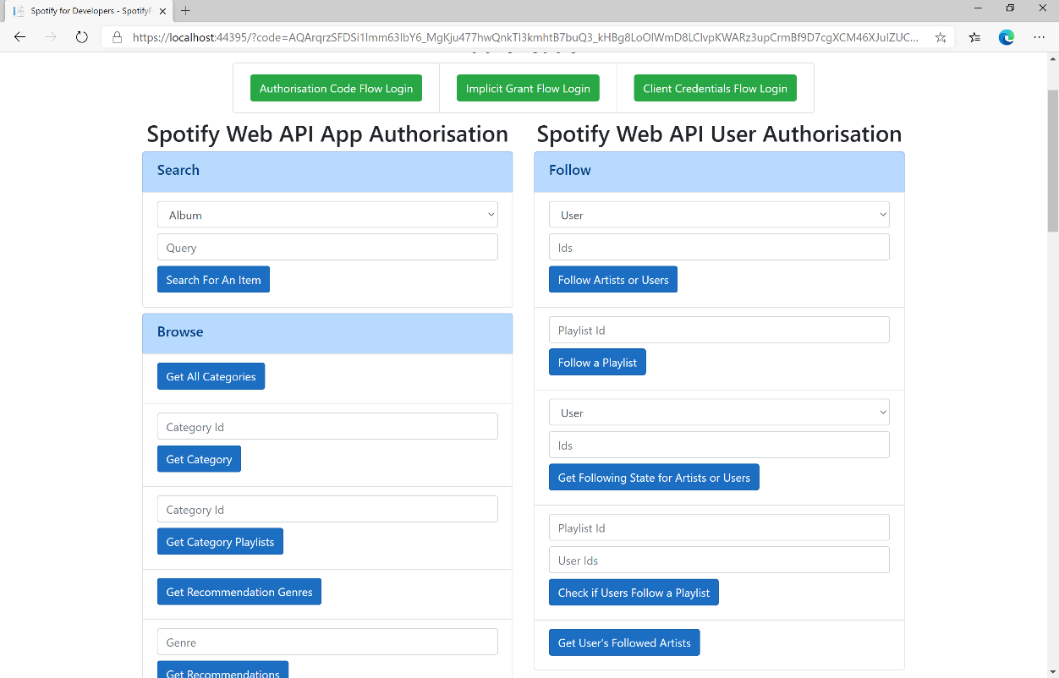

### Step 10

You can select **Get User's Followed Artists** and scroll down to view **Results** like the following:

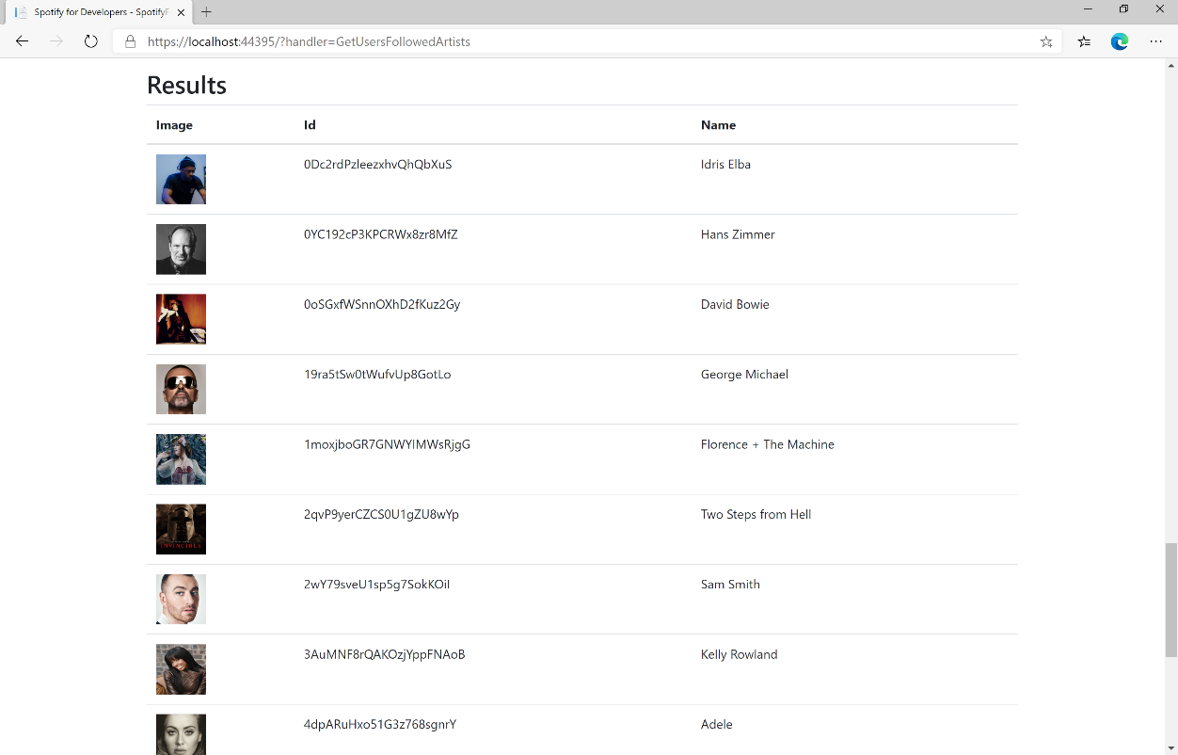

### Step 11

|  |  |
| --- | --- |
|  | You can stop the **web application** in **Visual Studio 2019** by selecting the **Stop debugging** button |

### Step 12

|  |  |
| --- | --- |
|  | You can choose to exit **Visual Studio 2019** by selecting the **Close** button in the top right of the **application** as that completes thispart of the workshop |

## Unfollow Artists or Users

Remove the current user as a follower of one or more artists or other Spotify users.

|  |  |
| --- | --- |
| DELETE https://api.spotify.com/v1/me/following | |
| Header | |
| Authorization | User Token from Spotify Accounts service with **user-follow-modify** scope |
| Query Parameter | |
| type | Type of artist or user |
| ids | Comma-separated list of the artist or the user Spotify Ids - maximum 50 |

|  |  |
| --- | --- |
| Header | Response |
| Success | |
| HTTP Status 204  No Content | Empty Response Body |
| Error | |
| Error Code | Error Object |

### Step 1

|  |  |
| --- | --- |
|  | If you chose to close **Visual Studio 2019** previously, in **Windows 10** choose **Start**, and then from the **Start Menu** find and select **Visual Studio 2019** |
|  | Once done, from the **Get started** screen for **Visual Studio 2019** select **Open a project or solution** |
|  | Then locate and select **SpotifyForDevelopers.sln** and select **Open** if you don’t have this file already then please follow the previous parts of the workshop including **Getting Started**, **Authorisation Guide**, **Search & Browse**, **Playlists & Artists**, **Albums & Tracks**, **Episodes & Shows** and **Follow** |

### Step 2

|  |  |
| --- | --- |
|  | Once opened, in the **Solution Explorer** open the **Pages** section, then open the **Index.cshtml** section and select **Index.cshtml.cs** |

### Step 3

|  |  |
| --- | --- |
|  | Then from the **Menu** choose **View** and then **Open** |

### Step 4

In the **Code View** for **Index.cshtml.cs** below the **method** for public async Task<IActionResult> OnPostGetUsersFollowedArtistsAsync(...) { ... } enter the following **method**:

|  |
| --- |
| public async Task<IActionResult> OnPostUnfollowArtistsOrUsersAsync(string value, FollowType option)  {  LoadToken();  var values = value.Split(",").ToList();  var result = await Api.UnfollowArtistsOrUsersAsync(values, option);  if (result != null)  {  Results = new List<Result>() { new Result()  {  Name = result.Success.ToString()  }};  }  return Page();  } |

The **method** for OnPostUnfollowArtistsOrUsersAsync is used to **unfollow** an **artist** or **user** by **Artist Id** or **User Id** on Spotify with the value and selected option and populate the **property** for Results accordingly with the **success** of the operation.

### Step 5

|  |  |
| --- | --- |
|  | In the **Solution Explorer** in the **Pages** section select **Index.cshtml** |

### Step 6

|  |  |
| --- | --- |
|  | Then from the **Menu** choose **View** and then **Open** |

### Step 7

Once in the **Code View** for **Index.cshtml** above <!-- Follow --> enter the following:

|  |
| --- |
| <li class="list-group-item">  <form **asp-page-handler**="UnfollowArtistsOrUsers" method="post">  <select **asp-for**="Option" class="form-control mb-2"  **asp-items**="Html.GetEnumSelectList<Spotify.NetStandard.Enums.FollowType>()">  </select>  <input **asp-for**="Value" placeholder="Id" class="form-control mb-2" />  <button class="btn btn-primary mb-2">  Unfollow Artists or Users  </button>  </form>  </li> |

This form will **post** to the **method** for UnfollowArtistsOrUsers with the Value of the **Ids** and the Option for the **Artist** or **User** and will output to the **Results**.

### Step 8

|  |  |
| --- | --- |
|  | Finally, in **Visual Studio 2019** select **IIS Application** to run the **Web Application** |

### Step 9

Once the **Web Application** is running and you select **Authorisation Code Flow Login** or **Implicit Grant Flow Login** and scroll down you should see something like the following:

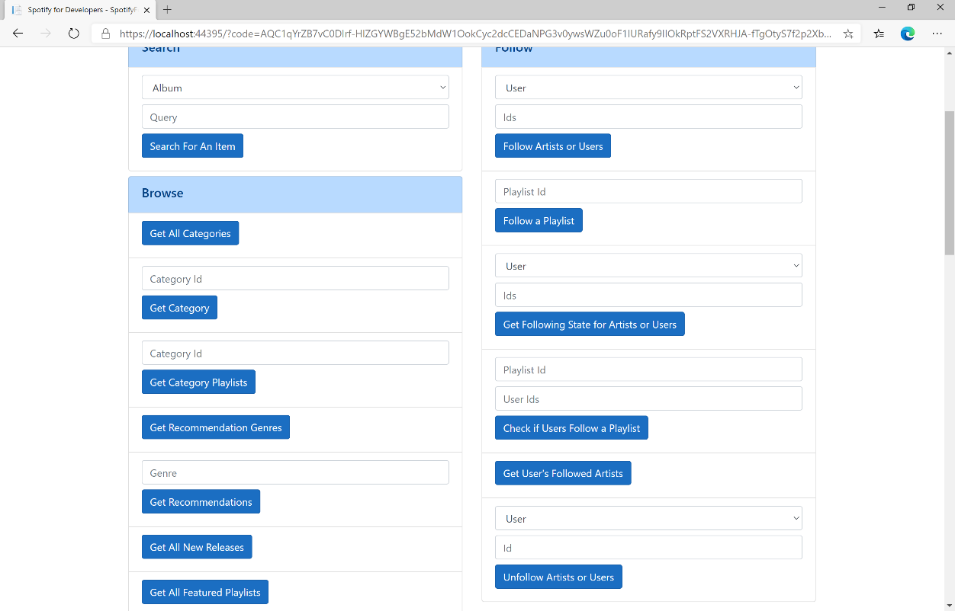

### Step 10

You can then enter an **Artist Id** from **Get All New Releases** or the same **Artist Id** from **Follow Artists or Users** to use and above **Unfollow Artists or Users** choose **Artist** and then select **Unfollow Artists or Users** and scroll down to view **Results** like the following:

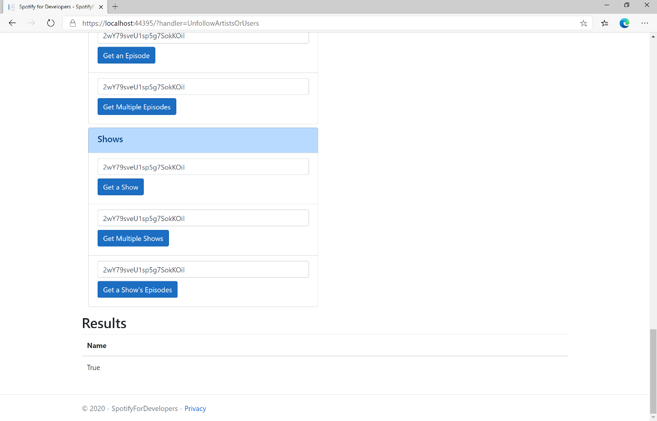

### Step 11

|  |  |
| --- | --- |
|  | You can stop the **web application** in **Visual Studio 2019** by selecting the **Stop debugging** button |

### Step 12

|  |  |
| --- | --- |
|  | You can choose to exit **Visual Studio 2019** by selecting the **Close** button in the top right of the **application** as that completes thispart of the workshop |

## Unfollow Playlist

Remove the current user as a follower of a playlist.

|  |  |
| --- | --- |
| DELETE https://api.spotify.com/v1/playlists/{playlist_id}/followers | |
| Header | |
| Authorization | User Token from Spotify Accounts service with **playlist-modify-public** scope for publicly followed playlist and **playlist-modify-private** for a privately followed playlist |
| Path Parameter | |
| playlist_id | Spotify Id of the playlist |

|  |  |
| --- | --- |
| Header | Response |
| Success | |
| HTTP Status 200 OK | Empty Response Body |
| Error | |
| Error Code | Error Object |

### Step 1

|  |  |
| --- | --- |
|  | If you chose to close **Visual Studio 2019** previously, in **Windows 10** choose **Start**, and then from the **Start Menu** find and select **Visual Studio 2019** |
|  | Once done, from the **Get started** screen for **Visual Studio 2019** select **Open a project or solution** |
|  | Then locate and select **SpotifyForDevelopers.sln** and select **Open** if you don’t have this file already then please follow the previous parts of the workshop including **Getting Started**, **Authorisation Guide**, **Search & Browse**, **Playlists & Artists**, **Albums & Tracks**, **Episodes & Shows** and **Follow** |

### Step 2

|  |  |
| --- | --- |
|  | Once opened, in the **Solution Explorer** open the **Pages** section, then open the **Index.cshtml** section and select **Index.cshtml.cs** |

### Step 3

|  |  |
| --- | --- |
|  | Then from the **Menu** choose **View** and then **Open** |

### Step 4

In the **Code View** for **Index.cshtml.cs** below the **method** for public async Task<IActionResult> OnPostUnfollowArtistsOrUsersAsync(...) { ... } enter the following **method**:

|  |
| --- |
| public async Task<IActionResult> OnPostUnfollowPlaylistAsync(string value)  {  LoadToken();  var result = await Api.UnfollowPlaylistAsync(value);  if (result != null)  {  Results = new List<Result>() { new Result()  {  Name = result.Success.ToString()  }};  }  return Page();  } |

The **method** for OnPostUnfollowPlaylistAsync is used to **unfollow** a **playlist** by **Playlist Id** on Spotify with the value and populate the **property** for Results accordingly with the **success** of the operation.

### Step 5

|  |  |
| --- | --- |
|  | In the **Solution Explorer** in the **Pages** section select **Index.cshtml** |

### Step 6

|  |  |
| --- | --- |
|  | Then from the **Menu** choose **View** and then **Open** |

### Step 7

Once in the **Code View** for **Index.cshtml** above <!-- Follow --> enter the following:

|  |
| --- |
| <li class="list-group-item">  <form **asp-page-handler**="UnfollowPlaylist" method="post">  <input **asp-for**="Value" placeholder="Playlist Id" class="form-control mb-2" />  <button class="btn btn-primary mb-2">  Unfollow a Playlist  </button>  </form>  </li> |

This form will **post** to the **method** for UnfollowPlaylist with the Value of the **Playlist Id** and will output to the **Results**.

### Step 8

|  |  |
| --- | --- |
|  | Finally, in **Visual Studio 2019** select **IIS Application** to run the **Web Application** |

### Step 9

Once the **Web Application** is running and you select **Authorisation Code Flow Login** or **Implicit Grant Flow Login** and scroll down you should see something like the following:

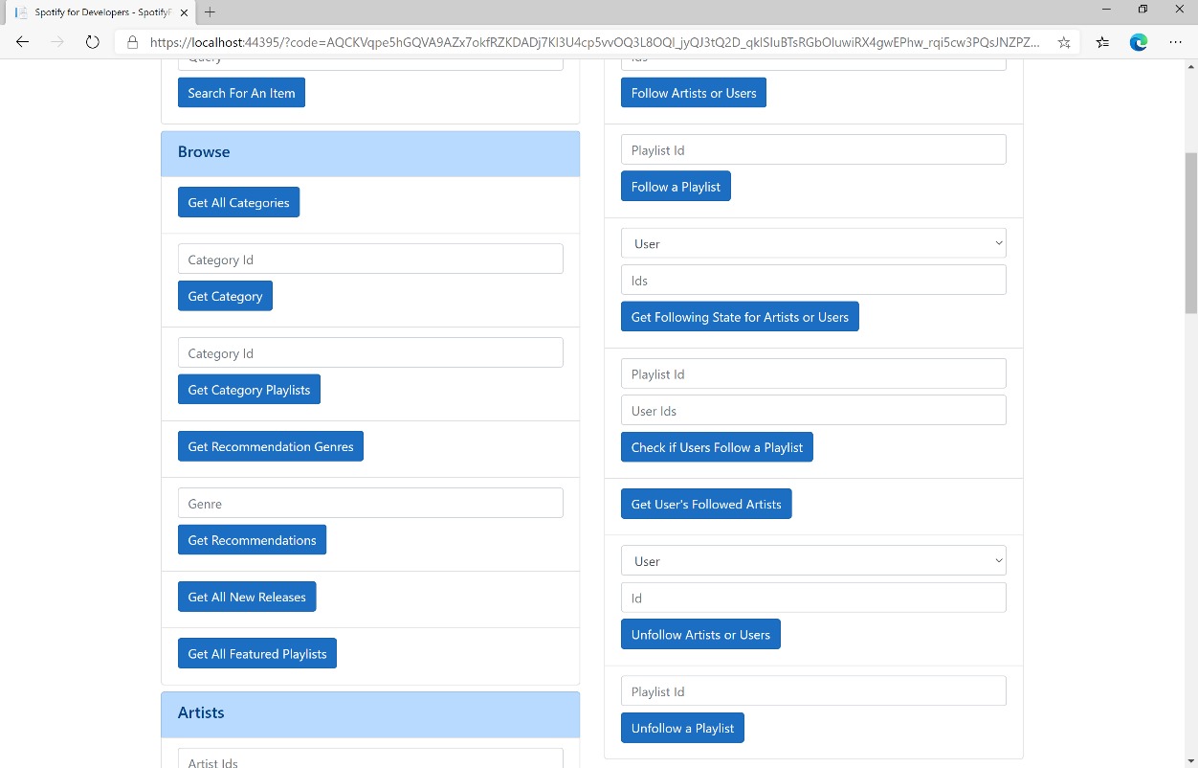

### Step 10

You can then enter a **Playlist Id** from **Get All Featured Playlists** or the same **Playlist Id** from **Follow a Playlist** to use and select **Unfollow a Playlist** and scroll down to view **Results** like the following:

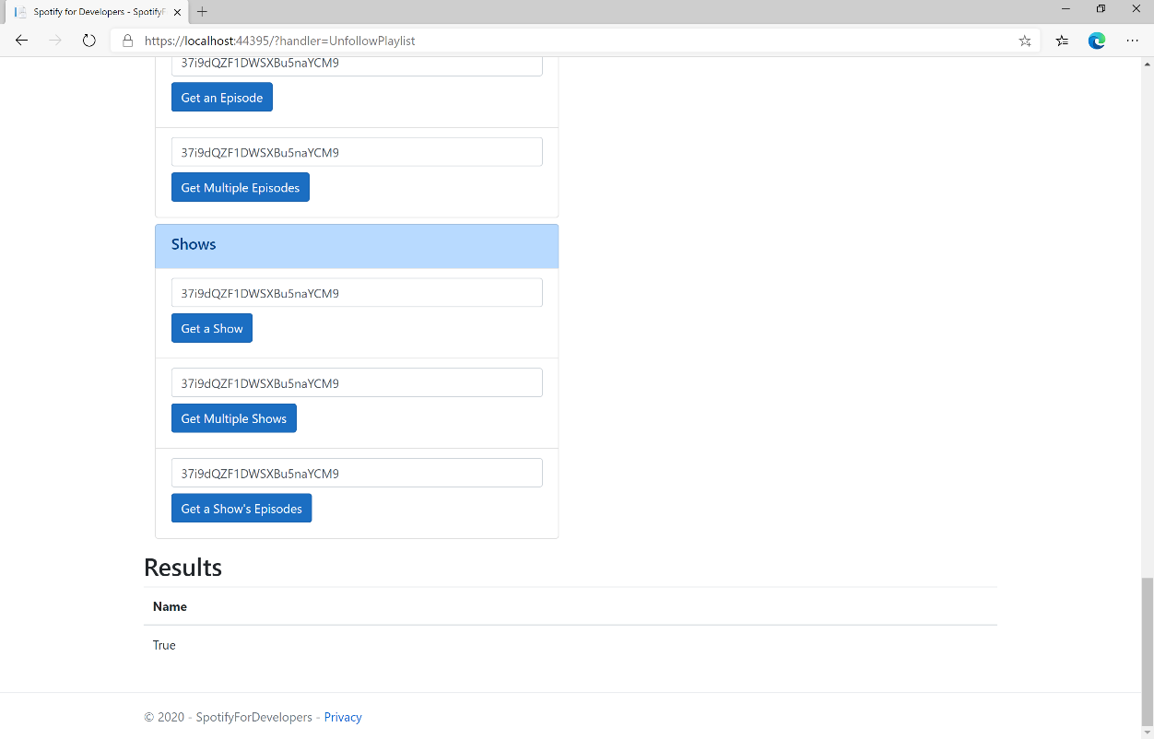

### Step 11

|  |  |
| --- | --- |
|  | You can stop the **web application** in **Visual Studio 2019** by selecting the **Stop debugging** button |

### Step 12

|  |  |
| --- | --- |
|  | You can exit **Visual Studio 2019** by selecting the **Close** button in the top right of the **application** as that completes thispart of the workshop |