**Access Keys** shows how to create a **CommandBar** that uses the **Alt** key on the **Keyboard** to then show on-screen which Keyboard Key to press to perform the task of the **CommandBar**

## Step 1

|  |  |
| --- | --- |
|  | Follow **Setup and Start** on how to Install and/or Get Started with **Visual Studio 2019** if not already or in **Windows 10** choose **Start**, find and select **Visual Studio 2019** then from the **Get started** screen select **Create a new project** |
|  | Then choose **Blank App (Universal Windows)** and select **Next** and then in **Configure your new project** enter the **Project name** as **AccessKeys** and select **Create** |
|  | Finally, in **New Universal Windows Platform Project** pick the **Target version** and **Minimum version** to be at least **Windows 10, version 1903 (10.0; Build 18362)** and then select **OK** |

**Target Version** will control the most recent features of **Windows 10** your application can use. To make sure you always have the most recent version, check for any **Notifications** or **Updates** in **Visual Studio 2019**

## Step 2

|  |  |
| --- | --- |
|  | In the **Solution Explorer** of **Visual Studio 2019** select **MainPage.xaml** |

## Step 3

|  |  |
| --- | --- |
|  | Choose **View** then **Designer** from the **Menu** in **Visual Studio 2019** |

## Step 4

In the **Design** View and **XAML** View of **Visual Studio 2019** will be displayed, and in this between the **Grid** and **/Grid** elements enter the following **XAML**:

|  |
| --- |
| <CommandBar VerticalAlignment="Bottom">  <AppBarButton Icon="Bold" Label="Bold"  AccessKey="B" Click="Button_Click"/>  <AppBarButton Icon="Italic" Label="Italic"  AccessKey="I" Click="Button_Click" />  <AppBarButton Icon="Underline" Label="Underline"  AccessKey="U" Click="Button_Click"/>  </CommandBar> |

This block of **XAML** is a **CommandBar** which contains some example options such as **Bold**, **Italic** and **Underline** which when triggered by their **AccessKey** or when tapped will perform the relevant function

## Step 5

|  |  |
| --- | --- |
|  | Choose **View** then **Code** from the **Menu** in **Visual Studio 2019** |

## Step 6

Once in the **Code** View, below the end of **public MainPage() { ... }** the following Code should be entered:

|  |
| --- |
| private async void Button_Click(object sender, RoutedEventArgs e)  {  await new Windows.UI.Popups.  MessageDialog($"{((AppBarButton)sender).Label}").ShowAsync();  } |

Button_Click is an **event** handler that will be triggered when the **Button** is Clicked. Within this is a MessageDialog which will be used to display a message depending on which AppBarButton has been triggered by clicking or using the AccessKey

## Step 7

|  |  |
| --- | --- |
|  | That completes the **Universal Windows Platform** Application, in **Visual Studio 2019** select **Local Machine** to run the Application |

## Step 8

Once the Application is running you can then press **Alt** on your **Keyboard** to show the access keys for the commands on the **CommandBar**

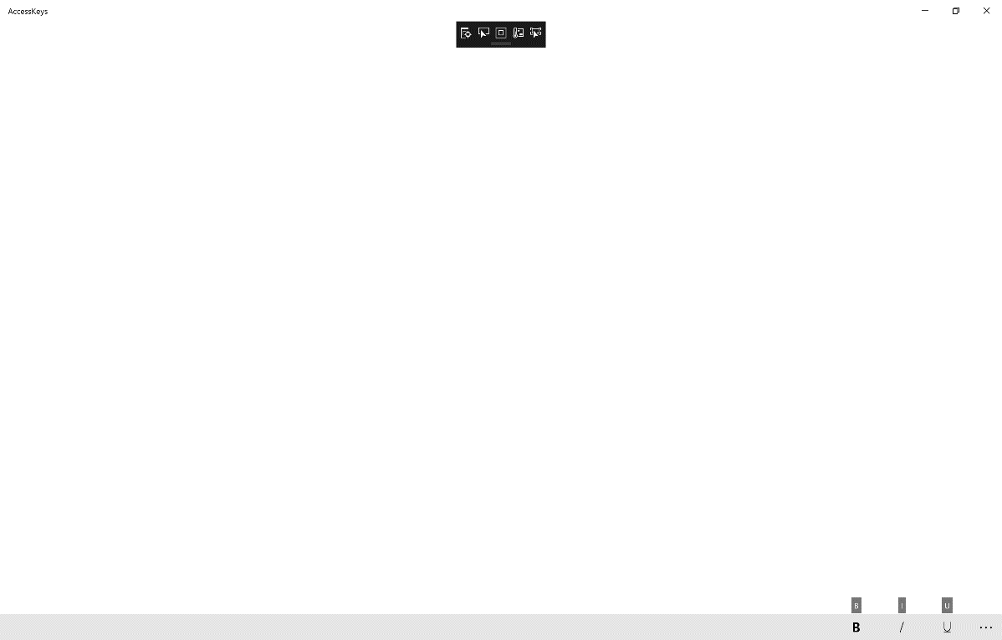

## Step 9

|  |  |
| --- | --- |
|  | To Exit the Application, select the **Close** button in the top right of the Application |