**Acrylic Material** shows how to use **Acrylic** which is a feature of the **Fluent Design System** in **Windows 10**

## Step 1

|  |  |
| --- | --- |
|  | Follow **Setup and Start** on how to Install and/or Get Started with **Visual Studio 2019** if not already or in **Windows 10** choose **Start**, find and select **Visual Studio 2019** then from the **Get started** screen select **Create a new project** |
|  | Then choose **Blank App (Universal Windows)** and select **Next** and then in **Configure your new project** enter the **Project name** as **AcrylicMaterial** and select **Create** |
|  | Finally, in **New Universal Windows Platform Project** pick the **Target version** and **Minimum version** to be at least **Windows 10, version 1903 (10.0; Build 18362)** and then select **OK** |

**Target Version** will control the most recent features of **Windows 10** your application can use. To make sure you always have the most recent version, check for any **Notifications** or **Updates** in **Visual Studio 2019**

## Step 2

|  |  |
| --- | --- |
|  | In the **Solution Explorer** of **Visual Studio 2019** select **MainPage.xaml** |

## Step 3

|  |  |
| --- | --- |
|  | Choose **View** then **Designer** from the **Menu** in **Visual Studio 2019** |

## Step 4

In the **Design** View and **XAML** View of **Visual Studio 2019** will be displayed, and in this between the **Grid** and **/Grid** elements enter the following **XAML**:

|  |
| --- |
| <Grid Margin="50">  <Grid.RowDefinitions>  <RowDefinition Height="Auto"/>  <RowDefinition Height="*"/>  </Grid.RowDefinitions>  <ComboBox Grid.Row="0" Name="Options"  HorizontalAlignment="Stretch"  SelectionChanged="Options_SelectionChanged">  <ComboBoxItem  Content="None" IsSelected="True"/>  <ComboBoxItem  Content="SystemControlAcrylicElementBrush"/>  <ComboBoxItem  Content="SystemControlAcrylicElementMediumHighBrush"/>  <ComboBoxItem  Content="SystemControlBaseHighAcrylicElementMediumBrush"/>  </ComboBox>  <Viewbox Grid.Row="1">  <Grid>  <StackPanel Spacing="5" Orientation="Horizontal"  HorizontalAlignment="Center">  <Rectangle Width="50" Height="50" Fill="Black"/>  <Rectangle Width="50" Height="50" Fill="Gray"/>  <Rectangle Width="50" Height="50" Fill="Red"/>  <Rectangle Width="50" Height="50" Fill="Orange"/>  <Rectangle Width="50" Height="50" Fill="Yellow"/>  <Rectangle Width="50" Height="50" Fill="Green"/>  <Rectangle Width="50" Height="50" Fill="Cyan"/>  <Rectangle Width="50" Height="50" Fill="Blue"/>  <Rectangle Width="50" Height="50" Fill="Magenta"/>  <Rectangle Width="50" Height="50" Fill="Purple"/>  </StackPanel>  <Rectangle x:Name="Overlay"/>  </Grid>  </Viewbox>  </Grid> |

The main block of **XAML** is a **Grid** with two Rows, the first Row contains a **ComboBox** with a selection of **Acrylic** options and the second Row contains a **Grid** with **Rectangle** Controls in a **StackPanel** and overlayed on them is another **Rectangle**

## Step 5

|  |  |
| --- | --- |
|  | Choose **View** then **Code** from the **Menu** in **Visual Studio 2019** |

## Step 6

Once in the **Code** View, below the end of **public MainPage() { ... }** the following Code should be entered:

|  |
| --- |
| private void Options_SelectionChanged(object sender, SelectionChangedEventArgs e)  {  if (Overlay != null && Windows.Foundation.Metadata.  ApiInformation.IsTypePresent(  "Windows.UI.Xaml.Media.XamlCompositionBrushBase"))  {  string value = (string)((ComboBoxItem)  Options.SelectedItem).Content;  Overlay.Fill = (value != "None" ?  (AcrylicBrush)Application.Current.Resources[value] : null);  }  } |

Options_SelectionChanged is an **event** handler that will be triggered when something is **selected** from the ComboBox. It uses the Windows.Foundation.Metadata.ApiInformation.IsTypePresent **method** to check that Windows.UI.Xaml.Media.XamlCompositionBrushBase is present which is used for **Acrylic** and one of the **Selected** options will be used to set the Fill of the Overlay Rectangle to an **AcrylicBrush**

## Step 7

|  |  |
| --- | --- |
|  | That completes the **Universal Windows Platform** Application, in **Visual Studio 2019** select **Local Machine** to run the Application |

## Step 8

Once the Application is running you can use the **ComboBox** to select an **AcrylicBrush** to use that will be overlaid on the coloured **Rectangle** Controls

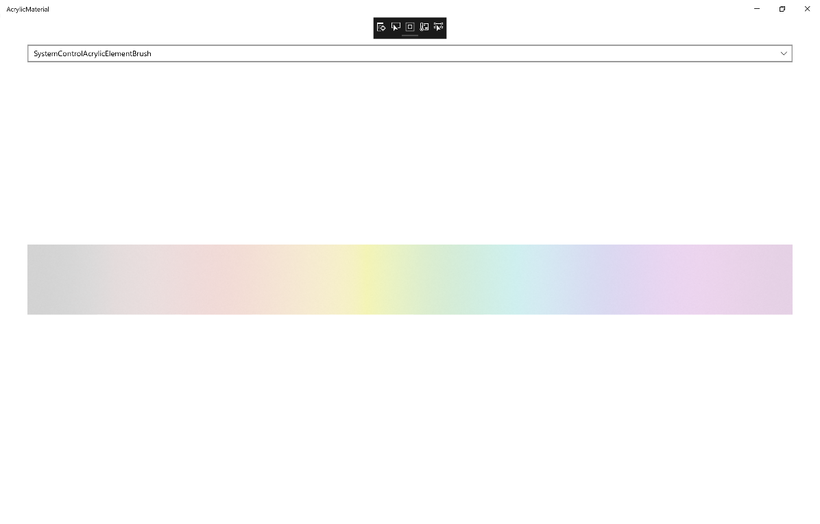

## Step 9

|  |  |
| --- | --- |
|  | To Exit the Application, select the **Close** button in the top right of the Application |