**Command Bar** is where **AppBarButton** Controls can be added, these allow a standard-looking interface for applications to perform actions or access options

## Step 1

|  |  |
| --- | --- |
|  | Follow **Setup and Start** on how to Install and/or Get Started with **Visual Studio 2019** if not already or in **Windows 10** choose **Start**, find and select **Visual Studio 2019** then from the **Get started** screen select **Create a new project** |
|  | Then choose **Blank App (Universal Windows)** and select **Next** and then in **Configure your new project** enter the **Project name** as **CommandBar** and select **Create** |
|  | Finally, in **New Universal Windows Platform Project** pick the **Target version** and **Minimum version** to be at least **Windows 10, version 1903 (10.0; Build 18362)** and then select **OK** |

**Target Version** will control the most recent features of **Windows 10** your application can use. To make sure you always have the most recent version, check for any **Notifications** or **Updates** in **Visual Studio 2019**

## Step 2

|  |  |
| --- | --- |
|  | In the **Solution Explorer** of **Visual Studio 2019** select **MainPage.xaml** |

## Step 3

|  |  |
| --- | --- |
|  | Choose **View** then **Designer** from the **Menu** in **Visual Studio 2019** |

## Step 4

In the **Design** View and **XAML** View of **Visual Studio 2019** will be displayed, and in this between the **Grid** and **/Grid** elements enter the following **XAML**:

|  |
| --- |
| <CommandBar IsOpen="True" IsSticky="True" VerticalAlignment="Bottom">  <CommandBar.SecondaryCommands>  <AppBarButton Name="Hide" Icon="Cancel" Label="Hide Other"  Visibility="Collapsed" Click="Show_Click"/>  </CommandBar.SecondaryCommands>  <AppBarButton Name="Show" Icon="Accept" Label="Show Other"  Click="Show_Click"/>  </CommandBar> |

**CommandBar** is a Control that can contain **AppBarButton** that will be displayed o show the main toolbar of a **Universal Windows Platform** Application in **Windows 10**

## Step 5

|  |  |
| --- | --- |
|  | Choose **View** then **Code** from the **Menu** in **Visual Studio 2019** |

## Step 6

Once in the **Code** View, below the end of public MainPage() { ... } the following Code should be entered:

|  |
| --- |
| private void Show_Click(object sender, RoutedEventArgs e)  {  if (Hide.Visibility == Visibility.Collapsed)  {  Hide.Visibility = Visibility.Visible;  }  else  {  Hide.Visibility = Visibility.Collapsed;  }  } |

Show_Click is an **Event** handler that will be triggered when **Hide Other** or **Show Other** is Clicked. This will if the Hide.Visibility is Visibility.Collapsed will set Hide.Visibility to Visibility.Visible or else it will set Hide.Visibility it to Visibility.Collapsed

## Step 7

|  |  |
| --- | --- |
|  | That completes the **Universal Windows Platform** Application, in **Visual Studio 2019** select **Local Machine** to run the Application |

## Step 8

Once the Application is running click **Show Other** to show an option on the bottom when **...** is tapped and tap **Hide Other** to hide this option again

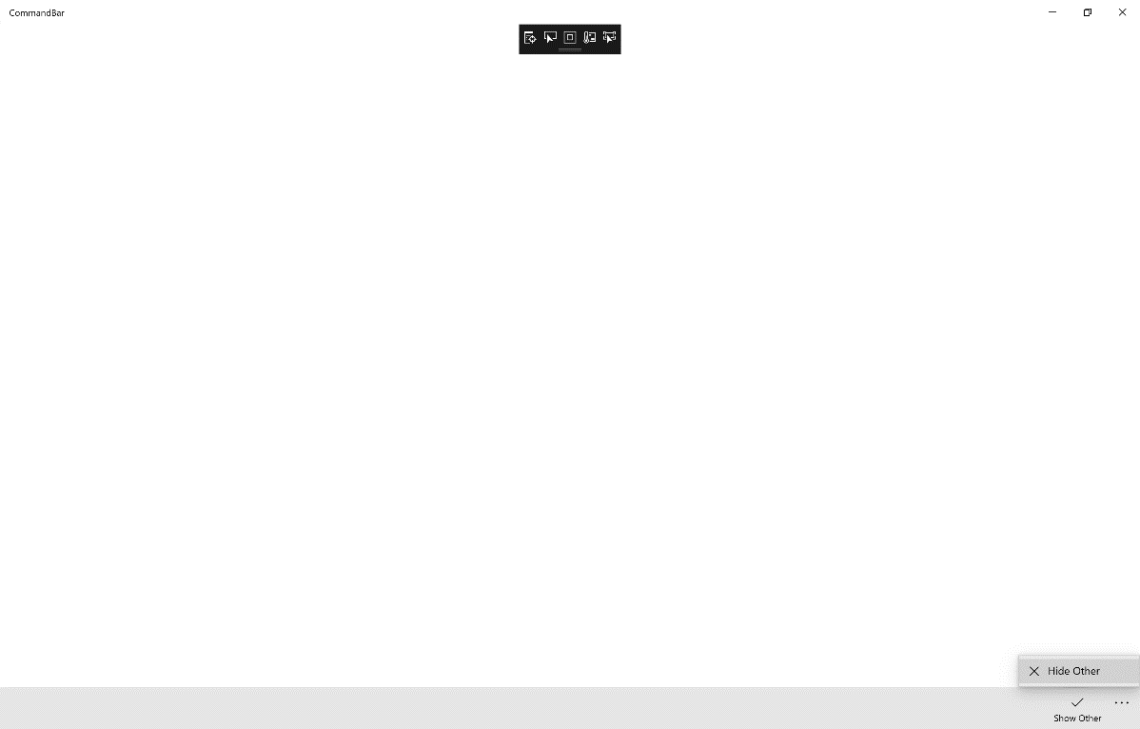

## Step 9

|  |  |
| --- | --- |
|  | To Exit the Application, select the **Close** button in the top right of the Application |