**Connected Animation** shows how to use a **Connected Animation** which is part of the **Fluent Design System** in **Windows 10**

## Step 1

|  |  |
| --- | --- |
|  | Follow **Setup and Start** on how to Install and/or Get Started with **Visual Studio 2019** if not already or in **Windows 10** choose **Start**, find and select **Visual Studio 2019** then from the **Get started** screen select **Create a new project** |
|  | Then choose **Blank App (Universal Windows)** and select **Next** and then in **Configure your new project** enter the **Project name** as **ConnectedAnimation** and select **Create** |
|  | Finally, in **New Universal Windows Platform Project** pick the **Target version** and **Minimum version** to be at least **Windows 10, version 1903 (10.0; Build 18362)** and then select **OK** |

**Target Version** will control the most recent features of **Windows 10** your application can use. To make sure you always have the most recent version, check for any **Notifications** or **Updates** in **Visual Studio 2019**

## Step 2

|  |  |
| --- | --- |
|  | Choose **Project** then **Add New Item...** from the **Menu** in **Visual Studio 2019** |

## Step 3

|  |  |
| --- | --- |
|  | Then choose **Code File** from **Add New Item** in **Visual Studio 2019**, enter the **Name** as **Library.cs** and select **Add** |

## Step 4

In the **Code** View of **Library.cs** will be displayed and in this the following should be entered:

|  |
| --- |
| using System.Linq;  using Windows.UI.Xaml.Controls;  using Windows.UI.Xaml.Media;  using Windows.UI.Xaml.Media.Animation;  using Windows.UI.Xaml.Shapes;  public static class Library  {  private const string animate_back = "AnimateBack";  private const string animate_next = "AnimateNext";  private static Windows.UI.Xaml.Media.Animation.  ConnectedAnimation _animation;  public static string Current { get; set; }  } |

There is a using statement to include functionality and there are const of string and a Windows.UI.Xaml.Media.Animation.ConnectedAnimation and a string **property**

Then below the **public static string Current { get; set; }** line the following **public static methods** should be entered:

|  |
| --- |
| public static void Back(ref ListView listview)  {  Rectangle rectangle = (Rectangle)listview.Items  .SingleOrDefault(f => ((Rectangle)f).Tag.Equals(Current));  _animation = ConnectedAnimationService.GetForCurrentView()  .GetAnimation(animate_back);  _animation?.TryStart(rectangle);  }  public static Brush Next(ref object selected)  {  Rectangle rectangle = (Rectangle)selected;  Current = (string)rectangle.Tag;  _animation = ConnectedAnimationService.GetForCurrentView()  .PrepareToAnimate(animate_next, rectangle);  return rectangle.Fill;  } |

The Back(...) **method** takes a ListView **parameter** and gets a Rectangle from the ListView and then gets the Windows.UI.Xaml.Media.Animation.ConnectedAnimation and calls the TryStart **method** on it. The Next **method** takes an object **parameter** which will be a Rectangle and then gets the Windows.UI.Xaml.Media.Animation.ConnectedAnimation for it and calls the PrepareToAnimate **method** of the ConnectedAnimationService.GetForCurrentView

Finally below the **public static Brush Next(ref object selected) { ... }** **method** the following **public static** **methods** should be entered:

|  |
| --- |
| public static void From(ref Rectangle from)  {  _animation =  ConnectedAnimationService.GetForCurrentView()  .PrepareToAnimate(animate_back, from);  }  public static void Loaded(ref Rectangle rectangle)  {  _animation =  ConnectedAnimationService.GetForCurrentView()  .GetAnimation(animate_next);  rectangle.Opacity = 1;  _animation?.TryStart(rectangle);  } |

The From(...) **method** calls the ConnectedAnimationService.GetForCurrentView **method** of PrepareToAnimate. The Loaded(...) **method** takes a Rectangle **parameter** and this calls the GetAnimation **method** of ConnectedAnimationService.GetForCurrentView and will set the Opacity to 1 and calls the TryStart **method**

## Step 5

|  |  |
| --- | --- |
|  | Choose **Project** then **Add New Item...** from the **Menu** in **Visual Studio 2019** |

## Step 6

|  |  |
| --- | --- |
|  | Then choose **Blank Page** from **Add New Item** in **Visual Studio 2019**, enter the **Name** as **DetailPage.xaml** and select **Add** |

## Step 7

In the **Design** View and **XAML** View of **Visual Studio 2019** will be displayed, and in this between the **Grid** and **/Grid** elements enter the following **XAML**:

|  |
| --- |
| <Rectangle Margin="50" Name="Target" Opacity="0" Loaded="Target_Loaded"/>  <CommandBar VerticalAlignment="Bottom">  <AppBarButton Icon="Back" Label="Back" Click="Back_Click"/>  </CommandBar> |

The first block of **XAML** is a **Rectangle** Control and the second block of **XAML** is a **CommandBar** with an **AppBarButton** for **Back**

## Step 8

|  |  |
| --- | --- |
|  | Choose **View** then **Code** from the **Menu** in **Visual Studio 2019** |

## Step 9

Once in the **Code** View, below the end of **public DetailPage() { ... }** the following Code should be entered:

|  |
| --- |
| protected override void OnNavigatedTo(NavigationEventArgs e)  {  Target.Fill = (SolidColorBrush)e.Parameter;  }  protected override void OnNavigatingFrom(NavigatingCancelEventArgs e)  {  if (e.NavigationMode == NavigationMode.Back)  Library.From(ref Target);  base.OnNavigatingFrom(e);  }  private void Target_Loaded(object sender, RoutedEventArgs e)  {  Library.Loaded(ref Target);  }  private void Back_Click(object sender, RoutedEventArgs e)  {  this.Frame.GoBack();  } |

OnNavigatedTo **event** handler will set the Fill **property** of the Rectangle, OnNavigatingFrom **event** handler will call the From **method** in the Library **class** and Back_Click will call GoBack to navigate to the previous **XAML** Page, **MainPage.xaml**

## Step 10

|  |  |
| --- | --- |
|  | In the **Solution Explorer** of **Visual Studio 2019** select **MainPage.xaml** |

## Step 11

|  |  |
| --- | --- |
|  | Choose **View** then **Designer** from the **Menu** in **Visual Studio 2019** |

## Step 12

In the **Design** View and **XAML** View of **Visual Studio 2019** will be displayed, and in this between the **Grid** and **/Grid** elements enter the following **XAML**:

|  |
| --- |
| <ListView Name="Display" Margin="50">  <Rectangle Margin="10" Width="64" Height="64"  Tag="Black" Fill="Black" Tapped="Rectangle_Tapped"/>  <Rectangle Margin="10" Width="64" Height="64"  Tag="Gray" Fill="Gray" Tapped="Rectangle_Tapped"/>  <Rectangle Margin="10" Width="64" Height="64"  Tag="Red" Fill="Red" Tapped="Rectangle_Tapped"/>  <Rectangle Margin="10" Width="64" Height="64"  Tag="Orange" Fill="Orange" Tapped="Rectangle_Tapped"/>  <Rectangle Margin="10" Width="64" Height="64"  Tag="Yellow" Fill="Yellow" Tapped="Rectangle_Tapped"/>  <Rectangle Margin="10" Width="64" Height="64"  Tag="Green" Fill="Green" Tapped="Rectangle_Tapped"/>  <Rectangle Margin="10" Width="64" Height="64"  Tag="Cyan" Fill="Cyan" Tapped="Rectangle_Tapped"/>  <Rectangle Margin="10" Width="64" Height="64"  Tag="Blue" Fill="Blue" Tapped="Rectangle_Tapped"/>  <Rectangle Margin="10" Width="64" Height="64"  Tag="Magenta" Fill="Magenta" Tapped="Rectangle_Tapped"/>  <Rectangle Margin="10" Width="64" Height="64"  Tag="Purple" Fill="Purple" Tapped="Rectangle_Tapped"/>  </ListView> |

The main block of **XAML** is a **ListView** which contains **Rectangle** Controls with their **Tapped** handler set properties set enabling the Control to support drag-and-drop. The second block of **XAML** is the **CommandBar** which contains the **Add** – to add to the **ListBox** and **Remove** - to remove items from the **ListBox**

## Step 13

|  |  |
| --- | --- |
|  | Choose **View** then **Code** from the **Menu** in **Visual Studio 2019** |

## Step 14

Once in the **Code** View, below the end of **public MainPage() { ... }** the following Code should be entered:

|  |
| --- |
| protected override void OnNavigatedTo(NavigationEventArgs e)  {  if (e.NavigationMode == NavigationMode.Back)  Library.Back(ref Display);  base.OnNavigatedTo(e);  }  private void Rectangle_Tapped(object sender, TappedRoutedEventArgs e)  {  this.Frame.Navigate(typeof(DetailPage), Library.Next(ref sender));  } |

OnNavigatedTo **event** handler calls the Back **method** from the Library **class** and Rectangle_Tapped calls the Navigate **method** of the **Page Frame** and pass the DetailPage and the result of the Next **method** in the Library **class**

## Step 10

|  |  |
| --- | --- |
|  | That completes the **Universal Windows Platform** Application, in **Visual Studio 2019** select **Local Machine** to run the Application |

## Step 11

Once the Application is running you can tap on any of the **Rectangle** Controls, this will Navigate to the **DetailsPage** to show a larger version of a **Rectangle** with the same **Fill** but will use a **Connected Animation** to transition to and from that page

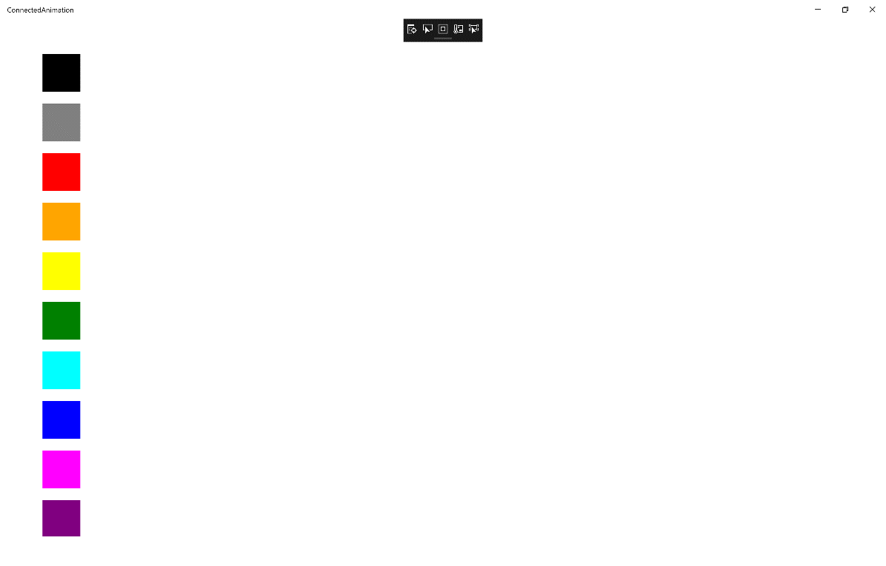

## Step 12

|  |  |
| --- | --- |
|  | To Exit the Application, select the **Close** button in the top right of the Application |