**Custom Dialog** shows how to use **ContentDialog** to display a customised dialog box

## Step 1

|  |  |
| --- | --- |
|  | Follow **Setup and Start** on how to Install and/or Get Started with **Visual Studio 2019** if not already or in **Windows 10** choose **Start**, find and select **Visual Studio 2019** then from the **Get started** screen select **Create a new project** |
|  | Then choose **Blank App (Universal Windows)** and select **Next** and then in **Configure your new project** enter the **Project name** as **CustomDialog** and select **Create** |
|  | Finally, in **New Universal Windows Platform Project** pick the **Target version** and **Minimum version** to be at least **Windows 10, version 1903 (10.0; Build 18362)** and then select **OK** |

**Target Version** will control the most recent features of **Windows 10** your application can use. To make sure you always have the most recent version, check for any **Notifications** or **Updates** in **Visual Studio 2019**

## Step 2

|  |  |
| --- | --- |
|  | In the **Solution Explorer** of **Visual Studio 2019** select **MainPage.xaml** |

## Step 3

|  |  |
| --- | --- |
|  | Choose **View** then **Designer** from the **Menu** in **Visual Studio 2019** |

## Step 4

In the **Design** View and **XAML** View of **Visual Studio 2019** will be displayed, and in this between the **Grid** and **/Grid** elements enter the following **XAML**:

|  |
| --- |
| <Button Content="Display" HorizontalAlignment="Center"  Click="Button_Click"/> |

**Button** has the content set to Display and will be used to trigger an **event** with the handler of Button_Click

## Step 5

|  |  |
| --- | --- |
|  | Choose **View** then **Code** from the **Menu** in **Visual Studio 2019** |

## Step 6

Once in the **Code** View, below the end of **public MainPage() { ... }** the following Code should be entered:

|  |
| --- |
| private async void Button_Click(object sender, RoutedEventArgs e)  {  ContentDialog dialog = new ContentDialog()  {  Title = "Custom Dialog",  MaxWidth = this.ActualWidth,  PrimaryButtonText = "Close",  Content = new TextBlock  {  Style = (Style)App.Current.Resources  ["SubheaderTextBlockStyle"],  Text = "Hello World",  }  };  await dialog.ShowAsync();  } |

Button_Click is an **Event** handler that will be triggered when the **Button** is Clicked. It creates ContentDialog and sets various **properties** including the Title and the Content which is set to a TextBlock with a Style of SubheaderTextBlockStyle and Text of Hello World.

## Step 7

|  |  |
| --- | --- |
|  | That completes the **Universal Windows Platform** Application, in **Visual Studio 2019** select **Local Machine** to run the Application |

## Step 8

Once the Application is running click the **Button** to show the **Custom Dialog** and then **Close** to dismiss it

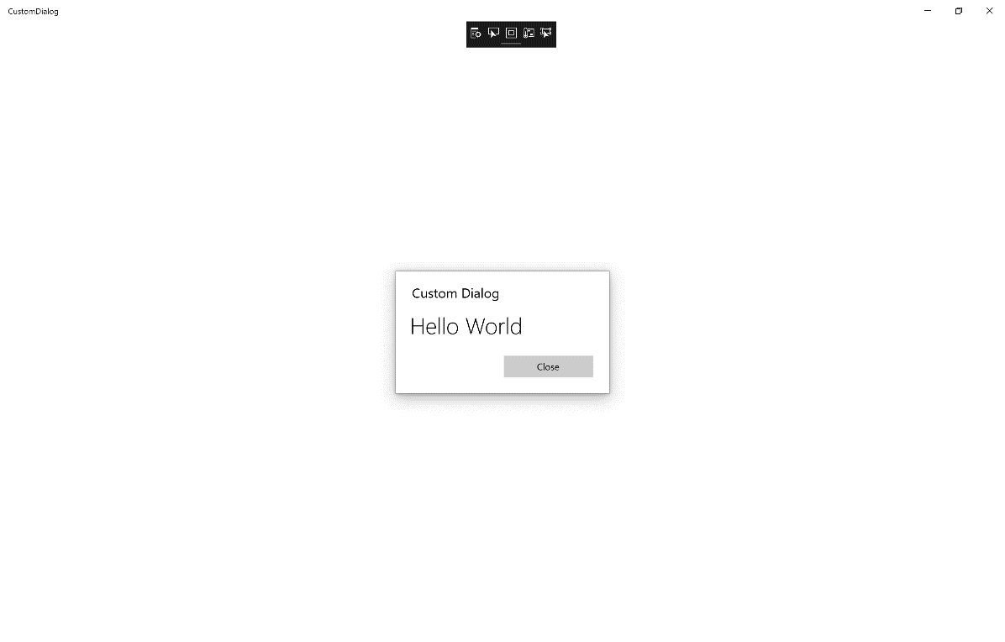

## Step 9

|  |  |
| --- | --- |
|  | To Exit the Application, select the **Close** button in the top right of the Application |