**Data Input** shows how to use **InputScope** for on-screen Keyboards where supported and and loading **ApplicationData**

## Step 1

|  |  |
| --- | --- |
|  | Follow **Setup and Start** on how to Install and/or Get Started with **Visual Studio 2019** if not already or in **Windows 10** choose **Start**, find and select **Visual Studio 2019** then from the **Get started** screen select **Create a new project** |
|  | Then choose **Blank App (Universal Windows)** and select **Next** and then in **Configure your new project** enter the **Project name** as **DataInput** and select **Create** |
|  | Finally, in **New Universal Windows Platform Project** pick the **Target version** and **Minimum version** to be at least **Windows 10, version 1903 (10.0; Build 18362)** and then select **OK** |

**Target Version** will control the most recent features of **Windows 10** your application can use. To make sure you always have the most recent version, check for any **Notifications** or **Updates** in **Visual Studio 2019**

## Step 2

|  |  |
| --- | --- |
|  | Choose **Project** then **Add New Item...** from the **Menu** in **Visual Studio 2019** |

## Step 3

|  |  |
| --- | --- |
|  | Then choose **Code File** from **Add New Item** in **Visual Studio 2019**, enter the **Name** as **Library.cs** and select **Add** |

## Step 4

In the **Code** View of **Library.cs** will be displayed and in this the following should be entered:

|  |
| --- |
| using Windows.Storage;  public class Library  {  public string LoadSetting(string key)  {  return (string)(ApplicationData.Current.LocalSettings.Values[key]  ?? string.Empty);  }  public void SaveSetting(string key, string value)  {  ApplicationData.Current.LocalSettings.Values[key] = value;  }  } |

There is a using statement to include functionality from Windows.Storage. LoadSetting(...) method takes a string parameter to return the LocalSettings with the key if present and using the **null coalesce** or ?? operator will be string.Empty if it is not. SaveSetting(...) method takes two string parameters to set the LocalSettings to be returned later with the key and value passed in

## Step 5

|  |  |
| --- | --- |
|  | In the **Solution Explorer** of **Visual Studio 2019** select **MainPage.xaml** |

## Step 6

|  |  |
| --- | --- |
|  | Choose **View** then **Designer** from the **Menu** in **Visual Studio 2019** |

## Step 7

In the **Design** View and **XAML** View of **Visual Studio 2019** will be displayed, and in this between the **Grid** and **/Grid** elements enter the following **XAML**:

|  |
| --- |
| <StackPanel>  <TextBox Name="Email" PlaceholderText="Email"  InputScope="EmailSmtpAddress" Margin="20"/>  <TextBox Name="Website" PlaceholderText="Website"  InputScope="Url" Margin="20"/>  <TextBox Name="Telephone" PlaceholderText="Telephone"  InputScope="TelephoneNumber" Margin="20"/>  </StackPanel>  <CommandBar VerticalAlignment="Bottom">  <AppBarButton Icon="Page2" Label="New" Click="New_Click"/>  <AppBarButton Icon="OpenLocal" Label="Open" Click="Open_Click"/>  <AppBarButton Icon="Save" Label="Save" Click="Save_Click"/>  </CommandBar> |

The first block of **XAML** comprises of **TextBox** Controls which will show the relevant on-screen Keyboard **InputScope** if supported. The second block of **XAML** is the **CommandBar** containing the operations

## Step 8

|  |  |
| --- | --- |
|  | Choose **View** then **Code** from the **Menu** in **Visual Studio 2019** |

## Step 9

Once in the **Code** View, below the end of **public MainPage() { ... }** the following Code should be entered:

|  |
| --- |
| Library library = new Library();  private void New_Click(object sender, RoutedEventArgs e)  {  Email.Text = string.Empty;  Website.Text = string.Empty;  Telephone.Text = string.Empty;  }  private void Open_Click(object sender, RoutedEventArgs e)  {  Email.Text = library.LoadSetting("Email");  Website.Text = library.LoadSetting("Website");  Telephone.Text = library.LoadSetting("Telephone");  }  private void Save_Click(object sender, RoutedEventArgs e)  {  library.SaveSetting("Email", Email.Text);  library.SaveSetting("Website", Website.Text);  library.SaveSetting("Telephone", Telephone.Text);  } |

Below the **MainPage(...)** method an instance of the Library **Class** is created. In the New_Click(...) **Event** handler the **TextBox** Controls have their **Text** property set to an Empty String. The Open_Click(...) **Event** handler uses the LoadSetting method to load a value that has been previously Saved and the Save_Click(...) **Event** handler will use SaveSetting to store a value to be loaded later

## Step 10

|  |  |
| --- | --- |
|  | That completes the **Universal Windows Platform** Application, in **Visual Studio 2019** select **Local Machine** to run the Application |

## Step 11

Once the Application is running you can then input some data such as an **Email Address**, **Website** and **Telephone Number** then store using the **Save** button and recall the data with the **Open** button or reset with the **New** button

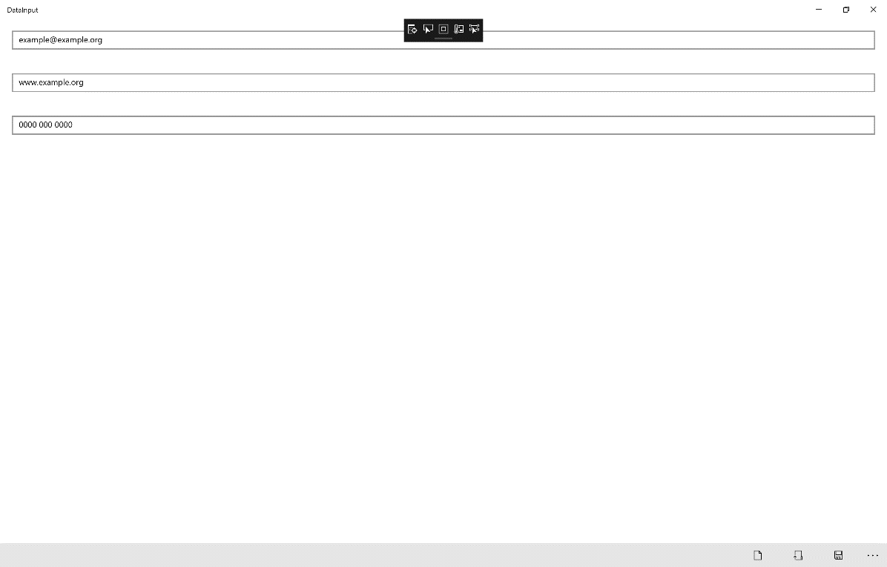

## Step 12

|  |  |
| --- | --- |
|  | To Exit the Application, select the **Close** button in the top right of the Application |