**Four in Row** shows how to create a simple two-player game where the objective is to get four pieces in a row in either horizontal, vertical or diagonal directions

## Step 1

|  |  |
| --- | --- |
|  | Follow **Setup and Start** on how to Install and/or Get Started with **Visual Studio 2019** if not already or in **Windows 10** choose **Start**, find and select **Visual Studio 2019** then from the **Get started** screen select **Create a new project** |
|  | Then choose **Blank App (Universal Windows)** and select **Next** and then in **Configure your new project** enter the **Project name** as **FourInRow** and select **Create** |
|  | Finally, in **New Universal Windows Platform Project** pick the **Target version** and **Minimum version** to be at least **Windows 10, version 1903 (10.0; Build 18362)** and then select **OK** |

**Target Version** will control the most recent features of **Windows 10** your application can use. To make sure you always have the most recent version, check for any **Notifications** or **Updates** in **Visual Studio 2019**

## Step 2

|  |  |
| --- | --- |
|  | Choose **Project** then **Add New Item...** from the **Menu** in **Visual Studio 2019** |

## Step 3

|  |  |
| --- | --- |
|  | Then choose **Code File** from **Add New Item** in **Visual Studio 2019**, enter the **Name** as **Library.cs** and select **Add** |

## Step 4

In the **Code** View of **Library.cs** will be displayed and in this the following should be entered:

|  |
| --- |
| using System;  using System.Linq;  using System.Threading.Tasks;  using Windows.UI.Popups;  using Windows.UI.Xaml;  using Windows.UI.Xaml.Controls;  using Windows.UI.Xaml.Media;  public class Library  {  private const string title = "Four In Row";  private const string yellow = "\U0001F7E1";  private const string red = "\U0001F534";  private const int total = 3;  private const int size = 7;  private readonly string[] _players =  {  string.Empty, "Yellow", "Red"  };  private int _value = 0;  private int _amend = 0;  private int _player = 0;  private bool _won = false;  private int[,] _board = new int[size, size];  } |

There are using statements to include necessary functionality. Also there are private const for the setup of the game and for the values that will represent the look-and-feel of the game, there are also private **members** to store values for the game including the _players and the _board

Then below the **private int[,] _board = new int[size, size];** line the following **methods** should be entered:

|  |
| --- |
| private void Show(string content, string title)  {  _ = new MessageDialog(content, title).ShowAsync();  }  private async Task<bool> ConfirmAsync(string content, string title,  string ok, string cancel)  {  bool result = false;  MessageDialog dialog = new MessageDialog(content, title);  dialog.Commands.Add(new UICommand(ok,  new UICommandInvokedHandler((cmd) => result = true)));  dialog.Commands.Add(new UICommand(cancel,  new UICommandInvokedHandler((cmd) => result = false)));  await dialog.ShowAsync(); return result;  } |

Show **method** is used to display a basic MessageDialog and ConfirmAsync is used to display a MessageDialog with an ok and cancel option

Next below the **private async Task<bool> ConfirmAsync(...) { ... }** **method** the following **method** should be entered:

|  |
| --- |
| private bool CheckVertical(int row, int column)  {  _value = 0;  do  {  _value++;  }  while (row + _value < size &&  _board[column, row + _value] == _player);  if (_value > total)  {  return true;  }  return false;  } |

CheckVertical **method** is used check the _board has a set of four vertical _player items in the _board

Next after the **private bool CheckVertical(...) { ... }** **method** the following **method** should be entered:

|  |
| --- |
| private bool CheckHorizontal(int row, int column)  {  _value = 0;  _amend = 0;  // From Left  do  {  _value++;  }  while (column - _value >= 0 &&  _board[column - _value, row] == _player);  if (_value > total)  {  return true;  }  // Deduct Middle - Prevent double count  _value -= 1;  // Then Right  do  {  _value++;  _amend++;  }  while (column + _amend < size &&  _board[column + _amend, row] == _player);  if (_value > total)  {  return true;  }  return false;  } |

CheckHorizontal **method** is used check the _board has a set of four horizontal _player items in the _board

Then after the **private bool CheckHorizontal(...) { ... }** **method** the following **method** should be entered:

|  |
| --- |
| private bool CheckDiagonalTopLeft(int row, int column)  {  _value = 0;  _amend = 0;  // From Top Left  do  {  _value++;  }  while (column - _value >= 0 && row - _value >= 0 &&  _board[column - _value, row - _value] == _player);  if (_value > total)  {  return true;  }  // Deduct Middle - Prevent double count  _value -= 1;  // To Bottom Right  do  {  _value++;  _amend++;  }  while (column + _amend < size && row + _amend < size &&  _board[column + _amend, row + _amend] == _player);  if (_value > total)  {  return true;  }  return false;  } |

CheckDiagonalTopLeft **method** is used check the _board has a set of four diagonal _player items in the _board from top left to bottom right

Next after the **private bool CheckDiagonalTopLeft(...) { ... }** **method** the following **method** should be entered:

|  |
| --- |
| private bool CheckDiagonalTopRight(int row, int column)  {  _value = 0;  _amend = 0;  // From Top Right  do  {  _value++;  }  while (column + _value < size && row - _value >= 0 &&  _board[column + _value, row - _value] == _player);  if (_value > total)  {  return true;  }  // Deduct Middle - Prevent double count  _value -= 1;  // To Bottom Left  do  {  _value++;  _amend++;  }  while (column - _amend >= 0 &&  row + _amend < size &&  _board[column - _amend,  row + _amend] == _player);  if (_value > total)  {  return true;  }  return false;  } |

CheckDiagonalTopRight **method** is used check the _board has a set of four diagonal _player items in the _board from top right to bottom left

Then after the **private bool CheckDiagonalTopRight(...) { ... }** **method** the following **methods** should be entered:

|  |
| --- |
| private bool Winner(int row, int column)  {  bool vertical = CheckVertical(row, column);  bool horizontal = CheckHorizontal(row, column);  bool diagonalTopLeft = CheckDiagonalTopLeft(row, column);  bool diagonalTopRight = CheckDiagonalTopRight(row, column);  return vertical || horizontal ||  diagonalTopLeft || diagonalTopRight;  }  private bool Full()  {  for (int row = 0; row < size; row++)  {  for (int column = 0; column < size; column++)  {  if (_board[column, row] == 0)  {  return false;  }  }  }  return true;  } |

Winner **method** will use all the check **methods** to see if there is a winner in either vertical, horizontal, diagonalTopLeft or diagonalTopRight directions. Full will check if the _board is full

Next after **the private bool Full() { ... }** **method** the following **method** should be entered:

|  |
| --- |
| private Viewbox Piece(int player)  {  TextBlock textblock = new TextBlock()  {  IsColorFontEnabled = true,  Text = player == 1 ? yellow : red,  TextLineBounds = TextLineBounds.Tight,  FontFamily = new FontFamily("Segoe UI Emoji"),  HorizontalTextAlignment = TextAlignment.Center  };  return new Viewbox()  {  Child = textblock  };  } |

Piece **method** is used to create a TextBlock for the player in the game

Then after the **private Viewbox Piece(int player)** **method** the following **method** should be entered:

|  |
| --- |
| private void Set(Grid grid, int row, int column)  {  for (int i = size - 1; i > -1; i--)  {  if (_board[column, i] == 0)  {  _board[column, i] = _player;  Button button = (Button)grid.Children.Single(  w => Grid.GetRow((Button)w) == i  && Grid.GetColumn((Button)w) == column);  button.Content = Piece(_player);  row = i;  break;  }  }  if (Winner(row, column))  {  _won = true;  Show($"{_players[_player]} has won!", title);  }  else if (Full())  Show("Board Full!", title);  _player = _player == 1 ? 2 : 1; // Set Player  } |

Set **method** is used to call Piece to set the _player and will check Winner **method** or Full method to see if the game has been won, or is over and will change the _player

After the **private void Set(...)** **method** the following **method** should be entered:

|  |
| --- |
| private void Add(Grid grid, int row, int column)  {  Button button = new Button()  {  Width = 100,  Height = 100,  Name = $"{row}:{column}",  Margin = new Thickness(5),  Style = (Style)Application.Current.Resources  ["ButtonRevealStyle"]  };  button.Click += (object sender, RoutedEventArgs e) =>  {  if (!_won)  {  button = (Button)sender;  row = (int)button.GetValue(Grid.RowProperty);  column = (int)button.GetValue(Grid.ColumnProperty);  if (_board[column, 0] == 0) // Check Free Row  Set(grid, row, column);  }  else  Show("Game Over!", title);  };  button.SetValue(Grid.ColumnProperty, column);  button.SetValue(Grid.RowProperty, row);  grid.Children.Add(button);  } |

Add **method** is used to create the elements that will make up the game and will also check if the game is over and will call Set **method** to play the game

Next after the **private void Add(...) { ... }** **method** the following **method** should be entered:

|  |
| --- |
| private void Layout(ref Grid Grid)  {  Grid.Children.Clear();  Grid.ColumnDefinitions.Clear();  Grid.RowDefinitions.Clear();  // Setup Grid  for (int index = 0; (index < size); index++)  {  Grid.RowDefinitions.Add(new RowDefinition());  Grid.ColumnDefinitions.Add(new ColumnDefinition());  }  // Setup Board  for (int column = 0; (column < size); column++)  {  for (int row = 0; (row < size); row++)  {  Add(Grid, row, column);  _board[row, column] = 0;  }  }  } |

Layout **method** is used to create the look-and-feel of the game including setting up the Grid by calling the Add **method**

Finally after the **private void Layout(...) { ... }** **method** the following public **method** should be entered:

|  |
| --- |
| public async void New(Grid grid)  {  Layout(ref grid);  _won = false;  _player = await ConfirmAsync("Who goes First?", title,  _players[1], _players[2]) ? 1 : 2;  } |

New **method** will setup the layout of the Grid using the Layout **method** and will use ConfirmAsync to choose Who goes First?

## Step 5

|  |  |
| --- | --- |
|  | In the **Solution Explorer** of **Visual Studio 2019** select **MainPage.xaml** |

## Step 6

|  |  |
| --- | --- |
|  | Choose **View** then **Designer** from the **Menu** in **Visual Studio 2019** |

## Step 7

In the **Design** View and **XAML** View of **Visual Studio 2019** will be displayed, and in this between the **Grid** and **/Grid** elements enter the following **XAML**:

|  |
| --- |
| <Viewbox>  <Grid Margin="50" Name="Display"  HorizontalAlignment="Center"  VerticalAlignment="Center"/>  </Viewbox>  <CommandBar VerticalAlignment="Bottom">  <AppBarButton Icon="Page2" Label="New" Click="New_Click"/>  </CommandBar> |

The first block of **XAML** the main user interface features a **Viewbox** to contain a **Grid** which will display the game. The second block of **XAML** is the **CommandBar** which contains **New** to start the game

## Step 8

|  |  |
| --- | --- |
|  | Choose **View** then **Code** from the **Menu** in **Visual Studio 2019** |

## Step 9

Once in the **Code** View, below the end of **public MainPage() { ... }** the following Code should be entered:

|  |
| --- |
| Library library = new Library();  private void New_Click(object sender, RoutedEventArgs e)  {  library.New(Display);  } |

Below the **MainPage** method an instance of the Library **Class** is created. The New_Click **event** handler will call the New **method** in the Library **class**

## Step 10

|  |  |
| --- | --- |
|  | That completes the **Universal Windows Platform** Application, in **Visual Studio 2019** select **Local Machine** to run the Application |

## Step 11

Once the Application is running use **New** to start the playing, first can chose to play as **Red** or **Yellow** and you can win by getting four pieces in a horizontal, vertical or diagonal row

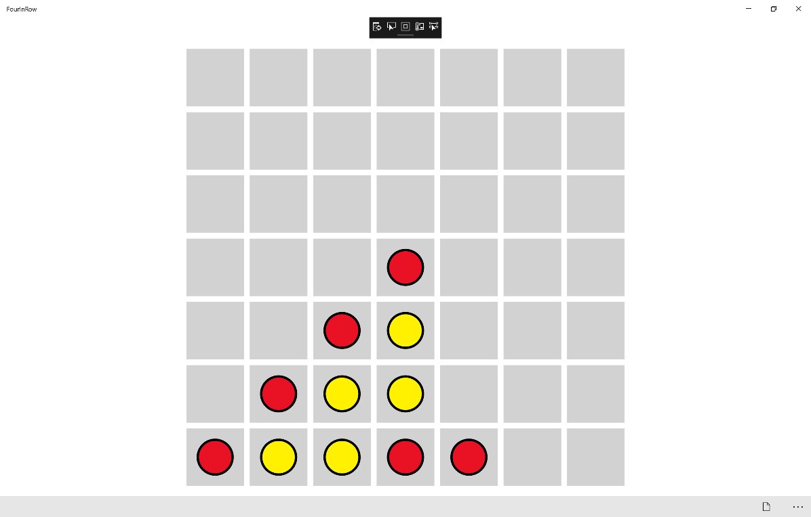

## Step 12

|  |  |
| --- | --- |
|  | To Exit the Application, select the **Close** button in the top right of the Application |