**Hit or Miss** shows how to create a simple random game where you can score a **Hit** or a **Miss** based on which **Button** is clicked

## Step 1

|  |  |
| --- | --- |
|  | Follow **Setup and Start** on how to Install and/or Get Started with **Visual Studio 2019** if not already or in **Windows 10** choose **Start**, find and select **Visual Studio 2019** then from the **Get started** screen select **Create a new project** |
|  | Then choose **Blank App (Universal Windows)** and select **Next** and then in **Configure your new project** enter the **Project name** as **HitOrMiss** and select **Create** |
|  | Finally, in **New Universal Windows Platform Project** pick the **Target version** and **Minimum version** to be at least **Windows 10, version 1903 (10.0; Build 18362)** and then select **OK** |

**Target Version** will control the most recent features of **Windows 10** your application can use. To make sure you always have the most recent version, check for any **Notifications** or **Updates** in **Visual Studio 2019**

## Step 2

|  |  |
| --- | --- |
|  | Choose **Project** then **Add New Item...** from the **Menu** in **Visual Studio 2019** |

## Step 3

|  |  |
| --- | --- |
|  | Then choose **Code File** from **Add New Item** in **Visual Studio 2019**, enter the **Name** as **Library.cs** and select **Add** |

## Step 4

In the **Code** View of **Library.cs** will be displayed and in this the following should be entered:

|  |
| --- |
| using System;  using System.Collections.Generic;  using Windows.UI.Popups;  using Windows.UI.Xaml;  using Windows.UI.Xaml.Controls;  using Windows.UI.Xaml.Media;  public class Library  {  private const string title = "Hit or Miss";  private const string miss = "\U0001F573";  private const string hit = "\U0001F4A5";  private const int score = 18;  private const int size = 6;  private int _go = 0;  private int _hits = 0;  private int _misses = 0;  private bool _won = false;  private string[,] _board = new string[size, size];  private Random _random = new Random((int)DateTime.Now.Ticks);  } |

There are using statements to include necessary functionality. Also there are private const for the setup of the game and for the values that will represent the look-and-feel of the game, there are also private **members** to store values for the game

Then below the **private Random _random = new Random((int)DateTime.UtcNow.Ticks);** line the following **methods** should be entered:

|  |
| --- |
| private void Show(string content, string title)  {  _ = new MessageDialog(content, title).ShowAsync();  }  private List<int> Choose(int minimum, int maximum, int total)  {  int number;  List<int> numbers = new List<int>();  while (numbers.Count < total) // Select Numbers  {  number = _random.Next(minimum, maximum + 1);  if (!numbers.Contains(number) || numbers.Count < 1)  {  numbers.Add(number); // Add if not Chosen or None  }  }  return numbers;  } |

The Show **method** is used to display a basic MessageDialog and Choose is used to return a List<int> of numbers using Random

Next below the **private List<int> Choose(...) { ... }** **method** the following **method** should be entered:

|  |
| --- |
| private Viewbox Piece(string value)  {  TextBlock textblock = new TextBlock()  {  Text = value,  IsColorFontEnabled = true,  TextLineBounds = TextLineBounds.Tight,  FontFamily = new FontFamily("Segoe UI Emoji"),  HorizontalTextAlignment = TextAlignment.Center  };  return new Viewbox()  {  Child = textblock  };  } |

The Piece **method** is used to create a TextBlock for the hit or miss in the game

Then after the **private Viewbox Piece(string value) { ... }** **method** the following **method** should be entered:

|  |
| --- |
| private void Add(ref Grid grid, int row, int column)  {  Button button = new Button()  {  Width = 50,  Height = 50,  Margin = new Thickness(5),  Style = (Style)Application.Current.Resources  ["ButtonRevealStyle"]  };  button.Click += (object sender, RoutedEventArgs e) =>  {  if (!_won)  {  button = (Button)(sender);  string selected = _board[(int)button.GetValue(Grid.RowProperty),  (int)button.GetValue(Grid.ColumnProperty)];  if (button.Content == null)  {  button.Content = (Piece(selected));  if (selected == hit)  _hits++;  else if (selected == miss)  _misses++;  _go++;  }  if (_go < (size * size) && _misses < score)  {  if (_hits == score)  {  Show($"You Won! With {_hits} hits and {_misses} misses",  title);  _won = true;  }  }  else  {  Show($"You Lost! With {_hits} hits and {_misses} misses",  title);  _won = true;  }  }  };  button.SetValue(Grid.ColumnProperty, column);  button.SetValue(Grid.RowProperty, row);  grid.Children.Add(button);  } |

The Add **method** is used to create the elements that will make up the game and will also check if have scored a hit or a miss and will also check if the game has been completed and if you won or lost

Next after the private void **Add(...) { ... }** **method** the following **method** should be entered:

|  |
| --- |
| private void Layout(ref Grid grid)  {  _go = 0;  _hits = 0;  _misses = 0;  grid.Children.Clear();  grid.RowDefinitions.Clear();  grid.ColumnDefinitions.Clear();  // Setup Grid  for (int index = 0; (index < size); index++)  {  grid.RowDefinitions.Add(new RowDefinition());  grid.ColumnDefinitions.Add(new ColumnDefinition());  }  for (int row = 0; (row < size); row++)  {  for (int column = 0; (column < size); column++)  {  Add(ref grid, row, column);  }  }  } |

The Layout **method** is used to create the look-and-feel of the game including setting up the Grid by calling the Add **method**

Finally after the **private void Layout(...) { ... }** **method** the following **public** **method** should be entered:

|  |
| --- |
| public void New(ref Grid grid)  {  Layout(ref grid);  _won = false;  int index = 0;  // Setup Values  List<string> values = new List<string>();  while (values.Count < (size * size))  {  values.Add(hit);  values.Add(miss);  }  List<int> indices = Choose(1, (size * size), (size * size));  // Setup Board  for (int column = 0; (column < size); column++)  {  for (int row = 0; (row < size); row++)  {  _board[column, row] = values[indices[index] - 1];  index++;  }  }  } |

The New **method** will setup the values for the game and will also setup the layout of the Grid using the Layout **method**

## Step 5

|  |  |
| --- | --- |
|  | In the **Solution Explorer** of **Visual Studio 2019** select **MainPage.xaml** |

## Step 6

|  |  |
| --- | --- |
|  | Choose **View** then **Designer** from the **Menu** in **Visual Studio 2019** |

## Step 7

In the **Design** View and **XAML** View of **Visual Studio 2019** will be displayed, and in this between the **Grid** and **/Grid** elements enter the following **XAML**:

|  |
| --- |
| <Viewbox>  <Grid Margin="50" Name="Display"  HorizontalAlignment="Center"  VerticalAlignment="Center"/>  </Viewbox>  <CommandBar VerticalAlignment="Bottom">  <AppBarButton Icon="Page2" Label="New" Click="New_Click"/>  </CommandBar> |

The first block of **XAML** the main user interface features a **Viewbox** to contain a **Grid** which will display the game. The second block of **XAML** is the **CommandBar** which contains **New** to start the game

## Step 8

|  |  |
| --- | --- |
|  | Choose **View** then **Code** from the **Menu** in **Visual Studio 2019** |

## Step 9

Once in the **Code** View, below the end of **public MainPage() { ... }** the following Code should be entered:

|  |
| --- |
| Library library = new Library();  private void New_Click(object sender, RoutedEventArgs e)  {  library.New(ref Display);  } |

Below the **MainPage** method an instance of the Library **Class** is created. The New_Click **event** handler will call the New **method** in the Library **class**

## Step 10

|  |  |
| --- | --- |
|  | That completes the **Universal Windows Platform** Application, in **Visual Studio 2019** select **Local Machine** to run the Application |

## Step 11

Once the Application is running you can click **New** to start the playing, to win need to get more hits (**Explosions**) than misses (**Holes**) up to a total of **18** to win!

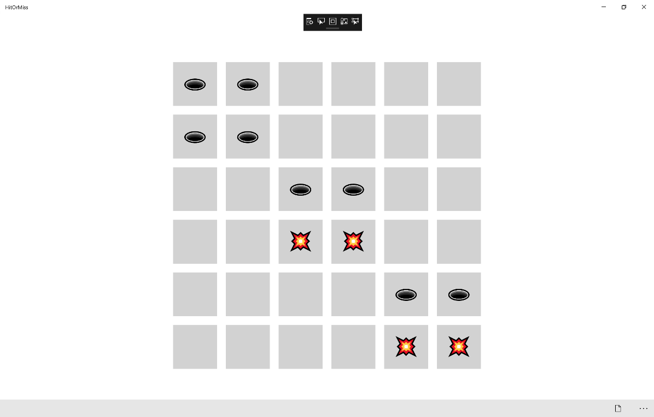

## Step 12

|  |  |
| --- | --- |
|  | To Exit the Application, select the **Close** button in the top right of the Application |