**Image Rotate** shows how to use a **Storyboard** to create a simple **DoubleAnimation** to rotate an image in the **X**, **Y** and **X** axis

## Step 1

|  |  |
| --- | --- |
|  | Follow **Setup and Start** on how to Install and/or Get Started with **Visual Studio 2019** if not already or in **Windows 10** choose **Start**, find and select **Visual Studio 2019** then from the **Get started** screen select **Create a new project** |
|  | Then choose **Blank App (Universal Windows)** and select **Next** and then in **Configure your new project** enter the **Project name** as **ImageRotate** and select **Create** |
|  | Finally, in **New Universal Windows Platform Project** pick the **Target version** and **Minimum version** to be at least **Windows 10, version 1903 (10.0; Build 18362)** and then select **OK** |

**Target Version** will control the most recent features of **Windows 10** your application can use. To make sure you always have the most recent version, check for any **Notifications** or **Updates** in **Visual Studio 2019**

## Step 2

|  |  |
| --- | --- |
|  | Choose **Project** then **Add New Item...** from the **Menu** in **Visual Studio 2019** |

## Step 3

|  |  |
| --- | --- |
|  | Then choose **Code File** from **Add New Item** in **Visual Studio 2019**, enter the **Name** as **Library.cs** and select **Add** |

## Step 4

In the **Code** View of **Library.cs** will be displayed and in this the following should be entered:

|  |
| --- |
| using System;  using Windows.UI.Xaml.Controls;  using Windows.UI.Xaml.Media.Animation;  public class Library  {  private bool _rotating = false;  private Storyboard _rotation = new Storyboard();  public void Rotate(string axis, ref Image target)  {  if (_rotating)  {  _rotation.Stop();  _rotating = false;  }  else  {  DoubleAnimation animation = new DoubleAnimation  {  From = 0.0,  To = 360.0,  BeginTime = TimeSpan.FromSeconds(1),  RepeatBehavior = RepeatBehavior.Forever  };  Storyboard.SetTarget(animation, target);  Storyboard.SetTargetProperty(animation,  $"(UIElement.Projection).(PlaneProjection.Rotation{axis})");  _rotation.Children.Clear();  _rotation.Children.Add(animation);  _rotation.Begin();  _rotating = true;  }  }  } |

There is a using statement to include functionality needed for the application. Storyboard is used as part of the later DoubleAnimation which will animate between **0** and **360** and this will repeat Forever after 1 second. The PlaneProjection.Rotation value for each Axis is set on the UIElement which in this case is the Image named target and uses **String Interpolation Syntax** or $

## Step 5

|  |  |
| --- | --- |
|  | In the **Solution Explorer** of **Visual Studio 2019** select **MainPage.xaml** |

## Step 6

|  |  |
| --- | --- |
|  | Choose **View** then **Designer** from the **Menu** in **Visual Studio 2019** |

## Step 7

In the **Design** View and **XAML** View of **Visual Studio 2019** will be displayed, and in this between the **Grid** and **/Grid** elements enter the following **XAML**:

|  |
| --- |
| <Grid>  <Grid.RowDefinitions>  <RowDefinition Height="Auto"/>  <RowDefinition Height="*"/>  </Grid.RowDefinitions>  <TextBox Grid.Row="0" Name="Value" Margin="20"  InputScope="Url" KeyDown="Go_KeyDown"/>  <Image Grid.Row="1" Margin="100" Stretch="Uniform" Name="Display">  <Image.Projection>  <PlaneProjection/>  </Image.Projection>  </Image>  </Grid>  <CommandBar VerticalAlignment="Bottom">  <AppBarButton Icon="RepeatAll" Label="Pitch" Click="Pitch_Click"/>  <AppBarButton Icon="Rotate" Label="Roll" Click="Roll_Click"/>  <AppBarButton Icon="Refresh" Label="Yaw" Click="Yaw_Click"/>  </CommandBar> |

The first block of **XAML** the main user interface features a **TextBox**. The second block of **XAML** is is the **CommandBar** which contains **Pitch** – to rotate the X Axis, **Roll** – to rotate the Y Axis and **Yaw** – to rotate the Z Axis

## Step 8

|  |  |
| --- | --- |
|  | Choose **View** then **Code** from the **Menu** in **Visual Studio 2019** |

## Step 9

Once in the **Code** View, below the end of **public MainPage() { ... }** the following Code should be entered:

|  |
| --- |
| Library library = new Library();  private void Go_KeyDown(object sender, KeyRoutedEventArgs e)  {  if (e.Key == Windows.System.VirtualKey.Enter)  {  Display.Source = new Windows.UI.Xaml.Media.Imaging  .BitmapImage(new Uri(Value.Text));  }  }  private void Pitch_Click(object sender, RoutedEventArgs e)  {  library.Rotate("X", ref Display);  }  private void Roll_Click(object sender, RoutedEventArgs e)  {  library.Rotate("Y", ref Display);  }  private void Yaw_Click(object sender, RoutedEventArgs e)  {  library.Rotate("Z", ref Display);  } |

Below the **MainPage(...)** method an instance of the Library **Class** is created. In the Go_KeyDown(...) **Event** handler the **Image** has the Source **property** set to the contents any URL entered in the **TextBox**, the Pitch_Click(...), Roll_Click(...) and Yaw_Click(...) **event** handler will use the Rotate method to set which Axis the **Image** should be rotated by

## Step 10

|  |  |
| --- | --- |
|  | That completes the **Universal Windows Platform** Application, in **Visual Studio 2019** select **Local Machine** to run the Application |

## Step 11

Once the Application is running you can then type in the URL of any image e.g. <https://dummyimage.com/300x200/000000/FFFFFF&text=Hello+World> then press or tap Enter to load it, then use the **Pitch**, **Roll** or **Yaw** buttons to rotate the **Image**

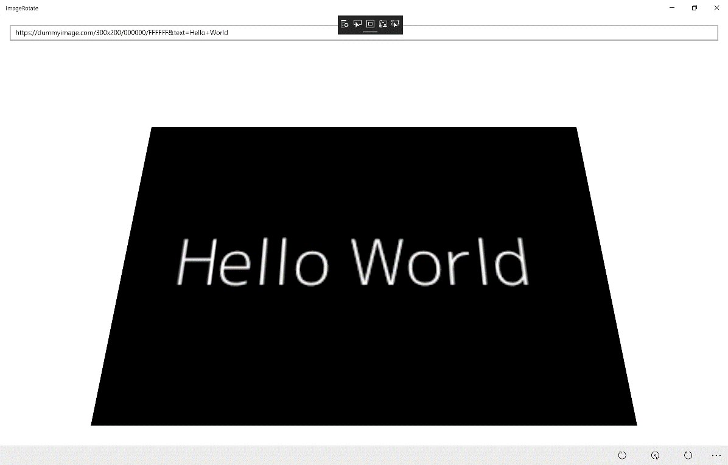

## Step 12

|  |  |
| --- | --- |
|  | To Exit the Application, select the **Close** button in the top right of the Application |