**Light Game** shows how to create a simple game to toggle all the squares from **Gold** to **Black**

## Step 1

|  |  |
| --- | --- |
|  | Follow **Setup and Start** on how to Install and/or Get Started with **Visual Studio 2019** if not already or in **Windows 10** choose **Start**, find and select **Visual Studio 2019** then from the **Get started** screen select **Create a new project** |
|  | Then choose **Blank App (Universal Windows)** and select **Next** and then in **Configure your new project** enter the **Project name** as **LightGame** and select **Create** |
|  | Finally, in **New Universal Windows Platform Project** pick the **Target version** and **Minimum version** to be at least **Windows 10, version 1903 (10.0; Build 18362)** and then select **OK** |

**Target Version** will control the most recent features of **Windows 10** your application can use. To make sure you always have the most recent version, check for any **Notifications** or **Updates** in **Visual Studio 2019**

## Step 2

|  |  |
| --- | --- |
|  | Choose **Project** then **Add New Item...** from the **Menu** in **Visual Studio 2019** |

## Step 3

|  |  |
| --- | --- |
|  | Then choose **Code File** from **Add New Item** in **Visual Studio 2019**, enter the **Name** as **Library.cs** and select **Add** |

## Step 4

In the **Code** View of **Library.cs** will be displayed and in this the following should be entered:

|  |
| --- |
| using Windows.UI;  using Windows.UI.Popups;  using Windows.UI.Xaml;  using Windows.UI.Xaml.Controls;  using Windows.UI.Xaml.Media;  public class Library  {  private const string title = "Light Game";  private const int on = 1;  private const int off = 0;  private const int size = 7;  private readonly Color lightOn = Colors.Gold;  private readonly Color lightOff = Colors.Black;  private int _moves = 0;  private bool _won = false;  private int[,] _board = new int[size, size];  } |

There are using statements to include necessary functionality. _board is a int[,] represents the overall state of the game and there are Color items for the **on** and **off** state colours

Then below the **private int[,] _board = new int[size, size];** line the following **methods** should be entered:

|  |
| --- |
| private void Show(string content, string title)  {  _ = new MessageDialog(content, title).ShowAsync();  }  private void Toggle(Grid grid, int row, int column)  {  _board[row, column] = _board[row, column] == on ? off : on;  Button element = (Button)grid.FindName($"{row}:{column}");  element.Background = _board[row, column] == on ?  new SolidColorBrush(lightOn) :  new SolidColorBrush(lightOff);  } |

Show **method** is used to display a MessageDialog and Toggle is used to set the _board states and set the Background **property**

Next below the **private void Toggle(...) { ... }** **method** the following **method** should be entered:

|  |
| --- |
| private void Set(Grid grid, int row, int column)  {  Toggle(grid, row, column);  if (row > 0)  {  Toggle(grid, row - 1, column); // Toggle Left  }  if (row < (size - 1))  {  Toggle(grid, row + 1, column); // Toggle Right  }  if (column > 0)  {  Toggle(grid, row, column - 1); // Toggle Above  }  if (column < (size - 1))  {  Toggle(grid, row, column + 1); // Toggle Below  }  } |

Set **method** is used to call the Toggle **method** for the selected item and those to the **Left** and **Right** plus those **Above** and **Below**

After the **private void Set(...) { ... }** **method** the following **method** should be entered:

|  |
| --- |
| private bool Winner()  {  for (int row = 0; row < size; row++)  {  for (int column = 0; column < size; column++)  {  if (_board[column, row] == on)  {  return false;  }  }  }  return true;  } |

Winner **method** is used to check if the board has been completed and the game is over

Then after the **private bool Winner() {...}** **method** the following **method** should be entered:

|  |
| --- |
| private void Select(Grid grid, Button button)  {  if (!_won)  {  int row = (int)button.GetValue(Grid.RowProperty);  int column = (int)button.GetValue(Grid.ColumnProperty);  Set(grid, row, column);  _moves++;  if (Winner())  {  Show($"Well Done! You won in {_moves} moves!", title);  _won = true;  }  }  else  {  Show($"Game Over!", title);  }  } |

Select **method** is used when a **Button** has been selected and controls how the game is played

Next after the **private void Select(...) { ... }** **method** the following **method** should be entered:

|  |
| --- |
| private void Add(Grid grid, int row, int column)  {  Button button = new Button()  {  Width = 50,  Height = 50,  Name = $"{row}:{column}",  Margin = new Thickness(2),  Background = new SolidColorBrush(lightOn),  Style = (Style)Application.Current.Resources  ["ButtonRevealStyle"]  };  button.Click += (object sender, RoutedEventArgs e) =>  {  Select(grid, button);  };  button.SetValue(Grid.ColumnProperty, column);  button.SetValue(Grid.RowProperty, row);  grid.Children.Add(button);  } |

Add **method** is used to create a Button and call the Select **method** when it is **clicked**

Then after the **private void Add(...) { ... }** **method** the following **method** should be entered:

|  |
| --- |
| private void Layout(Grid grid)  {  grid.Children.Clear();  grid.RowDefinitions.Clear();  grid.ColumnDefinitions.Clear();  // Setup Board  for (int index = 0; (index < size); index++)  {  grid.RowDefinitions.Add(new RowDefinition());  grid.ColumnDefinitions.Add(new ColumnDefinition());  }  // Setup Layout  for (int row = 0; (row < size); row++)  {  for (int column = 0; (column < size); column++)  {  Add(grid, row, column);  }  }  } |

Layout **method** is used to create the look-and-feel of the game and the Grid and call the Add **method**

Finally after **private void Layout(...) { ... }** **method** the following **public** **method** should be entered:

|  |
| --- |
| public void New(Grid grid)  {  _moves = 0;  _won = false;  Layout(grid);  // Reset Board  for (int column = 0; (column < size); column++)  {  for (int row = 0; (row < size); row++)  {  _board[column, row] = on;  }  }  } |

New **method** will setup and start playing the game by calling Layout **method**

## Step 5

|  |  |
| --- | --- |
|  | In the **Solution Explorer** of **Visual Studio 2019** select **MainPage.xaml** |

## Step 6

|  |  |
| --- | --- |
|  | Choose **View** then **Designer** from the **Menu** in **Visual Studio 2019** |

## Step 7

In the **Design** View and **XAML** View of **Visual Studio 2019** will be displayed, and in this between the **Grid** and **/Grid** elements enter the following **XAML**:

|  |
| --- |
| <Viewbox>  <Grid Name="Display" Margin="50"  HorizontalAlignment="Center"  VerticalAlignment="Center"/>  </Viewbox>  <CommandBar VerticalAlignment="Bottom">  <AppBarButton Icon="Page2" Label="New" Click="New_Click"/>  </CommandBar> |

The first block of **XAML** the main user interface features a **Grid** to represent the game and the second block of **XAML** is the **CommandBar** which contains **New** to setup and start the game

## Step 8

|  |  |
| --- | --- |
|  | Choose **View** then **Code** from the **Menu** in **Visual Studio 2019** |

## Step 9

Once in the **Code** View, below the end of **public MainPage() { ... }** the following Code should be entered:

|  |
| --- |
| Library library = new Library();  private void New_Click(object sender, RoutedEventArgs e)  {  library.New(Display);  } |

Below the **MainPage** method an instance of the Library **class** is created. In the New_Click(...) **Event** handler will setup and play the game using the New **method** in the Library **class**

## Step 10

|  |  |
| --- | --- |
|  | That completes the **Universal Windows Platform** Application, in **Visual Studio 2019** select **Local Machine** to run the Application |

## Step 11

Once the Application is running use **New** to start playing, you can win by setting all the **Gold** squares to **Black**

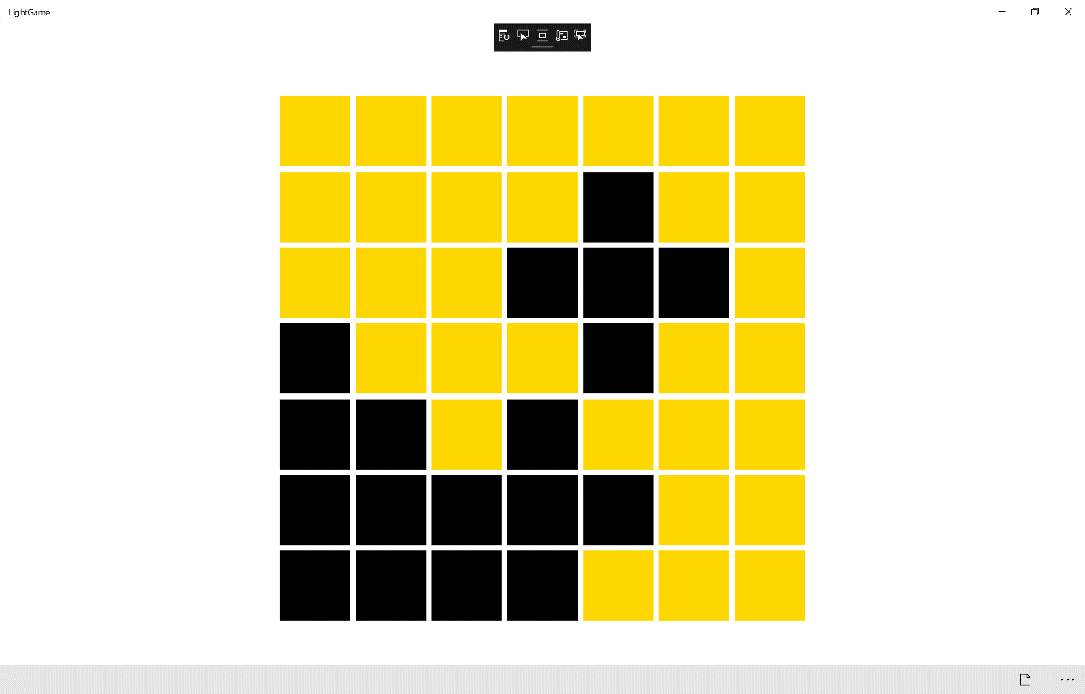

## Step 12

|  |  |
| --- | --- |
|  | To Exit the Application, select the **Close** button in the top right of the Application |