**Lucky Bingo** shows how to create a **Bingo** game using **Grid** and **Ellipse** controls to display which balls have been drawn and which match a random ticket until you get a **Full House**

## Step 1

|  |  |
| --- | --- |
|  | Follow **Setup and Start** on how to Install and/or Get Started with **Visual Studio 2019** if not already or in **Windows 10** choose **Start**, find and select **Visual Studio 2019** then from the **Get started** screen select **Create a new project** |
|  | Then choose **Blank App (Universal Windows)** and select **Next** and then in **Configure your new project** enter the **Project name** as **LuckyBingo** and select **Create** |
|  | Finally, in **New Universal Windows Platform Project** pick the **Target version** and **Minimum version** to be at least **Windows 10, version 1903 (10.0; Build 18362)** and then select **OK** |

**Target Version** will control the most recent features of **Windows 10** your application can use. To make sure you always have the most recent version, check for any **Notifications** or **Updates** in **Visual Studio 2019**

## Step 2

|  |  |
| --- | --- |
|  | Choose **Project** then **Add New Item...** from the **Menu** in **Visual Studio 2019** |

## Step 3

|  |  |
| --- | --- |
|  | Then choose **Code File** from **Add New Item** in **Visual Studio 2019**, enter the **Name** as **Library.cs** and select **Add** |

## Step 4

In the **Code** View of **Library.cs** will be displayed and in this the following should be entered:

|  |
| --- |
| using System;  using System.Collections.Generic;  using System.Linq;  using Windows.UI;  using Windows.UI.Popups;  using Windows.UI.Xaml;  using Windows.UI.Xaml.Controls;  using Windows.UI.Xaml.Media;  using Windows.UI.Xaml.Shapes;  public class Library  {  private const string title = "Lucky Bingo";  private const int size = 22;  private const int balls = 90;  private const int marks = 25;  private const int maximum = 90;  private readonly Color _accent =  (Color)Application.Current.Resources["SystemAccentColor"];  private int _count;  private int _house;  private List<int> _balls;  private List<int> _marks;  private bool _gameOver = false;  private Random _random = new Random((int)DateTime.UtcNow.Ticks);  } |

There are using statements to include necessary functionality. Also there are private const for the setup of the game and for the values that will represent the look-and-feel of the game, there are also private **members** to store values for the game

Then below the **private Random _random = new Random((int)DateTime.UtcNow.Ticks);** line the following **methods** should be entered:

|  |
| --- |
| private void Show(string content, string title)  {  _ = new MessageDialog(content, title).ShowAsync();  }  private List<int> Choose(int total)  {  int number;  List<int> numbers = new List<int>();  while (numbers.Count < total) // Select Numbers  {  number = _random.Next(1, maximum + 1);  if (!numbers.Contains(number) || numbers.Count < 1)  {  numbers.Add(number); // Add if not Chosen or None  }  }  return numbers;  } |

The Show **method** is used to display a basic MessageDialog and Choose is used to return a List<int> of numbers using Random

Next below the **private List<int> Choose(int total) { ... }** **method** the following **method** should be entered:

|  |
| --- |
| private Ellipse Ellipse(bool ball, int value)  {  Ellipse ellipse = new Ellipse()  {  Width = size,  Height = size,  VerticalAlignment = VerticalAlignment.Center,  HorizontalAlignment = HorizontalAlignment.Center  };  if (ball)  {  ellipse.StrokeThickness = 2;  ellipse.Stroke = new SolidColorBrush(_accent);  }  else  {  ellipse.Opacity = 0;  ellipse.Name = $"mark{value}";  ellipse.Fill = new SolidColorBrush(_accent);  }  return ellipse;  } |

The Ellipse **method** is used to create an Ellipse for the ball or else for indicating a mark on the ticket

Then after the **private Grid Pocket(int value) { ... } method** the following **method** should be entered:

|  |
| --- |
| private void Add(ref Grid grid, bool ball,  int row, int column, int value)  {  Grid element = new Grid()  {  Width = size,  Height = size,  };  if (ball)  {  element.Opacity = 0;  element.Name = $"ball{value}";  }  TextBlock label = new TextBlock()  {  FontSize = 12,  Text = $"{value}",  TextLineBounds = TextLineBounds.Tight,  VerticalAlignment = VerticalAlignment.Center,  Foreground = new SolidColorBrush(Colors.Black),  HorizontalAlignment = HorizontalAlignment.Center,  };  element.Children.Add(label);  element.Children.Add(Ellipse(ball, value));  element.SetValue(Grid.RowProperty, row);  element.SetValue(Grid.ColumnProperty, column);  grid.Children.Add(element);  } |

The Add **method** is used to create the elements that will make up a ball or that make up a ticket

Next after the private void **Add(...) { ... }** **method** the following **method** should be entered:

|  |
| --- |
| private Grid Layout(bool ball, int rows,  int cols, List<int> list)  {  int count = 0;  Grid grid = new Grid()  {  Width = 250,  Height = 250  };  grid.Children.Clear();  grid.RowDefinitions.Clear();  grid.ColumnDefinitions.Clear();  // Setup Grid  for (int row = 0; row < rows; row++)  {  grid.RowDefinitions.Add(new RowDefinition());  }  for (int column = 0; column < cols; column++)  {  grid.ColumnDefinitions.Add(new ColumnDefinition());  }  // Setup Board  for (int row = 0; row < rows; row++)  {  for (int column = 0; column < cols; column++)  {  Add(ref grid, ball, row, column, list[count]);  count++;  }  }  return grid;  } |

The Layout **method** is used to create the look-and-feel of the game including setting up the Grid by calling the Add **method**

Next after the **private Grid Layout(...) {...}** **method** the following **method** should be entered:

|  |
| --- |
| private void Set(ref StackPanel panel, bool isBall,  int value, double opacity)  {  string name = $"{(isBall ? "ball" : "mark")}{value}";  UIElement element = (UIElement)panel.FindName(name);  if (element != null) element.Opacity = opacity;  } |

The Set method will get a UIElement using FindName for the drawn ball or mark a matched value

Finally after the **private void Set(...) { ... }** **method** the following public **methods** should be entered:

|  |
| --- |
| public void New(StackPanel panel)  {  _count = 0;  _house = 0;  _gameOver = false;  _balls = Choose(balls);  _marks = Choose(marks);  panel.Children.Clear();  panel.Children.Add(Layout(true, 9, 10, _balls));  panel.Children.Add(Layout(false, 5, 5, _marks));  }  public void Play(StackPanel panel)  {  if (!panel.Children.Any()) New(panel);  if (_count < balls && !_gameOver)  {  var ball = _balls[_count];  Set(ref panel, true, ball, 1);  if (_marks.Contains(ball))  {  _house++;  Set(ref panel, false, ball, 0.5);  if (_house == marks)  {  _gameOver = true;  Show($"Full House in {_count} Balls!", title);  }  }  _count++;  }  else  {  Show($"Game Over!", title);  }  } |

The New **method** will setup the layout of the Grid using the Layout **method** using Choose the values for the ticket with marks and numbers to be drawn with balls and the Play **method** will check to see if a drawn value is the same as one in the ticket and when the _house value reaches the total in the ticket that's a **full house** and the game is won, or if not and all numbers are drawn then the game will be over

## Step 5

|  |  |
| --- | --- |
|  | In the **Solution Explorer** of **Visual Studio 2019** select **MainPage.xaml** |

## Step 6

|  |  |
| --- | --- |
|  | Choose **View** then **Designer** from the **Menu** in **Visual Studio 2019** |

## Step 7

In the **Design** View and **XAML** View of **Visual Studio 2019** will be displayed, and in this between the **Grid** and **/Grid** elements enter the following **XAML**:

|  |
| --- |
| <Viewbox>  <StackPanel Margin="50" Name="Display"  Orientation="Horizontal"  HorizontalAlignment="Center"  VerticalAlignment="Center"/>  </Viewbox>  <CommandBar VerticalAlignment="Bottom">  <AppBarButton Icon="Page2" Label="New" Click="New_Click"/>  <AppBarButton Icon="Play" Label="Play" Click="Play_Click"/>  </CommandBar> |

The first block of **XAML** the main user interface is a **Viewbox** to contain a **Grid** which will display the game. The second block of **XAML** is the **CommandBar** which contains **New** to setup the game and **Play** to start playing

## Step 8

|  |  |
| --- | --- |
|  | Choose **View** then **Code** from the **Menu** in **Visual Studio 2019** |

## Step 9

Once in the **Code** View, below the end of **public MainPage() { ... }** the following Code should be entered:

|  |
| --- |
| Library library = new Library();  private void New_Click(object sender, RoutedEventArgs e)  {  library.New(Display);  }  private void Play_Click(object sender, RoutedEventArgs e)  {  library.Play(Display);  } |

Below the **MainPage** method an instance of the Library **Class** is created. The New_Click **event** handler will call the New **method** in the Library **class** and the Play_Click **event** handler will call the Play **method**

## Step 10

|  |  |
| --- | --- |
|  | That completes the **Universal Windows Platform** Application, in **Visual Studio 2019** select **Local Machine** to run the Application |

## Step 11

Once the Application is running you can click **New** to setup the **Bingo Game** then click **Play** which will draw a **Ball** and if this matches the ticket it will be marked off, mark off all the numbers for a **Full House**

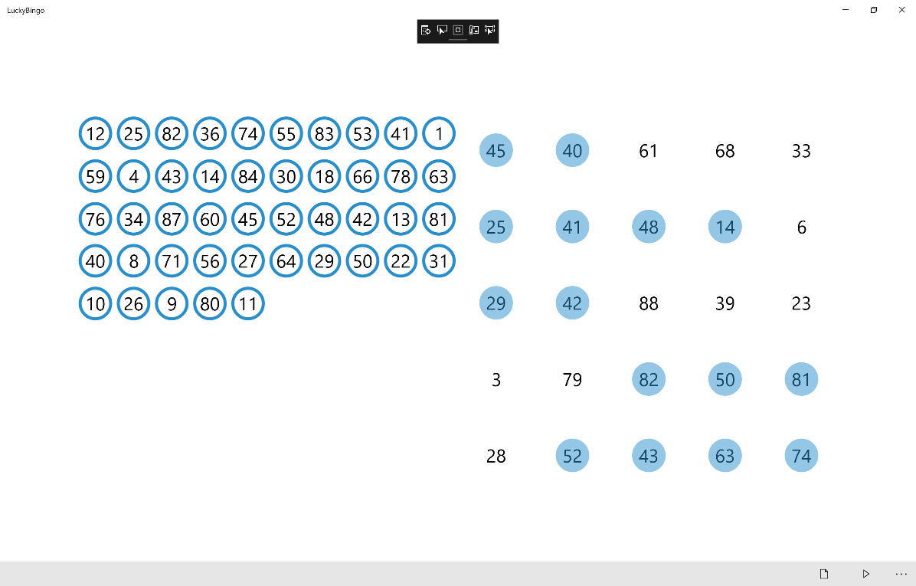

You can also add more functionality to this game to support 1-line, 2-line and other prizes for a more functional **bingo** game

## Step 12

|  |  |
| --- | --- |
|  | To Exit the Application, select the **Close** button in the top right of the Application |