## Step 1

|  |  |
| --- | --- |
|  | Follow **Setup and Start** on how to Install and/or Get Started with **Visual Studio 2019** if not already or in **Windows 10** choose **Start**, find and select **Visual Studio 2019** then from the **Get started** screen select **Create a new project** |
|  | Then choose **Blank App (Universal Windows)** and select **Next** and then in **Configure your new project** enter the **Project name** as **LuckyDice** and select **Create** |
|  | Finally, in **New Universal Windows Platform Project** pick the **Target version** and **Minimum version** to be at least **Windows 10, version 1903 (10.0; Build 18362)** and then select **OK** |

**Target Version** will control the most recent features of **Windows 10** your application can use. To make sure you always have the most recent version, check for any **Notifications** or **Updates** in **Visual Studio 2019**

## Step 2

|  |  |
| --- | --- |
|  | Choose **Project** then **Add New Item...** from the **Menu** in **Visual Studio 2019** |

## Step 3

|  |  |
| --- | --- |
|  | Then choose **Code File** from **Add New Item** in **Visual Studio 2019**, enter the **Name** as **Library.cs** and select **Add** |

## Step 4

In the **Code** View of **Library.cs** will be displayed and in this the following should be entered:

|  |
| --- |
| using System;  using System.Linq;  using Windows.UI;  using Windows.UI.Xaml;  using Windows.UI.Xaml.Controls;  using Windows.UI.Xaml.Media;  using Windows.UI.Xaml.Shapes;  public class Library  {  private const int size = 3;  private static readonly byte[][] layout =  {  // a, b, c, d, e, f, g, h, i  new byte[] { 0, 0, 0, 0, 0, 0, 0, 0, 0 }, // 0  new byte[] { 0, 0, 0, 0, 1, 0, 0, 0, 0 }, // 1  new byte[] { 1, 0, 0, 0, 0, 0, 0, 0, 1 }, // 2  new byte[] { 1, 0, 0, 0, 1, 0, 0, 0, 1 }, // 3  new byte[] { 1, 0, 1, 0, 0, 0, 1, 0, 1 }, // 4  new byte[] { 1, 0, 1, 0, 1, 0, 1, 0, 1 }, // 5  new byte[] { 1, 0, 1, 1, 0, 1, 1, 0, 1 }, // 6  };  private readonly Color _accent =  (Color)Application.Current.Resources["SystemAccentColor"];  private Random _random = new Random((int)DateTime.UtcNow.Ticks);  } |

There are using statements to include necessary functionality. layout is a byte[][] is a **two-dimensional array** of values that will represent which row and column of pips will be displayed on the dice or die. _accent is a Color that will be used to set the look of the dice and Random is used to create the numbers for the dice

Then below the **private Random _random = new Random((int)DateTime.UtcNow.Ticks);** line the following **method** should be entered:

|  |
| --- |
| private void Add(ref Grid grid, int row, int column)  {  Ellipse element = new Ellipse()  {  Fill = new SolidColorBrush(_accent),  Margin = new Thickness(5),  Opacity = 0  };  element.SetValue(Grid.ColumnProperty, column);  element.SetValue(Grid.RowProperty, row);  grid.Children.Add(element);  } |

Add(...) is used to create the Ellipse to represent the pips of the dice

Next below the private void Add(...) { } **method** the following **method** should be entered:

|  |
| --- |
| private void Set(ref Grid grid, int row, int column, byte opacity)  {  Grid element = (Grid)((Viewbox)grid.Children  .FirstOrDefault()).Child;  Ellipse ellipse = element.Children.Cast<Ellipse>()  .FirstOrDefault(f =>  Grid.GetRow(f) == row && Grid.GetColumn(f) == column);  if (ellipse != null) ellipse.Opacity = opacity;  } |

Set(...) is used to get the first with FirstOrDefault() existing Grid item within a Viewbox and then from this get the first Ellipse item and set the Opacity to the passed in value

After the **private void Set(...)** **method** the following **method** should be entered:

|  |
| --- |
| private void Update(ref Grid grid, int value)  {  int count = 0;  for (int row = 0; row < size; row++)  {  for (int column = 0; column < size; column++)  {  Set(ref grid, row, column, layout[value][count]);  count++;  }  }  } |

Update(...) will for a given Grid loop through all the **rows** and **columns** of this and use the Set(...) method to update pips of the dice using the value passed in

Finally, after the **private void Update(...)** **method** the following public **methods** should be entered:

|  |
| --- |
| public void New(ref Grid grid)  {  grid.Children.Clear();  Grid element = new Grid()  {  Width = 100,  Height = 100,  Padding = new Thickness(5)  };  // Setup Grid  for (int index = 0; index < size; index++)  {  element.RowDefinitions.Add(new RowDefinition());  element.ColumnDefinitions.Add(new ColumnDefinition());  }  for (int row = 0; row < size; row++)  {  for (int column = 0; column < size; column++)  {  Add(ref element, row, column);  }  }  Viewbox viewbox = new Viewbox()  {  Child = element  };  grid.Children.Add(viewbox);  Update(ref grid, 0);  }  public void Get(ref Grid grid)  {  if(!grid.Children.Any()) New(ref grid);  Update(ref grid, _random.Next(1, 7));  } |

New(...) will setup the layout of the Grid passed in with the RowDefinition and ColumnDefinition and use the Add(...) **method** to create the layout of the dice and then place this within a ViewBox and add this to the Grid. Get(...) will call the New **method** if nothing has been added to the Grid then calls the Update(...) method to set the dice value using the randomised number from Random

## Step 5

|  |  |
| --- | --- |
|  | In the **Solution Explorer** of **Visual Studio 2019** select **MainPage.xaml** |

## Step 6

|  |  |
| --- | --- |
|  | Choose **View** then **Designer** from the **Menu** in **Visual Studio 2019** |

## Step 7

In the **Design** View and **XAML** View of **Visual Studio 2019** will be displayed, and in this between the **Grid** and **/Grid** elements enter the following **XAML**:

|  |
| --- |
| <Viewbox>  <Grid>  <Grid.RowDefinitions>  <RowDefinition Height="*"/>  <RowDefinition Height="Auto"/>  <RowDefinition Height="*"/>  </Grid.RowDefinitions>  <Grid.ColumnDefinitions>  <ColumnDefinition Width="*"/>  <ColumnDefinition Width="Auto"/>  <ColumnDefinition Width="*"/>  <ColumnDefinition Width="Auto"/>  <ColumnDefinition Width="*"/>  </Grid.ColumnDefinitions>  <Grid Margin="50" Grid.Column="1" Grid.Row="1"  Name="DiceOne" CornerRadius="10" Background="WhiteSmoke"  Height="100" Width="100" Tapped="DiceOne_Tapped"/>  <Grid Margin="50" Grid.Column="3" Grid.Row="1"  Name="DiceTwo" CornerRadius="10" Background="WhiteSmoke"  Height="100" Width="100" Tapped="DiceTwo_Tapped"/>  </Grid>  </Viewbox>  <CommandBar VerticalAlignment="Bottom">  <AppBarButton Icon="Page2" Label="New" Click="New_Click"/>  </CommandBar> |

The first block of **XAML** the main user interface features a **Grid** with two **Grid** Controls within to represent the dice. The second block of **XAML** is the **CommandBar** which contains **New** to reset the game

## Step 8

|  |  |
| --- | --- |
|  | Choose **View** then **Code** from the **Menu** in **Visual Studio 2019** |

## Step 9

Once in the **Code** View, below the end of **public MainPage() { ... }** the following Code should be entered:

|  |
| --- |
| Library library = new Library();  private void New_Click(object sender, RoutedEventArgs e)  {  library.New(ref DiceOne);  library.New(ref DiceTwo);  }  private void DiceOne_Tapped(object sender, RoutedEventArgs e)  {  library.Get(ref DiceOne);  }  private void DiceTwo_Tapped(object sender, RoutedEventArgs e)  {  library.Get(ref DiceTwo);  } |

Below the **MainPage(...)** method an instance of the Library **Class** is created. In the New_Click(...) **Event** handler will setup the two **Grid** Controls, DiceOne_Tapped(...) and DiceTwo_Tapped(...) will call the Get **method** in the Library **Class**

## Step 10

|  |  |
| --- | --- |
|  | That completes the **Universal Windows Platform** Application, in **Visual Studio 2019** select **Local Machine** to run the Application |

## Step 11

Once the Application is running you can then click on either of the **Grid** controls to randomly show the value of the dice or use **New** to reset them

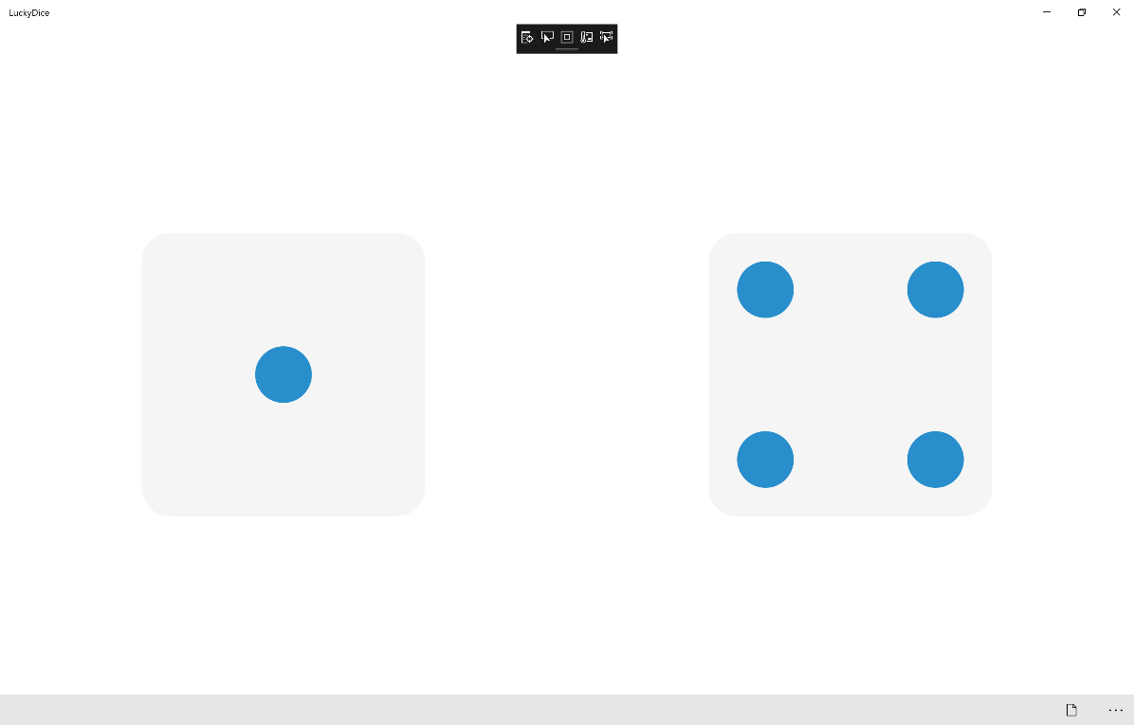

## Step 12

|  |  |
| --- | --- |
|  | To Exit the Application, select the **Close** button in the top right of the Application |