**Lucky Lotto** shows how to display selected Lottery Numbers in **Ellipse** controls within a **StackPanel**

## Step 1

|  |  |
| --- | --- |
|  | Follow **Setup and Start** on how to Install and/or Get Started with **Visual Studio 2019** if not already or in **Windows 10** choose **Start**, find and select **Visual Studio 2019** then from the **Get started** screen select **Create a new project** |
|  | Then choose **Blank App (Universal Windows)** and select **Next** and then in **Configure your new project** enter the **Project name** as **LuckyLotto** and select **Create** |
|  | Finally, in **New Universal Windows Platform Project** pick the **Target version** and **Minimum version** to be at least **Windows 10, version 1903 (10.0; Build 18362)** and then select **OK** |

**Target Version** will control the most recent features of **Windows 10** your application can use. To make sure you always have the most recent version, check for any **Notifications** or **Updates** in **Visual Studio 2019**

## Step 2

|  |  |
| --- | --- |
|  | Choose **Project** then **Add New Item...** from the **Menu** in **Visual Studio 2019** |

## Step 3

|  |  |
| --- | --- |
|  | Then choose **Code File** from **Add New Item** in **Visual Studio 2019**, enter the **Name** as **Library.cs** and select **Add** |

## Step 4

In the **Code** View of **Library.cs** will be displayed and in this the following should be entered:

|  |
| --- |
| using System;  using System.Collections.Generic;  using System.Linq;  using Windows.UI;  using Windows.UI.Xaml;  using Windows.UI.Xaml.Controls;  using Windows.UI.Xaml.Media;  using Windows.UI.Xaml.Shapes;  public class Library  {  private const int total = 6;  private const int maximum = 59;  private Dictionary<int, Color> _style = new Dictionary<int, Color>()  {  { 0, Colors.White },  { 10, Colors.RoyalBlue },  { 20, Colors.HotPink },  { 30, Colors.MediumSpringGreen },  { 40, Colors.Gold },  { 50, Colors.Indigo },  };  private Random _random = new Random((int)DateTime.UtcNow.Ticks);  } |

There are using statements to include necessary functionality. Also there are private const int for the total number of balls in the lottery and maximum which is the biggest lottery number that can be selected. Dictionary<int, Color> is used to store the lowest value for a range and their colour of the lottery balls. Random is used to create the randomised numbers.

Then below the **private Random _random = new Random((int)DateTime.UtcNow.Ticks);** line the following **method** should be entered:

|  |
| --- |
| private List<int> Choose()  {  int number;  List<int> numbers = new List<int>();  while (numbers.Count < total) // Select Numbers  {  number = _random.Next(1, maximum + 1);  if (!numbers.Contains(number) || numbers.Count < 1)  {  numbers.Add(number); // Add if not Chosen or None  }  }  numbers.Sort();  return numbers;  } |

Choose() is used to return a List<int> of sorted lottery numbers using Random to select them

Next below the **private void Choose() { }** **method** the following **method** should be entered:

|  |
| --- |
| private void Add(ref StackPanel panel, int value)  {  Color fill = _style.Where(w => value > w.Key)  .Select(s => s.Value).LastOrDefault();  Grid element = new Grid()  {  Width = 75,  Height = 75,  Margin = new Thickness(5),  };  Ellipse ball = new Ellipse()  {  StrokeThickness = 5,  Stroke = new SolidColorBrush(fill)  };  TextBlock label = new TextBlock()  {  FontSize = 32,  Text = value.ToString(),  TextLineBounds = TextLineBounds.Tight,  VerticalAlignment = VerticalAlignment.Center,  Foreground = new SolidColorBrush(Colors.Black),  HorizontalAlignment = HorizontalAlignment.Center,  };  element.Children.Add(ball);  element.Children.Add(label);  panel.Children.Add(element);  } |

Add(...) is used to create the lottery balls, there is a Grid which will contain the Ellipse for the ball with Stroke set to the SolidColorBrush of the Color selected using **LINQ** to get the LastOrDefault() value and TextBlock which will display the number itself

Finally, after **private void Add(...)** **method** the following **public** **method** should be entered:

|  |
| --- |
| public void New(ref Grid grid)  {  grid.Children.Clear();  StackPanel panel = new StackPanel()  {  Height = 100,  Orientation = Orientation.Horizontal  };  foreach (int number in Choose())  {  Add(ref panel, number);  }  Viewbox viewbox = new Viewbox()  {  Child = panel  };  grid.Children.Add(viewbox);  } |

New(...) will setup the layout of the StackPanel passed in and use the Add(...) **method** to create the layout of the lottery numbers and then place this within a ViewBox and add this to a Grid

## Step 5

|  |  |
| --- | --- |
|  | In the **Solution Explorer** of **Visual Studio 2019** select **MainPage.xaml** |

## Step 6

|  |  |
| --- | --- |
|  | Choose **View** then **Designer** from the **Menu** in **Visual Studio 2019** |

## Step 7

In the **Design** View and **XAML** View of **Visual Studio 2019** will be displayed, and in this between the **Grid** and **/Grid** elements enter the following **XAML**:

|  |
| --- |
| <Grid Margin="50" Name="Display"  VerticalAlignment="Center" HorizontalAlignment="Center"  CornerRadius="10" Background="WhiteSmoke"/>  <CommandBar VerticalAlignment="Bottom">  <AppBarButton Icon="Page2" Label="New" Click="New_Click"/>  </CommandBar> |

The first block of **XAML** the main user interface features a **Grid** to contain the lottery numbers. The second block of **XAML** is the **CommandBar** which contains **New** to select the lottery numbers

## Step 8

|  |  |
| --- | --- |
|  | Choose **View** then **Code** from the **Menu** in **Visual Studio 2019** |

## Step 9

Once in the **Code** View, below the end of **public MainPage() { ... }** the following Code should be entered:

|  |
| --- |
| Library library = new Library();  private void New_Click(object sender, RoutedEventArgs e)  {  library.New(ref Display);  } |

Below the **MainPage(...)** method an instance of the Library **Class** is created. In the New_Click(...) **Event** handler will call the New(...) **method** in the Library **class**

## Step 10

|  |  |
| --- | --- |
|  | That completes the **Universal Windows Platform** Application, in **Visual Studio 2019** select **Local Machine** to run the Application |

## Step 11

Once the Application is running you can then click on the **New** button to select some lottery numbers

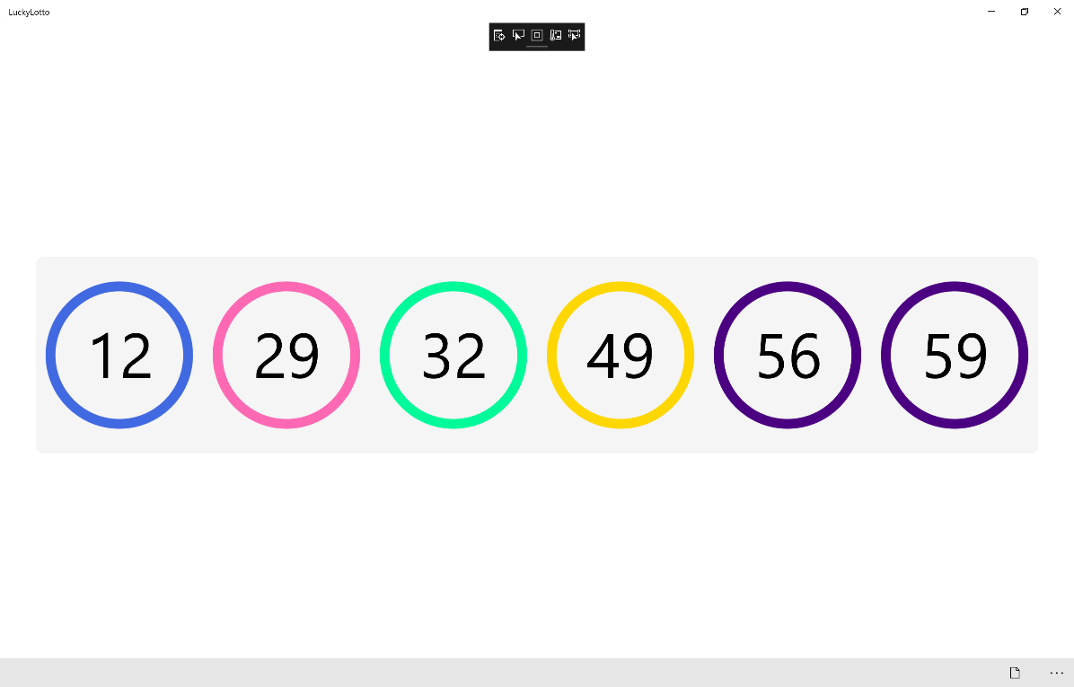

You can change the total, maximum and _style values to match the style of the lottery where you are

## Step 12

|  |  |
| --- | --- |
|  | To Exit the Application, select the **Close** button in the top right of the Application |