**Navigation View** shows how to use the **NavigationView** Control to create hamburger-style navigation

## Step 1

|  |  |
| --- | --- |
|  | Follow **Setup and Start** on how to Install and/or Get Started with **Visual Studio 2019** if not already or in **Windows 10** choose **Start**, find and select **Visual Studio 2019** then from the **Get started** screen select **Create a new project** |
|  | Then choose **Blank App (Universal Windows)** and select **Next** and then in **Configure your new project** enter the **Project name** as **NavigationView** and select **Create** |
|  | Finally, in **New Universal Windows Platform Project** pick the **Target version** and **Minimum version** to be at least **Windows 10, version 1903 (10.0; Build 18362)** and then select **OK** |

**Target Version** will control the most recent features of **Windows 10** your application can use. To make sure you always have the most recent version, check for any **Notifications** or **Updates** in **Visual Studio 2019**

## Step 2

|  |  |
| --- | --- |
|  | In the **Solution Explorer** of **Visual Studio 2019** select **MainPage.xaml** |

## Step 3

|  |  |
| --- | --- |
|  | Choose **View** then **Designer** from the **Menu** in **Visual Studio 2019** |

## Step 4

In the **Design** View and **XAML** View of **Visual Studio 2019** will be displayed, and in this between the **Grid** and **/Grid** elements enter the following **XAML**:

|  |
| --- |
| <NavigationView Name="Navigation" IsSettingsVisible="False">  <NavigationView.MenuItems>  <NavigationViewItem Content="Toggle" Tapped="Toggle_Tapped">  <NavigationViewItem.Icon>  <SymbolIcon Symbol="Accept"/>  </NavigationViewItem.Icon>  </NavigationViewItem>  </NavigationView.MenuItems>  </NavigationView> |

**NavigationView** is used to display a hamburger-style menu and contains **MenuItems** with a **NavigationViewItem** that can be used to toggle the visibility of the menu, this can also be done with the “hamburger” button near the top of the control

## Step 5

|  |  |
| --- | --- |
|  | Choose **View** then **Code** from the **Menu** in **Visual Studio 2019** |

## Step 6

Once in the **Code** View, below the end of public MainPage() { ... } the following Code should be entered:

|  |
| --- |
| private void Toggle_Tapped(object sender, TappedRoutedEventArgs e)  {  Navigation.IsPaneOpen = !Navigation.IsPaneOpen;  } |

Toggle_Tapped is an **event** handler that will toggle the IsPaneOpen value of the NavigationView

## Step 7

|  |  |
| --- | --- |
|  | That completes the **Universal Windows Platform** Application, in **Visual Studio 2019** select **Local Machine** to run the Application |

## Step 8

Once the Application is running it will display the **NavigationView**, you can use **Toggle** to show or hide the navigation pane

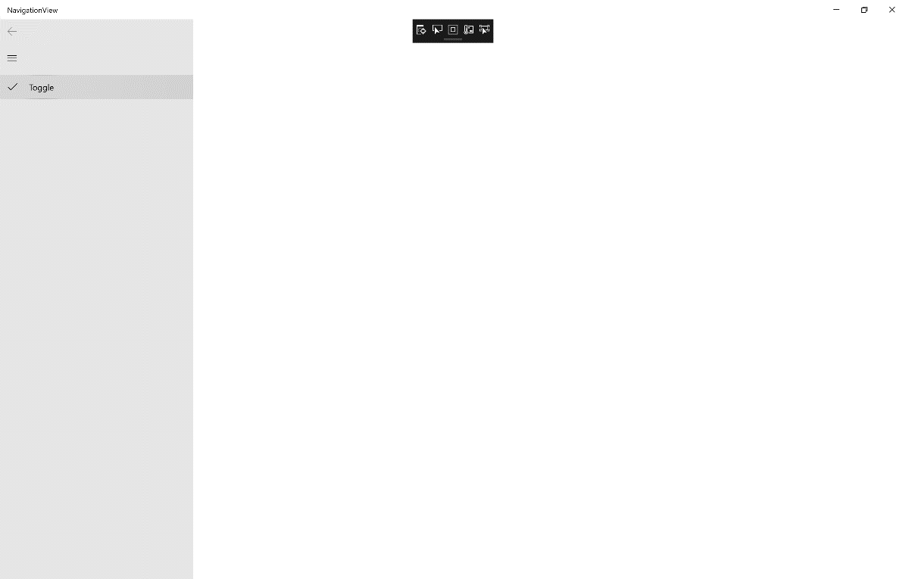

## Step 9

|  |  |
| --- | --- |
|  | To Exit the Application, select the **Close** button in the top right of the Application |