**Order Game** shows how to create a simple game where the objective is to re-arrange numbered squares in the correct sequence in the quickest time possible

## Step 1

|  |  |
| --- | --- |
|  | Follow **Setup and Start** on how to Install and/or Get Started with **Visual Studio 2019** if not already or in **Windows 10** choose **Start**, find and select **Visual Studio 2019** then from the **Get started** screen select **Create a new project** |
|  | Then choose **Blank App (Universal Windows)** and select **Next** and then in **Configure your new project** enter the **Project name** as **OrderGame** and select **Create** |
|  | Finally, in **New Universal Windows Platform Project** pick the **Target version** and **Minimum version** to be at least **Windows 10, version 1903 (10.0; Build 18362)** and then select **OK** |

**Target Version** will control the most recent features of **Windows 10** your application can use. To make sure you always have the most recent version, check for any **Notifications** or **Updates** in **Visual Studio 2019**

## Step 2

|  |  |
| --- | --- |
|  | Choose **Project** then **Add New Item...** from the **Menu** in **Visual Studio 2019** |

## Step 3

|  |  |
| --- | --- |
|  | Then choose **Code File** from **Add New Item** in **Visual Studio 2019**, enter the **Name** as **Library.cs** and select **Add** |

## Step 4

In the **Code** View of **Library.cs** will be displayed and in this the following should be entered:

|  |
| --- |
| using System;  using System.Collections.Generic;  using System.Collections.ObjectModel;  using System.Linq;  using Windows.UI.Popups;  using Windows.UI.Xaml.Controls;  public class Library  {  private const string title = "Order Game";  private const int size = 6;  private DateTime _timer;  private ObservableCollection<int> _list =  new ObservableCollection<int>();  private Random _random = new Random((int)DateTime.Now.Ticks);  } |

There are using statements to include necessary functionality. _list is a ObservableCollection<int> represents the elements of the game and Random is used to create the numbers for the **order** of the elements

Then below the **private Random _random = new Random((int)DateTime.Now.Ticks);** line the following **methods** should be entered:

|  |
| --- |
| private void Show(string content, string title)  {  _ = new MessageDialog(content, title).ShowAsync();  }  private List<int> Choose(int start, int total)  {  return Enumerable.Range(start, total)  .OrderBy(r => _random.Next(start, total)).ToList();  } |

Show **method** is used to display a MessageDialog and Choose is used to pick randomised numbers to **order** the elements in the game

Then below the **private List<int> Choose(...) { ... } method** the following **method** should be entered:

|  |
| --- |
| private void Layout(GridView grid)  {  int index = 0;  _list.Clear();  grid.IsEnabled = true;  grid.ItemsSource = null;  _timer = DateTime.UtcNow;  List<int> numbers = Choose(1, size * size);  while (index < numbers.Count)  {  _list.Add(numbers[index]);  index++;  }  grid.ItemsSource = _list;  } |

Layout **method** is used to create the look-and-feel of the game and the Grid and call Add **method** of _list

Finally after the **private void Layout(...) { ... }** **method** the following **public** **methods** should be entered:

|  |
| --- |
| public void New(GridView grid)  {  Layout(grid);  }  public void Order(GridView grid)  {  if (_list.OrderBy(o => o).SequenceEqual(_list))  {  TimeSpan duration = (DateTime.UtcNow - _timer).Duration();  Show($"Completed in {duration:hh\\:mm\\:ss}", title);  grid.IsEnabled = false;  }  } |

New **method** will setup and start playing the game by calling Layout **method** and Order **method** will check to see if the elements are in order then display a message to say how long the game took to complete

## Step 5

|  |  |
| --- | --- |
|  | In the **Solution Explorer** of **Visual Studio 2019** select **MainPage.xaml** |

## Step 6

|  |  |
| --- | --- |
|  | Choose **View** then **Designer** from the **Menu** in **Visual Studio 2019** |

## Step 7

In the **Design** View and **XAML** View of **Visual Studio 2019** will be displayed, and in this between the **Grid** and **/Grid** elements enter the following **XAML**:

|  |
| --- |
| <Viewbox>  <GridView Margin="50" Name="Display"  HorizontalAlignment="Center" VerticalAlignment="Center"  SelectionMode="Single" CanDrag="True" CanDragItems="True"  AllowDrop="True" CanReorderItems="True"  DragItemsCompleted="Display_DragItemsCompleted">  <GridView.ItemTemplate>  <DataTemplate>  <Grid Width="50" Height="50"  Background="{ThemeResource SystemAccentColor}">  <TextBlock Text="{Binding}" FontSize="24"  HorizontalAlignment="Center"  VerticalAlignment="Center"  Foreground="White"/>  </Grid>  </DataTemplate>  </GridView.ItemTemplate>  <GridView.ItemsPanel>  <ItemsPanelTemplate>  <ItemsWrapGrid Orientation="Horizontal"  MaximumRowsOrColumns="6"/>  </ItemsPanelTemplate>  </GridView.ItemsPanel>  </GridView>  </Viewbox>  <CommandBar VerticalAlignment="Bottom">  <AppBarButton Icon="Page2" Label="New" Click="New_Click"/>  </CommandBar> |

The first block of **XAML** the main user interface features a **ViewBox** containing a **GridView** that will be the look-and-feel of the game which has the ability to reorder items and has a **DataTemplate** which will represent the items themselves and the **ItemsPanel** of the **GridView** is a **ItemsWrapGrid** to make the items display correctly and the second block of **XAML** is the **CommandBar** which contains **New** to setup and start the game

## Step 8

|  |  |
| --- | --- |
|  | Choose **View** then **Code** from the **Menu** in **Visual Studio 2019** |

## Step 9

Once in the **Code** View, below the end of **public MainPage() { ... }** the following Code should be entered:

|  |
| --- |
| Library library = new Library();  private void New_Click(object sender, RoutedEventArgs e)  {  library.New(Display);  }  private void Display_DragItemsCompleted(ListViewBase sender,  DragItemsCompletedEventArgs args)  {  library.Order(Display);  } |

Below the **MainPage** method an instance of the Library **class** is created. In the New_Click(...) **Event** handler will setup and start the game using the New **method** in the Library **class** and the Display_DragItemsCompleted **event** handler will call the Order **method** in the Library **class**

## Step 10

|  |  |
| --- | --- |
|  | That completes the **Universal Windows Platform** Application, in **Visual Studio 2019** select **Local Machine** to run the Application |

## Step 11

Once the Application is running use **New** to start playing, you can win by putting all the numbers in order from **1** to **36** from left to right as quickly as possible by draging and moving them into the correct positions.

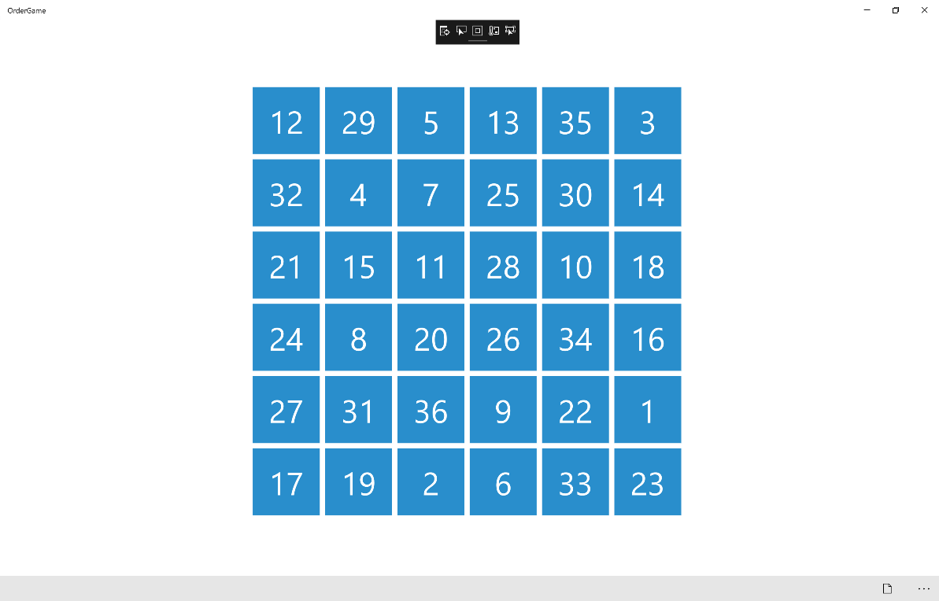

## Step 12

|  |  |
| --- | --- |
|  | To Exit the Application, select the **Close** button in the top right of the Application |