**ParallaxView Effect** shows how to use the **ParallaxView** Control which is part of the **Fluent Design System** in **Windows 10**

## Step 1

|  |  |
| --- | --- |
|  | Follow **Setup and Start** on how to Install and/or Get Started with **Visual Studio 2019** if not already or in **Windows 10** choose **Start**, find and select **Visual Studio 2019** then from the **Get started** screen select **Create a new project** |
|  | Then choose **Blank App (Universal Windows)** and select **Next** and then in **Configure your new project** enter the **Project name** as **ParallaxViewEffect** and select **Create** |
|  | Finally, in **New Universal Windows Platform Project** pick the **Target version** and **Minimum version** to be at least **Windows 10, version 1903 (10.0; Build 18362)** and then select **OK** |

**Target Version** will control the most recent features of **Windows 10** your application can use. To make sure you always have the most recent version, check for any **Notifications** or **Updates** in **Visual Studio 2019**

## Step 2

|  |  |
| --- | --- |
|  | In the **Solution Explorer** of **Visual Studio 2019** select **MainPage.xaml** |

## Step 3

|  |  |
| --- | --- |
|  | Choose **View** then **Designer** from the **Menu** in **Visual Studio 2019** |

## Step 4

In the **Design** View and **XAML** View of **Visual Studio 2019** will be displayed, and in this between the **Grid** and **/Grid** elements enter the following **XAML**:

|  |
| --- |
| <Grid Margin="50">  <Grid.RowDefinitions>  <RowDefinition Height="Auto"/>  <RowDefinition Height="*"/>  </Grid.RowDefinitions>  <AutoSuggestBox Grid.Row="0" Name="Value"  QueryIcon="Add" QuerySubmitted="Value_QuerySubmitted"/>  <Grid Grid.Row="1">  <ParallaxView Source="{x:Bind Display}" VerticalShift="100">  <StackPanel Spacing="5"  Orientation="Vertical"  HorizontalAlignment="Center">  <Rectangle Margin="10" Width="75"  Height="75" Fill="Black"/>  <Rectangle Margin="10" Width="75"  Height="75" Fill="Gray"/>  <Rectangle Margin="10" Width="75"  Height="75" Fill="Red"/>  <Rectangle Margin="10" Width="75"  Height="75" Fill="Orange"/>  <Rectangle Margin="10" Width="75"  Height="75" Fill="Yellow"/>  <Rectangle Margin="10" Width="75"  Height="75" Fill="Green"/>  <Rectangle Margin="10" Width="75"  Height="75" Fill="Cyan"/>  <Rectangle Margin="10" Width="75"  Height="75" Fill="Blue"/>  <Rectangle Margin="10" Width="75"  Height="75" Fill="Magenta"/>  <Rectangle Margin="10" Width="75"  Height="75" Fill="Purple"/>  </StackPanel>  </ParallaxView>  <!-- ListView -->  </Grid>  </Grid> |

Then below the **<!-- Viewbox -->** line the following **XAML** should be entered:

|  |
| --- |
| <ListView x:Name="Display">  <ListView.ItemTemplate>  <DataTemplate>  <Grid>  <Grid.ColumnDefinitions>  <ColumnDefinition Width="*"/>  <ColumnDefinition Width="Auto"/>  </Grid.ColumnDefinitions>  <TextBlock Grid.Column="0"  Text="{Binding Text}"  VerticalAlignment="Center"/>  <AppBarButton Grid.Column="1"  Icon="Remove" Label="Remove"  Tag="{Binding}" Click="Remove_Click"/>  </Grid>  </DataTemplate>  </ListView.ItemTemplate>  <ListView.ItemContainerStyle>  <Style TargetType="ListViewItem">  <Setter Property="HorizontalContentAlignment"  Value="Stretch" />  </Style>  </ListView.ItemContainerStyle>  </ListView> |

The main block of **XAML** is a **Grid** with two Rows, the first Row contains an **AutoSuggestBox** and the second Row contains a **ParallaxView** which itself contains a **StackPanel** of **Rectangle** Controls and a **ListView** Control with a **DataTemplate** with a **Grid** of a **TextBlock** and a **AppBarButton**

## Step 5

|  |  |
| --- | --- |
|  | Choose **View** then **Code** from the **Menu** in **Visual Studio 2019** |

## Step 6

Once in the **Code** View, below the end of **public MainPage() { ... }** the following Code should be entered:

|  |
| --- |
| private class Item  {  public Guid Id { get; set; } = Guid.NewGuid();  public string Text { get; set; } = string.Empty;  }  private void Value_QuerySubmitted(AutoSuggestBox sender,  AutoSuggestBoxQuerySubmittedEventArgs args)  {  Display.Items.Add(new Item { Text = Value.Text });  }  private void Remove_Click(object sender, RoutedEventArgs e)  {  Item item = (Item)((AppBarButton)sender).Tag;  Display.Items.Remove(item);  } |

Item is a **class** with a Guid Id and string Text then the Value_QuerySubmitted **event** hanlder responds when something has been entered in the AutoSuggestBox by adding an Item to the ListBox Control and Remove_Click will allow an Item to be removed from the ListBox

## Step 7

|  |  |
| --- | --- |
|  | That completes the **Universal Windows Platform** Application, in **Visual Studio 2019** select **Local Machine** to run the Application |

## Step 8

Once the Application is running you can use the **AutoSuggestBox** to add multiple items in the **ListBox** and when this is scrolled the **Rectangle** Controls will move in relation to the list to create a **ParallaxView Effect**

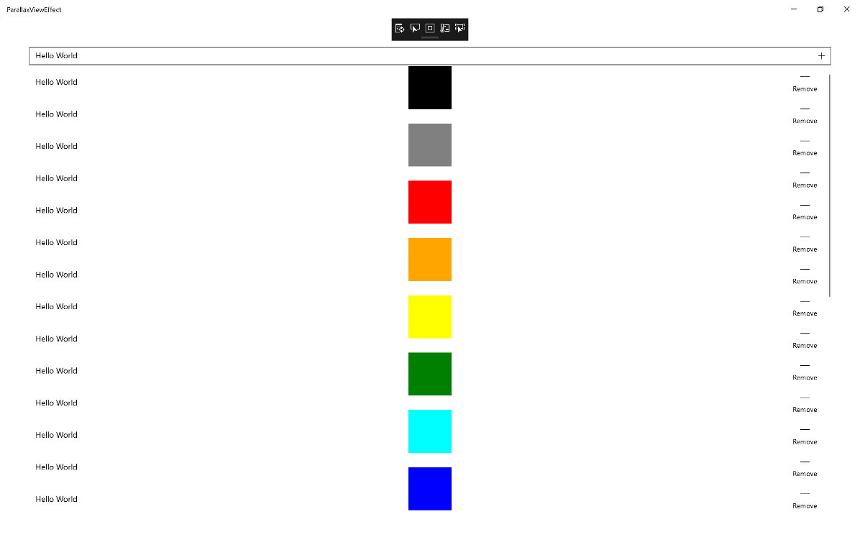

## Step 9

|  |  |
| --- | --- |
|  | To Exit the Application, select the **Close** button in the top right of the Application |