**Reveal Highlight** shows how to use **Reveal Highlight** which is a feature of the **Fluent Design System** in **Windows 10**

## Step 1

|  |  |
| --- | --- |
|  | Follow **Setup and Start** on how to Install and/or Get Started with **Visual Studio 2019** if not already or in **Windows 10** choose **Start**, find and select **Visual Studio 2019** then from the **Get started** screen select **Create a new project** |
|  | Then choose **Blank App (Universal Windows)** and select **Next** and then in **Configure your new project** enter the **Project name** as **RevealHighlight** and select **Create** |
|  | Finally, in **New Universal Windows Platform Project** pick the **Target version** and **Minimum version** to be at least **Windows 10, version 1903 (10.0; Build 18362)** and then select **OK** |

**Target Version** will control the most recent features of **Windows 10** your application can use. To make sure you always have the most recent version, check for any **Notifications** or **Updates** in **Visual Studio 2019**

## Step 2

|  |  |
| --- | --- |
|  | In the **Solution Explorer** of **Visual Studio 2019** select **MainPage.xaml** |

## Step 3

|  |  |
| --- | --- |
|  | Choose **View** then **Designer** from the **Menu** in **Visual Studio 2019** |

## Step 4

In the **Design** View and **XAML** View of **Visual Studio 2019** will be displayed, and in this between the **Grid** and **/Grid** elements enter the following **XAML**:

|  |
| --- |
| <Grid Margin="50">  <Grid.ColumnDefinitions>  <ColumnDefinition Width="85*"/>  <ColumnDefinition Width="24*"/>  </Grid.ColumnDefinitions>  <Grid.RowDefinitions>  <RowDefinition Height="Auto"/>  <RowDefinition Height="*"/>  </Grid.RowDefinitions>  <ComboBox Name="Options" Grid.ColumnSpan="2"  HorizontalAlignment="Stretch"  SelectionChanged="Options_SelectionChanged"  VerticalAlignment="Center">  <ComboBoxItem Content="None" IsSelected="True"/>  <ComboBoxItem  Content="SystemControlBackgroundBaseLowRevealBorderBrush"/>  <ComboBoxItem  Content="SystemControlBackgroundBaseMediumLowRevealBorderBrush"/>  <ComboBoxItem  Content="SystemControlBackgroundBaseMediumRevealBorderBrush"/>  <ComboBoxItem  Content="SystemControlBackgroundBaseMediumHighRevealBorderBrush"/>  <ComboBoxItem  Content="SystemControlBackgroundBaseHighRevealBorderBrush"/>  </ComboBox>  <!-- Viewbox -->  </Grid> |

Then below the **<!-- Viewbox -->** line the following **XAML** should be entered:

|  |
| --- |
| <Viewbox Grid.Row="1" Grid.ColumnSpan="2">  <StackPanel Name="Display" Spacing="5"  Orientation="Horizontal" HorizontalAlignment="Center">  <Rectangle Width="50" Height="50"  StrokeThickness="5" Fill="Black"/>  <Rectangle Width="50" Height="50"  StrokeThickness="5" Fill="Gray"/>  <Rectangle Width="50" Height="50"  StrokeThickness="5" Fill="Red"/>  <Rectangle Width="50" Height="50"  StrokeThickness="5" Fill="Orange"/>  <Rectangle Width="50" Height="50"  StrokeThickness="5" Fill="Yellow"/>  <Rectangle Width="50" Height="50"  StrokeThickness="5" Fill="Green"/>  <Rectangle Width="50" Height="50"  StrokeThickness="5" Fill="Cyan"/>  <Rectangle Width="50" Height="50"  StrokeThickness="5" Fill="Blue"/>  <Rectangle Width="50" Height="50"  StrokeThickness="5" Fill="Magenta"/>  <Rectangle Width="50" Height="50"  StrokeThickness="5" Fill="Purple"/>  </StackPanel>  </Viewbox> |

The main block of **XAML** is a **Grid** with two Rows, the first Row contains a **ComboBox** with a selection of **RevealBorderBrush** options and the second Row contains a **ViewBox** with **Rectangle** Controls in a **StackPanel**

## Step 5

|  |  |
| --- | --- |
|  | Choose **View** then **Code** from the **Menu** in **Visual Studio 2019** |

## Step 6

Once in the **Code** View, below the end of **public MainPage() { ... }** the following Code should be entered:

|  |
| --- |
| private void Options_SelectionChanged(object sender, SelectionChangedEventArgs e)  {  if (Display != null && Windows.Foundation.Metadata.ApiInformation.  IsTypePresent("Windows.UI.Xaml.Media.XamlCompositionBrushBase"))  {  string value = (string)  ((ComboBoxItem)Options.SelectedItem).Content;  foreach (Windows.UI.Xaml.Shapes.Rectangle item in Display.Children)  {  item.Stroke = (value != "None" ?  (RevealBorderBrush)Application.Current.Resources[value] :  null);  }  }  } |

Options_SelectionChanged is an **event** handler that will be triggered when something is **selected** from the ComboBox. It uses the Windows.Foundation.Metadata.ApiInformation.IsTypePresent Method to check that Windows.UI.Xaml.Media.XamlCompositionBrushBase is present which is used for **Reveal Highlight** and one of the Selected options will be used to set the Fill of the Overlay Rectangle to a RevealBorderBrush

## Step 7

|  |  |
| --- | --- |
|  | That completes the **Universal Windows Platform** Application, in **Visual Studio 2019** select **Local Machine** to run the Application |

## Step 8

Once the Application is running you can use the **ComboBox** to select a **RevealBorderBrush** to use that will be used for the Border of **Rectangle** Controls and will be visible when **Mouse**, **Pen** or **Gaze** is focused on those Controls

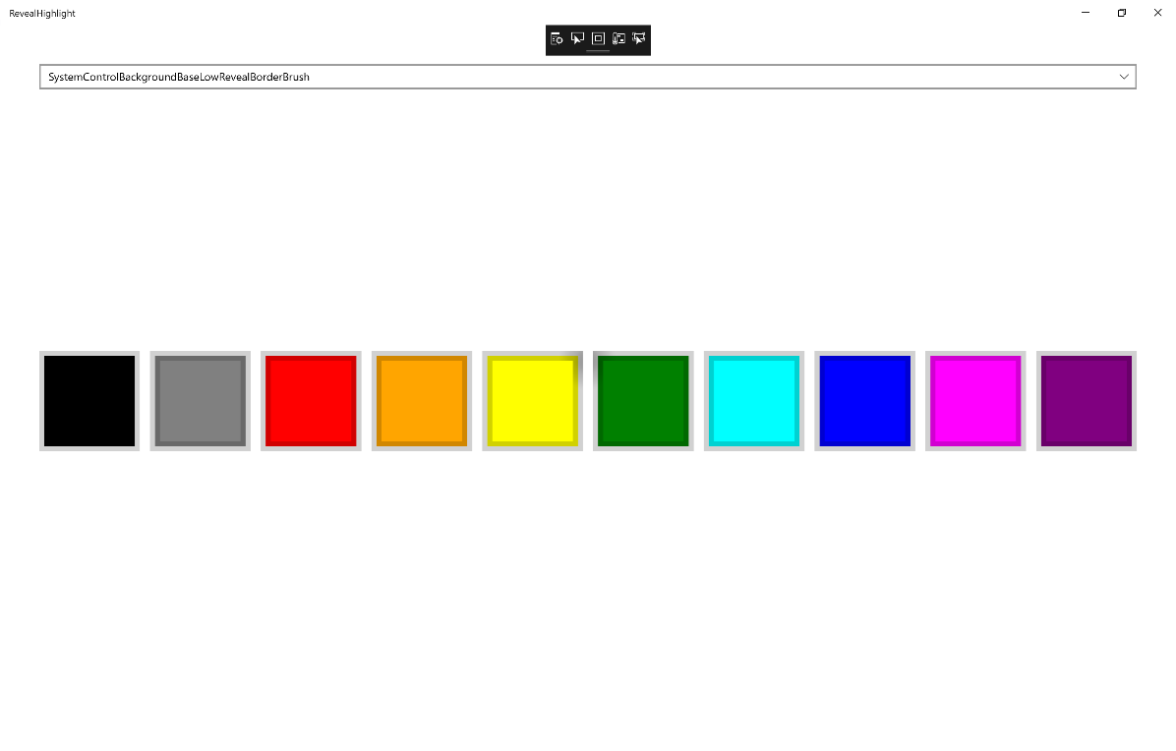

## Step 9

|  |  |
| --- | --- |
|  | To Exit the Application, select the **Close** button in the top right of the Application |