## Setup

You will need to enable **Developer Mode** in **Windows 10** if this has not been done already by completing the following:

|  |  |
| --- | --- |
|  | Choose **Start** then **Settings** from the **Start Menu** |
|  | Next from **Windows Settings** choose **Update & Security** |
|  | Then from **Update & Security** choose **For developers** |
|  | Finally make sure **Developer mode** is selected |

## Install

You will need to install **Visual Studio 2019 Community**, if this has not been done already you just need to do the following:

|  |  |
| --- | --- |
|  | Visit [**VisualStudio.com**](http://visualstudio.com) and then from the **Visual Studio IDE** section choose **Download Visual Studio** then **Community 2019** |
|  | Next on the **Thank you for downloading Visual Studio** page when the download prompt appears, select **Run** |
|  | Once downloaded, this should start the **Visual Studio Installer** and select **Continue** to begin the installation |
|  | Next once ready select **Universal Windows Platform development** from the **Workloads** section |
|  | Then make sure the latest **Windows 10 SDK** has been selected from **Installation details** if not already included then select **Install** and follow any instructions to complete the installation |

## Start

You will need to open **Visual Studio 2019 Community** and **Create a new project**, if this has not been done already you just need to do the following:

|  |  |
| --- | --- |
|  | In **Windows 10** choose **Start**, and then from the **Start Menu** find and select **Visual Studio 2019** |
|  | Once done, from the **Get started** screen for **Visual Studio 2019** select **Create a new project** |
|  | Choose **Blank App (Universal Windows)** and select **Next** |
|  | Then in **Configure your new project** enter a **Project name** and **Location** and select **Create** |
|  | Finally, in **New Universal Windows Platform Project** pick the latest **Target version** and **Minimum version** and select **OK** |

## Guide

In **Visual Studio 2019** there is a **Menu** at the top

Below this is the **Toolbar**, options there include **Local Machine** to start debugging

When an Application is running, the **Toolbar** will change to include other options including **Stop** to finish Debugging.

After a **Solution** or **Project** has been opened or created, choose **View** then **Code** from the **Menu**

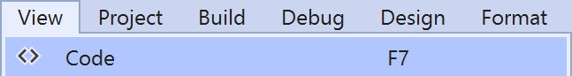

This will display the **Code** View for the code in a **Class** or for a **XAML** page such as **MainPage.xaml.cs**

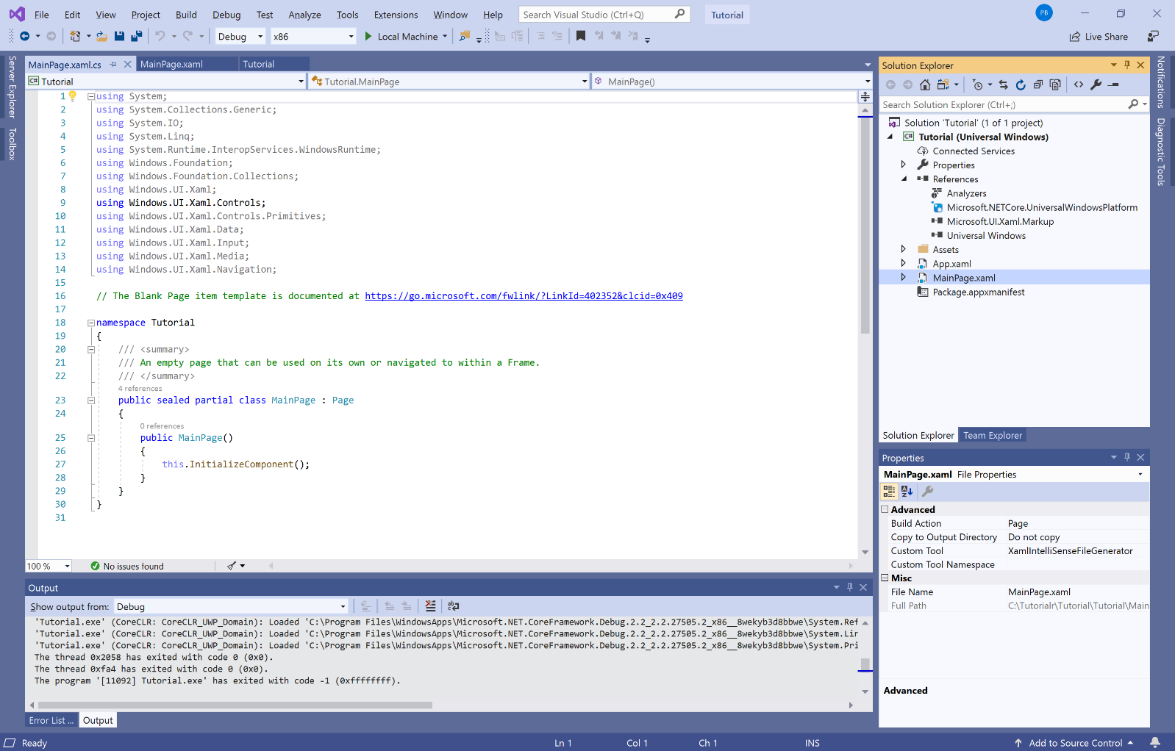

Also, after a **Solution** or **Project** has been opened or created, choose **View** then **Designer** from the **Menu**

This will display the **Design** and **XAML** views for a **XAML** page such as **MainPage.xaml**

