**Sound Game** shows how to create a simple game to play sounds using a **MediaElement** with a provided frequency as an audio stream

## Step 1

|  |  |
| --- | --- |
|  | Follow **Setup and Start** on how to Install and/or Get Started with **Visual Studio 2019** if not already or in **Windows 10** choose **Start**, find and select **Visual Studio 2019** then from the **Get started** screen select **Create a new project** |
|  | Then choose **Blank App (Universal Windows)** and select **Next** and then in **Configure your new project** enter the **Project name** as **SoundGame** and select **Create** |
|  | Finally, in **New Universal Windows Platform Project** pick the **Target version** and **Minimum version** to be at least **Windows 10, version 1903 (10.0; Build 18362)** and then select **OK** |

**Target Version** will control the most recent features of **Windows 10** your application can use. To make sure you always have the most recent version, check for any **Notifications** or **Updates** in **Visual Studio 2019**

## Step 2

|  |  |
| --- | --- |
|  | Choose **Project** then **Add New Item...** from the **Menu** in **Visual Studio 2019** |

## Step 3

|  |  |
| --- | --- |
|  | Then choose **Code File** from **Add New Item** in **Visual Studio 2019**, enter the **Name** as **Library.cs** and select **Add** |

## Step 4

In the **Code** View of **Library.cs** will be displayed and in this the following should be entered:

|  |
| --- |
| using System;  using System.Collections.Generic;  using System.IO;  using System.Linq;  using Windows.Storage.Streams;  using Windows.UI;  using Windows.UI.Xaml;  using Windows.UI.Xaml.Controls;  using Windows.UI.Xaml.Media;  public class Library  {  private const short tracks = 1;  private const short formatType = 1;  private const short bitsPerSample = 16;  private const int headerSize = 8;  private const int formatChunkSize = 16;  private const int samplesPerSecond = 44100;  private const short frameSize =  tracks * ((bitsPerSample + 7) / 8);  private const int bytesPerSecond =  samplesPerSecond * frameSize;  private const int waveSize = 4;  private const int riff = 0x46464952;  private const int wave = 0x45564157;  private const int data = 0x61746164;  private const int format = 0x20746D66;  private const int samples = 88200 * 4;  private const int dataChunkSize =  samples * frameSize;  private const int fileSize =  waveSize + headerSize + formatChunkSize +  headerSize + dataChunkSize;  private const string mime = "audio/wav";  private readonly Dictionary<string, double>  _notes = new Dictionary<string, double>()  {  { "C", 261.6 }, { "C#", 277.2 }, { "D", 293.7 },  { "D#", 311.1 } , { "E", 329.6 }, { "F", 349.2 },  { "F#", 370.0 }, { "G", 392.0 }, { "G#", 415.3 },  { "A", 440.0 }, { "A#", 466.2 }, { "B", 493.9 }  };  private readonly MediaElement _playback = new MediaElement();  private readonly Color _accent =  (Color)Application.Current.Resources["SystemAccentColor"];    } |

There are using statements to include necessary functionality and private const int that defind the elements to make up the sounds to be played, there's a Dictionary<string, double> for each note to be played and a MediaElement to allow playback of the sounds

Then below the **private readonly Color _accent = (Color)Application.Current.Resources["SystemAccentColor"];** line the following **method** should be entered:

|  |
| --- |
| private void Play(double note)  {  IRandomAccessStream stream = new InMemoryRandomAccessStream();  BinaryWriter writer = new BinaryWriter(stream.AsStream());  double frequency = note * 1.5;  writer.Write(riff);  writer.Write(fileSize);  writer.Write(wave);  writer.Write(format);  writer.Write(formatChunkSize);  writer.Write(formatType);  writer.Write(tracks);  writer.Write(samplesPerSecond);  writer.Write(bytesPerSecond);  writer.Write(frameSize);  writer.Write(bitsPerSample);  writer.Write(data);  writer.Write(dataChunkSize);  for (int index = 0; index < samples / 4; index++)  {  double time = index / (double)samplesPerSecond;  short sample = (short)(10000 *  Math.Sin(time * frequency * 2.0 * Math.PI));  writer.Write(sample);  }  stream.Seek(0);  _playback.SetSource(stream, mime);  _playback.Play();  } |

Play **method** is used to play a musical note with a MediaElement and an InMemoryRandomAccessStream which will be used to help create the audio with a BinaryWriter to create a **wave** audio stream that will be written to with the given frequency to produce the samples that will create the required musical note

Next below the **private void Play(...) { ... }** **method** the following **method** should be entered:

|  |
| --- |
| private void Add(Grid grid, int column)  {  Button button = new Button()  {  Width = 20,  Height = 80,  FontSize = 10,  Margin = new Thickness(5),  Padding = new Thickness(0),  Content = _notes.Keys.ElementAt(column),  Background = new SolidColorBrush(_accent),  Foreground = new SolidColorBrush(Colors.White),  Style = (Style)Application.Current.Resources  ["ButtonRevealStyle"]  };  button.Click += (object sender, RoutedEventArgs e) =>  {  button = (Button)sender;  int note = Grid.GetColumn(button);  Play(_notes[_notes.Keys.ElementAt(note)]);  };  button.SetValue(Grid.ColumnProperty, column);  grid.Children.Add(button);  } |

Add **method** will create a Button and set the **properties** for this and when clicked it will trigger the Play **method**

Then below the **private void Add(...) { ... }** **method** the following **method** should be entered:

|  |
| --- |
| private void Layout(Grid Grid)  {  Grid.Children.Clear();  Grid.RowDefinitions.Clear();  Grid.ColumnDefinitions.Clear();  // Setup Grid  for (int Column = 0; (Column < _notes.Count); Column++)  {  Grid.ColumnDefinitions.Add(new ColumnDefinition());  Add(Grid, Column);  }  } |

Layout **method** is used to create the look-and-feel using a Grid by calling the Add **method**

Finally after the **private void Layout(...) { ... }** **method** the following **public** **method** should be entered:

|  |
| --- |
| public void New(Grid grid)  {  Layout(grid);  } |

New **method** will setup and start playing the game by calling the Layout **method**

## Step 5

|  |  |
| --- | --- |
|  | In the **Solution Explorer** of **Visual Studio 2019** select **MainPage.xaml** |

## Step 6

|  |  |
| --- | --- |
|  | Choose **View** then **Designer** from the **Menu** in **Visual Studio 2019** |

## Step 7

In the **Design** View and **XAML** View of **Visual Studio 2019** will be displayed, and in this between the **Grid** and **/Grid** elements enter the following **XAML**:

|  |
| --- |
| <Viewbox>  <Grid Margin="50" Name="Display"  HorizontalAlignment="Center"  VerticalAlignment="Center"/>  </Viewbox>  <CommandBar VerticalAlignment="Bottom">  <AppBarButton Icon="Page2" Label="New" Click="New_Click"/>  </CommandBar> |

The first block of **XAML** the main user interface features a **Grid** to represent the game and the second block of **XAML** is the **CommandBar** which contains **New** to setup and start the game

## Step 8

|  |  |
| --- | --- |
|  | Choose **View** then **Code** from the **Menu** in **Visual Studio 2019** |

## Step 9

Once in the **Code** View, below the end of **public MainPage() { ... }** the following Code should be entered:

|  |
| --- |
| Library library = new Library();  private void New_Click(object sender, RoutedEventArgs e)  {  library.New(Display);  } |

Below the **MainPage** **method** an instance of the Library **class** is created. In the New_Click(...) **Event** handler will setup and play the game using the New **method** in the Library **class**

## Step 10

|  |  |
| --- | --- |
|  | That completes the **Universal Windows Platform** Application, in **Visual Studio 2019** select **Local Machine** to run the Application |

## Step 11

Once the Application is running use **New** to start then can play sounds by clicking the buttons

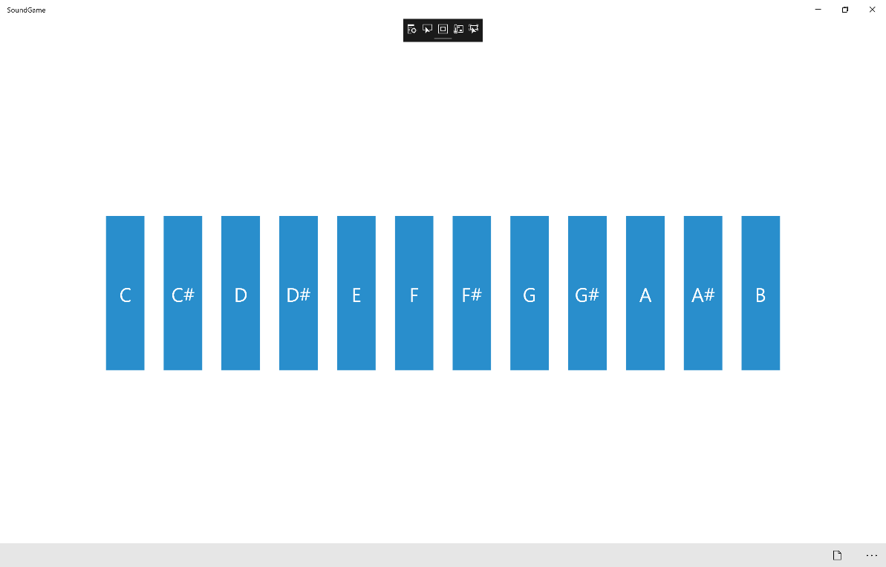

## Step 12

|  |  |
| --- | --- |
|  | To Exit the Application, select the **Close** button in the top right of the Application |