**Tic Tac Toe** shows how to use a **Grid** and **Emoji** to implement the Game of **Tic Tac Toe** also known as **Noughts and Crosses**

## Step 1

|  |  |
| --- | --- |
|  | Follow **Setup and Start** on how to Install and/or Get Started with **Visual Studio 2019** if not already or in **Windows 10** choose **Start**, find and select **Visual Studio 2019** then from the **Get started** screen select **Create a new project** |
|  | Then choose **Blank App (Universal Windows)** and select **Next** and then in **Configure your new project** enter the **Project name** as **TicTacToe** and select **Create** |
|  | Finally, in **New Universal Windows Platform Project** pick the **Target version** and **Minimum version** to be at least **Windows 10, version 1903 (10.0; Build 18362)** and then select **OK** |

**Target Version** will control the most recent features of **Windows 10** your application can use. To make sure you always have the most recent version, check for any **Notifications** or **Updates** in **Visual Studio 2019**

## Step 2

|  |  |
| --- | --- |
|  | Choose **Project** then **Add New Item...** from the **Menu** in **Visual Studio 2019** |

## Step 3

|  |  |
| --- | --- |
|  | Then choose **Code File** from **Add New Item** in **Visual Studio 2019**, enter the **Name** as **Library.cs** and select **Add** |

## Step 4

In the **Code** View of **Library.cs** will be displayed and in this the following should be entered:

|  |
| --- |
| using System;  using System.Threading.Tasks;  using Windows.UI.Popups;  using Windows.UI.Xaml;  using Windows.UI.Xaml.Controls;  using Windows.UI.Xaml.Media;  public class Library  {  private const string title = "Tic Tac Toe";  private const string blank = " ";  private const string nought = "\U00002B55";  private const string cross = "\U0000274C";  private const int size = 3;  private bool _won = false;  private string _piece = blank;  private string[,] _board = new string[size, size];  } |

There are using statements to include necessary functionality. There are private const string for the setup of the game and for the values that will represent the nought with and cross that makes up the game of Tic Tac Toe. There are private **members** including the two-dimensional array _board which represents what will appear in the game

Then below the **private string[,] _board = new string[size, size];** line the following **methods** should be entered:

|  |
| --- |
| private void Show(string content, string title)  {  _ = new MessageDialog(content, title).ShowAsync();  }  private async Task<bool> ConfirmAsync(string content, string title,  string ok, string cancel)  {  bool result = false;  MessageDialog dialog = new MessageDialog(content, title);  dialog.Commands.Add(new UICommand(ok,  new UICommandInvokedHandler((cmd) => result = true)));  dialog.Commands.Add(new UICommand(cancel,  new UICommandInvokedHandler((cmd) => result = false)));  await dialog.ShowAsync();  return result;  } |

Show() is used to display a basic MessageDialog and ConfirmAsync(...) is used to display a MessageDialog with UICommand for ok and cancel

Next below **private async Task<bool> ConfirmAsync { ... }** enter the following **methods**:

|  |
| --- |
| private bool Winner()  {  return (_board[0, 0] == _piece && _board[0, 1] ==  _piece && _board[0, 2] == _piece) ||  (_board[1, 0] == _piece && _board[1, 1] ==  _piece && _board[1, 2] == _piece) ||  (_board[2, 0] == _piece && _board[2, 1] ==  _piece && _board[2, 2] == _piece) ||  (_board[0, 0] == _piece && _board[1, 0] ==  _piece && _board[2, 0] == _piece) ||  (_board[0, 1] == _piece && _board[1, 1] ==  _piece && _board[2, 1] == _piece) ||  (_board[0, 2] == _piece && _board[1, 2] ==  _piece && _board[2, 2] == _piece) ||  (_board[0, 0] == _piece && _board[1, 1] ==  _piece && _board[2, 2] == _piece) ||  (_board[0, 2] == _piece && _board[1, 1] ==  _piece && _board[2, 0] == _piece);  }  private bool Drawn()  {  return _board[0, 0] != blank && _board[0, 1] !=  blank && _board[0, 2] != blank &&  _board[1, 0] != blank && _board[1, 1] !=  blank && _board[1, 2] != blank &&  _board[2, 0] != blank && _board[2, 1] !=  blank && _board[2, 2] != blank;  } |

Winner() is used to determine if a player has won and Drawn() is used to determine if the game is a draw

Then after **private bool Drawn() { ... }** **method** the following **method** should be entered:

|  |
| --- |
| private Viewbox Piece()  {  TextBlock textblock = new TextBlock()  {  Text = _piece,  IsColorFontEnabled = true,  TextLineBounds = TextLineBounds.Tight,  FontFamily = new FontFamily("Segoe UI Emoji"),  HorizontalTextAlignment = TextAlignment.Center  };  return new Viewbox()  {  Child = textblock  };  } |

Piece() is used to return a Viewbox which contains a TextBlock which will contain the **Emoji** value of the current player of either nought or cross

Next after the **private Viewbox Piece() { ... }** **method** the following **method** should be entered:

|  |
| --- |
| private void Add(ref Grid grid, int row, int column)  {  Button button = new Button()  {  Width = 75,  Height = 75,  Margin = new Thickness(10),  Style = (Style)Application.Current.Resources  ["ButtonRevealStyle"]  };  button.Click += (object sender, RoutedEventArgs e) =>  {  if (!_won)  {  button = (Button)sender;  if (button.Content == null)  {  button.Content = Piece();  _board[(int)button.GetValue(Grid.RowProperty),  (int)button.GetValue(Grid.ColumnProperty)] = _piece;  }  if (Winner())  {  _won = true;  Show($"{_piece} wins!", title);  }  else if (Drawn())  {  Show("Draw!", title);  }  else  {  // Swap Players  _piece = (_piece == cross ? nought : cross);  }  }  else  {  Show("Game Over!", title);  }  };  button.SetValue(Grid.ColumnProperty, column);  button.SetValue(Grid.RowProperty, row);  grid.Children.Add(button);  } |

The Add(...) method is used to add a Button to a Grid to contain each part of the game and to check if the game has been won, a draw, to swap the players or if the game is over

Next after the **Add(...) { ... }** **method** the following **method** should be entered:

|  |
| --- |
| private void Layout(ref Grid grid)  {  grid.Children.Clear();  grid.RowDefinitions.Clear();  grid.ColumnDefinitions.Clear();  // Setup Grid  for (int index = 0; (index < size); index++)  {  grid.RowDefinitions.Add(new RowDefinition());  grid.ColumnDefinitions.Add(new ColumnDefinition());  }  // Setup Board  for (int row = 0; (row < size); row++)  {  for (int column = 0; (column < size); column++)  {  Add(ref grid, row, column);  _board[row, column] = blank;  }  }  } |

Layout(...) configures a Grid and sets up the layout of the game using the Add(...) **method** and _board

Finally after the **private void Layout(...) { ... } method** the following **public** **method** should be entered:

|  |
| --- |
| public async void New(Grid grid)  {  Layout(ref grid);  _won = false;  _piece = await ConfirmAsync("Who goes First?", title,  nought, cross) ? nought : cross;  } |

New(...) will setup the layout of the Grid using the Layout method and will start the game and ask Who goes First? using the ConfirmAsync(...) **method**

## Step 5

|  |  |
| --- | --- |
|  | In the **Solution Explorer** of **Visual Studio 2019** select **MainPage.xaml** |

## Step 6

|  |  |
| --- | --- |
|  | Choose **View** then **Designer** from the **Menu** in **Visual Studio 2019** |

## Step 7

In the **Design** View and **XAML** View of **Visual Studio 2019** will be displayed, and in this between the **Grid** and **/Grid** elements enter the following **XAML**:

|  |
| --- |
| <Viewbox>  <Grid Margin="50" Name="Display"  HorizontalAlignment="Center"  VerticalAlignment="Center"/>  </Viewbox>  <CommandBar VerticalAlignment="Bottom">  <AppBarButton Icon="Page2" Label="New" Click="New_Click"/>  </CommandBar> |

The first block of **XAML** the main user interface features a **Viewbox** to contain a **Grid** which will display the game. The second block of **XAML** is the **CommandBar** which contains **New** to start a new game

## Step 8

|  |  |
| --- | --- |
|  | Choose **View** then **Code** from the **Menu** in **Visual Studio 2019** |

## Step 9

Once in the **Code** View, below the end of **public MainPage() { ... }** the following Code should be entered:

|  |
| --- |
| Library library = new Library();  private void New_Click(object sender, RoutedEventArgs e)  {  library.New(Display);  } |

Below the **MainPage(...)** method an instance of the Library **Class** is created. In the New_Click(...) **Event** handler will call the New(...) **method** in the Library **class**

## Step 10

|  |  |
| --- | --- |
|  | That completes the **Universal Windows Platform** Application, in **Visual Studio 2019** select **Local Machine** to run the Application |

## Step 11

Once the Application is running you can then click the **New** Button, then choose **X** or **O** then you can start playing the game

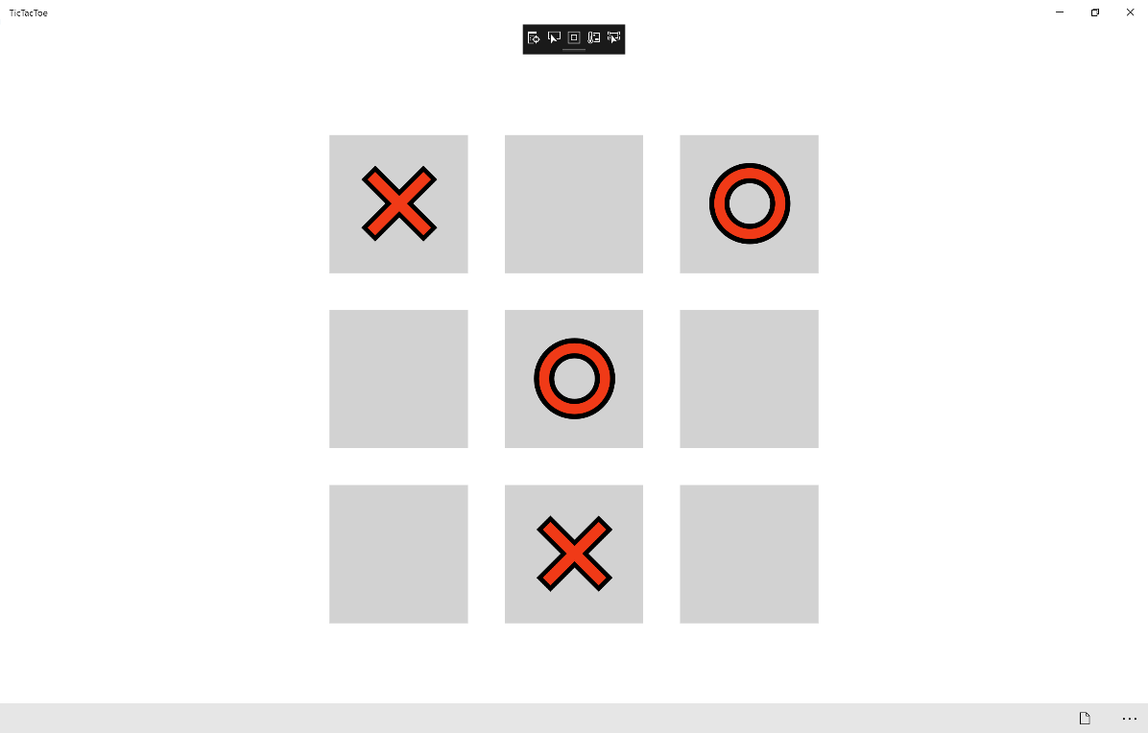

## Step 12

|  |  |
| --- | --- |
|  | To Exit the Application, select the **Close** button in the top right of the Application |