

[](https://www.tutorialr.com/tutorials/)

Windows App SDK

Badge Notifications





# Badge Notifications

**Badge Notifications** shows how you can use **BadgeNotification** with the **Windows App SDK**. This

allows you to display different **Badges** on the **Icon** for your application in the **Taskbar** of **Windows**.

## Step 1

Follow **Setup and Start** on how to get **Setup** and **Install** what you need for **Visual Studio 2022** and **Windows App SDK**.

|  |  |
| --- | --- |
| In **Windows 11** choose **Start** and then find or search for **Visual Studio 2022** and then select it. |  |
| Once **Visual Studio 2022** has started select **Create a new project**. |  |
| Then choose the **Blank App, Packages (WinUI in Desktop)** and then select **Next**. |  |
| After that in **Configure your new project** type in the **Project name** as *BadgeNotifications*, then select a Location and then select **Create** to start a new **Solution**. |  |

## Step 2

Then in **Visual Studio** within **Solution** **Explorer** for the **Solution**, right click on the **Project** shown below the **Solution** and then select **Add** then **New Item…**

## Step 3

Then in **Add New Item** from the **C# Items** list, select **Code** and then select **Code File** from the list next to this, then type in the name of *Library.cs* and then **Click** on **Add**.

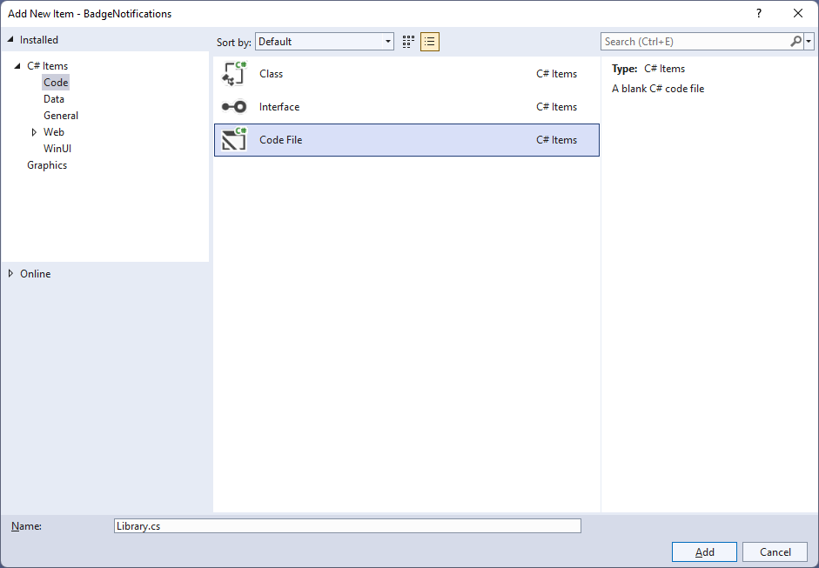

## Step 4

You will now be in the **View** for the **Code** of *Library.cs*, within this type the following **Code**:

using Microsoft.UI.Xaml.Controls;

using System.Collections.Generic;

using Windows.Data.Xml.Dom;

using Windows.UI.Notifications;

internal class Library

{

public List<string> Options => new()

{

"number", "activity", "alarm", "attention", "available", "away",

"busy", "error", "newMessage", "paused", "playing", "unavailable"

};

public void SetBadge(ComboBox options, TextBox number)

{

var selected = options.SelectedValue as string;

var result = selected == "number" ? number.Text : selected;

XmlDocument badge = BadgeUpdateManager.GetTemplateContent(

int.TryParse(result, out _) ?

BadgeTemplateType.BadgeNumber :

BadgeTemplateType.BadgeGlyph);

XmlNodeList attributes = badge.GetElementsByTagName("badge");

attributes[0].Attributes.GetNamedItem("value").NodeValue = result;

BadgeNotification notification = new(badge);

BadgeUpdateManager.CreateBadgeUpdaterForApplication().Update(notification);

}

public void ClearBadge()

{

BadgeUpdateManager.CreateBadgeUpdaterForApplication().Clear();

}

}

The **Class** that has been defined in *Library.cs* has a **Property** for **Options**, with the exception **number** these are all the different types of **Glyph** that can be shown for a **BadgeNotification**. Then there is a **Method** of **SetBadge** which will get the **SelectedValue** of a **ComboBox** passed in. To get the **Value** to use, if the selected option was **number** then it should use the contents of a **TextBox** passed in, which is the **Property** for **Text** along with the **BadgeTemplateType.BadgeNumber** or it should use the one for **BadgeTemplateType.BadgeGlyph**. The lines to do this use a value that is a **bool** before **?** which if **true**, the value after **?** will be used, if **false** the value after **:** will be used, these together are **Conditional Operators**. There is some code to build up the elements of the **Badge Notification** using **XML** which is needed to create the **BadgeNotification** and then this is used with the **BadgeUpdateManager.** The other **Method** is used to clear the **BadgeNotification** using with the **BadgeUpdateManager**.

## Step 5

|  |  |
| --- | --- |
| Then from **Solution** **Explorer** for the **Solution** double-click on **MainWindow.xaml** to see the **XAML** for the **Main Window**. |  |

## Step 6

In the **XAML** for **MainWindow.xaml** there be some **XAML** for a **StackPanel**, this should be **Removed** by removing the following:

<StackPanel Orientation="Horizontal"

HorizontalAlignment="Center" VerticalAlignment="Center">

<Button x:Name="myButton" Click="myButton_Click">Click Me</Button>

</StackPanel>

## Step 7

While still in the **XAML** for **MainWindow.xaml** above **</Window>**, type in the following **XAML**:

<Grid>

<Grid.RowDefinitions>

<RowDefinition Height="Auto"/>

<RowDefinition Height="*"/>

<RowDefinition Height="Auto"/>

</Grid.RowDefinitions>

<StackPanel Grid.Row="0" Margin="25">

<ComboBox Margin="5" Name="Options"

HorizontalAlignment="Stretch"/>

<TextBox Margin="5" PlaceholderText="Number"

Name="Number" HorizontalAlignment="Stretch"/>

</StackPanel>

<CommandBar Grid.Row="3" VerticalAlignment="Bottom">

<AppBarButton Icon="Accept" Label="Accept" Click="Accept_Click"/>

<AppBarButton Icon="Cancel" Label="Clear" Click="Clear_Click"/>

</CommandBar>

</Grid>

This **XAML** features a **Grid** with a **StackPanel** for the **ComboBox** and **TextBox** along with an **AppBarButton** to set or clear the **BadgeNotification** depending on which one was **Clicked**.

## Step 8

|  |  |
| --- | --- |
| Then, within **Solution** **Explorer** for the **Solution** select the arrow next to **MainWindow.xaml** then double-click on **MainWindow.xaml.cs** to see the **Code** for the **Main Window**. |  |

## Step 9

In the **Code** for **MainWindow.xaml.cs** there be a **Method** of **myButton_Click(...)** this should be **Removed** by removing the following:

private void myButton_Click(object sender, RoutedEventArgs e)

{

myButton.Content = "Clicked";

}

## Step 10

Once **myButton_Click(...)** has been removed, type in the following **Code** below the end of the **Constructor** of **public MainWindow() { ... }**:

private readonly Library _library = new();

private void Accept_Click(object sender, RoutedEventArgs e)

{

_library.SetBadge(Options, Number);

}

private void Clear_Click(object sender, RoutedEventArgs e)

{

_library.ClearBadge();

}

The **Methods** of **Accept_Click** and **Clear_Click** will call the **Methods** within *Library.cs* of **SetBadge** and **ClearBadge** respectively from an **Instance** of **Library** called **_library** created with **new()**.

## Step 11

While still in the **Code** for **MainWindow.xaml.cs** within the **Constructor** of **public MainWindow() { ... }** and below the line of **this.InitializeComponent();** type in the following **Code**:

Options.ItemsSource = _library.Options;

Options.SelectedIndex = 0;

The **Constructor** of **public MainWindow() { ... }** should look like the following:

public MainWindow()

{

this.InitializeComponent();

Options.ItemsSource = _library.Options;

Options.SelectedIndex = 0;

}

These set up the **Properties** for the **ComboBox** for **ItemsSource** to the list of **Options** from **Library** and for **SelectedIndex** to the first index which is **0** to select the first item.

## Step 12

|  |  |
| --- | --- |
| That completes the **Windows App SDK** application. In **Visual Studio 2022** from the **Toolbar** select **BadgeNotifications (Package)** to **Start** the application. |  |

## Step 13

Once running you should see the **ComboBox**, **TextBox** and **CommandBar** with *Accept* and *Clear* options.

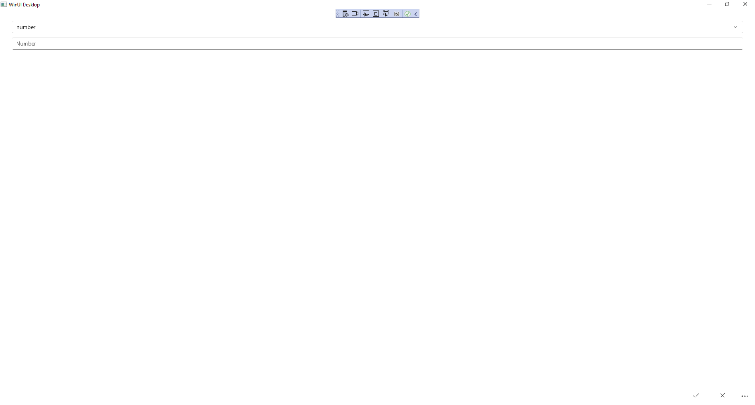

## Step 14

You can select a value from the **ComboBox** and then use *Accept* to see this on a **Badge** on the **Icon** for the application in the **Taskbar** for example select n*umber* then enter a number or use *Clear* to reset the **Badge**.

## Step 15

|  |  |
| --- | --- |
| To **Exit** the **Windows App SDK** application, select the **Close** button from the top right of the application as that concludes this **Tutorial** for **Windows App SDK** from [tutorialr.com](https://tutorialr.com)! |  |