

[](https://www.tutorialr.com/tutorials/)

Windows App SDK

Carousel Control





# Carousel Control

**Carousel Control** shows how to create a **Control** that can be used to display **Images** in a moving **Carousel** using **Windows App SDK**

## Step 1

Follow **Setup and Start** on how to get **Setup** and **Install** what you need for **Visual Studio 2022** and **Windows App SDK**.

|  |  |
| --- | --- |
| In **Windows 11** choose **Start** and then find or search for **Visual Studio 2022** and then select it. |  |
| Once **Visual Studio 2022** has started select **Create a new project**. |  |
| Then choose the **Blank App, Packages (WinUI in Desktop)** and then select **Next**. |  |
| After that in **Configure your new project** type in the **Project name** as *CarouselControl*, then select a Location and then select **Create** to start a new **Solution**. |  |

## Step 2

Then in **Visual Studio** within **Solution** **Explorer** for the **Solution**, right click on the **Project** shown below the **Solution** and then select **Add** then **New Item…**

## Step 3

Then in **Add New Item** from the **C# Items** list, select **WinUI** and then select **User Control (WinUI 3)** from the list next to this, then type in the name of *Carousel.xaml* and then **Click** on **Add**.

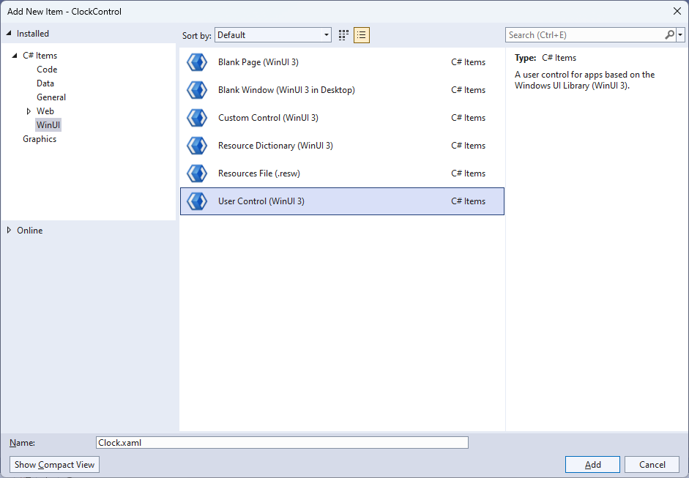

## Step 4

|  |  |
| --- | --- |
| Then from **Solution** **Explorer** for the **Solution** double-click on **Carousel.xaml** to see the **XAML** for the **User Control**. |  |

## Step 5

In the **XAML** for *Carousel.xaml* there be some **XAML** for a **Grid**, above **</Grid>**, type in the following **XAML**:

<Canvas Name="Display" HorizontalAlignment="Center"

VerticalAlignment="Center" Loaded="Load"/>

This **XAML** contains a **Canvas** with a **Loaded** event handler of **Load**.

## Step 6

|  |  |
| --- | --- |
| Then, within **Solution** **Explorer** for the **Solution** select the arrow next to **Carousel.xaml** then double-click on **Carousel.xaml.cs** to see the **Code** for the **User Control**. |  |

## Step 7

You will now be in the **View** for the **Code** of *Carousel.xaml.cs*, near the top of the **Code**, below the final **using** statement you will need to type the following **using** statements:

using Microsoft.UI.Xaml.Media.Animation;

using Microsoft.UI.Xaml.Media.Imaging;

## Step 8

Then, while still in the **View** for the **Code** of *Carousel.xaml.cs*, type in the following **Code** below the end of the **Constructor** of **public Carousel() { ... }**:

private const double speed = 0.0125;

private const double perspective = 55;

private readonly Storyboard _animation = new();

private readonly List<BitmapImage> _list = new();

private readonly Point _radius = new() { X = -20, Y = 200 };

private Point _position;

private double _distance;

// Rotate Method

// Layout Method

// Add, Remove, New & Load Methods

The **class** for **Carousel** represents the **User Control** for the **Carousel** and includes a **Storyboard** that will be used for rotating the images represented by the **List** of **BitmapImage** for the **Carousel.**

## Step 9

While still in the **class** of **Carousel** after the **Comment** of **// Rotate Method** type the following **Method**:

private void Rotate()

{

foreach (var item in Display.Children.Cast<Image>())

{

double angle = (double)item.Tag;

angle -= speed;

item.Tag = angle;

_position.X = Math.Cos(angle) * _radius.X;

_position.Y = Math.Sin(angle) * _radius.Y;

Canvas.SetLeft(item, _position.X - (item.Width - perspective));

Canvas.SetTop(item, _position.Y);

if (_radius.X >= 0)

{

_distance = 1 * (1 - (_position.X / perspective));

Canvas.SetZIndex(item, -(int)_position.X);

}

else

{

_distance = 1 / (1 - (_position.X / perspective));

Canvas.SetZIndex(item, (int)_position.X);

}

item.Opacity = ((ScaleTransform)item.RenderTransform).ScaleX =

((ScaleTransform)item.RenderTransform).ScaleY = _distance;

}

_animation.Begin();

}

This **Method** will be used for rotating the items in the **Carousel** by looping through all the **Image** controls and then adjusting the position of them along with triggering the **Storyboard**.

## Step 10

While still in the **class** of **Carousel** after the **Comment** of **// Layout Method** type the following **Method**:

private void Layout(Canvas display)

{

display.Children.Clear();

for (int index = 0; index < _list.Count; index++)

{

_distance = 1 / (1 - (_position.X / perspective));

var item = new Image

{

Width = 150,

Source = _list[index],

Tag = index * (Math.PI * 2 / _list.Count),

RenderTransform = new ScaleTransform()

};

_position.X = Math.Cos((double)item.Tag) * _radius.X;

_position.Y = Math.Sin((double)item.Tag) * _radius.Y;

Canvas.SetLeft(item, _position.X - (item.Width - perspective));

Canvas.SetTop(item, _position.Y);

item.Opacity = ((ScaleTransform)item.RenderTransform).ScaleX =

((ScaleTransform)item.RenderTransform).ScaleY = _distance;

display.Children.Add(item);

}

}

This **Method** will be used to create the look-and-feel of the **Carousel** by positioning each item as an **Image** onto the **Carousel** where needed.

## Step 11

While still in the **class** of **Carousel** after the **Comment** of **// Add, Remove, New & Load Methods** type the following **Methods**:

public void Add(BitmapImage image)

{

_list.Add(image);

Layout(Display);

}

public void Remove()

{

if (_list.Any())

{

_list.Remove(_list.Last());

Layout(Display);

}

}

public void New()

{

_list.Clear();

Layout(Display);

}

private void Load(object sender, RoutedEventArgs e)

{

_animation.Completed += (object s, object obj) =>

Rotate();

_animation.Begin();

}

**Add** will be used to add items to the **Carousel** and **Remove** will be used to remove the last item from the **Carousel**, then **New** will be used to clear the **Carousel** of all items and **Load** will be used to setup the **Carousel**.

## Step 12

|  |  |
| --- | --- |
| Within **Solution** **Explorer** for the **Solution** double-click on **MainWindow.xaml** to see the **XAML** for the **Main Window**. |  |

## Step 13

In the **XAML** for **MainWindow.xaml** there be some **XAML** for a **StackPanel**, this should be **Removed** by removing the following:

<StackPanel Orientation="Horizontal"

HorizontalAlignment="Center" VerticalAlignment="Center">

<Button x:Name="myButton" Click="myButton_Click">Click Me</Button>

</StackPanel>

## Step 14

While still in the **XAML** for **MainWindow.xaml** above **</Window>**, type in the following **XAML**:

<Grid>

<Grid.RowDefinitions>

<RowDefinition Height="Auto"/>

<RowDefinition Height="*"/>

</Grid.RowDefinitions>

<TextBox Grid.Row="0" Name="Value" InputScope="Url" Margin="20,20,20,20"/>

<local:Carousel Grid.Row="1" x:Name="Display" Width="400"

HorizontalAlignment="Center" VerticalAlignment="Center" />

<CommandBar Grid.Row="1" VerticalAlignment="Bottom">

<AppBarButton Icon="Add" Label="Add" Click="Add"/>

<AppBarButton Icon="Remove" Label="Remove" Click="Remove"/>

<AppBarButton Icon="Page2" Label="New" Click="New"/>

</CommandBar>

</Grid>

This **XAML** contains a **Grid** including a **TextBox**, the **User Control** of **Carousel** and a **CommandBar** with an **AppBarButton** with **Events** of **Click** for **Add**, **Remove** and **New**.

## Step 15

|  |  |
| --- | --- |
| Then, within **Solution** **Explorer** for the **Solution** select the arrow next to **MainWindow.xaml** then double-click on **MainWindow.xaml.cs** to see the **Code** for the **Main Window**. |  |

## Step 16

In the **Code** for **MainWindow.xaml.cs** there be a **Method** of **myButton_Click(...)** this should be **Removed** by removing the following:

private void myButton_Click(object sender, RoutedEventArgs e)

{

myButton.Content = "Clicked";

}

## Step 17

Once **myButton_Click(...)** has been removed, type in the following **Code** below the end of the **Constructor** of **public MainWindow() { ... }**:

private void Add(object sender, RoutedEventArgs e) =>

Display.Add(new BitmapImage(new Uri(Value.Text)));

private void New(object sender, RoutedEventArgs e) =>

Display.New();

private void Remove(object sender, RoutedEventArgs e) =>

Display.Remove();

The **Methods** of **Add**, **New** and **Remove** will be used with **Event Handler** from the **XAML**, these **Methods** use Arrow Syntax with the **=>** for an Expression Bodywhich is useful when a **Method** only has one line.

## Step 18

|  |  |
| --- | --- |
| That completes the **Windows App SDK** application. In **Visual Studio 2022** from the **Toolbar** select **CarouselControl (Package)** to **Start** the application. |  |

## Step 19

Once running you will see the **Carousel Control** displayed, then you can type in the *URL* of an image e.g. <https://www.tutorialr.com/tutorials/images/win-app-sdk-tutorials.png> then select *Add* to display this or multiple images on the **Carousel** or you can select *Remove* to remove the last image or *New* to clear the **Carousel**.

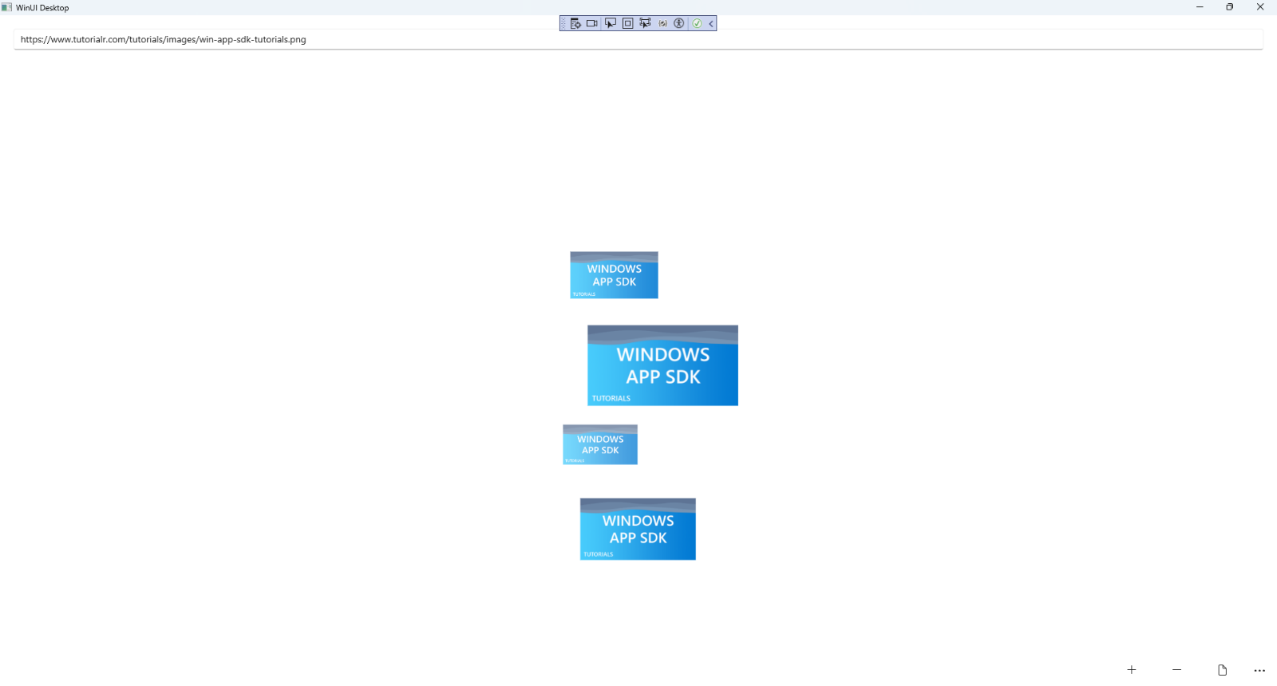

## Step 20

|  |  |
| --- | --- |
| To **Exit** the **Windows App SDK** application, select the **Close** button from the top right of the application as that concludes this **Tutorial** for **Windows App SDK** from [tutorialr.com](https://tutorialr.com)! |  |