

[](https://www.tutorialr.com/tutorials/)

Windows App SDK

Chessboard





# Chessboard

**Chessboard** shows how you can create a simple game of chess for two players using game assets and a

toolkit from **NuGet** using the **Windows App SDK**.

## Step 1

Follow **Setup and Start** on how to get **Setup** and **Install** what you need for **Visual Studio 2022** and **Windows App SDK**.

|  |  |
| --- | --- |
| In **Windows 11** choose **Start** and then find or search for **Visual Studio 2022** and then select it. |  |
| Once **Visual Studio 2022** has started select **Create a new project**. |  |
| Then choose the **Blank App, Packages (WinUI in Desktop)** and then select **Next**. |  |
| After that in **Configure your new project** type in the **Project name** as *Chessboard*, then select a Location and then select **Create** to start a new **Solution**. |  |

## Step 2

Then in **Visual Studio** within **Solution** **Explorer** for the **Solution**, right click on the **Project** shown below the **Solution** and then select **Manage NuGet Packages…**

## Step 3

Then in the **NuGet Package Manager** from the **Browse** tab search for **Comentsys.Toolkit.WindowsAppSdk** and then select **Comentsys.Toolkit.WindowsAppSdk by Comentsys** as indicated and select **Install**

This will add the package for **Comentsys.Toolkit.WindowsAppSdk** to your **Project**. If you get the **Preview Changes** screen saying **Visual Studio is about to make changes to this solution. Click OK to proceed with the changes listed below.** You can read the message and then select **OK** to **Install** the package.

## Step 4

Then while still in the **NuGet Package Manager** from the **Browse** tab search for **Comentsys.Assets.Games** and then select **Comentsys.Assets.Games by Comentsys** as indicated and select **Install**

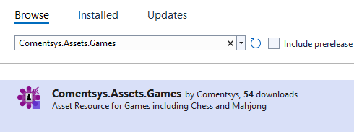

This will add the package for **Comentsys.Assets.Games** to your **Project**. If you get the **Preview Changes** screen saying **Visual Studio is about to make changes to this solution. Click OK to proceed with the changes listed below.** You can read the message and then select **OK** to **Install** the package, then you can close the **tab** for **Nuget: Chessboard** by selecting the **x** next to it.

## Step 5

Then in **Visual Studio** within **Solution** **Explorer** for the **Solution**, right click on the **Project** shown below the **Solution** and then select **Add** then **New Item…**

## Step 6

Then in **Add New Item** from the **C# Items** list, select **Code** and then select **Code File** from the list next to this, then type in the name of *Library.cs* and then **Click** on **Add**.

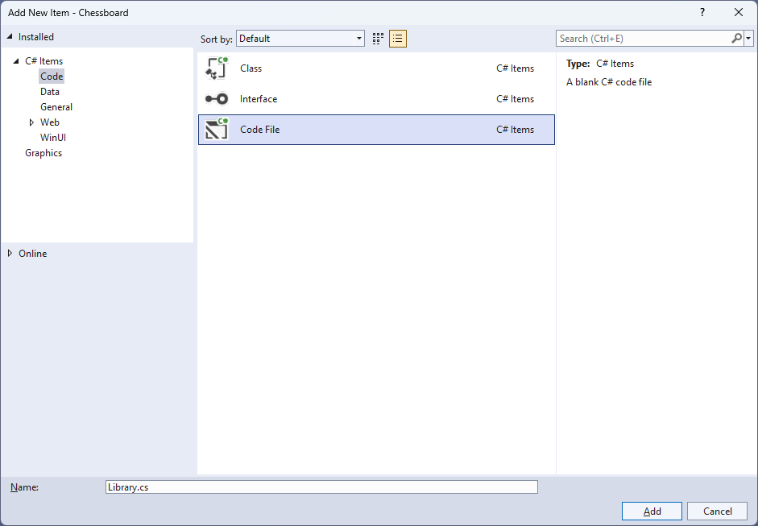

## Step 7

You will now be in the **View** for the **Code** of *Library.cs* then define a **namespace** allowing classes to be defined together, usually each is separate but will be defined in *Library.cs* by typing the following **Code**:

using Comentsys.Assets.Games;

using Comentsys.Toolkit.Binding;

using Comentsys.Toolkit.WindowsAppSdk;

using Microsoft.UI.Xaml;

using Microsoft.UI.Xaml.Controls;

using Microsoft.UI.Xaml.Data;

using Microsoft.UI.Xaml.Markup;

using Microsoft.UI.Xaml.Media;

using System;

using System.Collections.Generic;

using System.Text;

using System.Threading.Tasks;

namespace Chessboard;

public enum ChessBackground

{

Light,

Dark

}

// Chess Coordinate Class & Chess Class

// Chess Square Class

// Chess Position Class

// Chess Board Class & Chess Square Style Selector Class

// Chess Piece to Image Source Converter Class

// Binder Class

public class Library

{

// Constants, Variables, Property & Template Method

// Tapped & New

}

The **Class** defined so far *Library.cs* has **using** for packageof **Comentsys.Toolkit.WindowsAppSdk** and others including **Comentsys.Assets.Games** along with a **namespace** which allows many classes to be defined together, usually a **class** is defined per file but to make things easier each will be defined in *Library.cs* instead.

## Step 8

Still in *Library.cs* for the **Namespace** of **Chessboard** in *Library.cs* you will define a **class** for **ChessCoordinate** for the locations needed for the *chessboard*and **Chess** to represent the pieces and the colours after the **Comment** of **// Chess Coordinate & Chess Class** by typing the following:

public class ChessCoordinate

{

private const int size = 8;

private static readonly string[] ranks =

{ "8", "7", "6", "5", "4", "3", "2", "1" };

private static readonly string[] files =

{ "A", "B", "C", "D", "E", "F", "G", "H" };

public int Id { get; set; }

public int Row { get; set; }

public int Column { get; set; }

public ChessBackground Background { get; set; }

public string Notation { get; set; }

public ChessCoordinate(int id)

{

Id = id;

Row = Id / size;

Column = Id % size;

Background = (Row + Column) % 2 == 0 ?

ChessBackground.Light : ChessBackground.Dark;

Notation = $"{files[Column]}{ranks[Row]}";

}

}

public class Chess : ObservableBase

{

private ChessPieceSet _set;

private ChessPieceType _type;

public Chess(ChessPieceSet set, ChessPieceType type) =>

(_set, _type) = (set, type);

public ChessPieceSet Set

{

get => _set;

set => SetProperty(ref _set, value);

}

public ChessPieceType Type

{

get => _type;

set => SetProperty(ref _type, value);

}

}

## Step 9

Still in the **namespace** of **ChessBoard** in *Library.cs* after the **Comment** of **// Chess Square Class** type the following:

public class ChessSquare : ObservableBase

{

private int _id;

private Chess _piece;

private ChessCoordinate _coordinate;

private bool _isSelected;

public int Id

{

get => _id;

set => SetProperty(ref _id, value);

}

public Chess Piece

{

get => _piece;

set => SetProperty(ref _piece, value);

}

public ChessCoordinate Coordinate

{

get => _coordinate;

set => SetProperty(ref _coordinate, value);

}

public bool IsSelected

{

get => _isSelected;

set => SetProperty(ref _isSelected, value);

}

}

**ChessSquare** represents a chess piece on the chess board with **Properties**.

## Step 10

While still in the **namespace** of **Chessboard** in *Library.cs* to represent a position and chess piece on the chessboard after the **Comment** of **// Chess Position Class** type the following:

public class ChessPosition : List<Chess>

{

private const int size = 8;

public ChessPosition() : base(new Chess[size * size]) { }

public ChessPosition(string position) : this()

{

int i = 0;

var black = ChessPieceSet.Black;

var white = ChessPieceSet.White;

var pawn = ChessPieceType.Pawn;

var knight = ChessPieceType.Knight;

var bishop = ChessPieceType.Bishop;

var rook = ChessPieceType.Rook;

var queen = ChessPieceType.Queen;

var king = ChessPieceType.King;

foreach (char item in position)

{

switch (item)

{

case 'p': this[i++] = new Chess(black, pawn); break;

case 'n': this[i++] = new Chess(black, knight); break;

case 'b': this[i++] = new Chess(black, bishop); break;

case 'r': this[i++] = new Chess(black, rook); break;

case 'q': this[i++] = new Chess(black, queen); break;

case 'k': this[i++] = new Chess(black, king); break;

case 'P': this[i++] = new Chess(white, pawn); break;

case 'N': this[i++] = new Chess(white, knight); break;

case 'B': this[i++] = new Chess(white, bishop); break;

case 'R': this[i++] = new Chess(white, rook); break;

case 'Q': this[i++] = new Chess(white, queen); break;

case 'K': this[i++] = new Chess(white, king); break;

case '1':

case '2':

case '3':

case '4':

case '5':

case '6':

case '7':

case '8': i += int.Parse(item.ToString()); break;

case '/': if (i % size != 0)

throw new ArgumentException("Invalid FEN"); break;

default:

throw new ArgumentException($"Invalid FEN Character: '{item}'");

}

}

}

}

## Step 11

While still in the **namespace** of **Chessboard** in *Library.cs* after the **Comment** of **// ChessBoard & Chess Square Style Selector** type the following **Classes**:

public class ChessBoard

{

public ChessSquare[] ChessSquares { get; set; } = new ChessSquare[64];

public ChessBoard(string fen)

{

ChessPosition position = new(fen);

for (int i = 0; i < position.Count; i++)

{

ChessSquares[i] = new ChessSquare

{

Id = i,

Piece = position[i],

Coordinate = new ChessCoordinate(i)

};

}

}

}

public class ChessSquareStyleSelector : StyleSelector

{

private const int size = 8;

public Style Light { get; set; }

public Style Dark { get; set; }

protected override Style SelectStyleCore(

object item, DependencyObject container) =>

item is ChessSquare square

? (square.Id / size + square.Id % size) % 2 == 0 ? Light : Dark

: base.SelectStyleCore(item, container);

}

**Chessboard** will represent the chess board for the game itself with the positions and squares represented and then the **ChessSquareStyleSelector** will be used to style the look of the chess board for the light and dark squares.

## Step 12

While still in the **namespace** of **Chessboard** in *Library.cs* and after the **Comment** of **// Chess Piece to Image Source Converter Class** type the following **Class**:

public class ChessPieceToImageSourceConverter : IValueConverter

{

private static readonly Dictionary<string, ImageSource> _sources = new();

public static async Task SetSourcesAsync()

{

if (_sources.Count == 0)

foreach(var set in Enum.GetValues<ChessPieceSet>())

foreach(var type in Enum.GetValues<ChessPieceType>())

_sources.Add($"{set}{type}",

await ChessPiece.Get(set, type).AsImageSourceAsync());

}

public object Convert(object value, Type targetType,

object parameter, string language) =>

value is Chess piece ? _sources[$"{piece.Set}{piece.Type}"] : null;

public object ConvertBack(object value, Type targetType,

object parameter, string language) =>

throw new NotImplementedException();

}

**ChessPieceToImageSourceConverter** will be used to control the displaying of the chess pieces on the chessboard. It has a **Method** to set the image sources for each chess piece set and chess piece type, then this **Class** also implements an **Interface** of **IValueConverter** and will be used to return the appropriate value for use with **Data Binding**.

## Step 13

While still in the **namespace** of **Chessboard** in *Library.cs* and after the **Comment** of **// Binder** type the following **Class**:

public class Binder

{

public static readonly DependencyProperty GridColumnBindingPathProperty =

DependencyProperty.RegisterAttached("GridColumnBindingPath",

typeof(string), typeof(Binder),

new PropertyMetadata(null, GridBindingPathPropertyChanged));

public static readonly DependencyProperty GridRowBindingPathProperty =

DependencyProperty.RegisterAttached("GridRowBindingPath",

typeof(string), typeof(Binder),

new PropertyMetadata(null, GridBindingPathPropertyChanged));

public static string GetGridColumnBindingPath(DependencyObject obj) =>

(string)obj.GetValue(GridColumnBindingPathProperty);

public static void SetGridColumnBindingPath(

DependencyObject obj, string value) =>

obj.SetValue(GridColumnBindingPathProperty, value);

public static string GetGridRowBindingPath(DependencyObject obj) =>

(string)obj.GetValue(GridRowBindingPathProperty);

public static void SetGridRowBindingPath(

DependencyObject obj, string value) =>

obj.SetValue(GridRowBindingPathProperty, value);

private static void GridBindingPathPropertyChanged(

DependencyObject obj, DependencyPropertyChangedEventArgs e)

{

if (e.NewValue is string path)

{

DependencyProperty property = null;

if (e.Property == GridColumnBindingPathProperty)

property = Grid.ColumnProperty;

else if (e.Property == GridRowBindingPathProperty)

property = Grid.RowProperty;

BindingOperations.SetBinding(obj, property,

new Binding { Path = new PropertyPath(path) });

}

}

}

**Binder** is used to help with **Data Binding** when producing the layout based on the columns and rows of a **Grid** and will help create labels for each of the squares on the chess board.

## Step 14

While still in the **namespace** of **Chessboard** in *Library.cs* and in the **class** of **Library** after the **Comment** of **// Constants, Variables, Property & Template Method** type the following **Constants**, **Variables, Property** and **Method**:

private const int size = 8;

private const string start = "rnbqkbnr/pppppppp/8/8/8/8/PPPPPPPP/RNBQKBNR";

private ChessSquare _square;

public ChessBoard Board { get; set; } = new ChessBoard(start);

private static ItemsPanelTemplate Template()

{

StringBuilder rows = new();

StringBuilder columns = new();

for (int i = 0; i < size; i++)

{

rows.Append("<RowDefinition Height=\"*\"/>");

columns.Append("<ColumnDefinition Width=\"*\"/>");

}

return (ItemsPanelTemplate)

XamlReader.Load($@"<ItemsPanelTemplate

xmlns='http://schemas.microsoft.com/winfx/2006/xaml/presentation'

xmlns:x='http://schemas.microsoft.com/winfx/2006/xaml'>

<Grid>

<Grid.RowDefinitions>{rows}</Grid.RowDefinitions>

<Grid.ColumnDefinitions>{columns}</Grid.ColumnDefinitions>

</Grid>

</ItemsPanelTemplate>");

}

**Constants** are values that are used in the game that will not change and **Variables** are used to store various values for the game. **Template** is used to create the correct layout for the game to produce the rows and columns for the chess board as an **ItemsPanelTemplate**.

## Step 15

While still in the **namespace** of **Chessboard** in *Library.cs* and in the **class** of **Library** after the **Comment** of **// Tapped & New** type in the following **Methods**:

public void Tapped(ItemsControl display, ContentPresenter container)

{

ChessSquare square = (ChessSquare)display.ItemFromContainer(container);

if (_square == null && square.Piece != null)

{

square.IsSelected = true;

_square = square;

}

else if (square == _square)

{

square.IsSelected = false;

_square = null;

}

else if (_square?.Piece != null && _square.Piece.Set != square?.Piece?.Set)

{

square.Piece = _square.Piece;

_square.IsSelected = false;

_square.Piece = null;

_square = null;

}

}

public async void New(ItemsControl display)

{

await ChessPieceToImageSourceConverter.SetSourcesAsync();

display.ItemsSource = Board.ChessSquares;

display.ItemsPanel = Template();

Board = new ChessBoard(start);

}

**Tapped** respond to events from the displayed chess board and allow pieces to be moved although this is a simple movement system which will replace any piece on the board with another piece it could be expanded to implement the actual rules of chess if needed and **New** will setup and start a new game and assign the image source and set things needed for the look-and-feel for the game.

## Step 16

|  |  |
| --- | --- |
| Then from **Solution** **Explorer** for the **Solution** double-click on **MainWindow.xaml** to see the **XAML** for the **Main Window**. |  |

## Step 17

In the **XAML** for **MainWindow.xaml** there be some **XAML** for a **StackPanel**, this should be **Removed** by removing the following:

<StackPanel Orientation="Horizontal"

HorizontalAlignment="Center" VerticalAlignment="Center">

<Button x:Name="myButton" Click="myButton_Click">Click Me</Button>

</StackPanel>

## Step 18

While still in the **XAML** for **MainWindow.xaml** below **<Window**, type in the following **XAML**:

xmlns:ui="using:Comentsys.Toolkit.WindowsAppSdk"

The **XAML** for **<Window>** should then look as follows:

<Window

xmlns:ui="using:Comentsys.Toolkit.WindowsAppSdk"

x:Class="Chessboard.MainWindow"

xmlns="http://schemas.microsoft.com/winfx/2006/xaml/presentation"

xmlns:x="http://schemas.microsoft.com/winfx/2006/xaml"

xmlns:local="using:Chessboard"

xmlns:d="http://schemas.microsoft.com/expression/blend/2008"

xmlns:mc="http://schemas.openxmlformats.org/markup-compatibility/2006"

mc:Ignorable="d">

## Step 19

While still in the **XAML** for **MainWindow.xaml** above **</Window>**, type in the following **XAML**:

<Grid>

<Grid.Resources>

<Style TargetType="ContentPresenter" x:Key="SquareStyle">

<Setter Property="local:Binder.GridRowBindingPath"

Value="Coordinate.Row"/>

<Setter Property="local:Binder.GridColumnBindingPath"

Value="Coordinate.Column"/>

</Style>

<Style TargetType="ContentPresenter" BasedOn="{StaticResource SquareStyle}"

x:Key="DarkStyle">

<Setter Property="Background" Value="Peru"/>

<Setter Property="Foreground" Value="Wheat"/>

</Style>

<Style TargetType="ContentPresenter" BasedOn="{StaticResource SquareStyle}"

x:Key="LightStyle">

<Setter Property="Background" Value="Wheat"/>

<Setter Property="Foreground" Value="Peru"/>

</Style>

<local:ChessSquareStyleSelector x:Key="ChessSquareStyleSelector"

Dark="{StaticResource DarkStyle}" Light="{StaticResource LightStyle}"/>

<local:ChessPieceToImageSourceConverter

x:Key="ChessPieceToImageSourceConverter"/>

<ui:BoolToVisibilityConverter x:Key="BoolToVisibilityConverter"/>

<DataTemplate x:Key="ChessTemplate" x:DataType="local:ChessSquare">

<Grid IsHitTestVisible="False">

<Grid.RowDefinitions>

<RowDefinition Height="*"/>

<RowDefinition Height="Auto"/>

</Grid.RowDefinitions>

<Ellipse Grid.Row="0" Grid.RowSpan="2" Fill="Gray" Opacity="0.75"

HorizontalAlignment="Stretch" VerticalAlignment="Stretch"

Visibility="{Binding IsSelected, Mode=OneWay,

Converter={StaticResource BoolToVisibilityConverter}}">

</Ellipse>

<Viewbox Grid.Row="0" Grid.RowSpan="2">

<Image Height="42" Width="42" Source="{Binding}"

DataContext="{Binding Piece, Mode=OneWay,

Converter={StaticResource ChessPieceToImageSourceConverter}}"/>

</Viewbox>

<TextBlock Grid.Row="1" Margin="1" FontSize="4"

Text="{Binding Coordinate.Notation}"/>

</Grid>

</DataTemplate>

</Grid.Resources>

<!-- Viewbox & Command Bar -->

</Grid>

This **XAML** contains a **Grid** with the resources needed to create the look-and-feel for the chess board including the colours used on the squares and labels and the element when a piece is selected.

## Step 20

While still in the **XAML** for **MainWindow.xaml** below the **Comment** of **<!-- Viewbox & Command Bar -->**, type in the following **XAML**:

<Viewbox>

<ItemsControl Name="Display" Margin="50" Width="400" Height="400"

ItemContainerStyleSelector="{StaticResource ChessSquareStyleSelector}"

ItemTemplate="{StaticResource ChessTemplate}"

Loaded="New" Tapped="Tapped"/>

</Viewbox>

<CommandBar VerticalAlignment="Bottom">

<AppBarButton Icon="Page2" Label="New" Click="New"/>

</CommandBar>

This **XAML** contains a **Viewbox** which will **Scale** an **ItemsControl** and it has a **Loaded** event handler for **New** which is also shared by the **AppBarButton** and for **Tapped**.

## Step 21

|  |  |
| --- | --- |
| Then, within **Solution** **Explorer** for the **Solution** select the arrow next to **MainWindow.xaml** then double-click on **MainWindow.xaml.cs** to see the **Code** for the **Main Window**. |  |

## Step 22

In the **Code** for **MainWindow.xaml.cs** there be a **Method** of **myButton_Click(...)** this should be **Removed** by removing the following:

private void myButton_Click(object sender, RoutedEventArgs e)

{

myButton.Content = "Clicked";

}

## Step 23

Once **myButton_Click(...)** has been removed, type in the following **Code** below the end of the **Constructor** of **public MainWindow() { ... }**:

private readonly Library _library = new();

private void Tapped(object sender, TappedRoutedEventArgs e) =>

_library.Tapped(sender as ItemsControl, e.OriginalSource as ContentPresenter);

private void New(object sender, RoutedEventArgs e) =>

_library.New(Display);

Here an **Instance** of the **Class** of **Library** is created then below this is the **Method** of **Tapped** and **New** that will be used with **Event Handler** from the **XAML**, this **Method** uses Arrow Syntax with the **=>** for an Expression Bodywhich is useful when a **Method** only has one line.

## Step 24

|  |  |
| --- | --- |
| That completes the **Windows App SDK** application. In **Visual Studio 2022** from the **Toolbar** select **Chessboard (Package)** to **Start** the application. |  |

## Step 25

Once running you can tap on the appropriate **Chess** **Piece** and either move it to an **Empty** square or use to remove an opponent’s **Piece** from the **Board** or select *New* to start a new game.

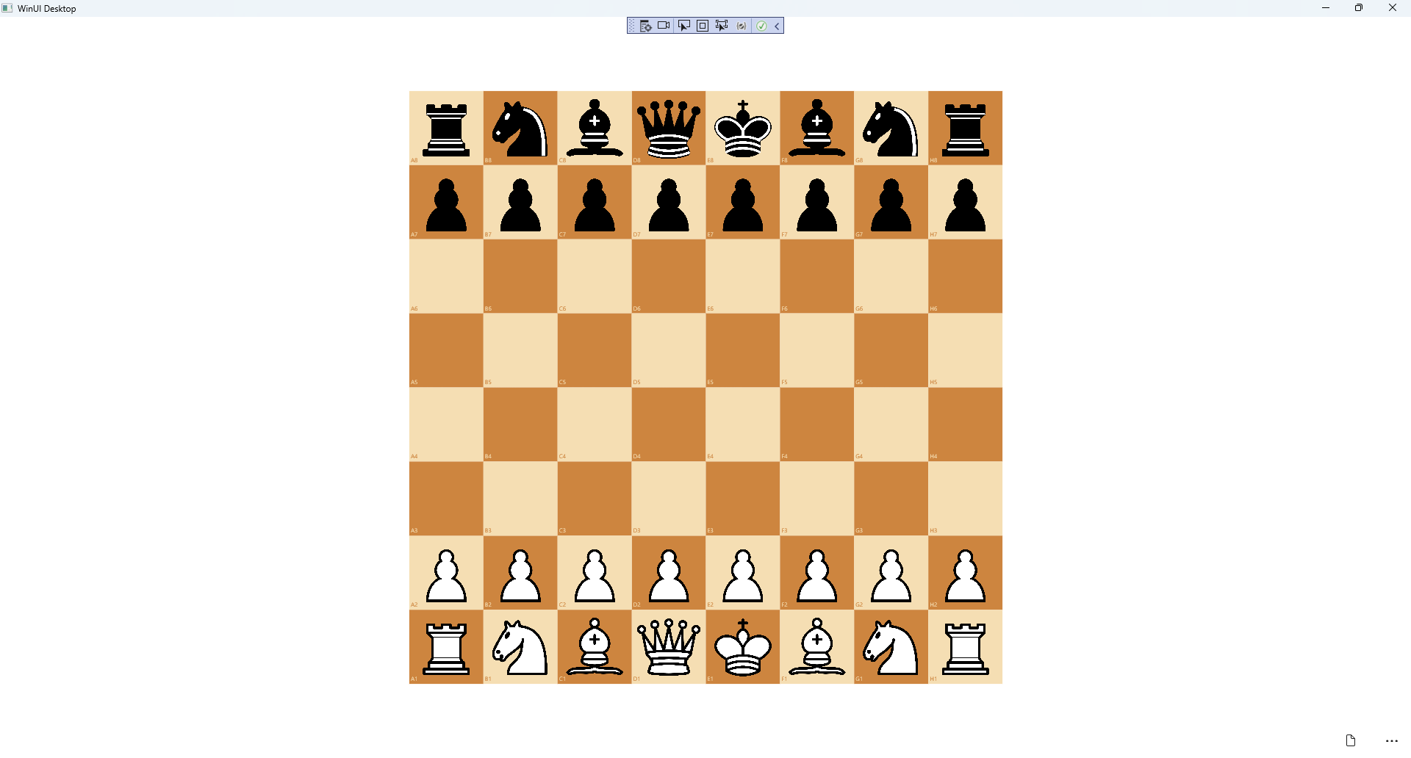

## Step 26

|  |  |
| --- | --- |
| To **Exit** the **Windows App SDK** application, select the **Close** button from the top right of the application as that concludes this **Tutorial** for **Windows App SDK** from [tutorialr.com](https://tutorialr.com)! |  |