

[](https://www.tutorialr.com/tutorials/)

Windows App SDK

Clock Control





# Clock Control

**Clock Control** shows how to create a **Control** that can be used as a **Clock** using **Windows App SDK**

## Step 1

Follow **Setup and Start** on how to get **Setup** and **Install** what you need for **Visual Studio 2022** and **Windows App SDK**.

|  |  |
| --- | --- |
| In **Windows 11** choose **Start** and then find or search for **Visual Studio 2022** and then select it. |  |
| Once **Visual Studio 2022** has started select **Create a new project**. |  |
| Then choose the **Blank App, Packages (WinUI in Desktop)** and then select **Next**. |  |
| After that in **Configure your new project** type in the **Project name** as *ClockControl*, then select a Location and then select **Create** to start a new **Solution**. |  |

## Step 2

Then in **Visual Studio** within **Solution** **Explorer** for the **Solution**, right click on the **Project** shown below the **Solution** and then select **Add** then **New Item…**

## Step 3

Then in **Add New Item** from the **C# Items** list, select **WinUI** and then select **User Control (WinUI 3)** from the list next to this, then type in the name of *Clock.xaml* and then **Click** on **Add**.

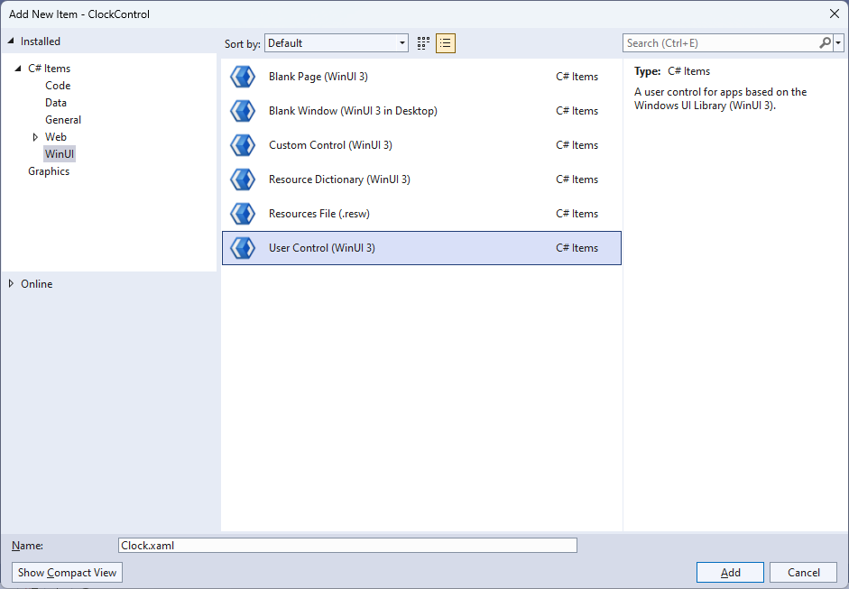

## Step 4

|  |  |
| --- | --- |
| Then from **Solution** **Explorer** for the **Solution** double-click on **Clock.xaml** to see the **XAML** for the **User Control**. |  |

## Step 5

In the **XAML** for *Clock.xaml* there be some **XAML** for a **Grid**, above **</Grid>**, type in the following **XAML**:

<Viewbox>

<Canvas Name="Display" Height="300" Width="300" Loaded="Load"/>

</Viewbox>

This **XAML** contains a **Viewbox** which will **Scale** a **Canvas** with a **Loaded** event handler of **Load**.

## Step 6

|  |  |
| --- | --- |
| Then, within **Solution** **Explorer** for the **Solution** select the arrow next to **Clock.xaml** then double-click on **Clock.xaml.cs** to see the **Code** for the **User Control**. |  |

## Step 7

You will now be in the **View** for the **Code** of *Clock.xaml.cs*, near the top of the **Code**, below the final **using** statement you will need to type the following **using** statement:

using Microsoft.UI.Xaml.Shapes;

## Step 8

Then, while still in the **View** for the **Code** of *Clock.xaml.cs*, type in the following **Code** below the end of the **Constructor** of **public Clock() { ... }**:

private const int seconds_width = 2;

private const int minutes_width = 4;

private const int hours_width = 8;

private readonly DispatcherTimer _timer = new();

private readonly Canvas _markers = new();

private readonly Canvas _face = new();

private double _diameter;

// Dependency Property & Properties

// Transform Method

// Markers Method

// Hand, GetHand, AddHand & RemoveHand Methods

// SecondHand, MinuteHand & HourHand Methods

// Layout & Load Methods

The **class** for **Clock** represents the **User Control** for the **Clock** and includes a **DispatcherTimer** that will be used for the time of the **Clock** along with a **double** for the diameter of the **Clock**.

## Step 9

While still in the **class** of **Gauge** after the **Comment** of **// Dependency Property & Properties** type the following **Dependency Property** and **Properties**:

public static readonly DependencyProperty FillProperty =

DependencyProperty.Register(nameof(Fill), typeof(Brush),

typeof(Clock), null);

public Brush Fill

{

get { return (Brush)GetValue(FillProperty); }

set { SetValue(FillProperty, value); }

}

public bool IsRealTime { get; set; } = true;

public bool ShowSeconds { get; set; } = true;

public bool ShowMinutes { get; set; } = true;

public bool ShowHours { get; set; } = true;

public DateTime Time { get; set; } = DateTime.Now;

public bool Enabled

{

get { return _timer.IsEnabled; }

set

{

if (_timer.IsEnabled)

{

_timer.Stop();

}

else

{

_timer.Start();

}

}

}

The **Dependency Property** will be used for elements of the **Clock** that will use the **Property** of **Fill** and the other **Properties** configure aspects of the **Clock** including which hands to show and if the **Clock** is **Enabled** or not.

## Step 10

While still in the **class** of **Clock** after the **Comment** of **// Transform Method** type the following **Method**:

private TransformGroup Transform(double angle, double x, double y)

{

var transformGroup = new TransformGroup();

var firstTranslate = new TranslateTransform()

{

X = x,

Y = y

};

transformGroup.Children.Add(firstTranslate);

var rotateTransform = new RotateTransform()

{

Angle = angle

};

transformGroup.Children.Add(rotateTransform);

var secondTranslate = new TranslateTransform()

{

X = _diameter / 2,

Y = _diameter / 2

};

transformGroup.Children.Add(secondTranslate);

return transformGroup;

}

This **Method** will create a **TransformGroup** to rotate elements to be used on the **Clock**.

## Step 11

While still in the **class** of **Clock** after the **Comment** of **// Markers Method** type the following **Method**:

private void Markers(Canvas canvas, double thickness)

{

double inner = _diameter - 15;

_markers.Children.Clear();

_markers.Width = inner;

_markers.Height = inner;

for (int i = 0; i < 60; i++)

{

var marker = new Rectangle

{

Fill = Foreground

};

if ((i % 5) == 0)

{

marker.Width = 3;

marker.Height = 8;

marker.RenderTransform = Transform(i * 6, -(marker.Width / 2),

-(marker.Height * 2 + 4.5 - thickness / 2 - inner / 2 - 6));

}

else

{

marker.Width = 1;

marker.Height = 4;

marker.RenderTransform = Transform(i * 6, -(marker.Width / 2),

-(marker.Height * 2 + 12.75 - thickness / 2 - inner / 2 - 8));

}

_markers.Children.Add(marker);

}

canvas.Children.Add(_markers);

}

This **Method** will create the set of small and large markers to be displayed on the **Clock**.

## Step 12

While still in the **class** of **Clock** after the **Comment** of **// Hand, GetHand, AddHand & Remove Hand Methods** type the following **Methods**:

private Rectangle Hand(double width, double height) => new()

{

Width = width,

Height = height,

Fill = Fill,

RadiusX = width / 2,

RadiusY = width / 2,

Name = width.ToString()

};

private Rectangle GetHand(int width) =>

FindName(width.ToString()) as Rectangle;

private Rectangle AddHand(int width, int height)

{

var hand = GetHand(width);

if (hand == null)

{

hand = Hand(width, height);

_face.Children.Add(hand);

}

return hand;

}

private void RemoveHand(int width)

{

var hand = GetHand(width);

if (hand != null)

{

_face.Children.Remove(hand);

}

}

**Hand** will be used to create the hands for the **Clock** and will take advantage of the different widths to tell them apart in the next **Methods** of **AddHand,** which will put the hands on the **Clock** and **RemoveHand** which will remove any hands.

## Step 13

While still in the **class** of **Clock** after the **Comment** of **// SecondHand, MinuteHand & HourHand Methods** type the following **Methods**:

private void SecondHand(int seconds)

{

if (ShowSeconds)

{

var secondsHeight = (int)_diameter / 2 - 20;

var secondsHand = AddHand(seconds_width, secondsHeight);

secondsHand.RenderTransform = Transform(seconds * 6,

-seconds_width / 2, -secondsHeight + 4.25);

}

else

{

RemoveHand(seconds_width);

}

}

private void MinuteHand(int minutes, int seconds)

{

if (ShowMinutes)

{

var minutesHeight = (int)_diameter / 2 - 40;

var minutesHand = AddHand(minutes_width, minutesHeight);

minutesHand.RenderTransform = Transform(6 * minutes + seconds / 10,

-minutes_width / 2, -minutesHeight + 4.25);

}

else

{

RemoveHand(minutes_width);

}

}

private void HourHand(int hours, int minutes, int seconds)

{

if (ShowHours)

{

var hoursHeight = (int)_diameter / 2 - 60;

var hoursHand = AddHand(hours_width, hoursHeight);

hoursHand.RenderTransform = Transform(

30 * hours + minutes / 2 + seconds / 120,

-hours_width / 2, -hoursHeight + 4.25);

}

else

{

RemoveHand(hours_width);

}

}

These **Methods** will manage the display and movement of the three hands of the **Clock** for seconds, minutes and hours.

## Step 14

While still in the **class** of **Clock** after the **Comment** of **// Layout & Load Methods** type the following **Methods**:

private void Layout(Canvas canvas)

{

canvas.Children.Clear();

_diameter = canvas.Width;

var rim = new Ellipse

{

Height = _diameter,

Width = _diameter,

Stroke = Fill,

StrokeThickness = 20

};

canvas.Children.Add(rim);

Markers(canvas, rim.StrokeThickness);

_face.Width = _diameter;

_face.Height = _diameter;

canvas.Children.Add(_face);

}

private void Load(object sender, RoutedEventArgs e)

{

Layout(Display);

_timer.Interval = TimeSpan.FromSeconds(1);

_timer.Tick += (object s, object obj) =>

{

if (IsRealTime)

{

Time = DateTime.Now;

}

SecondHand(Time.Second);

MinuteHand(Time.Minute, Time.Second);

HourHand(Time.Hour, Time.Minute, Time.Second);

};

_timer.Start();

}

**Layout** will create the look-and-feel of the **Clock** and uses the **Method** for **Markers** and **Load** will be used when the **Canvas** of the **User Control** is loaded and setup the **DispatcherTimer** to allow the time to be displayed along with the hands of the **Clock**.

## Step 15

|  |  |
| --- | --- |
| Within **Solution** **Explorer** for the **Solution** double-click on **MainWindow.xaml** to see the **XAML** for the **Main Window**. |  |

## Step 16

In the **XAML** for **MainWindow.xaml** there be some **XAML** for a **StackPanel**, this should be **Removed** by removing the following:

<StackPanel Orientation="Horizontal"

HorizontalAlignment="Center" VerticalAlignment="Center">

<Button x:Name="myButton" Click="myButton_Click">Click Me</Button>

</StackPanel>

## Step 17

While still in the **XAML** for **MainWindow.xaml** above **</Window>**, type in the following **XAML**:

<local:Clock Margin="50" Foreground="WhiteSmoke"

Fill="{ThemeResource SystemControlHighlightAccentBrush}"/>

This **XAML** contains the **User Control** of **Clock** with **Properties** set including **Foreground** and **Fill**.

## Step 18

|  |  |
| --- | --- |
| Then, within **Solution** **Explorer** for the **Solution** select the arrow next to **MainWindow.xaml** then double-click on **MainWindow.xaml.cs** to see the **Code** for the **Main Window**. |  |

## Step 19

In the **Code** for **MainWindow.xaml.cs** there be a **Method** of **myButton_Click(...)** this should be **Removed** by removing the following:

private void myButton_Click(object sender, RoutedEventArgs e)

{

myButton.Content = "Clicked";

}

## Step 20

|  |  |
| --- | --- |
| That completes the **Windows App SDK** application. In **Visual Studio 2022** from the **Toolbar** select **ClockControl (Package)** to **Start** the application. |  |

## Step 21

Once running you will see the **Clock Control** displayed, with the current time displayed on the **Clock**.

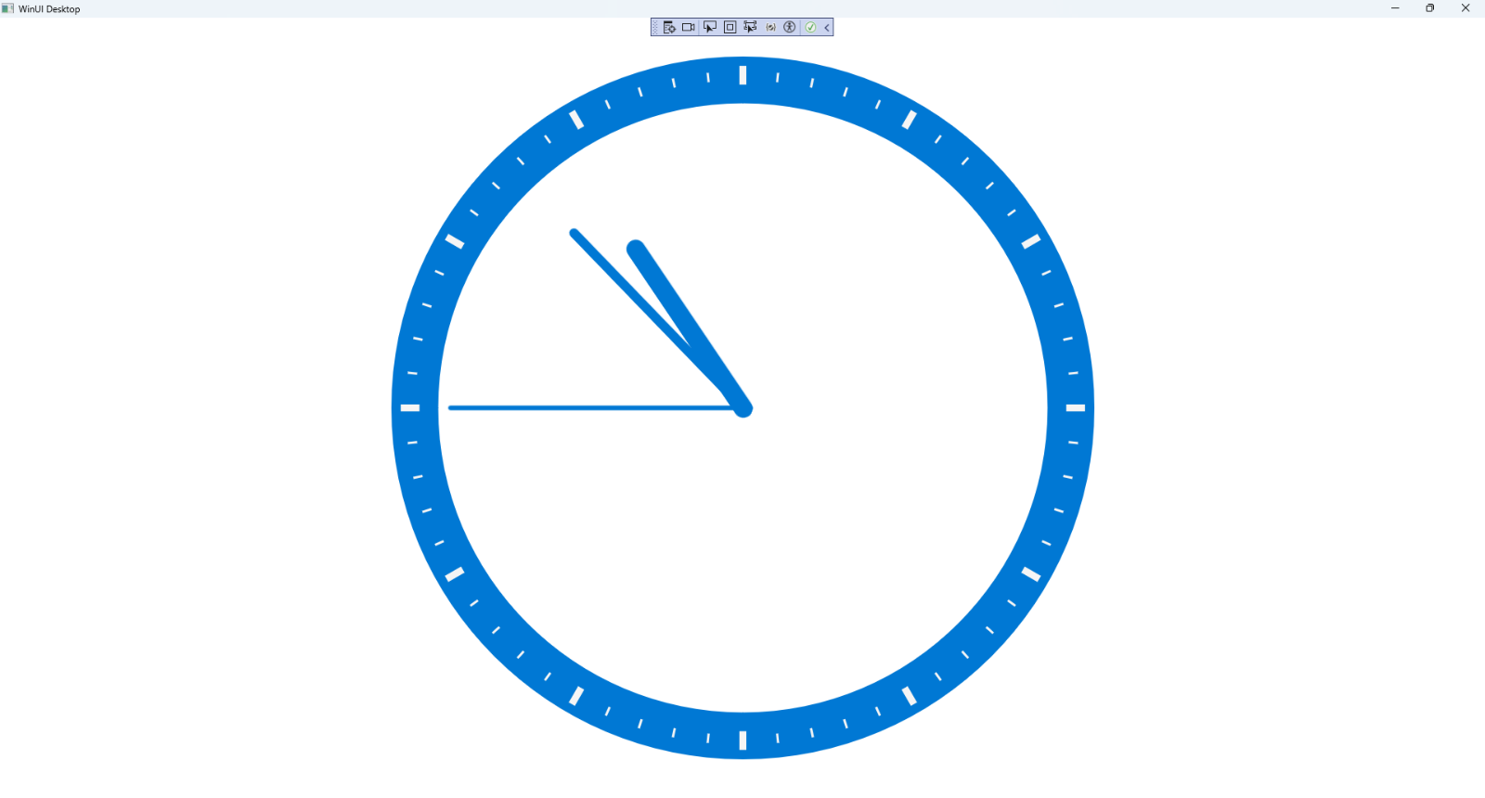

## Step 22

|  |  |
| --- | --- |
| To **Exit** the **Windows App SDK** application, select the **Close** button from the top right of the application as that concludes this **Tutorial** for **Windows App SDK** from [tutorialr.com](https://tutorialr.com)! |  |