

[](https://www.tutorialr.com/tutorials/)

Windows App SDK

Codes Game





# Codes Game

**Codes Game** shows how to create a game where you need to guess the correct combination of four

numbers between *1* and *9* using a toolkit from **NuGet** using the **Windows App SDK**.

## Step 1

Follow **Setup and Start** on how to get **Setup** and **Install** what you need for **Visual Studio 2022** and **Windows App SDK**.

|  |  |
| --- | --- |
| In **Windows 11** choose **Start** and then find or search for **Visual Studio 2022** and then select it. |  |
| Once **Visual Studio 2022** has started select **Create a new project**. |  |
| Then choose the **Blank App, Packages (WinUI in Desktop)** and then select **Next**. |  |
| After that in **Configure your new project** type in the **Project name** as *CodesGame*, then select a Location and then select **Create** to start a new **Solution**. |  |

## Step 2

Then in **Visual Studio** within **Solution** **Explorer** for the **Solution**, right click on the **Project** shown below the **Solution** and then select **Manage NuGet Packages…**

## Step 3

Then in the **NuGet Package Manager** from the **Browse** tab search for **Comentsys.Toolkit.WindowsAppSdk** and then select **Comentsys.Toolkit.WindowsAppSdk by Comentsys** as indicated and select **Install**

This will add the package for **Comentsys.Toolkit.WindowsAppSdk** to your **Project**. If you get the **Preview Changes** screen saying **Visual Studio is about to make changes to this solution. Click OK to proceed with the changes listed below.** You can read the message and then select **OK** to **Install** the package, then you can close the **tab** for **Nuget: CodesGame** by selecting the **x** next to it.

## Step 4

Then in **Visual Studio** within **Solution** **Explorer** for the **Solution**, right click on the **Project** shown below the **Solution** and then select **Add** then **New Item…**

## Step 5

Then in **Add New Item** from the **C# Items** list, select **Code** and then select **Code File** from the list next to this, then type in the name of *Library.cs* and then **Click** on **Add**.

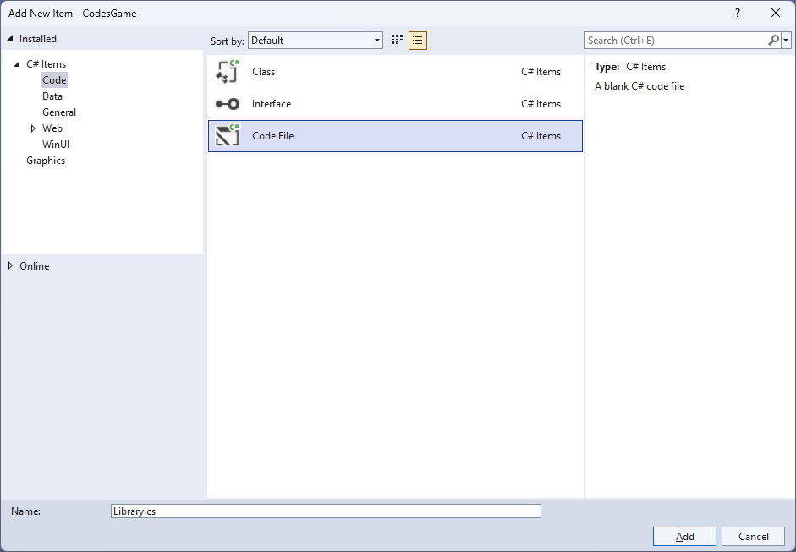

## Step 6

You will now be in the **View** for the **Code** of *Library.cs*, within this first type the following **Code**:

using Comentsys.Toolkit.Binding;

using Comentsys.Toolkit.WindowsAppSdk;

using Microsoft.UI;

using Microsoft.UI.Xaml.Controls;

using Microsoft.UI.Xaml.Data;

using Microsoft.UI.Xaml.Media;

using System;

using System.Collections.Generic;

using System.Collections.ObjectModel;

using System.Linq;

using System.Windows.Input;

namespace CodesGame;

public enum State

{

None,

Match

}

// Code Class

// StateToBrushConverter Class

public class Library

{

// Library Constants, Variables and Choose Method

// Library GetCode, IsMatch & Setup Method

// Library Accept & New Method

}

**Class** defined so far *Library.cs* has **using** for packageof **Comentsys.Toolkit.WindowsAppSdk** and others along with a **namespace** which allows many classes to be defined together, usually a **class** is defined per file but to make things easier each will be defined in *Library.cs* instead.

## Step 7

Still in *Library.cs* for the **namespace** of **CodesGame** in *Library.cs* you will define a **class** after the **Comment** of **// Code Class** by typing the following:

public class Code : ObservableBase

{

private int _value;

private State _state;

private readonly int _index;

private readonly Action<int> _action;

public Code(int index, int value, State state, Action<int> action) =>

(_index, Value, State, _action) = (index, value, state, action);

public ICommand Command =>

new ActionCommandHandler((param) => _action(_index));

public int Value

{

get => _value;

set => SetProperty(ref _value, value);

}

public State State

{

get => _state;

set => SetProperty(ref _state, value);

}

}

**Code** uses the **class** from the toolkit of **ObservableBase** which will be used for **Data Binding** the **Properties** which include the **State** and **Value** along with the **Command** which will be used to allow interaction with the element using **Commanding**.

## Step 8

Still in *Library.cs* for the **namespace** of **CodesGame** in *Library.cs* you will define a **class** after the **Comment** of **// StateToBrushConverter Class** by typing the following:

public class StateToBrushConverter : IValueConverter

{

public object Convert(object value, Type targetType,

object parameter, string language)

{

if (value is State state)

{

var invert = bool.Parse(parameter as string);

var none = state == State.None;

var color = none ^= invert;

return new SolidColorBrush(color ? Colors.White : Colors.Black);

}

return null;

}

public object ConvertBack(object value, Type targetType,

object parameter, string language) =>

throw new NotImplementedException();

}

**StateToBrushConverter** uses the **interface** of **IValueConverter** for **Data Binding** which will allow the colours of the **Codes** in the game to be represented from either *White* or *Black* as a **SolidColorBrush**.

## Step 9

While still in the **namespace** of **CodesGame** in *Library.cs* and in the **class** of **Library** after the **Comment** of **// Library Constants, Variables and Choose Method** type in the following **Constants**, **Variables** and **Method**:

private const string title = "Codes Game";

private const int max = 9;

private const int total = 4;

private readonly ObservableCollection<Code> _codes = new();

private readonly Random _random = new((int)DateTime.UtcNow.Ticks);

private List<int> _values = new();

private int _turns = 0;

private Dialog _dialog;

private ItemsControl _items;

private List<int> Choose(int minimum, int maximum, int total)

{

var choose = new List<int>();

var values = Enumerable.Range(minimum, maximum).ToList();

for (int index = 0; index < total; index++)

{

var value = _random.Next(0, values.Count);

choose.Add(values[value]);

}

return choose;

}

**Constants** are values that are used in the game that will not change and **Variables** are used to store various values for the game. The **Method** of **Choose** will be used to create a list of randomised numbers that are not unique as you can have the same number in a **Code** for the game.

## Step 10

While still in the **namespace** of **CodesGame** in *Library.cs* and in the **class** of **Library** after the **Comment** of **// Library GetCode, IsMatch & Setup Method** type the following **Methods**:

private Code GetCode(int index, int value) =>

new(index, value, State.None, (int i) =>

{

var code = _codes[i];

if (code.State == State.None)

code.Value = (code.Value == max) ? 1 : code.Value + 1;

});

private bool IsMatch(int index, int value)

{

var code = _codes[index];

return value == code.Value ?

(code.State = State.Match) == State.Match :

(code.State = State.None) == State.Match;

}

private void Setup()

{

_turns = 0;

_codes.Clear();

for (int index = 0; index < total; index++)

{

_codes.Add(GetCode(index, index + 1));

}

_values = Choose(1, max, total);

_items.ItemsSource = _codes;

}

**GetCode** is used to get a part of a **Code** for the game, **IsMatch** will check if the selected part of a **Code** matches the part of a **Code** and **Setup** is used to initialise the game with a given **Code** using **Choose**.

## Step 11

While still in the **namespace** of **CodesGame** in *Library.cs* and in the **class** of **Library** after the **Comment** of **// Library Accept & New Method** type the following **Methods**:

public void Accept()

{

int index = 0;

int correct = 0;

foreach (var value in _values)

{

if (IsMatch(index, value))

correct++;

index++;

}

_turns++;

if (correct == total)

{

string code = string.Join(string.Empty, _codes.Select(s => s.Value));

_dialog.Show($"Matched {code} in {_turns} turns");

Setup();

}

}

public void New(ItemsControl items)

{

_dialog = new Dialog(items.XamlRoot, title);

_items = items;

Setup();

}

**Accept** will check if the selected parts of the **Code** are correct using **IsMatch** if they are all correct then a message will be displayed using the **Dialog** and **New** will be used to begin a game and uses **Setup**.

## Step 12

|  |  |
| --- | --- |
| Then from **Solution** **Explorer** for the **Solution** double-click on **MainWindow.xaml** to see the **XAML** for the **Main Window**. |  |

## Step 13

In the **XAML** for **MainWindow.xaml** there be some **XAML** for a **StackPanel**, this should be **Removed** by removing the following:

<StackPanel Orientation="Horizontal"

HorizontalAlignment="Center" VerticalAlignment="Center">

<Button x:Name="myButton" Click="myButton_Click">Click Me</Button>

</StackPanel>

## Step 14

While still in the **XAML** for **MainWindow.xaml** below **<Window**, type in the following **XAML**:

xmlns:ui="using:Comentsys.Toolkit.WindowsAppSdk"

The **XAML** for **<Window>** should then look as follows:

<Window

xmlns:ui="using:Comentsys.Toolkit.WindowsAppSdk"

x:Class="CodesGame.MainWindow"

xmlns="http://schemas.microsoft.com/winfx/2006/xaml/presentation"

xmlns:x="http://schemas.microsoft.com/winfx/2006/xaml"

xmlns:local="using:CodesGame"

xmlns:d="http://schemas.microsoft.com/expression/blend/2008"

xmlns:mc="http://schemas.openxmlformats.org/markup-compatibility/2006"

mc:Ignorable="d">

## Step 15

While still in the **XAML** for **MainWindow.xaml** above **</Window>**, type in the following **XAML**:

<Grid>

<Grid.Resources>

<local:StateToBrushConverter x:Key="StateToBrushConverter"/>

</Grid.Resources>

<Viewbox>

<ItemsControl Margin="50" Name="Display"

HorizontalAlignment="Center"

VerticalAlignment="Center" Loaded="New">

<ItemsControl.ItemTemplate>

<DataTemplate x:Name="DataTemplate">

<Button Command="{Binding Command}">

<ui:Piece Value="{Binding Value}" IsSquare="True"

Fill="{Binding State, Mode=OneWay,

Converter={StaticResource StateToBrushConverter},

ConverterParameter=True}"

Foreground="{Binding State, Mode=OneWay,

Converter={StaticResource StateToBrushConverter},

ConverterParameter=False}" />

</Button>

</DataTemplate>

</ItemsControl.ItemTemplate>

<ItemsControl.ItemsPanel>

<ItemsPanelTemplate>

<StackPanel Orientation="Horizontal"/>

</ItemsPanelTemplate>

</ItemsControl.ItemsPanel>

</ItemsControl>

</Viewbox>

<CommandBar VerticalAlignment="Bottom">

<AppBarButton Icon="Accept" Label="Accept" Click="Accept"/>

<AppBarButton Icon="Page2" Label="New" Click="New"/>

</CommandBar>

</Grid>

This **XAML** contains a **Grid** with **Resources** using the **StateToBrushConverter** and also contains a **Viewbox** which will **Scale** an **ItemsControl** which has a **DataTemplate** which contains a **Button** and **Piece** which will be bound using **Data Binding**. It has a **Loaded** event handler for **New** which is also shared by the **AppBarButton** along with one for **Accept**.

## Step 16

|  |  |
| --- | --- |
| Then, within **Solution** **Explorer** for the **Solution** select the arrow next to **MainWindow.xaml** then double-click on **MainWindow.xaml.cs** to see the **Code** for the **Main Window**. |  |

## Step 17

In the **Code** for **MainWindow.xaml.cs** there be a **Method** of **myButton_Click(...)** this should be **Removed** by removing the following:

private void myButton_Click(object sender, RoutedEventArgs e)

{

myButton.Content = "Clicked";

}

## Step 18

Once **myButton_Click(...)** has been removed, type in the following **Code** below the end of the **Constructor** of **public MainWindow() { ... }**:

private readonly Library _library = new();

private void Accept(object sender, RoutedEventArgs e) =>

_library.Accept();

private void New(object sender, RoutedEventArgs e) =>

_library.New(Display);

Here an **Instance** of the **Class** of **Library** is created then below this is the **Method** of **Accept** and **New** that will be used with **Event Handler** from the **XAML**, these **Methods** use Arrow Syntax with the **=>** for an Expression Bodywhich is useful when a **Method** only has one line.

## Step 19

|  |  |
| --- | --- |
| That completes the **Windows App SDK** application. In **Visual Studio 2022** from the **Toolbar** select **CodesGame (Package)** to **Start** the application. |  |

## Step 20

Once running you win the game by selecting four numbers between *1* and *9* to guess the secret **Code** by selecting the numbers you can go through them to find the correct combination and once happy select *Accept* if you guessed a number incorrectly then it will turn **Black** with **White** text or if correct it will be **White** with **Black** text, or you can select *New*to start a new game.

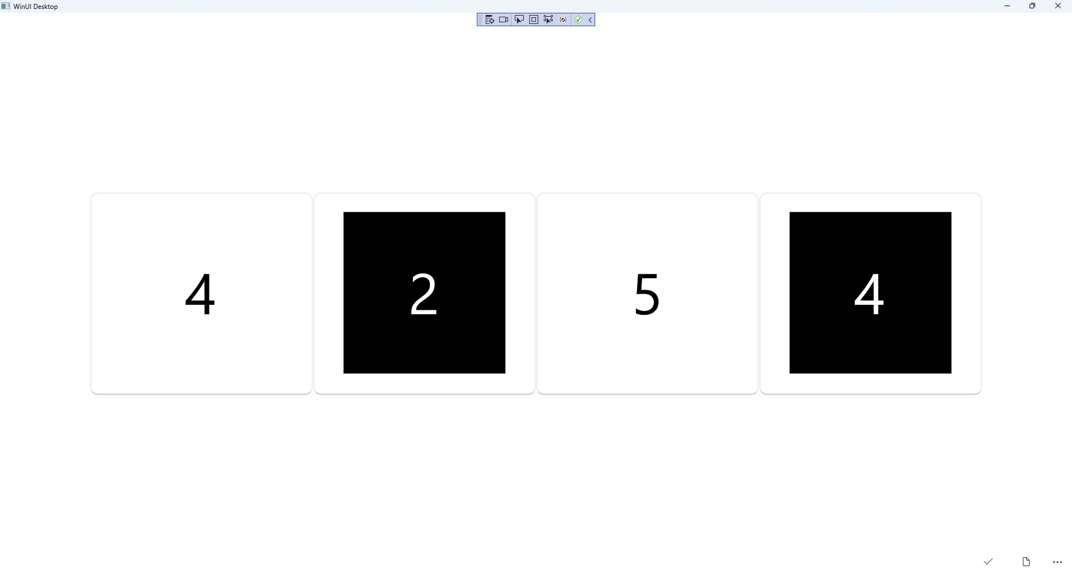

## Step 21

|  |  |
| --- | --- |
| To **Exit** the **Windows App SDK** application, select the **Close** button from the top right of the application as that concludes this **Tutorial** for **Windows App SDK** from [tutorialr.com](https://tutorialr.com)! |  |