

[](https://www.tutorialr.com/tutorials/)

Windows App SDK

Command Bar





# Command Bar

**Command Bar** shows how you can use the **CommandBar** with the **Windows App SDK** allowing for a

standard-looking interface to perform actions or access options within an Application.

## Step 1

Follow **Setup and Start** on how to get **Setup** and **Install** what you need for **Visual Studio 2022** and **Windows App SDK**.

|  |  |
| --- | --- |
| In **Windows 11** choose **Start** and then find or search for **Visual Studio 2022** and then select it. |  |
| Once **Visual Studio 2022** has started select **Create a new project**. |  |
| Then choose the **Blank App, Packages (WinUI in Desktop)** and then select **Next**. |  |
| After that in **Configure your new project** type in the **Project name** as *CommandBar*, then select a Location and then select **Create** to start a new **Solution**. |  |

## Step 2

|  |  |
| --- | --- |
| Within **Solution** **Explorer** for the **Solution** and double-click on **MainWindow.xaml** to see the **XAML** for the **Main Window**. |  |

## Step 3

In the **XAML** for **MainWindow.xaml** there be some **XAML** for a **StackPanel**, this should be **Removed** by removing the following:

<StackPanel Orientation="Horizontal"

HorizontalAlignment="Center" VerticalAlignment="Center">

<Button x:Name="myButton" Click="myButton_Click">Click Me</Button>

</StackPanel>

## Step 4

While still in the **XAML** for **MainWindow.xaml** above **</Window>**, type in the following **XAML**:

<CommandBar IsOpen="True" IsSticky="True" VerticalAlignment="Bottom">

<CommandBar.SecondaryCommands>

<AppBarButton Name="Hide" Icon="Cancel"

Visibility="Collapsed" Label="Hide Other" Click="Toggle_Click"/>

</CommandBar.SecondaryCommands>

<AppBarButton Name="Toggle" Icon="Accept" AccessKey="T"

Label="Toggle Other" Click="Toggle_Click"/>

</CommandBar>

**CommandBar** is a **Control** that can contain **AppBarButton**, in this case one for *Toggle Other* which will be used to show or hide another **AppBarButton** for *Hide Other* in the **SecondaryCommands**, which are displayed under a **Menu** on the **CommandBar** indicated with **…**

The **AppBarButton** for *Toggle Other* also has an **AccessKey** of *T* to it can be triggered with a **Click** or by pressing **Alt** and then **T** on the keyboard.

## Step 5

|  |  |
| --- | --- |
| Then, within **Solution** **Explorer** for the **Solution** select the arrow next to **MainWindow.xaml** then double-click on **MainWindow.xaml.cs** to see the **Code** for the **Main Window**. |  |

## Step 6

In the **Code** for **MainWindow.xaml.cs** there be a **Method** of **myButton_Click(...)** this should be **Removed** by removing the following:

private void myButton_Click(object sender, RoutedEventArgs e)

{

myButton.Content = "Clicked";

}

## Step 7

Once **myButton_Click(...)** has been removed, below the end of **public MainWindow() { ... }** type in the following **Code**:

private void Toggle_Click(object sender, RoutedEventArgs e)

{

if (Hide.Visibility == Visibility.Collapsed)

{

Hide.Visibility = Visibility.Visible;

}

else

{

Hide.Visibility = Visibility.Collapsed;

}

}

The **Method** of **Toggle_Click** will be triggered when the **AppBarButton** of *Toggle Other* or *Hide Other* is **Clicked** it can also be triggered by pressing **Alt** and then **T** on the keyboard. It will check the value of the **Visibility** of **AppBarButton** for **Hide**, if this is **Collapsed** or it is hidden, it will set it to **Visible** which will mean it can be seen, otherwise it will do the opposite and hide it to make it **Collapsed** again.

## Step 8

|  |  |
| --- | --- |
| That completes the **Windows App SDK** application. In **Visual Studio 2022** from the **Toolbar** select **CommandBar (Package)** to **Start** the application. |  |

## Step 9

Once running you should see an **AppBarButton** with the Text *Toggle Other* along with … which is where the **SecondaryCommands** for *Hide Other* would be displayed.

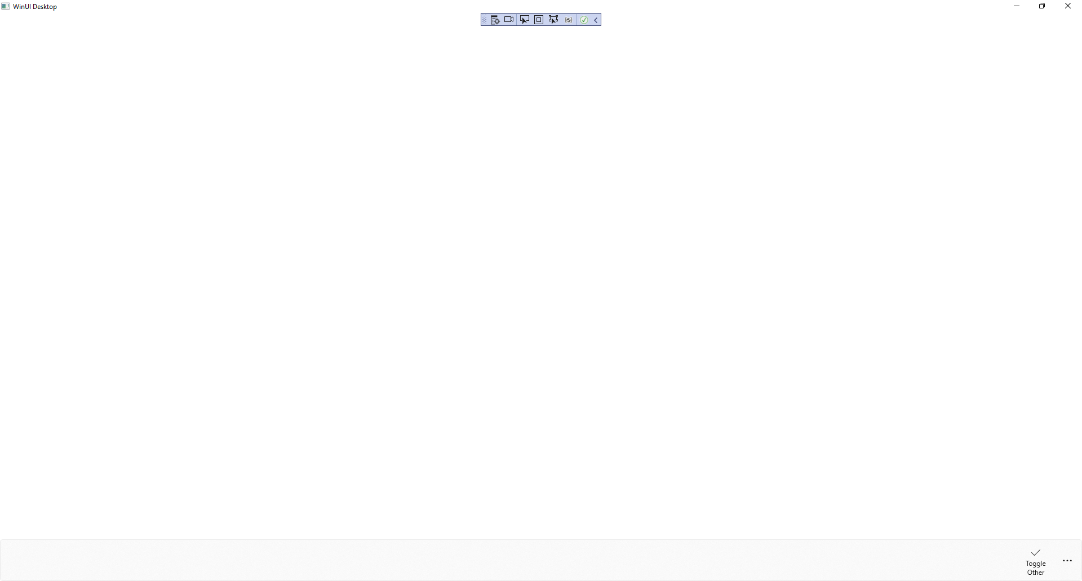

## Step 10

If you **Click** on the **AppBarButton** with the Text *Toggle Other* or press **Alt** and then **T** this will **Toggle** the

**AppBarButton** of*Hide Other* when **…** is **Clicked** you can also **Click** on *Hide Other* to hide itself.

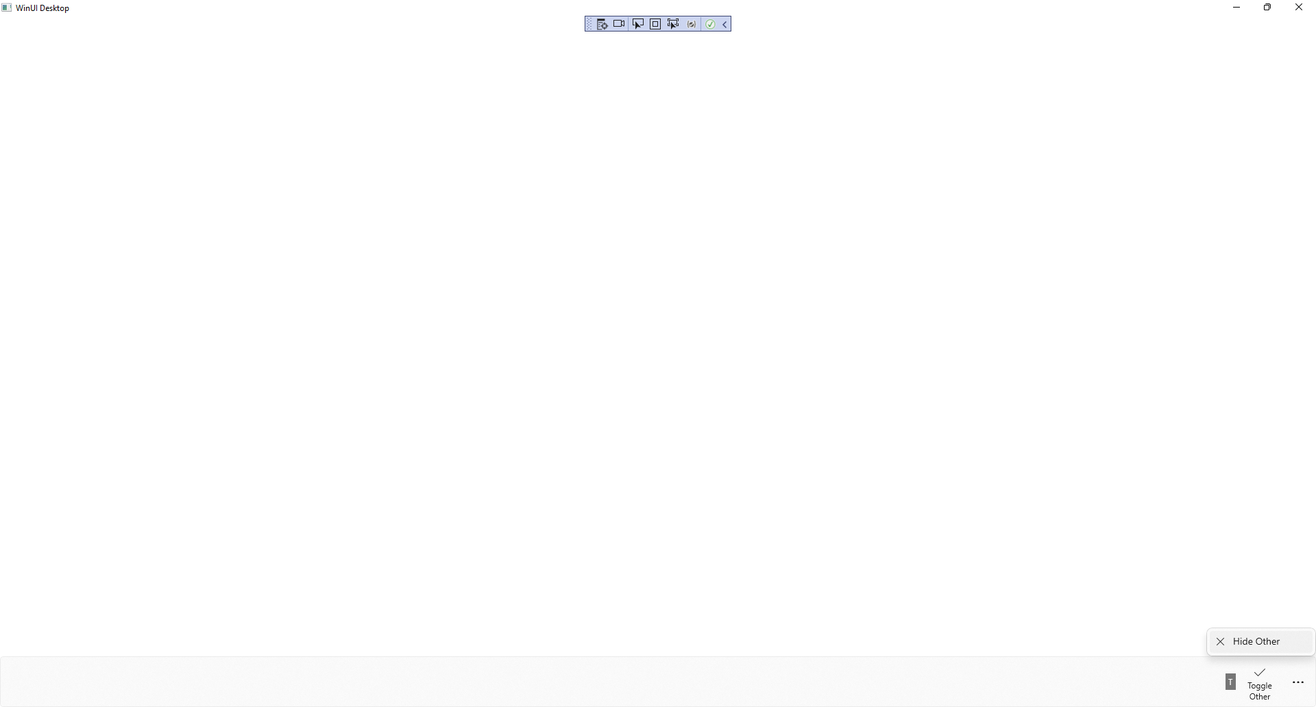

## Step 11

|  |  |
| --- | --- |
| To **Exit** the **Windows App SDK** application, select the **Close** button from the top right of the application as that concludes this **Tutorial** for **Windows App SDK** from [tutorialr.com](https://tutorialr.com)! |  |