

[](https://www.tutorialr.com/tutorials/)

Windows App SDK

Connected Animation





# Connected Animation

**Connected Animation** shows how you can create **Connected Animations** between **Pages** within an

application using the **Windows App SDK**.

## Step 1

Follow **Setup and Start** on how to get **Setup** and **Install** what you need for **Visual Studio 2022** and **Windows App SDK**.

|  |  |
| --- | --- |
| In **Windows 11** choose **Start** and then find or search for **Visual Studio 2022** and then select it. |  |
| Once **Visual Studio 2022** has started select **Create a new project**. |  |
| Then choose the **Blank App, Packages (WinUI in Desktop)** and then select **Next**. |  |
| After that in **Configure your new project** type in the **Project name** as *ConnectedAnimation*, then select a Location and then select **Create** to start a new **Solution**. |  |

## Step 2

Then in **Visual Studio** within **Solution** **Explorer** for the **Solution**, right click on the **Project** shown below the **Solution** and then select **Add** then **New Item…**

## Step 3

Then in **Add New Item** from the **C# Items** list, select **Code** and then select **Code File** from the list next to this, then type in the name of *Library.cs* and then **Click** on **Add**.

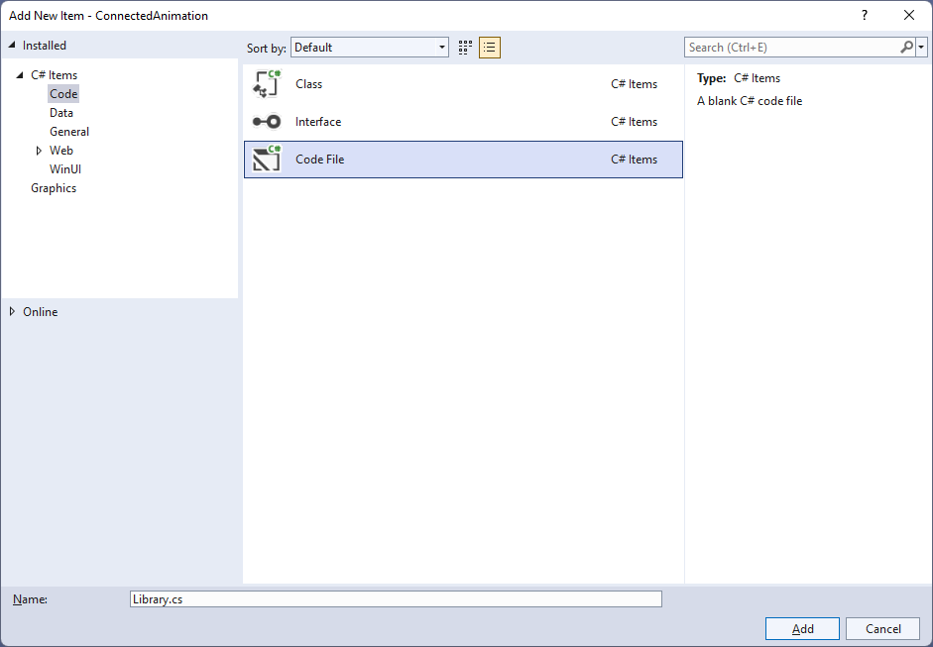

## Step 4

You will now be in the **View** for the **Code** of *Library.cs*, within this first type the following **Code**:

using Microsoft.UI.Xaml.Controls;

using Microsoft.UI.Xaml.Media;

using Microsoft.UI.Xaml.Media.Animation;

using Microsoft.UI.Xaml.Shapes;

using System;

using System.Linq;

internal static class Library

{

private const string animate_back = "AnimateBack";

private const string animate_next = "AnimateNext";

public static Frame Frame { get; set; }

public static string Current { get; set; }

public static void Back(ListView listview)

{

var rectangle = listview.Items

.SingleOrDefault(f => (f as Rectangle)

.Tag.Equals(Current)) as Rectangle;

var animation = ConnectedAnimationService

.GetForCurrentView()

.GetAnimation(animate_back);

animation?.TryStart(rectangle);

}

public static Brush Next(object selected)

{

var rectangle = selected as Rectangle;

Current = rectangle.Tag as string;

ConnectedAnimationService

.GetForCurrentView()

.PrepareToAnimate(animate_next, rectangle);

return rectangle.Fill;

}

// Other Methods

}

The **Class** that has been defined so far in *Library.cs* has **const** values along with **Properties** for **Frame** and **Current** then a **Method** for **Back** and **Next** that will be used to create the **Connected Animation** when going backwards and forwards between the **Pages** using the **ConnectedAnimationService.**

## Step 5

While still in the **Class** for *Library.cs* and after the **Comment** of **// Other Methods** type in the following other **Methods**:

public static void From(Rectangle from)

{

ConnectedAnimationService

.GetForCurrentView()

.PrepareToAnimate(animate_back, from);

}

public static void Loaded(Rectangle rectangle)

{

var animation = ConnectedAnimationService

.GetForCurrentView()

.GetAnimation(animate_next);

rectangle.Opacity = 1;

animation?.TryStart(rectangle);

}

public static void Navigate(Type page, object parameter)

{

Frame.Navigate(page, Next(parameter));

}

public static Brush GetBrush(object parameter)

{

return parameter as SolidColorBrush;

}

The **Methods** for **From** and **Loaded** will create the animation flow when going between the **Pages** and **Method** for **Navigate** will use the **Method** for **Navigate** of the **Frame** and the **Method** for **GetBrush** will return a **SolidColorBrush** from an **object** of **parameter**.

## Step 6

Then within **Solution** **Explorer** for the **Solution**, right click on the **Project** shown below the **Solution** and then select **Add** then **New Item…**

## Step 7

Then in **Add New Item** from the **WinUI** itemslist, select **Page** and then select **Blank page (WinUI 3)** from the list next to this, then type in the name of *ContentPage.xaml* and then **Click** on **Add**.

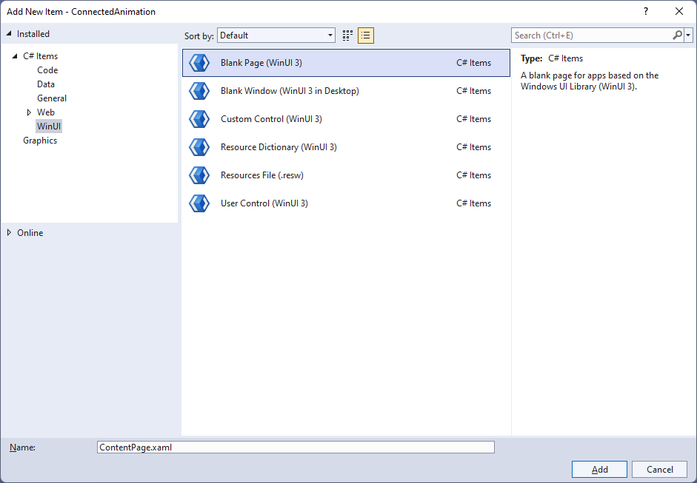

## Step 8

|  |  |
| --- | --- |
| Then from **Solution** **Explorer** for the **Solution** double-click on **ContentPage.xaml** to see the **XAML** for the **Content Page**. |  |

## Step 9

Then in the **XAML** for **ContentPage.xaml**, below **<Grid>** and above **</Grid>**, type in the following **XAML**:

<ListView Name="Display" Margin="10">

<Rectangle HorizontalAlignment="Left" Margin="10"

Width="64" Height="64" Tag="Black" Fill="Black" Tapped="Rectangle_Tapped"/>

<Rectangle HorizontalAlignment="Left" Margin="10"

Width="64" Height="64" Tag="Gray" Fill="Gray" Tapped="Rectangle_Tapped"/>

<Rectangle HorizontalAlignment="Left" Margin="10"

Width="64" Height="64" Tag="Red" Fill="Red" Tapped="Rectangle_Tapped"/>

<Rectangle HorizontalAlignment="Left" Margin="10"

Width="64" Height="64" Tag="Orange" Fill="Orange" Tapped="Rectangle_Tapped"/>

<Rectangle HorizontalAlignment="Left" Margin="10"

Width="64" Height="64" Tag="Yellow" Fill="Yellow" Tapped="Rectangle_Tapped"/>

<Rectangle HorizontalAlignment="Left" Margin="10"

Width="64" Height="64" Tag="Green" Fill="Green" Tapped="Rectangle_Tapped"/>

<Rectangle HorizontalAlignment="Left" Margin="10"

Width="64" Height="64" Tag="Cyan" Fill="Cyan" Tapped="Rectangle_Tapped"/>

<Rectangle HorizontalAlignment="Left" Margin="10"

Width="64" Height="64" Tag="Blue" Fill="Blue" Tapped="Rectangle_Tapped"/>

<Rectangle HorizontalAlignment="Left" Margin="10"

Width="64" Height="64" Tag="Magenta" Fill="Magenta" Tapped="Rectangle_Tapped"/>

<Rectangle HorizontalAlignment="Left" Margin="10"

Width="64" Height="64" Tag="Purple" Fill="Purple" Tapped="Rectangle_Tapped"/>

</ListView>

This **ListView** contains **Rectangle** elements of different colours plus each has the **Event** for **Tapped** set to the **Method** of **Rectangle_Tapped** which will be triggered when the **Rectangle** is **Tapped** or **Clicked**.

## Step 10

|  |  |
| --- | --- |
| Then, within **Solution** **Explorer** for the **Solution** select the arrow next to **ContentPage.xaml** then double-click on **ContentPage.xaml.cs** to see the **Code** for the **Content Page**. |  |

## Step 11

In the **Code** for **ContentPage.xaml.cs** type in the following **Code** below the end of the **Constructor** of **public ContentPage() { ... }**:

protected override void OnNavigatedTo(NavigationEventArgs e)

{

if (e.NavigationMode == NavigationMode.Back)

{

Library.Back(Display);

}

base.OnNavigatedTo(e);

}

private void Rectangle_Tapped(object sender, TappedRoutedEventArgs e)

{

Library.Navigate(typeof(DetailPage), sender);

}

There is the **Method** for **OnNavigatedTo** that uses **override** to change the functionality of the **Method** for **OnNavigatedTo** which will check the **NavigationMode** and call the **Method** of **Back** in the **Class** of **Library** and pass through the **ListView** it also calls the version of the **Method** that was **Overridden** with **base.OnNavigatedTo(e)** there is also another **Method** of **Rectangle_Tapped** which will call the **Method** of **Navigate** in the **Class** of **Library** when a **Rectangle** is **Tapped** or **Clicked**.

## Step 12

Then within **Solution** **Explorer** for the **Solution**, right click on the **Project** shown below the **Solution** and then select **Add** then **New Item…**

## Step 13

Then in **Add New Item** from the **WinUI** itemslist, select **Page** and then select **Blank page (WinUI 3)** from the list next to this, then type in the name of *DetailPage.xaml* and then **Click** on **Add**.

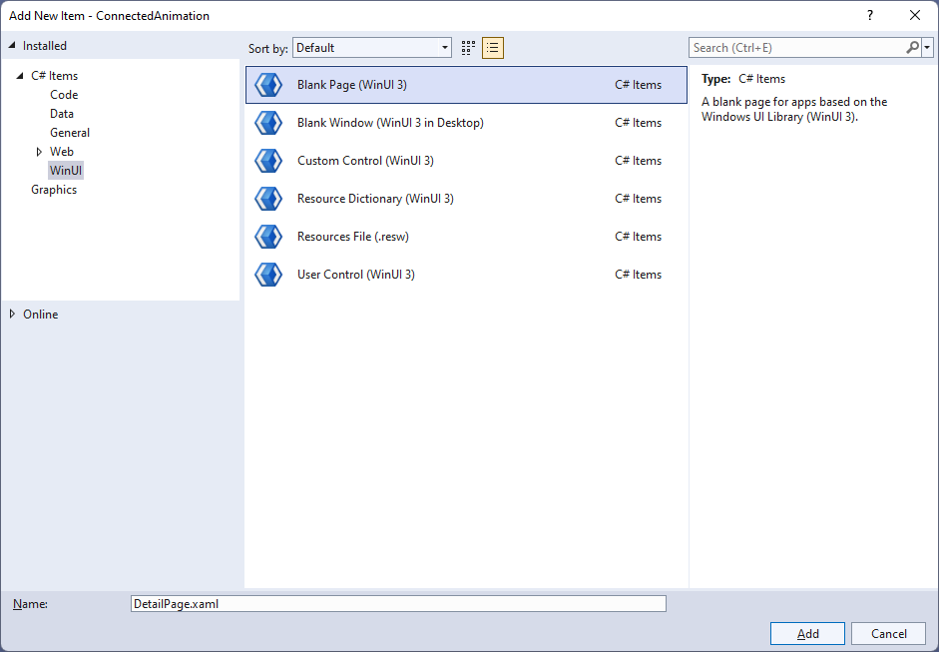

## Step 14

|  |  |
| --- | --- |
| Then from **Solution** **Explorer** for the **Solution** double-click on **DetailPage.xaml** to see the **XAML** for the **Detail Page**. |  |

## Step 15

Then in the **XAML** for **DetailPage.xaml** below **<Grid>** and above **</Grid>**, type in the following **XAML**:

<Rectangle Margin="50" Name="Target" Opacity="0" Loaded="Target_Loaded"/>

<CommandBar VerticalAlignment="Bottom">

<AppBarButton Icon="Back" Label="Back" Click="Back_Click"/>

</CommandBar>

There is **Rectangle** element of **Target** which has an **Event** for **Loaded** set to a **Method** of **Target_Loaded** along with an **AppBarButton** set to a **Method** of **Back_Click** which will be triggered when the **AppBarButton** is **Clicked**.

## Step 16

|  |  |
| --- | --- |
| Then, within **Solution** **Explorer** for the **Solution** select the arrow next to **DetailPage.xaml** then double-click on **DetailPage.xaml.cs** to see the **Code** for the **Detail Page**. |  |

## Step 17

In the **Code** for **DetailPage.xaml.cs** type in the following **Code** below the end of the **Constructor** of **public DetailPage() { ... }**:

protected override void OnNavigatedTo(NavigationEventArgs e)

{

Target.Fill = Library.GetBrush(e.Parameter);

}

protected override void OnNavigatingFrom(NavigatingCancelEventArgs e)

{

if (e.NavigationMode == NavigationMode.Back)

Library.From(Target);

base.OnNavigatingFrom(e);

}

private void Target_Loaded(object sender, RoutedEventArgs e)

{

Library.Loaded(Target);

}

private void Back_Click(object sender, RoutedEventArgs e)

{

Library.Frame.GoBack();

}

There is a **Method** for **OnNavigatedTo** that uses **override** to change the functionality of the **Method** for **OnNavigatedTo** which will set **Fill** for the **Rectangle** element of **Target** using the **Method** of **GetBrush** from the **Class** for **Library** there is also an **override** for **OnNavigatingFrom** which will call the **Method** for **From** in the **Class** for **Library** when navigating backwards. There is also a **Method** of **Target_Loaded** for when the **Rectangle** element of **Target** has loaded and there is the **Method** for when the **AppBarButton** is **Clicked** of **Back_Click** which calls the **Method** of **GoBack** for the **Frame** in the **Class** for **Library**.

## Step 18

|  |  |
| --- | --- |
| Then from **Solution** **Explorer** for the **Solution** double-click on **MainWindow.xaml** to see the **XAML** for the **Main Window**. |  |

## Step 19

In the **XAML** for **MainWindow.xaml** there be some **XAML** for a **StackPanel**, this should be **Removed** by removing the following:

<StackPanel Orientation="Horizontal"

HorizontalAlignment="Center" VerticalAlignment="Center">

<Button x:Name="myButton" Click="myButton_Click">Click Me</Button>

</StackPanel>

## Step 20

While still in the **XAML** for **MainWindow.xaml** above **</Window>**, type in the following **XAML** for a **Frame**:

<Frame Name="Frame"/>

## Step 21

|  |  |
| --- | --- |
| Then, within **Solution** **Explorer** for the **Solution** select the arrow next to **MainWindow.xaml** then double-click on **MainWindow.xaml.cs** to see the **Code** for the **Main Window**. |  |

## Step 22

In the **Code** for **MainWindow.xaml.cs** there be a **Method** of **myButton_Click(...)** this should be **Removed** by removing the following:

private void myButton_Click(object sender, RoutedEventArgs e)

{

myButton.Content = "Clicked";

}

## Step 23

Once **myButton_Click(...)** has been removed, within the **Constructor** of **public MainWindow() { ... }** and below the line of **this.InitializeComponent();** type in the following **Code**:

Library.Frame = Frame;

Library.Frame.Navigate(typeof(ContentPage));

The **Constructor** of **public MainWindow() { ... }** should look like the following:

public MainWindow()

{

this.InitializeComponent();

Library.Frame = Frame;

Library.Frame.Navigate(typeof(ContentPage));

}

These set up the **Property** for the **Frame** and call the **Method** for **Navigate** in the **class** of **Library**.

## Step 24

|  |  |
| --- | --- |
| That completes the **Windows App SDK** application. In **Visual Studio 2022** from the **Toolbar** select **ConnectedAnimation (Package)** to **Start** the application. |  |

## Step 25

Once running you should see the **Rectangle** elements.

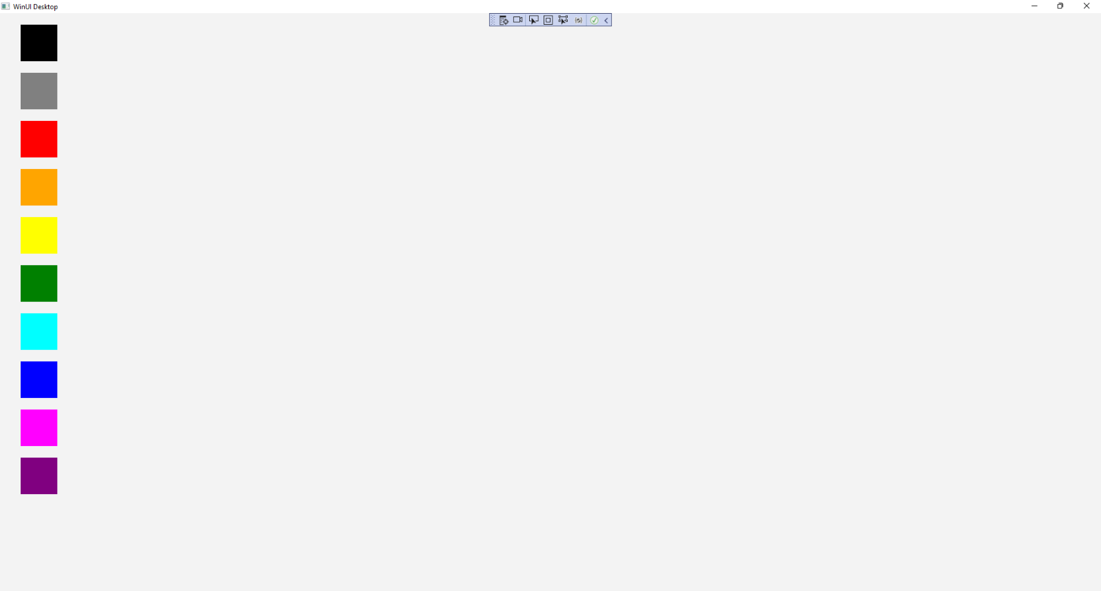

## Step 26

You can **Click** on any of the **Rectangle** elements to switch from the **Content Page** to the **Detail** **Page** and observe the **Connected Animation**.

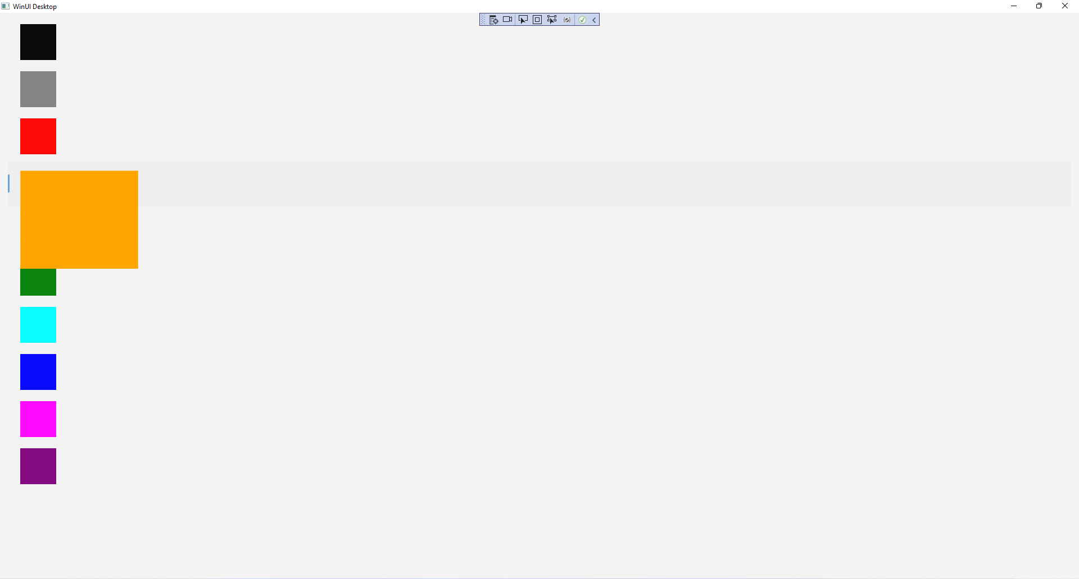

## Step 27

|  |  |
| --- | --- |
| To **Exit** the **Windows App SDK** application, select the **Close** button from the top right of the application as that concludes this **Tutorial** for **Windows App SDK** from [tutorialr.com](https://tutorialr.com)! |  |