

[](https://www.tutorialr.com/tutorials/)

Windows App SDK

Custom CheckBox





# Custom CheckBox

**Custom CheckBox** shows how to create a customised **Style** for a **CheckBox** using **Windows App SDK**

## Step 1

Follow **Setup and Start** on how to get **Setup** and **Install** what you need for **Visual Studio 2022** and **Windows App SDK**.

|  |  |
| --- | --- |
| In **Windows 11** choose **Start** and then find or search for **Visual Studio 2022** and then select it. |  |
| Once **Visual Studio 2022** has started select **Create a new project**. |  |
| Then choose the **Blank App, Packages (WinUI in Desktop)** and then select **Next**. |  |
| After that in **Configure your new project** type in the **Project name** as *CustomCheckBox*, then select a Location and then select **Create** to start a new **Solution**. |  |

## Step 2

|  |  |
| --- | --- |
| Then in **Visual Studio** within **Solution** **Explorer** for the **Solution** double-click on **App.xaml** to see the **XAML** for the **Project**. |  |

## Step 3

In the **XAML** for **App.xaml** below the **Comment** of **<!-- Other app resources here -->** type in the following **XAML**:

<Style x:Key="CustomCheckBox" TargetType="CheckBox">

<Setter Property="Background" Value="Transparent"/>

<Setter Property="Foreground"

Value="{ThemeResource SystemControlForegroundBaseHighBrush}"/>

<Setter Property="Padding" Value="5,5,0,0"/>

<Setter Property="HorizontalAlignment" Value="Left"/>

<Setter Property="VerticalAlignment" Value="Center"/>

<Setter Property="HorizontalContentAlignment" Value="Left"/>

<Setter Property="VerticalContentAlignment" Value="Top"/>

<Setter Property="FontFamily"

Value="{ThemeResource ContentControlThemeFontFamily}"/>

<Setter Property="FontSize"

Value="{ThemeResource ControlContentThemeFontSize}"/>

<Setter Property="UseSystemFocusVisuals" Value="True"/>

<Setter Property="Template">

<Setter.Value>

<ControlTemplate TargetType="CheckBox">

<Grid BorderBrush="{TemplateBinding BorderBrush}"

BorderThickness="{TemplateBinding BorderThickness}"

Background="{TemplateBinding Background}">

<Grid.ColumnDefinitions>

<ColumnDefinition Width="30"/>

<ColumnDefinition Width="*"/>

</Grid.ColumnDefinitions>

<!-- Visual State Groups -->

<!-- Content -->

</Grid>

</ControlTemplate>

</Setter.Value>

</Setter>

</Style>

This **XAML** is part of a **Style** of **CustomCheckBox** that will be used to target a **CheckBox** which will contain some **Visual State Groups** and **Content** for the **Custom CheckBox**.

## Step 4

While still in the **XAML** for **App.xaml** below the **Comment** of **<!-- Visual State Groups -->** type the following **XAML**:

<VisualStateManager.VisualStateGroups>

<VisualStateGroup x:Name="CombinedStates">

<VisualState x:Name="Unchecked">

<Storyboard>

<ObjectAnimationUsingKeyFrames

Storyboard.TargetProperty="Opacity"

Storyboard.TargetName="InnerRectangle">

<DiscreteObjectKeyFrame KeyTime="0" Value="0"/>

</ObjectAnimationUsingKeyFrames>

</Storyboard>

</VisualState>

<VisualState x:Name="Checked">

<Storyboard>

<ObjectAnimationUsingKeyFrames

Storyboard.TargetProperty="Opacity"

Storyboard.TargetName="InnerRectangle">

<DiscreteObjectKeyFrame KeyTime="0" Value="1"/>

</ObjectAnimationUsingKeyFrames>

</Storyboard>

</VisualState>

</VisualStateGroup>

</VisualStateManager.VisualStateGroups>

This **XAML** is for the **Visual State Groups** that will represent the **States** for the **CheckBox** including how it will behave when it is **Unchecked** and when it is **Checked** for the **Custom CheckBox**.

## Step 5

Then in the **XAML** for **App.xaml** below the **Comment** of **<!-- Content -->** type the following **XAML:**

<Grid>

<Rectangle x:Name="NormalRectangle"

Height="30" Width="30" RadiusY="10" RadiusX="10"

UseLayoutRounding="False" StrokeThickness="2"

Stroke="Salmon" Fill="LightSalmon"/>

<Rectangle x:Name="InnerRectangle" Height="20"

Width="20" RadiusY="4" RadiusX="4"

UseLayoutRounding="False" StrokeThickness="2"

Stroke="Goldenrod" Fill="Gold" Opacity="0"/>

</Grid>

<ContentPresenter x:Name="ContentPresenter" Grid.Column="1"

AutomationProperties.AccessibilityView="Raw"

ContentTemplate="{TemplateBinding ContentTemplate}"

ContentTransitions="{TemplateBinding ContentTransitions}"

Content="{TemplateBinding Content}"

HorizontalAlignment="{TemplateBinding HorizontalContentAlignment}"

Margin="{TemplateBinding Padding}" TextWrapping="Wrap"

VerticalAlignment="{TemplateBinding VerticalContentAlignment}"/>

This **XAML** is the **Content** for the layout of a **CheckBox** when the **Style** is applied for the **Custom CheckBox**.

## Step 6

|  |  |
| --- | --- |
| Within **Solution** **Explorer** for the **Solution** double-click on **MainWindow.xaml** to see the **XAML** for the **Main Window**. |  |

## Step 7

In the **XAML** for **MainWindow.xaml** there be some **XAML** for a **StackPanel**, this should be **Removed** by removing the following:

<StackPanel Orientation="Horizontal"

HorizontalAlignment="Center" VerticalAlignment="Center">

<Button x:Name="myButton" Click="myButton_Click">Click Me</Button>

</StackPanel>

## Step 8

While still in the **XAML** for **MainWindow.xaml** above **</Window>**, type in the following **XAML**:

<CheckBox HorizontalAlignment="Center" Content="CheckBox"

Style="{StaticResource CustomCheckBox}"/>

This **XAML** contains a **CheckBox** with **Style** set to the **StaticResource** of **CustomCheckBox** from **App.xaml**.

## Step 9

|  |  |
| --- | --- |
| Then, within **Solution** **Explorer** for the **Solution** select the arrow next to **MainWindow.xaml** then double-click on **MainWindow.xaml.cs** to see the **Code** for the **Main Window**. |  |

## Step 10

In the **Code** for **MainWindow.xaml.cs** there be a **Method** of **myButton_Click(...)** this should be **Removed** by removing the following:

private void myButton_Click(object sender, RoutedEventArgs e)

{

myButton.Content = "Clicked";

}

## Step 11

|  |  |
| --- | --- |
| That completes the **Windows App SDK** application. In **Visual Studio 2022** from the **Toolbar** select **CustomCheckBox (Package)** to **Start** the application. |  |

## Step 12

Once running you will see the **Custom Checkbox** displayed which you can then set to **Checked**.

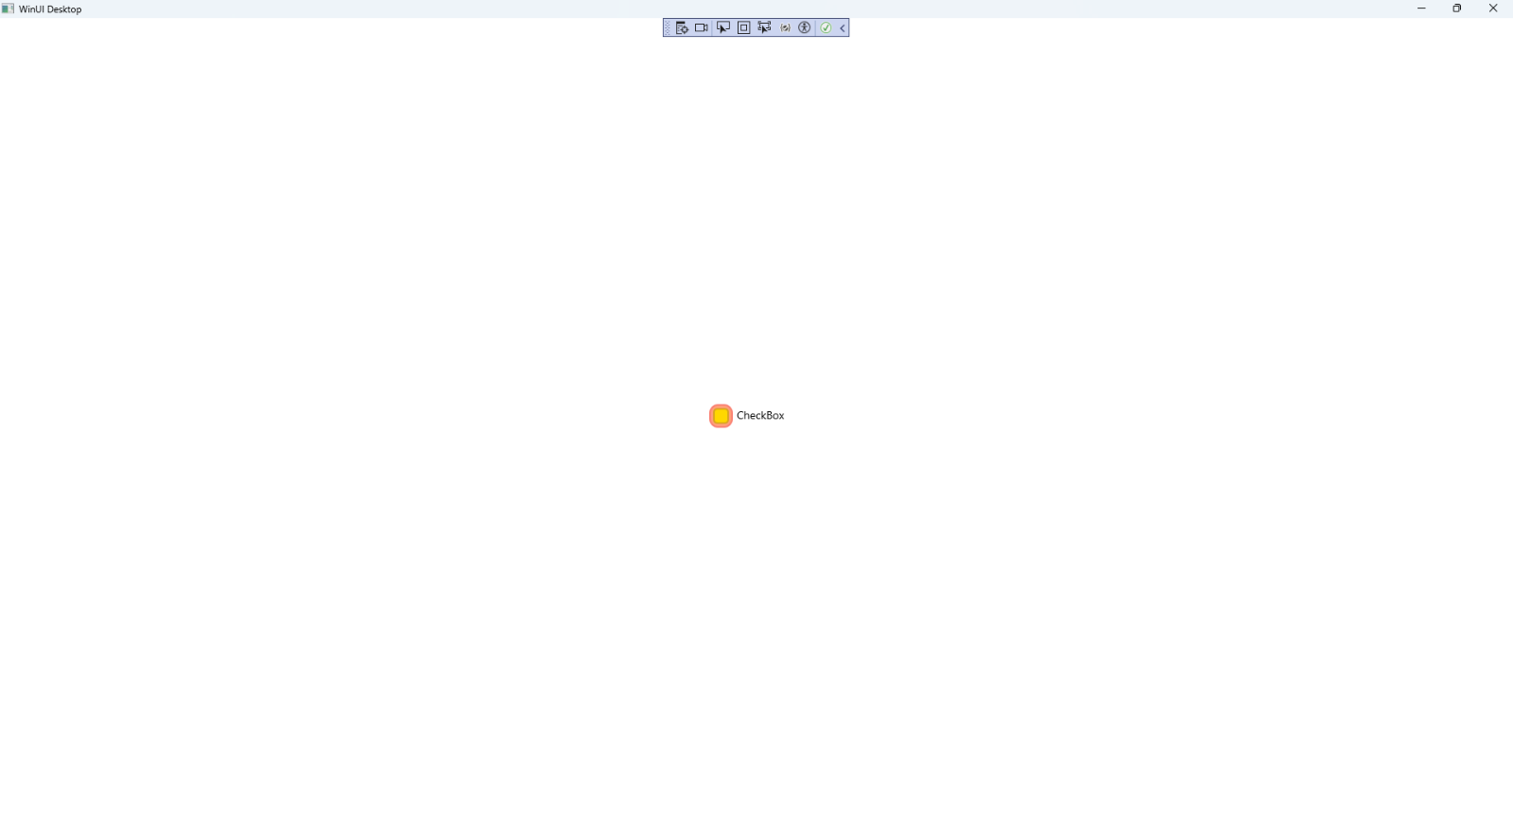

## Step 13

|  |  |
| --- | --- |
| To **Exit** the **Windows App SDK** application, select the **Close** button from the top right of the application as that concludes this **Tutorial** for **Windows App SDK** from [tutorialr.com](https://tutorialr.com)! |  |