

[](https://www.tutorialr.com/tutorials/)

Windows App SDK

Custom RatingControl





# Custom RatingControl

**Custom RatingControl** shows how to create a **Style** for a **RatingControl** using **Windows App SDK**

## Step 1

Follow **Setup and Start** on how to get **Setup** and **Install** what you need for **Visual Studio 2022** and **Windows App SDK**.

|  |  |
| --- | --- |
| In **Windows 11** choose **Start** and then find or search for **Visual Studio 2022** and then select it. |  |
| Once **Visual Studio 2022** has started select **Create a new project**. |  |
| Then choose the **Blank App, Packages (WinUI in Desktop)** and then select **Next**. |  |
| After that in **Configure your new project** type in the **Project name** as *CustomRatingControl*, then select a Location and then select **Create** to start a new **Solution**. |  |

## Step 2

|  |  |
| --- | --- |
| Then in **Visual Studio** within **Solution** **Explorer** for the **Solution** double-click on **App.xaml** to see the **XAML** for the **Project**. |  |

## Step 3

In the **XAML** for **App.xaml** below the **Comment** of **<!-- Other app resources here -->** type in the following **XAML**:

<RatingItemFontInfo x:Key="RatingControlFontInfo" Glyph="&#xE00B;"/>

<Style x:Key="CustomRatingControl" TargetType="RatingControl">

<Setter Property="Foreground"

Value="{ThemeResource RatingControlCaptionForeground}"/>

<Setter Property="UseSystemFocusVisuals"

Value="{StaticResource UseSystemFocusVisuals}"/>

<Setter Property="FontFamily"

Value="Segoe MDL2 Assets"/>

<Setter Property="ItemInfo"

Value="{StaticResource RatingControlFontInfo}"/>

<Setter Property="Template">

<Setter.Value>

<ControlTemplate TargetType="RatingControl">

<Grid x:Name="LayoutRoot">

<!-- Visual State Groups -->

<!-- Content -->

</Grid>

</ControlTemplate>

</Setter.Value>

</Setter>

</Style>

This **XAML** is part of a **Style** of **CustomRatingControl** that will be used to target a **RatingControl** which will contain some **Visual State Groups** and **Content** for the **Custom RatingControl** along with a **RatingItemFontInfo** which will set the **Glyph** will be used for the **Custom RatingControl**.

## Step 4

While still in the **XAML** for **App.xaml** below the **Comment** of **<!-- Visual State Groups -->** type the following **XAML**:

<VisualStateManager.VisualStateGroups>

<VisualStateGroup x:Name="CommonStates">

<VisualState x:Name="Disabled">

<VisualState.Setters>

<Setter Target="ForegroundContentPresenter.Foreground"

Value="{ThemeResource

RatingControlDisabledSelectedForeground}"/>

</VisualState.Setters>

</VisualState>

<VisualState x:Name="Placeholder">

<VisualState.Setters>

<Setter Target="ForegroundContentPresenter.Foreground"

Value="Goldenrod"/>

</VisualState.Setters>

</VisualState>

<VisualState x:Name="PointerOverPlaceholder">

<VisualState.Setters>

<Setter Target="ForegroundContentPresenter.Foreground"

Value="{ThemeResource

RatingControlPointerOverPlaceholderForeground}"/>

</VisualState.Setters>

</VisualState>

<VisualState x:Name="PointerOverUnselected">

<VisualState.Setters>

<Setter Target="ForegroundContentPresenter.Foreground"

Value="{ThemeResource

RatingControlPointerOverUnselectedForeground}"/>

</VisualState.Setters>

</VisualState>

<VisualState x:Name="Set">

<VisualState.Setters>

<Setter Target="ForegroundContentPresenter.Foreground"

Value="Salmon"/>

</VisualState.Setters>

</VisualState>

<VisualState x:Name="PointerOverSet">

<VisualState.Setters>

<Setter Target="ForegroundContentPresenter.Foreground"

Value="Gold"/>

</VisualState.Setters>

</VisualState>

</VisualStateGroup>

</VisualStateManager.VisualStateGroups>

This **XAML** is for the **Visual State Groups** that will represent the **States** for the **RatingControl** used in the **Custom RatingControl**.

## Step 5

Then in the **XAML** for **App.xaml** below the **Comment** of **<!-- Content -->** type the following **XAML:**

<StackPanel Margin="-20,-20,-20,-20" Orientation="Horizontal" Grid.Row="0">

<StackPanel x:Name="RatingBackgroundStackPanel"

Background="Transparent" Margin="20,20,0,20"

Orientation="Horizontal"/>

<TextBlock x:Name="Caption" AutomationProperties.AccessibilityView="Raw"

Height="32" IsHitTestVisible="False" Margin="4,9,20,0"

AutomationProperties.Name="RatingCaption"

Style="{ThemeResource CaptionTextBlockStyle}"

TextLineBounds="TrimToBaseline" Text="{TemplateBinding Caption}"

VerticalAlignment="Center"/>

</StackPanel>

<ContentPresenter x:Name="ForegroundContentPresenter"

IsHitTestVisible="False" Grid.Row="0">

<StackPanel Margin="-40,-40,-40,-40"

Orientation="Horizontal">

<StackPanel x:Name="RatingForegroundStackPanel"

IsHitTestVisible="False" Margin="40,40,40,40"

Orientation="Horizontal"/>

</StackPanel>

</ContentPresenter>

This **XAML** is the **Content** for the layout of a **RatingControl** when the **Style** is applied for the **Custom RatingControl**.

## Step 6

|  |  |
| --- | --- |
| Within **Solution** **Explorer** for the **Solution** double-click on **MainWindow.xaml** to see the **XAML** for the **Main Window**. |  |

## Step 7

In the **XAML** for **MainWindow.xaml** there be some **XAML** for a **StackPanel**, this should be **Removed** by removing the following:

<StackPanel Orientation="Horizontal"

HorizontalAlignment="Center" VerticalAlignment="Center">

<Button x:Name="myButton" Click="myButton_Click">Click Me</Button>

</StackPanel>

## Step 8

While still in the **XAML** for **MainWindow.xaml** above **</Window>**, type in the following **XAML**:

<Viewbox>

<RatingControl Margin="50" Name="Rating"

Style="{StaticResource CustomRatingControl}"/>

</Viewbox>

This **XAML** contains a **ViewBox** with a **RatingControl** with **Style** set to the **StaticResource** of **CustomRatingControl** from **App.xaml**.

## Step 9

|  |  |
| --- | --- |
| Then, within **Solution** **Explorer** for the **Solution** select the arrow next to **MainWindow.xaml** then double-click on **MainWindow.xaml.cs** to see the **Code** for the **Main Window**. |  |

## Step 10

In the **Code** for **MainWindow.xaml.cs** there be a **Method** of **myButton_Click(...)** this should be **Removed** by removing the following:

private void myButton_Click(object sender, RoutedEventArgs e)

{

myButton.Content = "Clicked";

}

## Step 11

|  |  |
| --- | --- |
| That completes the **Windows App SDK** application. In **Visual Studio 2022** from the **Toolbar** select **CustomRatingControl (Package)** to **Start** the application. |  |

## Step 12

Once running you will see the **Custom RatingControl** displayed where you can select a **Value**.

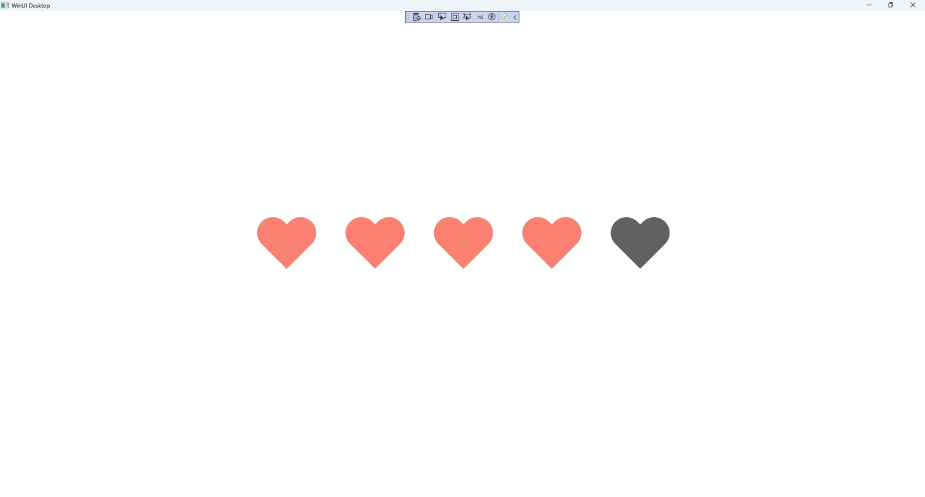

## Step 13

|  |  |
| --- | --- |
| To **Exit** the **Windows App SDK** application, select the **Close** button from the top right of the application as that concludes this **Tutorial** for **Windows App SDK** from [tutorialr.com](https://tutorialr.com)! |  |