

[](https://www.tutorialr.com/tutorials/)

Windows App SDK

Custom Slider





# Custom Slider

**Custom Slider** shows how to create a customised **Style** for a **Slider** using **Windows App SDK**

## Step 1

Follow **Setup and Start** on how to get **Setup** and **Install** what you need for **Visual Studio 2022** and **Windows App SDK**.

|  |  |
| --- | --- |
| In **Windows 11** choose **Start** and then find or search for **Visual Studio 2022** and then select it. |  |
| Once **Visual Studio 2022** has started select **Create a new project**. |  |
| Then choose the **Blank App, Packages (WinUI in Desktop)** and then select **Next**. |  |
| After that in **Configure your new project** type in the **Project name** as *CustomSlider*, then select a Location and then select **Create** to start a new **Solution**. |  |

## Step 2

|  |  |
| --- | --- |
| Then in **Visual Studio** within **Solution** **Explorer** for the **Solution** double-click on **App.xaml** to see the **XAML** for the **Project**. |  |

## Step 3

In the **XAML** for **App.xaml** below the **Comment** of **<!-- Other app resources here -->** type in the following **XAML**:

<Style x:Key="CustomSlider" TargetType="Slider">

<Setter Property="Background" Value="LightSalmon"/>

<Setter Property="BorderBrush" Value="Salmon"/>

<Setter Property="BorderThickness" Value="2"/>

<Setter Property="Foreground" Value="Gold"/>

<Setter Property="Template">

<Setter.Value>

<ControlTemplate TargetType="Slider">

<Grid Margin="{TemplateBinding Padding}">

<Grid.Resources>

<Style x:Key="SliderThumbStyle" TargetType="Thumb">

<Setter Property="BorderThickness" Value="2"/>

<Setter Property="BorderBrush" Value="Goldenrod"/>

<Setter Property="Foreground" Value="Gold"/>

<Setter Property="Template">

<Setter.Value>

<ControlTemplate TargetType="Thumb">

<Ellipse StrokeThickness="2"

Stroke="{TemplateBinding BorderBrush}"

Fill="{TemplateBinding Foreground}"/>

</ControlTemplate>

</Setter.Value>

</Setter>

</Style>

</Grid.Resources>

<Grid.RowDefinitions>

<RowDefinition Height="Auto"/>

<RowDefinition Height="*"/>

</Grid.RowDefinitions>

<Grid x:Name="SliderContainer"

Background="Transparent" Grid.Row="1">

<!-- Horizontal Template -->

<!-- Vertical Template -->

</Grid>

</Grid>

</ControlTemplate>

</Setter.Value>

</Setter>

</Style>

This **XAML** is part of a **Style** of **CustomSlider** that will be used to target a **Slider** which will contain a **Template** for when it is **Horizontal** or **Vertical** for the **Custom Slider**.

## Step 4

While still in the **XAML** for **App.xaml** below the **Comment** of **<!-- Horizontal Template -->** type the following **XAML**:

<Grid x:Name="HorizontalTemplate">

<Grid.ColumnDefinitions>

<ColumnDefinition Width="Auto"/>

<ColumnDefinition Width="Auto"/>

<ColumnDefinition Width="*"/>

</Grid.ColumnDefinitions>

<Grid.RowDefinitions>

<RowDefinition Height="17"/>

<RowDefinition Height="Auto"/>

<RowDefinition Height="17"/>

</Grid.RowDefinitions>

<Rectangle x:Name="HorizontalTrackRect"

Grid.ColumnSpan="3" Fill="{TemplateBinding Background}"

Grid.Row="1" Height="10" RadiusX="5" RadiusY="5"/>

<Rectangle x:Name="HorizontalDecreaseRect"

Fill="{TemplateBinding Background}"

Grid.Row="1" Height="10" RadiusX="5" RadiusY="5"/>

<Rectangle x:Name="HorizontalBorder"

Grid.ColumnSpan="3" Grid.Row="1"

Stroke="{TemplateBinding BorderBrush}"

StrokeThickness="{TemplateBinding BorderThickness}"

Height="10" RadiusX="5" RadiusY="5"/>

<Thumb x:Name="HorizontalThumb"

AutomationProperties.AccessibilityView="Raw"

Background="{ThemeResource SliderThumbBackgroundThemeBrush}"

Grid.Column="1" DataContext="{TemplateBinding Value}"

Grid.Row="1" Style="{StaticResource SliderThumbStyle}"

Height="25" Width="25"/>

</Grid>

This **XAML** is for the **Horizontal Template** when the **Slider** is **Horizontal** for the **Custom Slider**.

## Step 5

Then in the **XAML** for **App.xaml** below the **Comment** of **<!-- Vertical Template -->** type the following **XAML:**

<Grid x:Name="VerticalTemplate" Visibility="Collapsed">

<Grid.ColumnDefinitions>

<ColumnDefinition Width="17"/>

<ColumnDefinition Width="Auto"/>

<ColumnDefinition Width="17"/>

</Grid.ColumnDefinitions>

<Grid.RowDefinitions>

<RowDefinition Height="*"/>

<RowDefinition Height="Auto"/>

<RowDefinition Height="Auto"/>

</Grid.RowDefinitions>

<Rectangle x:Name="VerticalTrackRect" Grid.Column="1"

Fill="{TemplateBinding Background}" Grid.RowSpan="3"

Width="10" RadiusX="5" RadiusY="5"/>

<Rectangle x:Name="VerticalDecreaseRect" Grid.Column="1"

Fill="{TemplateBinding Background}" Grid.Row="2"/>

<Rectangle x:Name="VerticalBorder" Grid.RowSpan="3"

Grid.Column="1" Stroke="{TemplateBinding BorderBrush}"

StrokeThickness="{TemplateBinding BorderThickness}"

Width="10" RadiusX="5" RadiusY="5" />

<Thumb x:Name="VerticalThumb" AutomationProperties.AccessibilityView="Raw"

Background="{ThemeResource SliderThumbBackgroundThemeBrush}"

Grid.Column="1" DataContext="{TemplateBinding Value}" Grid.Row="1"

Style="{StaticResource SliderThumbStyle}" Height="25" Width="25"/>

</Grid>

This **XAML** is for the **Vertical Template** when the **Slider** is **Vertical** for the **Custom Slider**.

## Step 6

|  |  |
| --- | --- |
| Within **Solution** **Explorer** for the **Solution** double-click on **MainWindow.xaml** to see the **XAML** for the **Main Window**. |  |

## Step 7

In the **XAML** for **MainWindow.xaml** there be some **XAML** for a **StackPanel**, this should be **Removed** by removing the following:

<StackPanel Orientation="Horizontal"

HorizontalAlignment="Center" VerticalAlignment="Center">

<Button x:Name="myButton" Click="myButton_Click">Click Me</Button>

</StackPanel>

## Step 8

While still in the **XAML** for **MainWindow.xaml** above **</Window>**, type in the following **XAML**:

<Slider Margin="50" VerticalAlignment="Center"

Style="{StaticResource CustomSlider}"/>

This **XAML** contains a **Slider** with **Style** set to the **StaticResource** of **CustomSlider** from **App.xaml**.

## Step 9

|  |  |
| --- | --- |
| Then, within **Solution** **Explorer** for the **Solution** select the arrow next to **MainWindow.xaml** then double-click on **MainWindow.xaml.cs** to see the **Code** for the **Main Window**. |  |

## Step 10

In the **Code** for **MainWindow.xaml.cs** there be a **Method** of **myButton_Click(...)** this should be **Removed** by removing the following:

private void myButton_Click(object sender, RoutedEventArgs e)

{

myButton.Content = "Clicked";

}

## Step 11

|  |  |
| --- | --- |
| That completes the **Windows App SDK** application. In **Visual Studio 2022** from the **Toolbar** select **CustomSlider (Package)** to **Start** the application. |  |

## Step 12

Once running you will see the **Custom Slider** displayed.

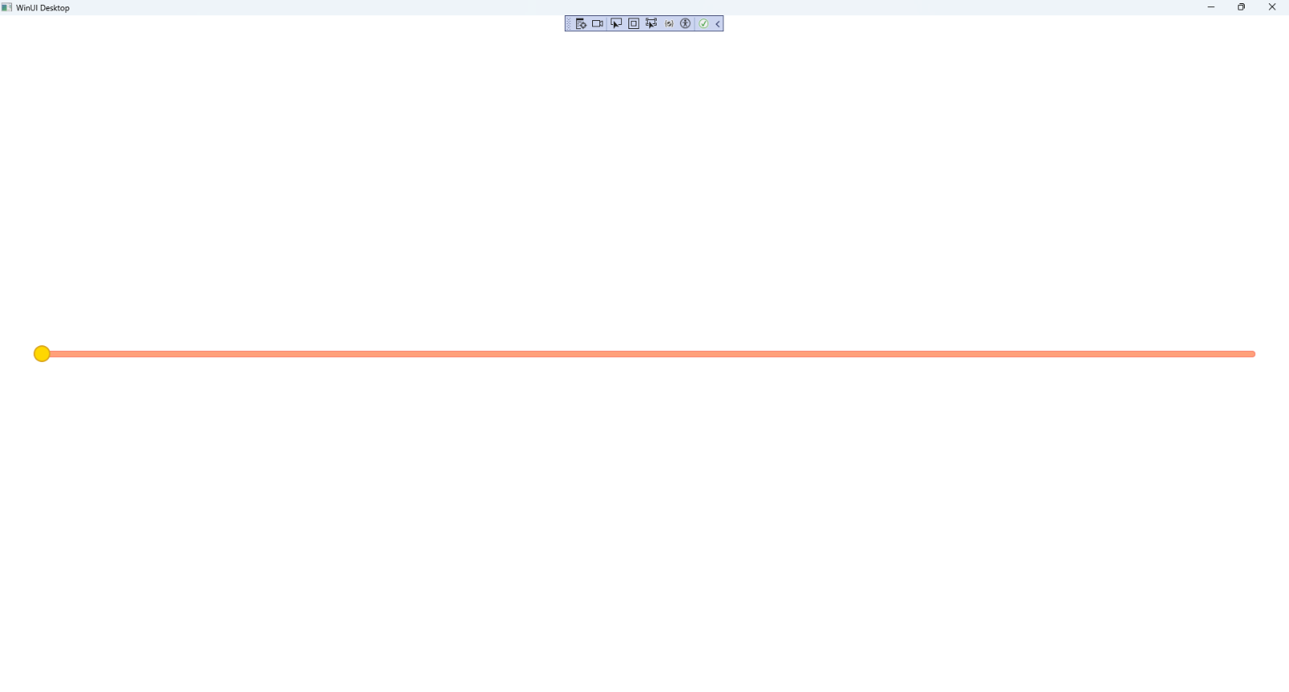

## Step 13

|  |  |
| --- | --- |
| To **Exit** the **Windows App SDK** application, select the **Close** button from the top right of the application as that concludes this **Tutorial** for **Windows App SDK** from [tutorialr.com](https://tutorialr.com)! |  |