

[](https://www.tutorialr.com/tutorials/)

Windows App SDK

Custom TextBox





# Custom TextBox

**Custom TextBox** shows how to create a **Style** for a **TextBox** using **Windows App SDK**

## Step 1

Follow **Setup and Start** on how to get **Setup** and **Install** what you need for **Visual Studio 2022** and **Windows App SDK**.

|  |  |
| --- | --- |
| In **Windows 11** choose **Start** and then find or search for **Visual Studio 2022** and then select it. |  |
| Once **Visual Studio 2022** has started select **Create a new project**. |  |
| Then choose the **Blank App, Packages (WinUI in Desktop)** and then select **Next**. |  |
| After that in **Configure your new project** type in the **Project name** as *CustomTextBox*, then select a Location and then select **Create** to start a new **Solution**. |  |

## Step 2

|  |  |
| --- | --- |
| Then in **Visual Studio** within **Solution** **Explorer** for the **Solution** double-click on **App.xaml** to see the **XAML** for the **Project**. |  |

## Step 3

In the **XAML** for **App.xaml** below the **Comment** of **<!-- Other app resources here -->** type in the following **XAML** for the **Style** of **CustomTextBox** that will be used to target a **TextBox**:

<Style x:Key="CustomTextBox" TargetType="TextBox">

<Setter Property="MinWidth"

Value="{ThemeResource TextControlThemeMinWidth}"/>

<Setter Property="MinHeight"

Value="{ThemeResource TextControlThemeMinHeight}"/>

<Setter Property="Foreground" Value="Gold"/>

<Setter Property="Background"

Value="{ThemeResource TextControlBackground}"/>

<Setter Property="SelectionHighlightColor"

Value="{ThemeResource TextControlSelectionHighlightColor}"/>

<Setter Property="BorderThickness" Value="2"/>

<Setter Property="FontFamily"

Value="{ThemeResource ContentControlThemeFontFamily}"/>

<Setter Property="FontSize"

Value="{ThemeResource ControlContentThemeFontSize}"/>

<Setter Property="ScrollViewer.HorizontalScrollMode" Value="Auto"/>

<Setter Property="ScrollViewer.VerticalScrollMode" Value="Auto"/>

<Setter Property="ScrollViewer.HorizontalScrollBarVisibility" Value="Hidden"/>

<Setter Property="ScrollViewer.VerticalScrollBarVisibility" Value="Hidden"/>

<Setter Property="ScrollViewer.IsDeferredScrollingEnabled" Value="False"/>

<Setter Property="Padding" Value="{ThemeResource TextControlThemePadding}"/>

<Setter Property="Template">

<Setter.Value>

<ControlTemplate TargetType="TextBox">

<Grid>

<Grid.ColumnDefinitions>

<ColumnDefinition Width="*"/>

<ColumnDefinition Width="Auto"/>

</Grid.ColumnDefinitions>

<Grid.RowDefinitions>

<RowDefinition Height="Auto"/>

<RowDefinition Height="*"/>

</Grid.RowDefinitions>

<VisualStateManager.VisualStateGroups>

<VisualStateGroup x:Name="CommonStates">

<!-- Visual State Disabled -->

<!-- Visual State Normal & Pointer Over -->

<!-- Visual State Focused -->

</VisualStateGroup>

</VisualStateManager.VisualStateGroups>

<!-- Content -->

</Grid>

</ControlTemplate>

</Setter.Value>

</Setter>

</Style>

## Step 4

While still in the **XAML** for **App.xaml** below the **Comment** of **<!-- Visual State Disabled -->** type the following **XAML**:

<VisualState x:Name="Disabled">

<Storyboard>

<ObjectAnimationUsingKeyFrames

Storyboard.TargetProperty="Foreground"

Storyboard.TargetName="HeaderContentPresenter">

<DiscreteObjectKeyFrame KeyTime="0"

Value="{ThemeResource TextControlHeaderForegroundDisabled}"/>

</ObjectAnimationUsingKeyFrames>

<ObjectAnimationUsingKeyFrames

Storyboard.TargetProperty="Background"

Storyboard.TargetName="BorderElement">

<DiscreteObjectKeyFrame KeyTime="0"

Value="{ThemeResource TextControlBackgroundDisabled}"/>

</ObjectAnimationUsingKeyFrames>

<ObjectAnimationUsingKeyFrames

Storyboard.TargetProperty="BorderBrush"

Storyboard.TargetName="BorderElement">

<DiscreteObjectKeyFrame KeyTime="0"

Value="{ThemeResource TextControlBorderBrushDisabled}"/>

</ObjectAnimationUsingKeyFrames>

<ObjectAnimationUsingKeyFrames

Storyboard.TargetProperty="Foreground"

Storyboard.TargetName="ContentElement">

<DiscreteObjectKeyFrame KeyTime="0"

Value="{ThemeResource TextControlForegroundDisabled}"/>

</ObjectAnimationUsingKeyFrames>

<ObjectAnimationUsingKeyFrames

Storyboard.TargetProperty="Foreground"

Storyboard.TargetName="PlaceholderTextContentPresenter">

<DiscreteObjectKeyFrame KeyTime="0"

Value="{ThemeResource TextControlPlaceholderForegroundDisabled}"/>

</ObjectAnimationUsingKeyFrames>

</Storyboard>

</VisualState>

This **XAML** is for the **Visual State** that will represent the **State** of **Disabled** for the **TextBox** used in the **Custom TextBox**.

## Step 5

While still in the **XAML** for **App.xaml** below the **Comment** of **<!-- Visual State Normal & Pointer Over -->** type the following **XAML**:

<VisualState x:Name="Normal"/>

<VisualState x:Name="PointerOver">

<Storyboard>

<ObjectAnimationUsingKeyFrames

Storyboard.TargetProperty="BorderBrush"

Storyboard.TargetName="BorderElement">

<DiscreteObjectKeyFrame KeyTime="0" Value="GoldenRod"/>

</ObjectAnimationUsingKeyFrames>

<ObjectAnimationUsingKeyFrames

Storyboard.TargetProperty="Background"

Storyboard.TargetName="BorderElement">

<DiscreteObjectKeyFrame KeyTime="0"

Value="{ThemeResource TextControlBackgroundPointerOver}"/>

</ObjectAnimationUsingKeyFrames>

<ObjectAnimationUsingKeyFrames

Storyboard.TargetProperty="Foreground"

Storyboard.TargetName="PlaceholderTextContentPresenter">

<DiscreteObjectKeyFrame KeyTime="0"

Value="{ThemeResource TextControlPlaceholderForegroundPointerOver}"/>

</ObjectAnimationUsingKeyFrames>

<ObjectAnimationUsingKeyFrames

Storyboard.TargetProperty="Foreground"

Storyboard.TargetName="ContentElement">

<DiscreteObjectKeyFrame KeyTime="0"

Value="{ThemeResource TextControlForegroundPointerOver}"/>

</ObjectAnimationUsingKeyFrames>

</Storyboard>

</VisualState>

This **XAML** is for the **Visual State** that will represent the **States** of **Normal** and **PointerOver** for the **TextBox** used in the **Custom TextBox**.

## Step 6

While still in the **XAML** for **App.xaml** below the **Comment** of **<!-- Visual State Focused -->** type the following **XAML**:

<VisualState x:Name="Focused">

<Storyboard>

<ObjectAnimationUsingKeyFrames

Storyboard.TargetProperty="Foreground"

Storyboard.TargetName="PlaceholderTextContentPresenter">

<DiscreteObjectKeyFrame KeyTime="0"

Value="{ThemeResource TextControlPlaceholderForegroundFocused}"/>

</ObjectAnimationUsingKeyFrames>

<ObjectAnimationUsingKeyFrames

Storyboard.TargetProperty="Background"

Storyboard.TargetName="BorderElement">

<DiscreteObjectKeyFrame KeyTime="0"

Value="{ThemeResource TextControlBackgroundFocused}"/>

</ObjectAnimationUsingKeyFrames>

<ObjectAnimationUsingKeyFrames

Storyboard.TargetProperty="BorderBrush"

Storyboard.TargetName="BorderElement">

<DiscreteObjectKeyFrame KeyTime="0" Value="Gold"/>

</ObjectAnimationUsingKeyFrames>

<ObjectAnimationUsingKeyFrames

Storyboard.TargetProperty="Foreground"

Storyboard.TargetName="ContentElement">

<DiscreteObjectKeyFrame KeyTime="0"

Value="{ThemeResource TextControlForegroundFocused}"/>

</ObjectAnimationUsingKeyFrames>

<ObjectAnimationUsingKeyFrames

Storyboard.TargetProperty="RequestedTheme"

Storyboard.TargetName="ContentElement">

<DiscreteObjectKeyFrame KeyTime="0" Value="Light"/>

</ObjectAnimationUsingKeyFrames>

</Storyboard>

</VisualState>

This **XAML** is for the **Visual State** that will represent the **State** of **Focused** for the **TextBox** used in the **Custom TextBox**.

## Step 7

Then in the **XAML** for **App.xaml** below the **Comment** of **<!-- Content -->** type the following **XAML:**

<Border x:Name="BorderElement" Grid.Row="1"

Grid.RowSpan="1" Grid.ColumnSpan="2" CornerRadius="15"

BorderBrush="Salmon" Background="LightSalmon"

BorderThickness="{TemplateBinding BorderThickness}" />

<ScrollViewer x:Name="ContentElement" Grid.Row="1"

AutomationProperties.AccessibilityView="Raw"

IsTabStop="False" ZoomMode="Disabled"

HorizontalScrollMode="{TemplateBinding

ScrollViewer.HorizontalScrollMode}"

HorizontalScrollBarVisibility="{TemplateBinding

ScrollViewer.HorizontalScrollBarVisibility}"

IsHorizontalRailEnabled="{TemplateBinding

ScrollViewer.IsHorizontalRailEnabled}"

IsVerticalRailEnabled="{TemplateBinding

ScrollViewer.IsVerticalRailEnabled}"

IsDeferredScrollingEnabled="{TemplateBinding

ScrollViewer.IsDeferredScrollingEnabled}"

Margin="{TemplateBinding BorderThickness}"

Padding="{TemplateBinding Padding}"

VerticalScrollBarVisibility="{TemplateBinding

ScrollViewer.VerticalScrollBarVisibility}"

VerticalScrollMode="{TemplateBinding

ScrollViewer.VerticalScrollMode}" />

<ContentPresenter x:Name="PlaceholderTextContentPresenter"

Grid.Row="1" Grid.ColumnSpan="2"

Content="{TemplateBinding PlaceholderText}"

Foreground="Gold" IsHitTestVisible="False"

Margin="{TemplateBinding BorderThickness}"

Padding="{TemplateBinding Padding}"

TextWrapping="{TemplateBinding TextWrapping}"/>

This **XAML** is the **Content** for the layout of a **TextBox** when the **Style** is applied for the **Custom TextBox**.

## Step 8

|  |  |
| --- | --- |
| Within **Solution** **Explorer** for the **Solution** double-click on **MainWindow.xaml** to see the **XAML** for the **Main Window**. |  |

## Step 9

In the **XAML** for **MainWindow.xaml** there be some **XAML** for a **StackPanel**, this should be **Removed** by removing the following:

<StackPanel Orientation="Horizontal"

HorizontalAlignment="Center" VerticalAlignment="Center">

<Button x:Name="myButton" Click="myButton_Click">Click Me</Button>

</StackPanel>

## Step 10

While still in the **XAML** for **MainWindow.xaml** above **</Window>**, type in the following **XAML**:

<TextBox Margin="50" Text="TextBox" VerticalAlignment="Center"

Style="{StaticResource CustomTextBox}"/>

This **XAML** contains a **TextBox** with **Style** set to the **StaticResource** of **CustomTextBox** from **App.xaml**.

## Step 11

|  |  |
| --- | --- |
| Then, within **Solution** **Explorer** for the **Solution** select the arrow next to **MainWindow.xaml** then double-click on **MainWindow.xaml.cs** to see the **Code** for the **Main Window**. |  |

## Step 12

In the **Code** for **MainWindow.xaml.cs** there be a **Method** of **myButton_Click(...)** this should be **Removed** by removing the following:

private void myButton_Click(object sender, RoutedEventArgs e)

{

myButton.Content = "Clicked";

}

## Step 13

|  |  |
| --- | --- |
| That completes the **Windows App SDK** application. In **Visual Studio 2022** from the **Toolbar** select **CustomTextBox (Package)** to **Start** the application. |  |

## Step 14

Once running you will see the **Custom TextBox** displayed.

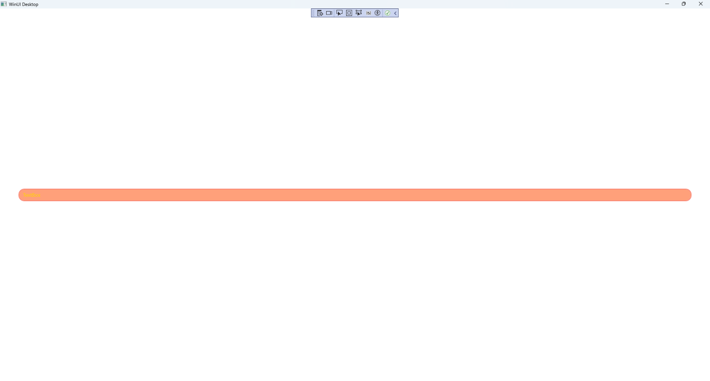

## Step 15

|  |  |
| --- | --- |
| To **Exit** the **Windows App SDK** application, select the **Close** button from the top right of the application as that concludes this **Tutorial** for **Windows App SDK** from [tutorialr.com](https://tutorialr.com)! |  |