

[](https://www.tutorialr.com/tutorials/)

Windows App SDK

Custom ToggleSwitch





# Custom ToggleSwitch

**Custom ToggleSwitch** shows how to create a customised **Style** for a **ToggleSwitch** using **Windows App SDK**

## Step 1

Follow **Setup and Start** on how to get **Setup** and **Install** what you need for **Visual Studio 2022** and **Windows App SDK**.

|  |  |
| --- | --- |
| In **Windows 11** choose **Start** and then find or search for **Visual Studio 2022** and then select it. |  |
| Once **Visual Studio 2022** has started select **Create a new project**. |  |
| Then choose the **Blank App, Packages (WinUI in Desktop)** and then select **Next**. |  |
| After that in **Configure your new project** type in the **Project name** as *CustomToggleSwitch*, then select a Location and then select **Create** to start a new **Solution**. |  |

## Step 2

|  |  |
| --- | --- |
| Then in **Visual Studio** within **Solution** **Explorer** for the **Solution** double-click on **App.xaml** to see the **XAML** for the **Project**. |  |

## Step 3

In the **XAML** for **App.xaml** below the **Comment** of **<!-- Other app resources here -->** type in the following **XAML**:

<Style x:Key="CustomToggleSwitch" TargetType="ToggleSwitch">

<Setter Property="Background" Value="LightSalmon"/>

<Setter Property="BorderBrush" Value="Salmon"/>

<Setter Property="Foreground" Value="Gold"/>

<Setter Property="ManipulationMode" Value="System,TranslateX"/>

<Setter Property="UseSystemFocusVisuals" Value="True"/>

<Setter Property="Template">

<Setter.Value>

<ControlTemplate TargetType="ToggleSwitch">

<Grid HorizontalAlignment="Center">

<VisualStateManager.VisualStateGroups>

<VisualStateGroup x:Name="ToggleStates">

<VisualStateGroup.Transitions>

<!-- Transitions -->

</VisualStateGroup.Transitions>

<!-- Visual States -->

</VisualStateGroup>

</VisualStateManager.VisualStateGroups>

<!-- Content -->

</Grid>

</ControlTemplate>

</Setter.Value>

</Setter>

</Style>

This **XAML** is part of a **Style** of **CustomToggleSwitch** that will be used to target a **ToggleSwitch** which will contain some **Transitions** and **Visual States** along with the **Content** for the **Custom ToggleSwitch**.

## Step 4

While still in the **XAML** for **App.xaml** below the **Comment** of **<!-- Transitions -->** type the following **XAML**:

<VisualTransition x:Name="DraggingToOnTransition"

From="Dragging" GeneratedDuration="0" To="On">

<Storyboard>

<RepositionThemeAnimation

FromHorizontalOffset="{Binding

TemplateSettings.KnobCurrentToOnOffset,

RelativeSource={RelativeSource Mode=TemplatedParent}}"

TargetName="SwitchKnob"/>

</Storyboard>

</VisualTransition>

<VisualTransition x:Name="DraggingToOffTransition"

From="Dragging" GeneratedDuration="0" To="Off">

<Storyboard>

<RepositionThemeAnimation

FromHorizontalOffset="{Binding

TemplateSettings.KnobCurrentToOffOffset,

RelativeSource={RelativeSource Mode=TemplatedParent}}"

TargetName="SwitchKnob"/>

</Storyboard>

</VisualTransition>

<VisualTransition x:Name="OnToOffTransition"

From="On" GeneratedDuration="0" To="Off">

<Storyboard>

<RepositionThemeAnimation FromHorizontalOffset="{Binding

TemplateSettings.KnobOnToOffOffset,

RelativeSource={RelativeSource Mode=TemplatedParent}}"

TargetName="SwitchKnob"/>

</Storyboard>

</VisualTransition>

<VisualTransition x:Name="OffToOnTransition"

From="Off" GeneratedDuration="0" To="On">

<Storyboard>

<RepositionThemeAnimation FromHorizontalOffset="{Binding

TemplateSettings.KnobOffToOnOffset,

RelativeSource={RelativeSource Mode=TemplatedParent}}"

TargetName="SwitchKnob"/>

</Storyboard>

</VisualTransition>

This **XAML** is for the **Transitions** between the **States** for the **ToggleSwitch** including how it will behave when it is either **Dragging** or **Switched** between **On** or **Off** for the **Custom** **ToggleSwitch**.

## Step 5

Next in the **XAML** for **App.xaml** below the **Comment** of **<!-- Visual States -->** type the following **XAML**:

<VisualState x:Name="Dragging"/>

<VisualState x:Name="Off"/>

<VisualState x:Name="On">

<Storyboard>

<DoubleAnimation Duration="0" To="24" Storyboard.TargetProperty="X"

Storyboard.TargetName="KnobTranslateTransform"/>

<ObjectAnimationUsingKeyFrames

Storyboard.TargetProperty="Opacity"

Storyboard.TargetName="SwitchKnobBounds">

<DiscreteObjectKeyFrame KeyTime="0" Value="1"/>

</ObjectAnimationUsingKeyFrames>

<ObjectAnimationUsingKeyFrames

Storyboard.TargetProperty="Opacity"

Storyboard.TargetName="SwitchKnobOn">

<DiscreteObjectKeyFrame KeyTime="0" Value="1"/>

</ObjectAnimationUsingKeyFrames>

<ObjectAnimationUsingKeyFrames

Storyboard.TargetProperty="Opacity"

Storyboard.TargetName="SwitchKnobOff">

<DiscreteObjectKeyFrame KeyTime="0" Value="0"/>

</ObjectAnimationUsingKeyFrames>

</Storyboard>

</VisualState>

This **XAML** is for the **Visual States** that will represent the **States** for the **ToggleSwitch** including how it will behave when it is **Off** and when it is **On** for the **Custom ToggleSwitch**.

## Step 6

Then in the **XAML** for **App.xaml** below the **Comment** of **<!-- Content -->** type the following **XAML:**

<Rectangle x:Name="OuterBorder"

Height="30" Width="55" RadiusY="15" RadiusX="15"

StrokeThickness="1" Stroke="{TemplateBinding BorderBrush}"

Fill="{TemplateBinding Background}"/>

<Rectangle x:Name="SwitchKnobBounds"

Height="30" Width="55" RadiusY="15" RadiusX="15"

StrokeThickness="1" Stroke="Goldenrod"

Fill="{TemplateBinding Foreground}" Opacity="0"/>

<Grid x:Name="SwitchKnob" Grid.Row="2"

HorizontalAlignment="Left"

Height="25" Width="30">

<Grid.RenderTransform>

<TranslateTransform x:Name="KnobTranslateTransform"/>

</Grid.RenderTransform>

<Ellipse x:Name="SwitchKnobOn"

Height="15" Width="15"

Fill="{TemplateBinding Background}" Opacity="0"/>

<Ellipse x:Name="SwitchKnobOff"

Height="15" Width="15"

Fill="{TemplateBinding Foreground}"/>

</Grid>

<Thumb x:Name="SwitchThumb"

AutomationProperties.AccessibilityView="Raw">

<Thumb.Template>

<ControlTemplate TargetType="Thumb">

<Rectangle Fill="Transparent"/>

</ControlTemplate>

</Thumb.Template>

</Thumb>

This **XAML** is the **Content** for the layout of a **ToggleSwitch** when the **Style** is applied for the **Custom ToggleSwitch**.

## Step 7

|  |  |
| --- | --- |
| Within **Solution** **Explorer** for the **Solution** double-click on **MainWindow.xaml** to see the **XAML** for the **Main Window**. |  |

## Step 8

In the **XAML** for **MainWindow.xaml** there be some **XAML** for a **StackPanel**, this should be **Removed** by removing the following:

<StackPanel Orientation="Horizontal"

HorizontalAlignment="Center" VerticalAlignment="Center">

<Button x:Name="myButton" Click="myButton_Click">Click Me</Button>

</StackPanel>

## Step 9

While still in the **XAML** for **MainWindow.xaml** above **</Window>**, type in the following **XAML**:

<ToggleSwitch HorizontalAlignment="Center"

Style="{StaticResource CustomToggleSwitch}"/>

This **XAML** contains a **ToggleSwitch** with **Style** set to the **StaticResource** of **CustomToggleSwitch** from **App.xaml**.

## Step 10

|  |  |
| --- | --- |
| Then, within **Solution** **Explorer** for the **Solution** select the arrow next to **MainWindow.xaml** then double-click on **MainWindow.xaml.cs** to see the **Code** for the **Main Window**. |  |

## Step 11

In the **Code** for **MainWindow.xaml.cs** there be a **Method** of **myButton_Click(...)** this should be **Removed** by removing the following:

private void myButton_Click(object sender, RoutedEventArgs e)

{

myButton.Content = "Clicked";

}

## Step 12

|  |  |
| --- | --- |
| That completes the **Windows App SDK** application. In **Visual Studio 2022** from the **Toolbar** select **CustomToggleSwitch (Package)** to **Start** the application. |  |

## Step 13

Once running you will see the **Custom ToggleSwitch** displayed which you can then set to **On**.

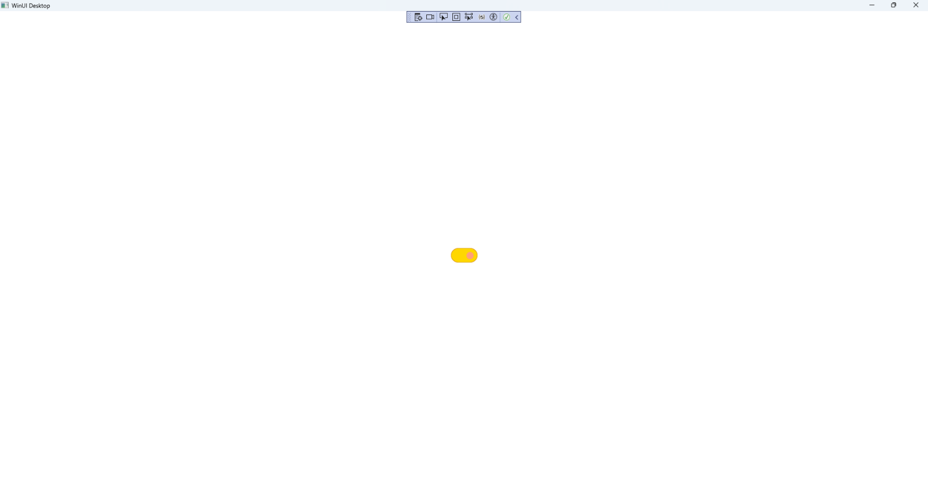

## Step 14

|  |  |
| --- | --- |
| To **Exit** the **Windows App SDK** application, select the **Close** button from the top right of the application as that concludes this **Tutorial** for **Windows App SDK** from [tutorialr.com](https://tutorialr.com)! |  |