

[](https://www.tutorialr.com/tutorials/)

Windows App SDK

Deal or Not





# Deal or Not

**Deal or Not** shows how you can create simple box-opening game where every so often you can choose to

accept a deal, or not and continue but risk winning a smaller amount, the last box will be the amount won,

unless you took the deal, using a toolkit from **NuGet** using the **Windows App SDK**.

## Step 1

Follow **Setup and Start** on how to get **Setup** and **Install** what you need for **Visual Studio 2022** and **Windows App SDK**.

|  |  |
| --- | --- |
| In **Windows 11** choose **Start** and then find or search for **Visual Studio 2022** and then select it. |  |
| Once **Visual Studio 2022** has started select **Create a new project**. |  |
| Then choose the **Blank App, Packages (WinUI in Desktop)** and then select **Next**. |  |
| After that in **Configure your new project** type in the **Project name** as *DealOrNot*, then select a Location and then select **Create** to start a new **Solution**. |  |

## Step 2

Then in **Visual Studio** within **Solution** **Explorer** for the **Solution**, right click on the **Project** shown below the **Solution** and then select **Manage NuGet Packages…**

## Step 3

Then in the **NuGet Package Manager** from the **Browse** tab search for **Comentsys.Toolkit.WindowsAppSdk** and then select **Comentsys.Toolkit.WindowsAppSdk by Comentsys** as indicated and select **Install**

This will add the package for **Comentsys.Toolkit.WindowsAppSdk** to your **Project**. If you get the **Preview Changes** screen saying **Visual Studio is about to make changes to this solution. Click OK to proceed with the changes listed below.** You can read the message and then select **OK** to **Install** the package,, then you can close the **tab** for **Nuget: DealOrNot** by selecting the **x** next to it.

## Step 4

Then in **Visual Studio** within **Solution** **Explorer** for the **Solution**, right click on the **Project** shown below the **Solution** and then select **Add** then **New Item…**

## Step 5

Then in **Add New Item** from the **C# Items** list, select **Code** and then select **Code File** from the list next to this, then type in the name of *Library.cs* and then **Click** on **Add**.

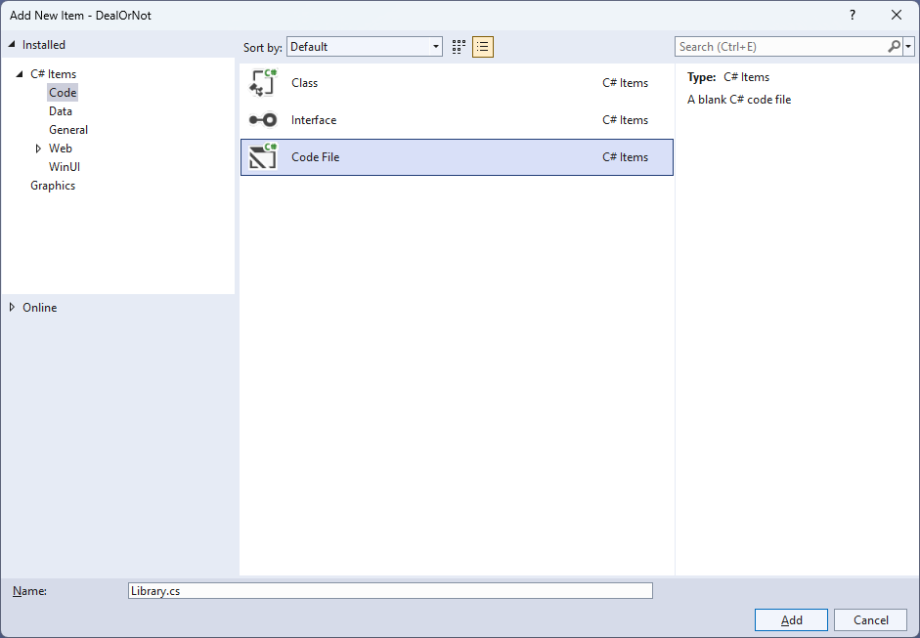

## Step 6

You will now be in the **View** for the **Code** of *Library.cs*, within this first type the following **Code**:

using Comentsys.Toolkit.WindowsAppSdk;

using Microsoft.UI;

using Microsoft.UI.Text;

using Microsoft.UI.Xaml;

using Microsoft.UI.Xaml.Controls;

using Microsoft.UI.Xaml.Media;

using Microsoft.UI.Xaml.Shapes;

using System;

using System.Collections.Generic;

using System.Globalization;

using System.Linq;

using Windows.UI;

public class Library

{

private const string title = "Deal or Not";

private const int rate = 5;

private static readonly double[] amounts =

{

0.01, 0.10, 0.50, 1, 5, 10, 50, 100, 250, 500, 750,

1000, 3000, 5000, 10000, 15000, 20000, 35000, 50000, 75000, 100000, 250000

};

private static readonly string[] colors =

{

"0026ff", "0039ff", "004dff", "0060ff", "0073ff", "0086ff",

"0099ff", "0099ff", "0099ff", "00acff", "00bfff",

"ff5900", "ff4d00", "ff4000", "ff3300", "ff2600", "ff2600",

"ff2600", "ff2600", "ff1a00", "ff1c00", "ff0d00",

};

private static readonly string[] names = {

"a", "b", "c", "d", "e", "f", "g", "h", "i", "j", "k",

"l", "m", "n", "o", "p", "q", "r", "s", "t", "u", "v"

};

private readonly Random _random = new((int)DateTime.UtcNow.Ticks);

private readonly List<double> _values = new();

private int _turn;

private bool _over;

private bool _dealt;

private double _amount;

private Dialog _dialog;

// Choose, Get Color, Get Background & Get Amount

// Get Offer & Select Box

// Add Box

// Add Row, Layout & New

}

**Class** defined so far *Library.cs* has **using** for packageof **Comentsys.Toolkit.WindowsAppSdk** and others.

## Step 7

Still in the **Class** for *Library.cs* after the **Comment** of **// Choose, Get Color, Get Background & Get Amount** type the following **Methods**:

private List<int> Choose(int minimum, int maximum, int total) =>

Enumerable.Range(minimum, maximum)

.OrderBy(r => _random.Next(minimum, maximum))

.Take(total).ToList();

private Color GetColor(string hex)

{

byte r = byte.Parse(hex[0..^4], NumberStyles.HexNumber);

byte g = byte.Parse(hex[2..^2], NumberStyles.HexNumber);

byte b = byte.Parse(hex[4..^0], NumberStyles.HexNumber);

return Color.FromArgb(255, r, g, b);

}

private Color GetBackground(double amount)

{

var position = Array.FindIndex(amounts, a => a.Equals(amount));

return GetColor(colors[position]);

}

private Grid GetAmount(double value, Color background)

{

Grid grid = new()

{

Background = new SolidColorBrush(background)

};

TextBlock text = new()

{

Text = string.Format(new CultureInfo("en-GB"), "{0:c}", value),

HorizontalAlignment = HorizontalAlignment.Center,

VerticalAlignment = VerticalAlignment.Center,

Foreground = new SolidColorBrush(Colors.White),

Margin = new Thickness(10),

FontSize = 33

};

grid.Children.Add(text);

return grid;

}

**Choose** is used to select a list of randomised numbers, **GetColor** is used to get a **Color** from the hex representation of the colour and **GetBackground** will use this to get the appropriate background colour based on the amount passed in. **GetAmount** will be used to display an amount with an appropriate colour.

## Step 8

While still in the **Class** for *Library.cs* after the **Comment** of **// Get Offer & Select Box** type in the following **Methods** for **GetOffer** to generate an offer and **SelectBox** used when picking a box.

private double GetOffer()

{

int count = 0;

double total = 0.0;

foreach (double value in _values)

{

total += value;

count++;

}

double average = total / count;

double offer = average * _turn / 10;

return Math.Round(offer, 0);

}

private async void SelectBox(Button button, string name)

{

if (!_over)

{

if (_turn < names.Length)

{

button.Opacity = 0;

_amount = _values[Array.IndexOf(names, name)];

bool response = await _dialog.ConfirmAsync(

GetAmount(_amount, GetBackground(_amount)));

if (response)

{

if (!_dealt && _turn % rate == 0 && _turn > 1)

{

double offer = GetOffer();

bool accept = await _dialog.ConfirmAsync(

GetAmount(offer, Colors.Black), "Deal", "Not");

if (accept)

{

_amount = offer;

_dealt = true;

}

}

_turn++;

}

}

if (_turn == names.Length || _dealt)

_over = true;

}

if (_over)

{

object content = _dealt ?

GetAmount(_amount, Colors.Black) :

GetAmount(_amount, GetBackground(_amount));

await _dialog.ConfirmAsync(content, "Game Over", null);

}

}

## Step 9

While still in the **Class** for *Library.cs* after the **Comment** of **// Add Box** type in the following **Method**:

private void AddBox(StackPanel panel, string name, int value)

{

Button button = new()

{

Name = $"box.{name}",

Margin = new Thickness(5)

};

button.Click += (object sender, RoutedEventArgs e) =>

SelectBox((Button)sender, name);

StackPanel box = new()

{

Width = 100

};

Rectangle lid = new()

{

Height = 10,

Fill = new SolidColorBrush(Colors.DarkRed)

};

Grid front = new()

{

Height = 75,

Background = new SolidColorBrush(Colors.Red)

};

Grid label = new()

{

Width = 50,

Background = new SolidColorBrush(Colors.White),

HorizontalAlignment = HorizontalAlignment.Center,

VerticalAlignment = VerticalAlignment.Center

};

TextBlock text = new()

{

TextAlignment = TextAlignment.Center,

FontWeight = FontWeights.Bold,

Foreground = new SolidColorBrush(Colors.Black),

FontSize = 32,

Text = value.ToString()

};

label.Children.Add(text);

front.Children.Add(label);

box.Children.Add(lid);

box.Children.Add(front);

button.Content = box;

panel.Children.Add(button);

}

**AddBox** is used to add a box that can be selected when **Clicked** to the game and give it a game-specific appearance using various elements to create the look-and-feel of the box that can be selected.

## Step 10

While still in the **Class** for *Library.cs* after the **Comment** of **// Add Row, Layout & New** type in the following **Methods** of **AddRow** which will add a row of boxes for the game, **Layout** which will create the look-and-feel for the game and **New** which will start a game.

private StackPanel AddRow()

{

int count = 0;

StackPanel panel = new();

int[] rows = { 5, 6, 6, 5 };

for (int r = 0; r < 4; r++)

{

StackPanel places = new()

{

Orientation = Orientation.Horizontal,

HorizontalAlignment = HorizontalAlignment.Center

};

for (int column = 0; column < rows[r]; column++)

{

AddBox(places, names[count], count + 1);

count++;

}

panel.Children.Add(places);

}

return panel;

}

private void Layout(Grid grid)

{

grid.Children.Clear();

Viewbox view = new()

{

Child = AddRow()

};

grid.Children.Add(view);

}

public void New(Grid grid)

{

_turn = 0;

_amount = 0;

_over = false;

_dealt = false;

_dialog = new Dialog(grid.XamlRoot, title);

var positions = Choose(0, names.Length, names.Length);

foreach (var position in positions)

{

_values.Add(amounts[position]);

}

Layout(grid);

}

## Step 11

|  |  |
| --- | --- |
| Then from **Solution** **Explorer** for the **Solution** double-click on **MainWindow.xaml** to see the **XAML** for the **Main Window**. |  |

## Step 12

In the **XAML** for **MainWindow.xaml** there be some **XAML** for a **StackPanel**, this should be **Removed** by removing the following:

<StackPanel Orientation="Horizontal"

HorizontalAlignment="Center" VerticalAlignment="Center">

<Button x:Name="myButton" Click="myButton_Click">Click Me</Button>

</StackPanel>

## Step 13

While still in the **XAML** for **MainWindow.xaml** above **</Window>**, type in the following **XAML**:

<Grid>

<Viewbox>

<Grid Margin="50" Name="Display"

HorizontalAlignment="Center"

VerticalAlignment="Center" Loaded="New"/>

</Viewbox>

<CommandBar VerticalAlignment="Bottom">

<AppBarButton Icon="Page2" Label="New" Click="New"/>

</CommandBar>

</Grid>

This **XAML** contains a **Grid** with a **Viewbox** which will scale a **Grid**. It has a **Loaded** event handler for **New** which is also shared by the **AppBarButton**.

## Step 14

|  |  |
| --- | --- |
| Then, within **Solution** **Explorer** for the **Solution** select the arrow next to **MainWindow.xaml** then double-click on **MainWindow.xaml.cs** to see the **Code** for the **Main Window**. |  |

## Step 15

In the **Code** for **MainWindow.xaml.cs** there be a **Method** of **myButton_Click(...)** this should be **Removed** by removing the following:

private void myButton_Click(object sender, RoutedEventArgs e)

{

myButton.Content = "Clicked";

}

## Step 16

Once **myButton_Click(...)** has been removed, type in the following **Code** below the end of the **Constructor** of **public MainWindow() { ... }**:

private readonly Library _library = new();

private void New(object sender, RoutedEventArgs e) =>

_library.New(Display);

Here an **Instance** of the **Class** of **Library** is created then below this is the **Method** of **New** that will be used with **Event Handler** from the **XAML**, this **Method** uses Arrow Syntax with the **=>** for an Expression Bodywhich is useful when a **Method** only has one line.

## Step 17

|  |  |
| --- | --- |
| That completes the **Windows App SDK** application. In **Visual Studio 2022** from the **Toolbar** select **DealOrNot (Package)** to **Start** the application. |  |

## Step 18

Once running you can then select one of the boxes and an amount will be displayed but each five turns, then you’ll have the chance to take a **Deal** or **Not** and can continue until there is just one box left, which you’ll win the amount, but if you took the **Deal** then you win that amount instead, or you can select *New*to start a new game.

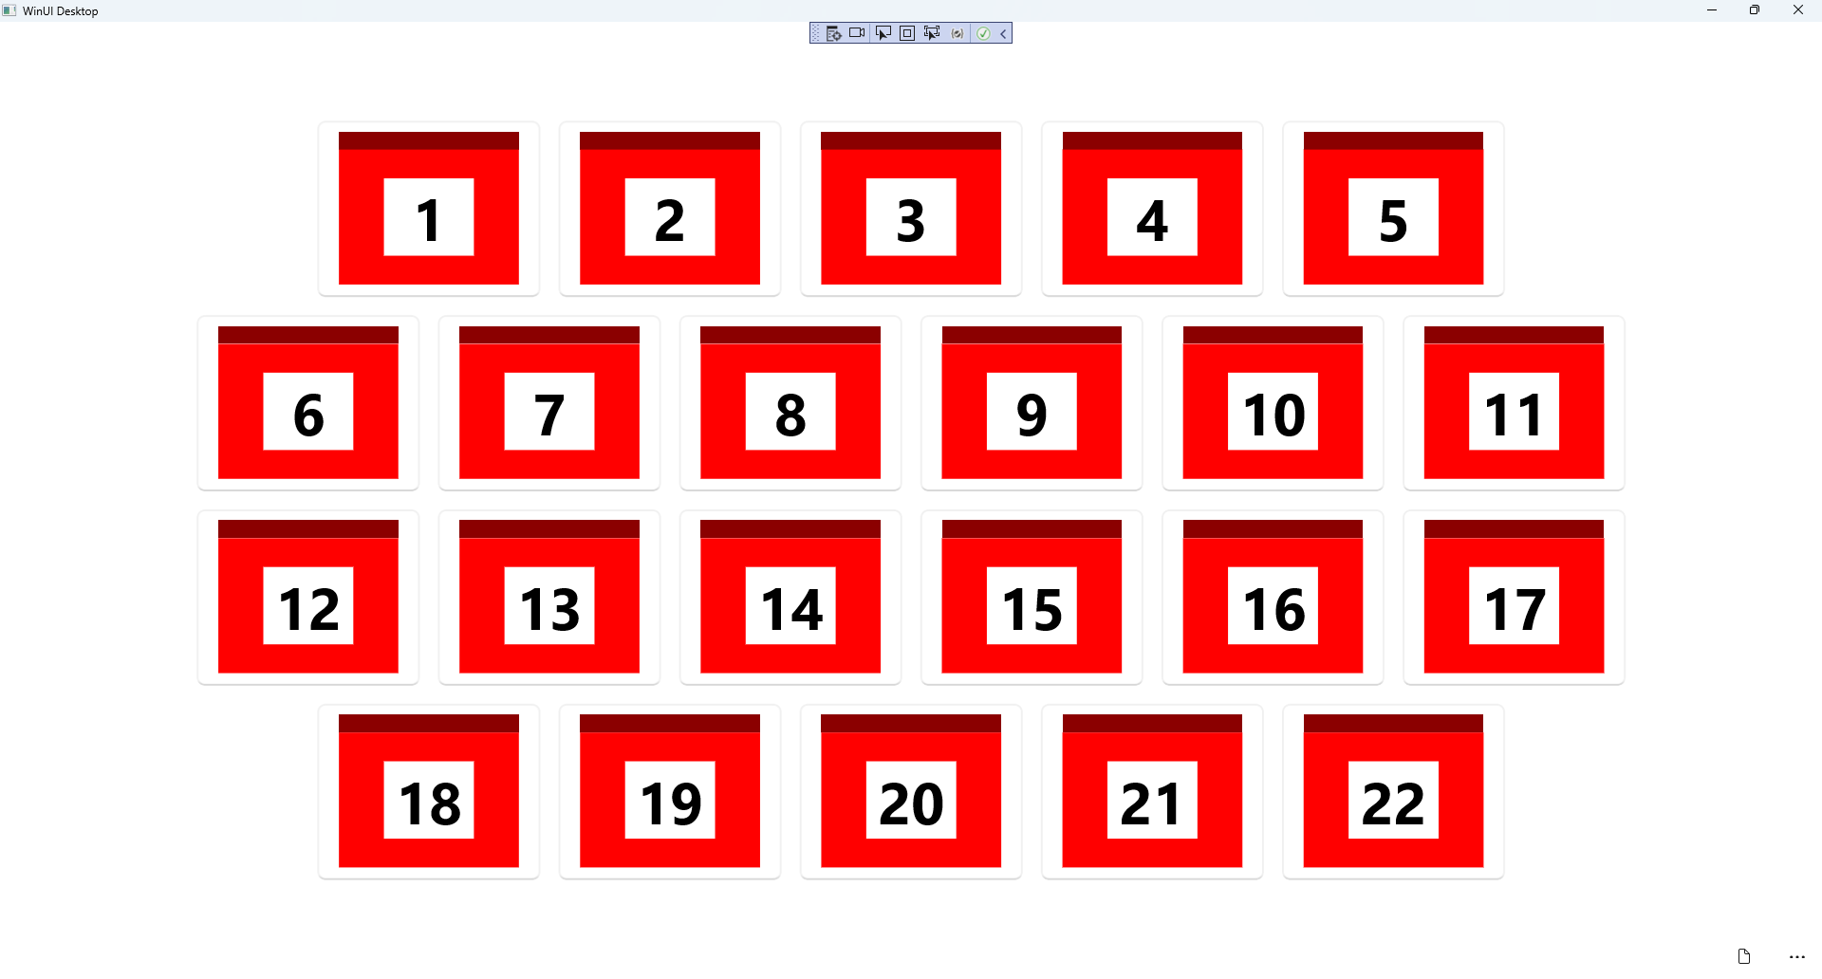

## Step 19

|  |  |
| --- | --- |
| To **Exit** the **Windows App SDK** application, select the **Close** button from the top right of the application as that concludes this **Tutorial** for **Windows App SDK** from [tutorialr.com](https://tutorialr.com)! |  |