

[](https://www.tutorialr.com/tutorials/)

Windows App SDK

Dipad Control





# Dipad Control

**Dipad Control** shows how to create a **Directional Pad** that can be used for selecting a **Direction** using **Windows App SDK**

## Step 1

Follow **Setup and Start** on how to get **Setup** and **Install** what you need for **Visual Studio 2022** and **Windows App SDK**.

|  |  |
| --- | --- |
| In **Windows 11** choose **Start** and then find or search for **Visual Studio 2022** and then select it. |  |
| Once **Visual Studio 2022** has started select **Create a new project**. |  |
| Then choose the **Blank App, Packages (WinUI in Desktop)** and then select **Next**. |  |
| After that in **Configure your new project** type in the **Project name** as *DipadControl*, then select a Location and then select **Create** to start a new **Solution**. |  |

## Step 2

Then in **Visual Studio** within **Solution** **Explorer** for the **Solution**, right click on the **Project** shown below the **Solution** and then select **Add** then **New Item…**

## Step 3

Then in **Add New Item** from the **C# Items** list, select **Code** and then select **Code File** from the list next to this, then type in the name of *Dipad.cs* and then **Click** on **Add**.

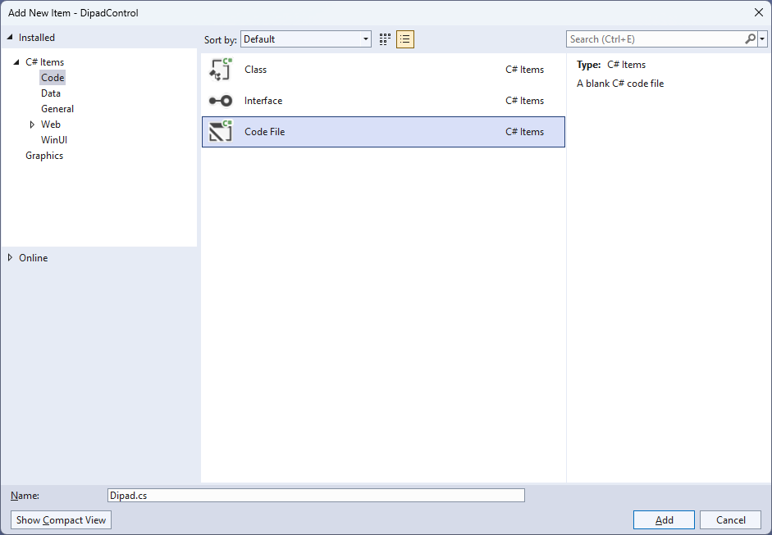

## Step 4

|  |  |
| --- | --- |
| Then from **Solution** **Explorer** for the **Solution** double-click on **Dipad.cs** to see the **Code** for the **User Control**. |  |

## Step 5

You will now be in the **View** for the **Code** of *Dipad.cs*, within this type in the following **Code**:

using Microsoft.UI.Input;

using Microsoft.UI.Xaml;

using Microsoft.UI.Xaml.Controls;

using Microsoft.UI.Xaml.Data;

using Microsoft.UI.Xaml.Input;

using Microsoft.UI.Xaml.Markup;

using Microsoft.UI.Xaml.Media;

using Microsoft.UI.Xaml.Shapes;

using System;

namespace DipadControl;

public enum DipadDirection

{

Up,

Down,

Left,

Right

}

public class Dipad : Grid

{

// Constants, Event, Dependency Property & Property

// GetPath & GetDirection Methods

// Add Method

// Constructor

}

There are **using** statements for the **User Control**, a **namespace** for **DipadControl** with an **enum** for the **Directions** along with a **class** of **Dipad** that will represent the **User Control** for the **Directional Pad**.

## Step 6

Then in the **namespace** of **DipadControl** in the **class** of **Dipad** after the **Comment** of **// Constants, Event, Dependency Property & Property** type the following **Constants**, **Event**, **Dependency Property** and **Property**:

private const int size = 3;

private const string path_up = "M 0,0 40,0 40,60 20,80 0,60 0,0 z";

private const string path_down = "M 0,20 20,0 40,20 40,80 0,80 z";

private const string path_left = "M 0,0 60,0 80,20 60,40 0,40 z";

private const string path_right = "M 0,20 20,0 80,0 80,40 20,40 z";

public delegate void DirectionEvent(object sender, DipadDirection direction);

public event DirectionEvent Direction;

public static readonly DependencyProperty ForegroundProperty =

DependencyProperty.Register(nameof(Foreground), typeof(Brush),

typeof(Dipad), null);

public Brush Foreground

{

get { return (Brush)GetValue(ForegroundProperty); }

set { SetValue(ForegroundProperty, value); }

}

**Constants** include the **Paths** needed to represent the different directional parts of the **Directional Pad** and there is also a **delegate** along with an **event** for when a particular direction of the **Directional Pad** is interacted with. There is also a **Dependency Property** and **Property** for the **Foreground** of the **Directional Pad**.

## Step 7

While still in the **namespace** of **DipadControl** in the **class** of **Dipad** after the **Comment** of **// GetPath & GetDirection Methods** type the following **Methods**:

private static Path GetPath(string value) =>

(Path)XamlReader.Load(

@$"<Path xmlns='http://schemas.microsoft.com/winfx/2006/xaml/presentation'>

<Path.Data>{value}</Path.Data>

</Path>");

private void GetDirection(object sender, PointerRoutedEventArgs e)

{

var path = (Path)sender;

var point = e.GetCurrentPoint(this);

bool fire = (e.Pointer.PointerDeviceType == PointerDeviceType.Mouse) ?

point.Properties.IsLeftButtonPressed : point.IsInContact;

if (fire)

{

Direction?.Invoke(path, (DipadDirection)

Enum.Parse(typeof(DipadDirection), path.Name));

}

}

The **Method** of **GetPath** will be used to obtain a **Path** from the **Constants** defined earlier and **GetDirection** will determine if the **Directional Pad** has been interacted with and for which **Direction**.

## Step 8

While still in the **namespace** of **DipadControl** in the **class** of **Dipad** after the **Comment** of **// Add Method** type the following **Method**:

private void Add(Grid grid,

DipadDirection direction, string value,

int row, int column,

int? rowspan, int? columnspan,

VerticalAlignment? vertical = null,

HorizontalAlignment? horizontal = null)

{

var path = GetPath(value);

path.Margin = new Thickness(5);

path.Name = direction.ToString();

if (vertical != null)

path.VerticalAlignment = vertical.Value;

if (horizontal != null)

path.HorizontalAlignment = horizontal.Value;

path.SetBinding(Shape.FillProperty, new Binding()

{

Path = new PropertyPath(nameof(Foreground)),

Mode = BindingMode.TwoWay,

Source = this

});

path.PointerPressed += GetDirection;

path.PointerMoved += GetDirection;

path.SetValue(RowProperty, row);

path.SetValue(ColumnProperty, column);

if (rowspan != null)

path.SetValue(RowSpanProperty, rowspan);

if (columnspan != null)

path.SetValue(ColumnSpanProperty, columnspan);

grid.Children.Add(path);

}

**Add** will be used to add items to the **Directional Pad** for each of the **Directions** along with **Binding** the **Shape** that uses a **Path** with the **Property** of **Foreground** for the **User Control**.

## Step 9

While still in the **namespace** of **DipadControl** in the **class** of **Dipad** after the **Comment** of **// Constructor** type the following **Constructor**:

public Dipad()

{

var grid = new Grid()

{

Height = 180,

Width = 180

};

grid.Children.Clear();

grid.ColumnDefinitions.Clear();

grid.RowDefinitions.Clear();

for (int index = 0; index < size; index++)

{

grid.RowDefinitions.Add(new RowDefinition()

{

Height = (index == 1) ? GridLength.Auto :

new GridLength(100, GridUnitType.Star)

});

grid.ColumnDefinitions.Add(new ColumnDefinition()

{

Width = (index == 1) ? GridLength.Auto :

new GridLength(100, GridUnitType.Star)

});

}

Add(grid, DipadDirection.Up, path_up, 0, 1, 2, null,

VerticalAlignment.Top, null);

Add(grid, DipadDirection.Down, path_down, 1, 1, 2, null,

VerticalAlignment.Bottom, null);

Add(grid, DipadDirection.Left, path_left, 1, 0, null, 2, null,

HorizontalAlignment.Left);

Add(grid, DipadDirection.Right, path_right, 1, 1, null, 2, null,

HorizontalAlignment.Right);

var box = new Viewbox()

{

Child = grid

};

Children.Add(box);

}

The **Constructor** will be used to create the look-and-feel of the **User Control** and will use the **Method** of **Add** for each of the **Directions** needed to be displayed for the **Directional Pad**.

## Step 10

|  |  |
| --- | --- |
| Within **Solution** **Explorer** for the **Solution** double-click on **MainWindow.xaml** to see the **XAML** for the **Main Window**. |  |

## Step 11

In the **XAML** for **MainWindow.xaml** there be some **XAML** for a **StackPanel**, this should be **Removed** by removing the following:

<StackPanel Orientation="Horizontal"

HorizontalAlignment="Center" VerticalAlignment="Center">

<Button x:Name="myButton" Click="myButton_Click">Click Me</Button>

</StackPanel>

## Step 12

While still in the **XAML** for **MainWindow.xaml** above **</Window>**, type in the following **XAML**:

<StackPanel Margin="50" VerticalAlignment="Center" HorizontalAlignment="Center">

<TextBlock Name="Label" HorizontalAlignment="Center"

Style="{StaticResource SubtitleTextBlockStyle}"/>

<local:Dipad x:Name="Pad" Height="400" Width="400"

Foreground="{ThemeResource AccentButtonBackground}"

Direction="Direction"/>

</StackPanel>

This **XAML** contains a **StackPanel** including a **TextBlock** and the **User Control** of **Dipad** with the **Event** of **Direction**.

## Step 13

|  |  |
| --- | --- |
| Then, within **Solution** **Explorer** for the **Solution** select the arrow next to **MainWindow.xaml** then double-click on **MainWindow.xaml.cs** to see the **Code** for the **Main Window**. |  |

## Step 14

In the **Code** for **MainWindow.xaml.cs** there be a **Method** of **myButton_Click(...)** this should be **Removed** by removing the following:

private void myButton_Click(object sender, RoutedEventArgs e)

{

myButton.Content = "Clicked";

}

## Step 15

Once **myButton_Click(...)** has been removed, type in the following **Code** below the end of the **Constructor** of **public MainWindow() { ... }**:

private void Direction(object sender, DipadDirection direction) =>

Label.Text = direction.ToString();

The **Method** of **Direction** will be used with **Event Handler** from the **XAML** to display the selected **Direction**. This **Method** uses Arrow Syntax with the **=>** for an Expression Bodywhich is useful when a **Method** only has one line.

## Step 16

|  |  |
| --- | --- |
| That completes the **Windows App SDK** application. In **Visual Studio 2022** from the **Toolbar** select **DipadControl (Package)** to **Start** the application. |  |

## Step 17

Once running you will see the **Dipad Control** displayed, then you can select the parts of the **Directional Pad** for *Up*, *Down*, *Left* and *Right*.

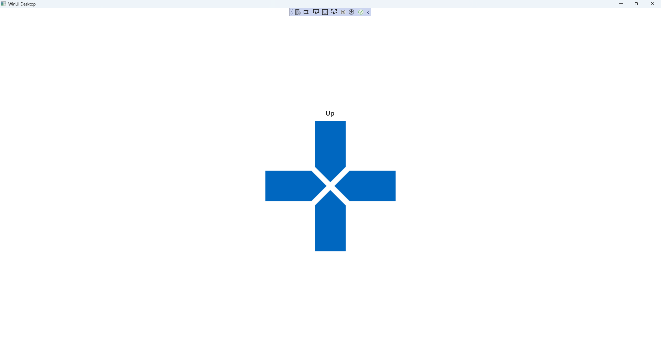

## Step 18

|  |  |
| --- | --- |
| To **Exit** the **Windows App SDK** application, select the **Close** button from the top right of the application as that concludes this **Tutorial** for **Windows App SDK** from [tutorialr.com](https://tutorialr.com)! |  |