

[](https://www.tutorialr.com/tutorials/)

Windows App SDK

Donut Control





# Donut Control

**Donut Control** shows how to create a **Control** that displays values in the form of a **Donut Chart**, which is

like a **Pie Chart** but with a hole in the middle using a toolkit from **NuGet** using the **Windows App SDK**.

## Step 1

Follow **Setup and Start** on how to get **Setup** and **Install** what you need for **Visual Studio 2022** and **Windows App SDK**.

|  |  |
| --- | --- |
| In **Windows 11** choose **Start** and then find or search for **Visual Studio 2022** and then select it. |  |
| Once **Visual Studio 2022** has started select **Create a new project**. |  |
| Then choose the **Blank App, Packages (WinUI in Desktop)** and then select **Next**. |  |
| After that in **Configure your new project** type in the **Project name** as *DonutControl*, then select a Location and then select **Create** to start a new **Solution**. |  |

## Step 2

Then in **Visual Studio** within **Solution** **Explorer** for the **Solution**, right click on the **Project** shown below the **Solution** and then select **Manage NuGet Packages…**

## Step 3

Then in the **NuGet Package Manager** from the **Browse** tab search for **Comentsys.Toolkit.WindowsAppSdk** and then select **Comentsys.Toolkit.WindowsAppSdk by Comentsys** as indicated and select **Install**

This will add the package for **Comentsys.Toolkit.WindowsAppSdk** to your **Project**. If you get the **Preview Changes** screen saying **Visual Studio is about to make changes to this solution. Click OK to proceed with the changes listed below.** You can read the message and then select **OK** to **Install** the package, then you can close the **tab** for **Nuget: DonutControl** by selecting the **x** next to it.

## Step 4

Then in **Visual Studio** within **Solution** **Explorer** for the **Solution**, right click on the **Project** shown below the **Solution** and then select **Add** then **New Item…**

## Step 5

Then in **Add New Item** from the **C# Items** list, select **Code** and then select **Code File** from the list next to this, then type in the name of *Library.cs* and then **Click** on **Add**.

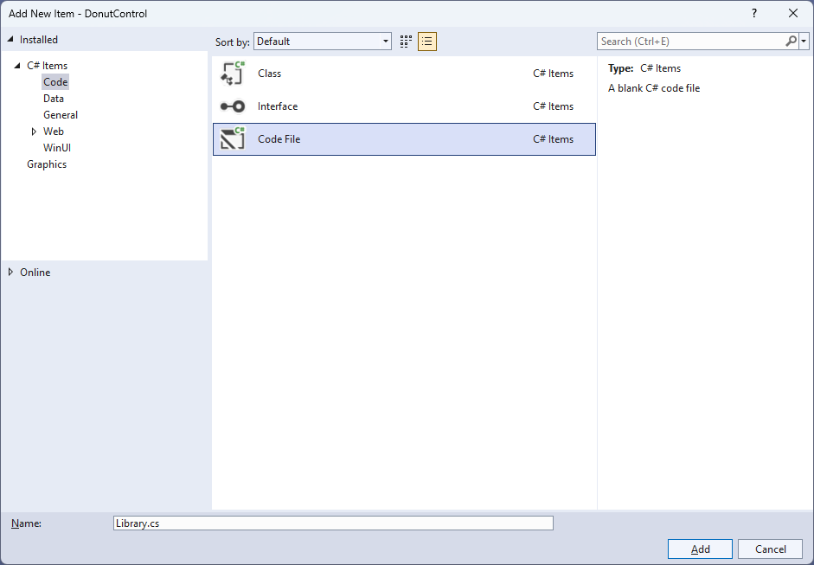

## Step 6

You will now be in the **View** for the **Code** of *Library.cs* and then you need to type the following **Code**:

using Comentsys.Toolkit.WindowsAppSdk;

using Microsoft.UI;

using Microsoft.UI.Xaml;

using Microsoft.UI.Xaml.Controls;

using Microsoft.UI.Xaml.Media;

using System.Collections.Generic;

using System.Linq;

using Windows.UI;

namespace DonutControl;

public class Donut : Grid

{

private const double total = 100;

private const double circle = 360;

private List<double> _items = new();

// Donut GetSector & Percentages Method

// Donut Layout Method

// Donut Properties

}

public class Library

{

private readonly List<Color> _colours = new()

{

Colors.Black,

Colors.Gray,

Colors.Red,

Colors.Orange,

Colors.Yellow,

Colors.Green,

Colors.Cyan,

Colors.Blue,

Colors.Magenta,

Colors.Purple

};

// Library Methods

}

*Library.cs* defines a **namespace** which allows classes to be defined together, usually each is separate but will be defined in *Library.cs* along with adding **using** statements such as for the package of **Comentsys.Toolkit.WindowsAppSdk**.

## Step 7

While still in the **namespace** of **DonutControl** in *Library.cs* and in the **class** of **Donut** after the **Comment** of **// Donut GetSector & Percentages Method** type the following **Methods**:

private static Sector GetSector(double size, double start,

double finish, double radius, double hole, Color fill)

{

Sector sector = new()

{

Hole = hole,

Start = start,

Finish = finish,

Radius = radius,

Fill = new SolidColorBrush(fill),

Stroke = new SolidColorBrush(Colors.WhiteSmoke)

};

Canvas.SetLeft(sector, (size - radius * 2) / 2);

Canvas.SetTop(sector, (size - radius * 2) / 2);

return sector;

}

private List<double> Percentages()

{

List<double> results = new();

double total = _items.Sum();

foreach (double item in _items)

{

results.Add(item / total * 100);

}

return results.OrderBy(o => o).ToList();

}

**GetSector** is used to obtain a **Sector** from **Comentsys.Toolkit.WindowsAppSdk** and then set the values for this along with positioning it on a **Canvas** and **Percentages** is used to get the values as a set of percentages to be displayed in the **Control**.

## Step 8

While still in the **namespace** of **DonutControl** in *Library.cs* and in the **class** of **Donut** after the **Comment** of **// Donut Layout Method** type the following **Method**:

internal void Layout()

{

double finish = 0;

double value = circle / total;

List<double> percentages = Percentages();

Canvas canvas = new()

{

Width = Radius * 2,

Height = Radius * 2

};

Children.Clear();

for (int index = 0; index < percentages.Count; index++)

{

double start = finish;

double percentage = percentages[index];

Color colour = (index < Palette.Count) ? Palette[index] : Colors.Black;

double sweep = value * percentage;

finish = sweep + start;

if (finish >= 360)

finish = sweep;

Sector sector = GetSector(Radius * 2, start, finish, Radius, Hole, colour);

canvas.Children.Add(sector);

}

Viewbox viewbox = new()

{

Child = canvas

};

Children.Add(viewbox);

}

**Layout** uses **Percentages** to get the values to be used then builds up the **Control** by using **GetSector** and will use **Properties** that will be defined in the next **Step**.

## Step 9

While still in the **namespace** of **DonutControl** in *Library.cs* and in the **class** of **Donut** after the **Comment** of **// Donut Properties** type the following **Properties**:

public List<Color> Palette { get; set; } = new();

public List<double> Items

{

get { return _items; }

set { _items = value; Layout(); }

}

public static readonly DependencyProperty RadiusProperty =

DependencyProperty.Register("Radius", typeof(int),

typeof(Donut), new PropertyMetadata(100, new PropertyChangedCallback(

(DependencyObject obj, DependencyPropertyChangedEventArgs eventArgs) =>

{

((Donut)obj).Layout();

})));

public static readonly DependencyProperty HoleProperty =

DependencyProperty.Register("Hole", typeof(UIElement),

typeof(Donut), new PropertyMetadata(50.0, new PropertyChangedCallback(

(DependencyObject obj, DependencyPropertyChangedEventArgs eventArgs) =>

{

((Donut)obj).Layout();

})));

public int Radius

{

get { return (int)GetValue(RadiusProperty); }

set { SetValue(RadiusProperty, value); Layout(); }

}

public double Hole

{

get { return (double)GetValue(HoleProperty); }

set { SetValue(HoleProperty, value); Layout(); }

}

**Palette** is used for the colours for the **Control** and **Items** is for the values. **Radius** and **Hole** also have **Dependency Properties** which are used for **Data Binding**.

## Step 10

While still in the **namespace** of **DonutControl** in *Library.cs* and in the **class** of **Library** after the **Comment** of **// Library Methods** type the following **Methods**:

private int Fibonacci(int value) => value > 1 ?

Fibonacci(value - 1) + Fibonacci(value - 2) : value;

public void Load(Grid grid)

{

grid.Children.Clear();

Donut donut = new()

{

Palette = _colours

};

donut.Items = Enumerable.Range(1, donut.Palette.Count)

.Select(Fibonacci).Select(s => (double)s).ToList();

grid.Children.Add(donut);

}

**Fibonacci** is used to get numbers to use with the **Control** and is used by **Load** to get the values to be displayed using the **Control**.

## Step 11

|  |  |
| --- | --- |
| Then from **Solution** **Explorer** for the **Solution** double-click on **MainWindow.xaml** to see the **XAML** for the **Main Window**. |  |

## Step 12

In the **XAML** for **MainWindow.xaml** there be some **XAML** for a **StackPanel**, this should be **Removed** by removing the following:

<StackPanel Orientation="Horizontal"

HorizontalAlignment="Center" VerticalAlignment="Center">

<Button x:Name="myButton" Click="myButton_Click">Click Me</Button>

</StackPanel>

## Step 13

While still in the **XAML** for **MainWindow.xaml** above **</Window>**, type in the following **XAML**:

<Grid>

    <Viewbox>

        <Grid Margin="50" Name="Display"

        HorizontalAlignment="Center"

        VerticalAlignment="Center" Loaded="Load"/>

    </Viewbox>

</Grid>

This **XAML** contains a **Grid** with a **Viewbox** which will scale a **Grid** and a **Loaded** event handler for **Load**

## Step 14

|  |  |
| --- | --- |
| Then, within **Solution** **Explorer** for the **Solution** select the arrow next to **MainWindow.xaml** then double-click on **MainWindow.xaml.cs** to see the **Code** for the **Main Window**. |  |

## Step 15

In the **Code** for **MainWindow.xaml.cs** there be a **Method** of **myButton_Click(...)** this should be **Removed** by removing the following:

private void myButton_Click(object sender, RoutedEventArgs e)

{

myButton.Content = "Clicked";

}

## Step 16

Once **myButton_Click(...)** has been removed, type in the following **Code** below the end of the **Constructor** of **public MainWindow() { ... }**:

private readonly Library _library = new();

private void Load(object sender, RoutedEventArgs e) =>

_library.Load(Display);

Here an **Instance** of the **Class** of **Library** is created then below this is the **Method** of **Load** that will be used with **Event Handler** from the **XAML**, this **Method** uses Arrow Syntax with the **=>** for an Expression Bodywhich is useful when a **Method** only has one line.

## Step 17

|  |  |
| --- | --- |
| That completes the **Windows App SDK** application. In **Visual Studio 2022** from the **Toolbar** select **DonutControl (Package)** to **Start** the application. |  |

## Step 18

Once running you will see the **Donut** **Control** displayed showing a representation of the first few numbers of the *Fibonacci Sequence*.

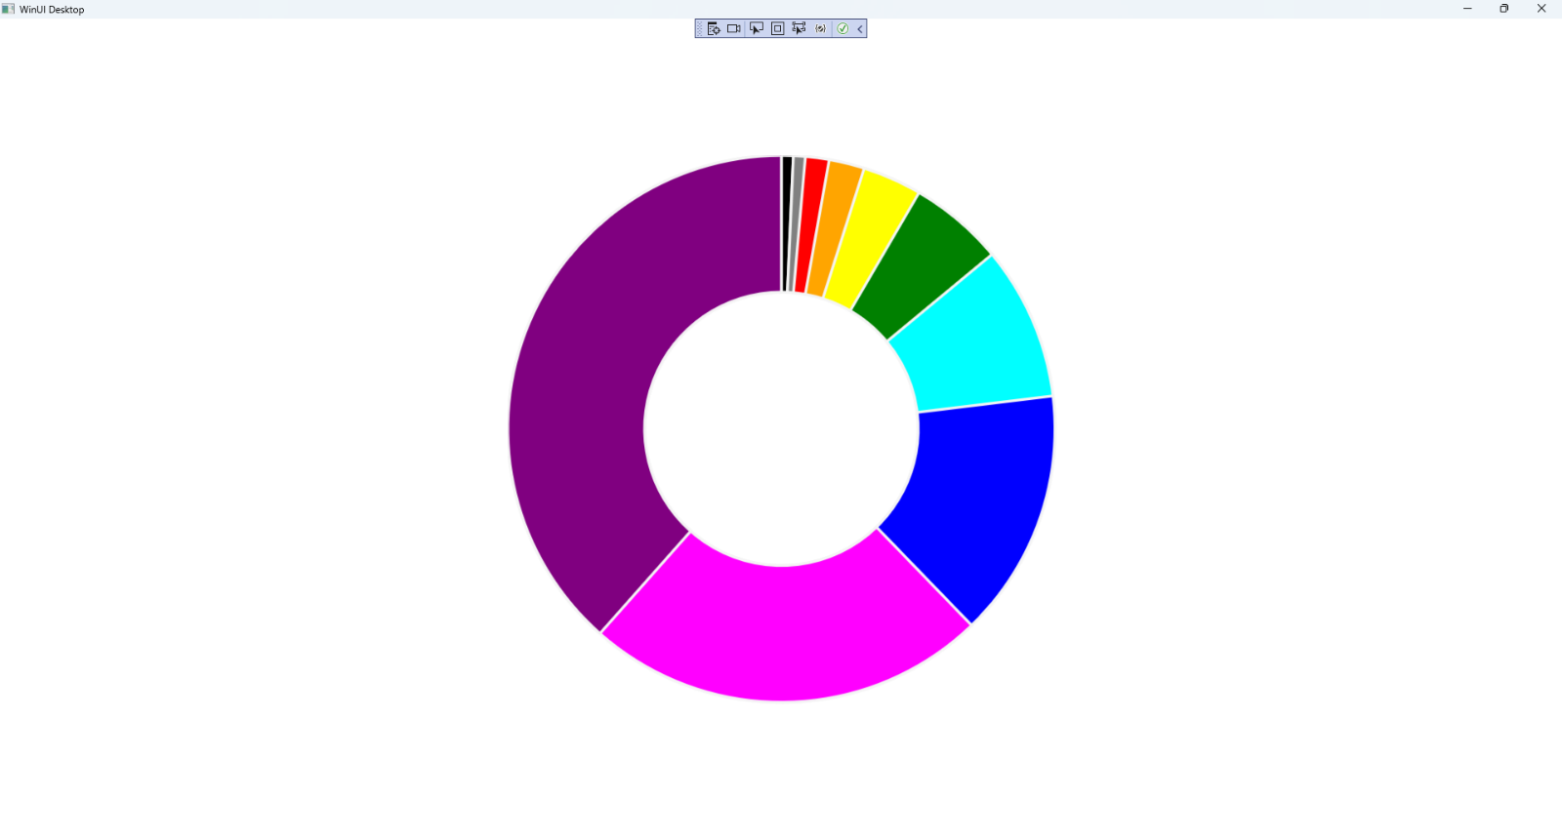

## Step 19

|  |  |
| --- | --- |
| To **Exit** the **Windows App SDK** application, select the **Close** button from the top right of the application as that concludes this **Tutorial** for **Windows App SDK** from [tutorialr.com](https://tutorialr.com)! |  |