

[](https://www.tutorialr.com/tutorials/)

Windows App SDK

Flags Game





# Flags Game

**Flags Game** shows how you can create a simple game where the aim is to guess the correct country’s **Flag**

from a set of **Flags** using flag assets and a toolkit from **NuGet** using the **Windows App SDK**.

## Step 1

Follow **Setup and Start** on how to get **Setup** and **Install** what you need for **Visual Studio 2022** and **Windows App SDK**.

|  |  |
| --- | --- |
| In **Windows 11** choose **Start** and then find or search for **Visual Studio 2022** and then select it. |  |
| Once **Visual Studio 2022** has started select **Create a new project**. |  |
| Then choose the **Blank App, Packages (WinUI in Desktop)** and then select **Next**. |  |
| After that in **Configure your new project** type in the **Project name** as *FlagsGame*, then select a Location and then select **Create** to start a new **Solution**. |  |

## Step 2

Then in **Visual Studio** within **Solution** **Explorer** for the **Solution**, right click on the **Project** shown below the **Solution** and then select **Manage NuGet Packages…**

## Step 3

Then in the **NuGet Package Manager** from the **Browse** tab search for **Comentsys.Toolkit.WindowsAppSdk** and then select **Comentsys.Toolkit.WindowsAppSdk by Comentsys** as indicated and select **Install**

This will add the package for **Comentsys.Toolkit.WindowsAppSdk** to your **Project**. If you get the **Preview Changes** screen saying **Visual Studio is about to make changes to this solution. Click OK to proceed with the changes listed below.** You can read the message and then select **OK** to **Install** the package.

## Step 4

Then while still in the **NuGet Package Manager** from the **Browse** tab search for **Comentsys.Assets.Flags** and then select **Comentsys.Assets.Flags by Comentsys** as indicated and select **Install**

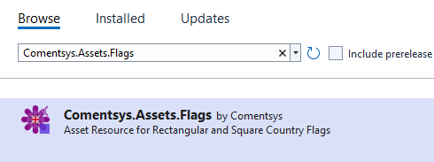

This will add the package for **Comentsys.Assets.Flags** to your **Project**. If you get the **Preview Changes** screen saying **Visual Studio is about to make changes to this solution. Click OK to proceed with the changes listed below.** You can read the message and then select **OK** to **Install** the package, then you can close the **tab** for **Nuget: FlagsGame** by selecting the **x** next to it.

## Step 5

Then in **Visual Studio** within **Solution** **Explorer** for the **Solution**, right click on the **Project** shown below the **Solution** and then select **Add** then **New Item…**

## Step 6

Then in **Add New Item** from the **C# Items** list, select **Code** and then select **Code File** from the list next to this, then type in the name of *Library.cs* and then **Click** on **Add**.

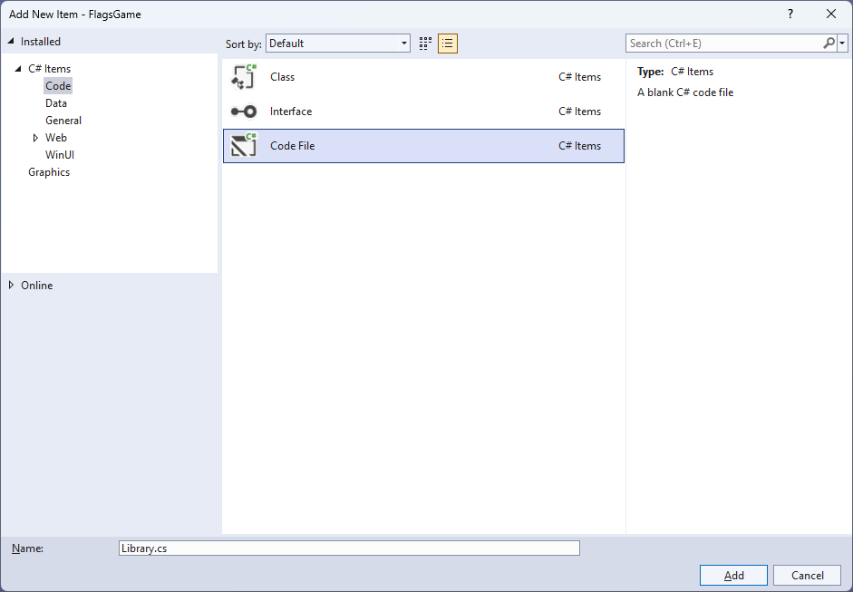

## Step 7

You will now be in the **View** for the **Code** of *Library.cs*, within this first type the following **Code**:

using Comentsys.Assets.Flags;

using Comentsys.Toolkit.WindowsAppSdk;

using Microsoft.UI;

using Microsoft.UI.Xaml;

using Microsoft.UI.Xaml.Controls;

using Microsoft.UI.Xaml.Media;

using System;

using System.Collections.Generic;

using System.Linq;

using System.Text.RegularExpressions;

using System.Threading.Tasks;

public class Library

{

private const string space = " ";

private const int flag_size = 72;

private const int font = 20;

private const int size = 3;

private readonly Random _random = new((int)DateTime.UtcNow.Ticks);

private Grid _grid;

private TextBlock _text;

private Dictionary<FlagType, ImageSource> _sources;

private List<int> _indexes = new();

private List<int> _choices = new();

private int _turns;

private bool _over;

private string _name;

// GetSourceAsync & SetSourcesAsync

// Chose, Name, Country, Select & Set

// Play & Add

// Layout & New

}

**Class** defined so far *Library.cs* has **using** for packageof **Comentsys.Toolkit.WindowsAppSdk** and others including **Comentsys.Assets.Flags**. It also has **Constants** to represent things needed in the game and there are **Variables** to keep track of values used in the game.

## Step 8

While still in the **class** for *Library.cs* after the **Comment** of **// GetSourceAsync & SetSourcesAsync** type the following **Methods**:

private async Task<ImageSource> GetSourceAsync(FlagType flagType) =>

await Flag.Get(FlagSet.Square, flagType)

.AsImageSourceAsync();

private async Task SetSourcesAsync() =>

_sources ??= new Dictionary<FlagType, ImageSource>()

{

{ FlagType.Armenia, await GetSourceAsync(FlagType.Armenia) },

{ FlagType.Austria, await GetSourceAsync(FlagType.Austria) },

{ FlagType.Belgium, await GetSourceAsync(FlagType.Belgium) },

{ FlagType.Bulgaria, await GetSourceAsync(FlagType.Bulgaria) },

{ FlagType.Estonia, await GetSourceAsync(FlagType.Estonia) },

{ FlagType.France, await GetSourceAsync(FlagType.France) },

{ FlagType.Gabon, await GetSourceAsync(FlagType.Gabon) },

{ FlagType.Germany, await GetSourceAsync(FlagType.Germany) },

{ FlagType.Guinea, await GetSourceAsync(FlagType.Guinea) },

{ FlagType.Ireland, await GetSourceAsync(FlagType.Ireland) },

{ FlagType.Italy, await GetSourceAsync(FlagType.Italy) },

{ FlagType.Lithuania, await GetSourceAsync(FlagType.Lithuania) },

{ FlagType.Luxembourg, await GetSourceAsync(FlagType.Luxembourg) },

{ FlagType.Mali, await GetSourceAsync(FlagType.Mali) },

{ FlagType.Netherlands, await GetSourceAsync(FlagType.Netherlands) },

{ FlagType.Nigeria, await GetSourceAsync(FlagType.Nigeria) },

{ FlagType.Romania, await GetSourceAsync(FlagType.Romania) },

{ FlagType.Hungary, await GetSourceAsync(FlagType.Hungary) },

{ FlagType.SierraLeone, await GetSourceAsync(FlagType.SierraLeone) },

{ FlagType.Yemen, await GetSourceAsync(FlagType.Yemen) }

};

**GetSourceAsync** will be used to get an **ImageSource** for a given **FlagType** and is used by the **Method** of **SetSourcesAsync** which will create a **Dictionary** of **Flags** which these have either horizontal or vertical stripes.

## Step 9

While still in the **class** for *Library.cs* after the **Comment** of **// Chose, Name, Country, Select & Set** type the following **Methods**:

private List<int> Choose(int minimum, int maximum, int total) =>

Enumerable.Range(minimum, maximum)

.OrderBy(r => _random.Next(minimum, maximum))

.Take(total).ToList();

private string Name(FlagType flag) =>

Enum.GetName(typeof(FlagType), flag);

private string Country(FlagType flag) =>

string.Join(space, new Regex(@"\p{Lu}\p{Ll}*")

.Matches(Name(flag))

.Select(s => s.Value));

private void Select()

{

var choice = _choices[_turns];

var index = _indexes[choice];

var flag = _sources.ElementAt(index);

_name = Name(flag.Key);

_text.Text = Country(flag.Key);

_turns++;

}

private void Set(string name, bool display) =>

(_grid.FindName(name) as Button).Opacity = display ? 1 : 0;

**Choose** is used to get a set of randomised unique numbers, **Name** will return the **Flag** as a **string** and **Country** will return the **Name** as a formatted **string**. **Select** will be used when performing an action in the game and **Set** will be used to hide a **Flag** once selected.

## Step 10

While still in the **class** for *Library.cs* after the **Comment** of **// Play & Add** type the following **Methods**:

private void Play(Button button)

{

if(!_over)

{

string name = button.Name;

if(_name == name)

{

Set(name, false);

if(_turns < size * size)

Select();

else

_text.Text = "You Won!";

}

else

_over = true;

}

if(_over)

_text.Text = "Game Over!";

}

private void Add(int row, int column, int index)

{

var flag = _sources.ElementAt(_indexes[index]);

var border = new Border()

{

BorderBrush = new SolidColorBrush(Colors.Black),

BorderThickness = new Thickness(2)

};

var image = new Image()

{

Height = flag_size,

Width = flag_size,

Source = flag.Value

};

border.Child = image;

var button = new Button()

{

Name = Name(flag.Key),

Content = border

};

button.Click += (object sender, RoutedEventArgs e) =>

Play(sender as Button);

button.SetValue(Grid.RowProperty, row);

button.SetValue(Grid.ColumnProperty, column);

_grid.Children.Add(button);

}

**Play** is used when interacting with a **Button** and is used by **Add** for elements of the game.

## Step 11

While still in the **class** for *Library.cs* after the **Comment** of **// Layout & New** type the following **Methods**:

private void Layout(Grid grid)

{

var index = 0;

grid.Children.Clear();

grid.RowDefinitions.Clear();

grid.RowDefinitions.Add(new RowDefinition()

{

Height = GridLength.Auto

});

grid.RowDefinitions.Add(new RowDefinition()

{

Height = new GridLength(1, GridUnitType.Star)

});

_text = new TextBlock()

{

FontSize = font,

HorizontalAlignment = HorizontalAlignment.Center

};

Grid.SetRow(_text, 0);

grid.Children.Add(_text);

_grid = new Grid();

for (int row = 0; row < size; row++)

{

_grid.RowDefinitions.Add(new RowDefinition());

for (int column = 0; column < size; column++)

{

if (row == 0)

_grid.ColumnDefinitions.Add(new ColumnDefinition());

Add(row, column, index);

index++;

}

}

Grid.SetRow(_grid, 1);

grid.Children.Add(_grid);

}

public async void New(Grid grid)

{

_turns = 0;

_over = false;

await SetSourcesAsync();

_indexes = Choose(0, _sources.Count, _sources.Count);

_choices = Choose(0, size * size, size * size);

Layout(grid);

Select();

}

**Layout** will create the look-and-feel of the game and is used by **New** which will setup and begin a game.

## Step 12

|  |  |
| --- | --- |
| Then from **Solution** **Explorer** for the **Solution** double-click on **MainWindow.xaml** to see the **XAML** for the **Main Window**. |  |

## Step 13

In the **XAML** for **MainWindow.xaml** there be some **XAML** for a **StackPanel**, this should be **Removed** by removing the following:

<StackPanel Orientation="Horizontal"

HorizontalAlignment="Center" VerticalAlignment="Center">

<Button x:Name="myButton" Click="myButton_Click">Click Me</Button>

</StackPanel>

## Step 14

While still in the **XAML** for **MainWindow.xaml** above **</Window>**, type in the following **XAML**:

<Grid>

<Viewbox>

<Grid Margin="50" Name="Display"

HorizontalAlignment="Center"

VerticalAlignment="Center" Loaded="New"/>

</Viewbox>

<CommandBar VerticalAlignment="Bottom">

<AppBarButton Icon="Page2" Label="New" Click="New"/>

</CommandBar>

</Grid>

This **XAML** contains a **Grid** with a **Viewbox** which will scale a **Grid**. It has a **Loaded** event handler for **New** which is also shared by the **AppBarButton**.

## Step 15

|  |  |
| --- | --- |
| Then, within **Solution** **Explorer** for the **Solution** select the arrow next to **MainWindow.xaml** then double-click on **MainWindow.xaml.cs** to see the **Code** for the **Main Window**. |  |

## Step 16

In the **Code** for **MainWindow.xaml.cs** there be a **Method** of **myButton_Click(...)** this should be **Removed** by removing the following:

private void myButton_Click(object sender, RoutedEventArgs e)

{

myButton.Content = "Clicked";

}

## Step 17

Once **myButton_Click(...)** has been removed, type in the following **Code** below the end of the **Constructor** of **public MainWindow() { ... }**:

private readonly Library _library = new();

private void New(object sender, RoutedEventArgs e) =>

_library.New(Display);

Here an **Instance** of the **Class** of **Library** is created then below this is the **Method** of **New** that will be used with **Event Handler** from the **XAML**, this **Method** uses Arrow Syntax with the **=>** for an Expression Bodywhich is useful when a **Method** only has one line.

## Step 18

|  |  |
| --- | --- |
| That completes the **Windows App SDK** application. In **Visual Studio 2022** from the **Toolbar** select **FlagsGame (Package)** to **Start** the application. |  |

## Step 19

Once running there will be *9* options for **Flags** available to select from and the aim is to correctly guess which **Flag** belongs to which country and if you guess all of them correctly you win but get any wrong and you lose or you can select *New* to start a new game.

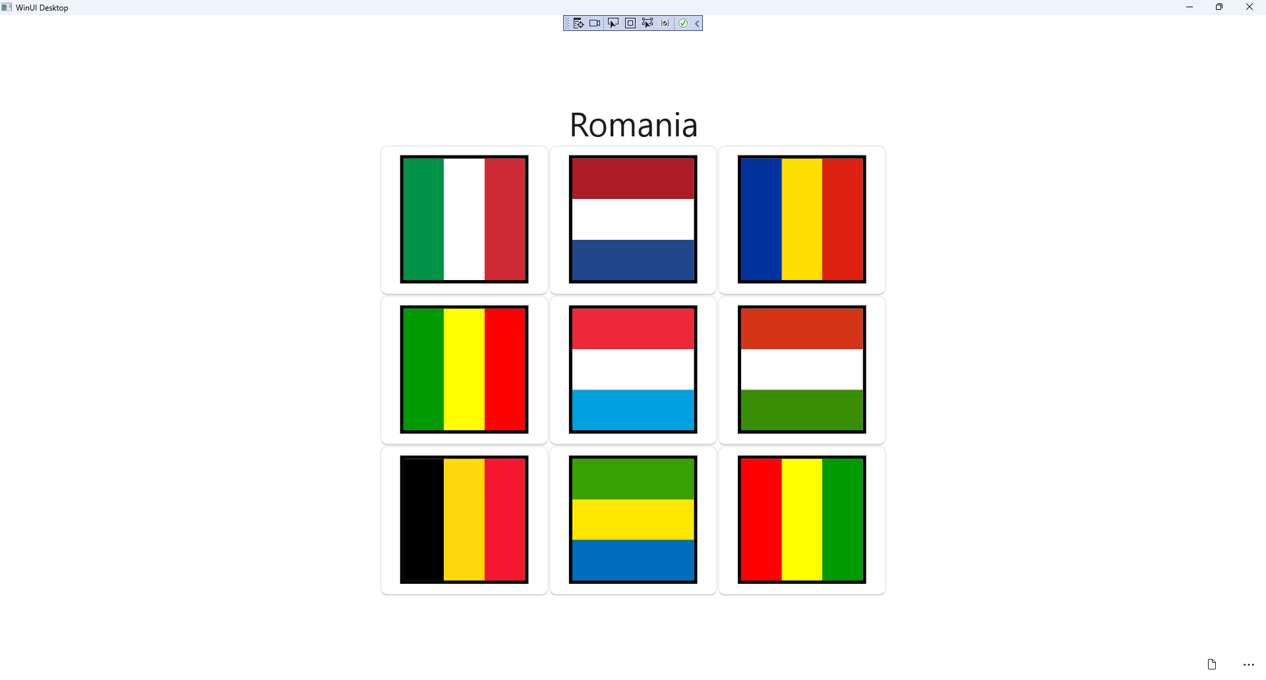

## Step 20

|  |  |
| --- | --- |
| To **Exit** the **Windows App SDK** application, select the **Close** button from the top right of the application as that concludes this **Tutorial** for **Windows App SDK** from [tutorialr.com](https://tutorialr.com)! |  |